312/2
GEOGRAPHY
Paper 2
JUNE 2018
Time: 2¾ hours

NAME:…………………………………………….. ……………… ADMIN NO:…………

CLASS:……………… INDEX NO:…………………… SIGNATURE:……………

KASSU-JET JOINT EXAMINATION
Kenya Certificate of Secondary Education
312/2
Paper 2
GEOGRAPHY
INSTRUCTIONS TO CANDIDATES

- This paper has two sections A and B
- Answer ALL the questions in section A.
- In section B answer questions 6 and any other TWO questions.
- Candidates should check to ascertain that all pages are printed and that no questions are missing.
- Candidates should answer the questions in section B on separate answer sheets.

SECTION A
QUESTION 6
QUESTION 7
QUESTION 8
QUESTION 9
QUESTION 10
TOTAL

SECTION A

Answer all the Questions in this section

1. a) State two factors that determine the mode of occurrence of minerals.
(2 marks)

b) Give three ways in which mining causes land derelictions. (3 marks)

2. a) What is fish farming? (1mark)

b) The photograph provided shows a type of fishing method.

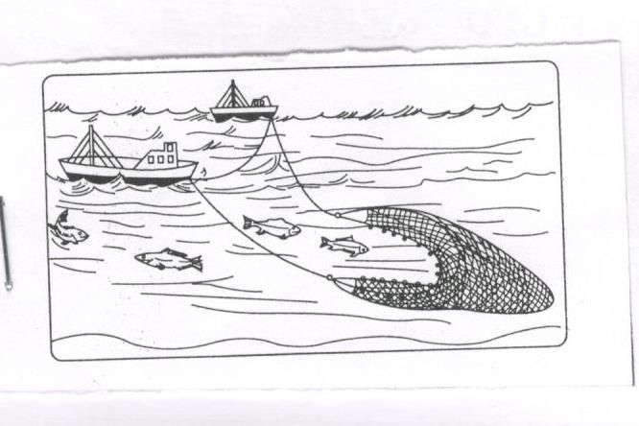

Identify the method and describe how it is used. (4 marks)

3. a) Define domestic tourism. (2 marks)

b) State three ways in which eco-tourism is being promoted in East Africa. (3 marks)

4. a) Name two canals found along the Great lakes and Lawrence Seaway (2 marks)

b) Give three benefits of the St Lawrence Seaway to the economy of Canada and
U.S.A (3 marks)

5. a) Define the term Trade. (2 marks)

b) State measures that can be taken to reduce unfavorable balance of trade. (3 marks)

SECTION B

6. The table below shows the production of maize in tonnes between 2015 and 2017 in four divisions in Baringo county. Use it to answer the questions below.

Division | 2015 | 2016 | 2017
Bartabwa  Barwesa  Kabartonjo  Kipsaraman | 3005  6087  6753  4078 | 3500  6198  6547  5465 | 4000  7786  6698  5567

- (i) Calculate the percentage increase of the total maize production in the
four divisions between 2016 and 2017 (3 marks)

(ii) What is the difference in kilograms between the highest production and the lowest production in the three years. (2 marks)

- (i) Using a radius of 5cm, draw a pie chart to represent production of 2017. (6 marks)

(ii) Give three advantages of using a pie chart in representing information. (3 marks)

- State three climatic conditions favouring the growing of maize. (3 marks)

- Explain four problems facing small scale maize farmers in Kenya. (8 marks)

7. a) (i) What is reafforestation? (2 marks)

(ii) Give five reasons why afforestation is being encouraged in Kenya. (5 marks)

b) (i) List three factors that influence the distribution and types of natural forests
in Kenya (3 marks)

(ii) State three differences between natural forests and planted forests. (3 marks)

(iii) Give two economic uses of Mangroove forests. (2 marks)

c) (i) Explain two problems that affect forestry in Canada. (4 marks)

(ii) Give measures that the government of Kenya is taking to manage forests
in the Country. (6 marks)

8. a) Define the following terms
- Urban sprawl (2 marks)

- Conurbation (2 marks)

Use the sketch map below to answer Questions

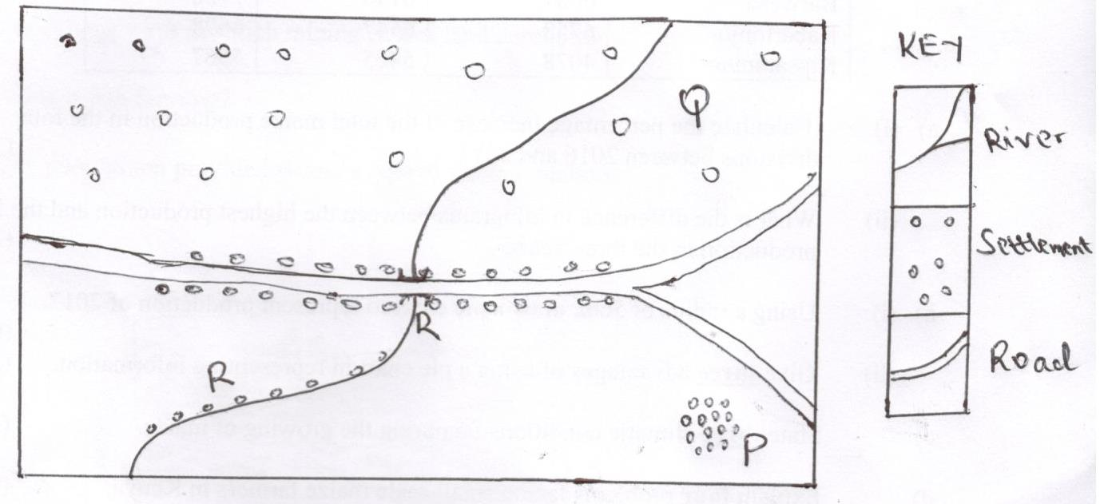
b) (i) Name the settlement pattern marked P. Q and R (3 marks)

(ii) Explain four factors that favour the development of the settlement pattern
marked R (8 marks)

c) State factors which led to the growth of Eldoret town as an agricultural center. (4 marks)

d) State the differences in functions between the cities of New York and Nairobi. (6 marks)

9. a) (i) Define cottage industry. (2 marks)

(ii) State five ways in which Kenya Government assists Jua Kali industries. (5 marks)

b) Form Four Geography students carried out a field study at Webuye pan paper
mills.

(i) Give three importance of preparing working schedule. (3 marks)

(ii) State four reasons the students could have found out why the industry was located near River Nzoia. (4 marks)

c) The map below shows the Ruhr Industrial region. Use it to answer questions below

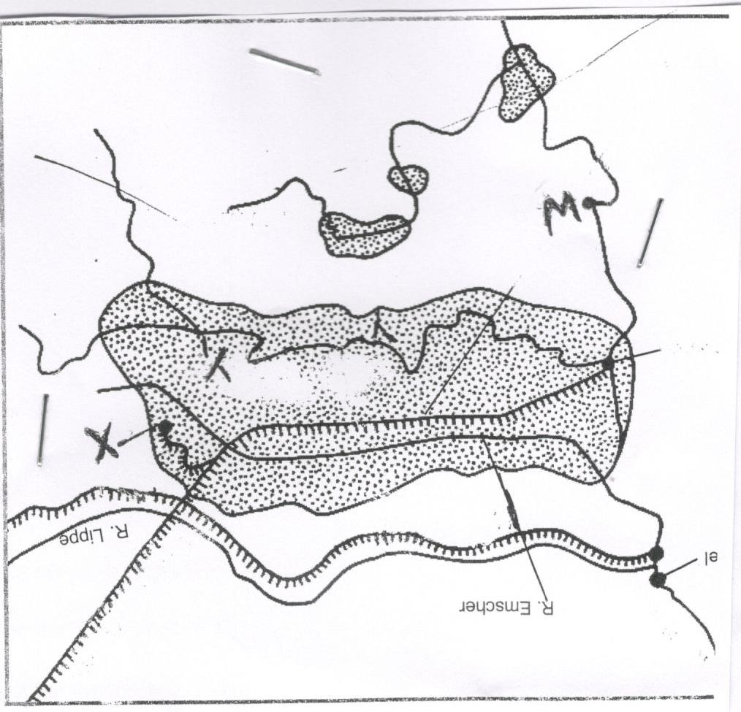

- Name the canal marked X (1mk)

- Name the River marked Y (1mk)

- Name the town marked W (1mk)

- Explain how the following factors led to the growth of Iron and steel industry in the Ruhr region

- Raw materials (2mks)
- Energy (2mks)
- Capital availability (2mks)

10. a) Define population growth. (2mks)

b) State three causes of rural-rural migration in Kenya. (3mks)

c) The diagram below represents population structure in Kenya.

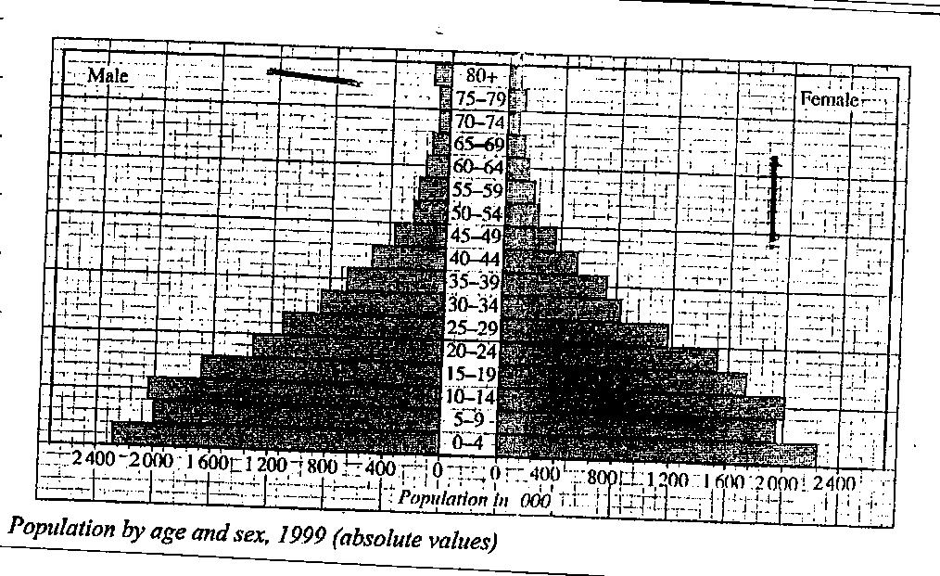

- Describe the characteristic of the population as represented by the pyramid. (4mks)

d) (i) Apart from natural calamities, give two other causes of mortality in Kenya. (2mks)

- Give three primary sources of population data. (3mks)

- Identify three ways cultural belief and traditions influence population growth. (3mks)

e) Explain four consequences of over population. (8mks)

