

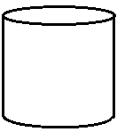
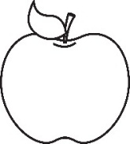
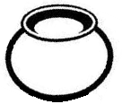
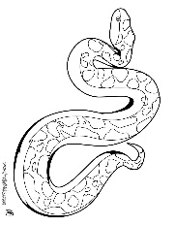
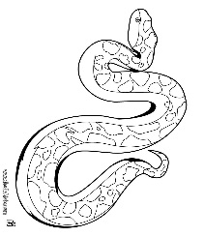
BABY CLASS: HOLIDAY WORK
- Match the same pictures

- Colour
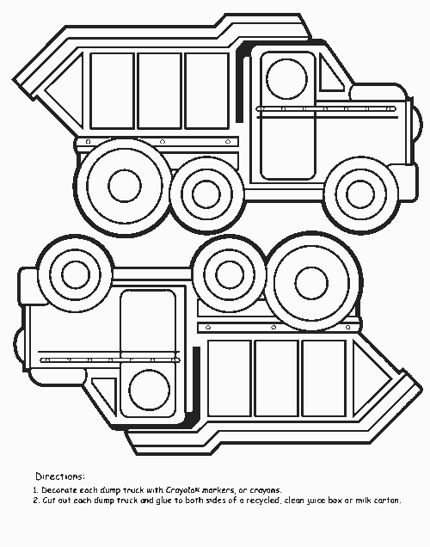

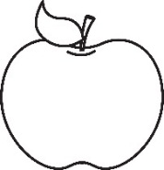
- Write over
s n
a p
t i
i t
p a
n s

- Count number orally

1 | 2 | 3 | 4 | 5

- Colour

- Write over the shapes

- Shading is fun

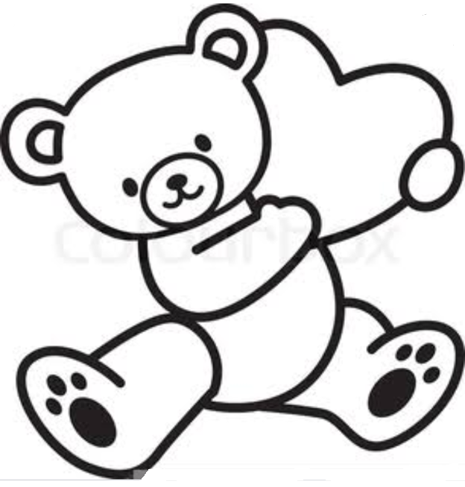
- Copy the same
0 | 1 | 0 | 1 | 0 | 1 | 0 | 1
a | t | a | t | a | t | a | t


- Colour the birthday gift

- Copy and write
2 | 2 | 2 | 2 | 2 | 2
-End-

