SUCCESS INTEGRATED NURSERY SCHOOL
Internal End of First Term Examinations 2020
Literacy 5-6 years

Name _____________________________Stream____________
1. X the body parts.
a) cat ear rat
b) nose shorts boy
c) tongue food stick
2. Match things used to clean the environment to words.
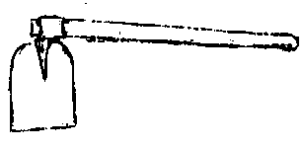
wheel barrow
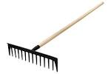
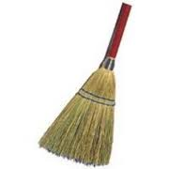
broom

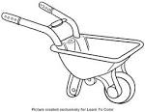
hoe

rake
3. Read and draw things used to clean our body.
toothbrush | toothpaste | water | razorblade
4. Fill in the missing letters.
ey___ m__uth n__se ea__s
5. Complete the sentences.
I have ___________ senses.
Mummy has ______________legs
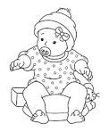
6. Match people at home to words.
mother
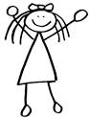
baby
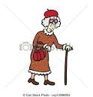
grandfather
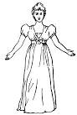
sister
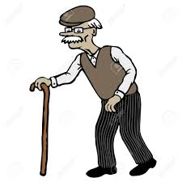
grandmother

7. Underline things used to clean the environment.
trashcan sponge soap
rake vaseline eyes
towel hoe baby
sister broom brother
8. Read and draw the body parts.
head legs eyes

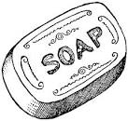
9. Match pictures to words.
toothpaste
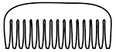
vaseline
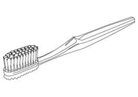
comb

soap
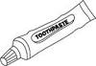
toothbrush
10. Match body parts to their uses.
eyes smelling
legs hearing
nose tasting
ears seeing
tongue walking
11. Draw the food we eat.
eggs | fish | mango

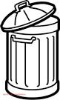
12. Z the correct word for the picture.
dustbin bucket
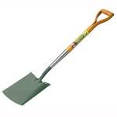
broom spade
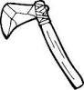
axe panga
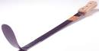
knife slasher

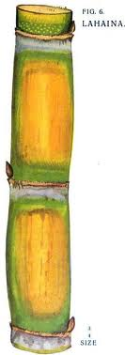
13. Tick the correct name of the fruit.
stick sugarcane
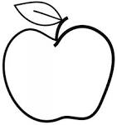
apple stone
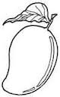
ball mango

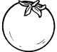
orange pineapple

14. Fill in the missing letters.
m__ther sist__r grandm__ther
f__ther ba__y broth__r

