SUCCESS INTEGRATED NURSERY SCHOOL
Internal End of First Term Examinations 2020
Reading 4-5 years

Name ________________________Stream__________
1. Blend and read the syllables.
f-a r-a k-a s-a m-a
n-i l-i z-i v-i t-i
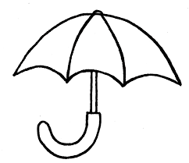
2. Match sound to pictures.
a
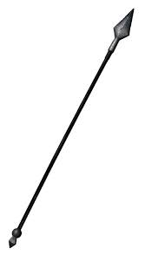
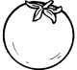
e
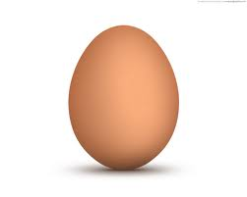
i
o
u
3. Circle the same words.
pen pen fan
hat zip hat
cot cot bat
tin cup cup
4. Tick ( √ ) for the given picture.
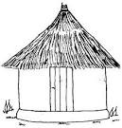

 | 
 | 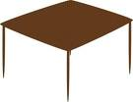  
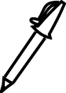 | 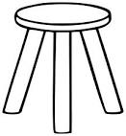  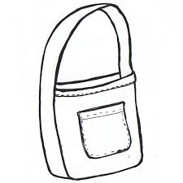
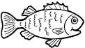 | 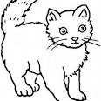

5. Form the words.
fi-n = fin
te- n = _____________ po – t = _____________ si – t = _____________ ca – t = _____________

