LOHANA SCHOOLS
MIDDLE CLASS REVISION WORK ACTIVITY ONE :2020
Learning Area 5 – English
My name is …………………………………………………..
I am in middle class ………………………………………..
Copy and learn.
d | e | f

LOHANA SCHOOLS
MIDDLE CLASS REVISION WORK ACTIVITY ONE :2020
Learning Area 2 – General knowledge
My name is …………………………………………………..
I am in middle class ………………………………………..
Draw and shade.
shirt | trousers

LOHANA SCHOOLS
MIDDLE CLASS REVISION WORK ACTIVITY ONE :2020
Learning Area 4 – Numeracy
My name is …………………………………………………..
I am in middle class ………………………………………..
Copy and learn the numbers.
6 | 7 | 8 | 9 | 10

LOHANA SCHOOLS
MIDDLE CLASS REVISION WORK ACTIVITY ONE :2020
Learning Area 5 – Reading
My name is …………………………………………………..
I am in middle class ………………………………………..
Circle the correct sound.
 | b | d
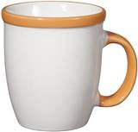 | k | c
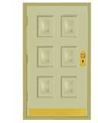 | d | b
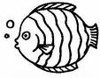 | f | s

