

MIDDLE CLASS : HOLIDAY WORK
Name: ……………………………………………………………
- Copy and read these sounds.

g p oo n st ai
___ ___ ___ ___ ____ ____

___ ____ ____ ____ ____
ch v m qu ee
yo
pr
z
sh
y
oo
st
oo
tr
sh
pr
z
x
w
ee
ee
ee
oo
oo
oo
sh
sh
sh
sh

- Sound, read and match.
cat 
mat 
tin 
sun 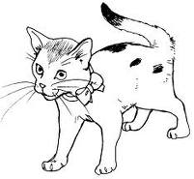
pot 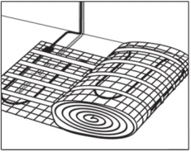
- Write 5 sounds you know.

- Copy and write.
00 0 | 1 | 2 | 3 | 4 | 5 | 6 | 7 | 8 | 9

00 10 | 11 | 12 | 13 | 14 | 15 | 16 | 17 | 18 | 19

- Count and match.
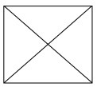 6
 8
5
 3
 7
 4
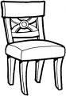 2
 1

- Copy and read sentences.
It is a book.
__________________________________________
It is a pot.
_________________________________________
It is a bed.
_________________________________________
It is a roof.
________________________________________
This is a cup.
________________________________________
It is a mat.
_________________________________________
- Write numbers 0 – 13.

0
0

- Match sound to a word and write.
sh clock_______
oo tree_______
s pot_______
th book______
p set________
ee short_______
ck tooth______
- Count and write.

= = = = =

- Read the sounds.
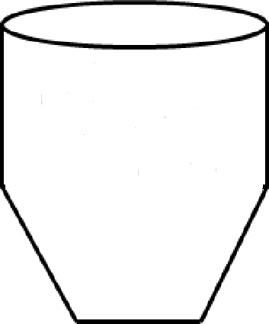
s a t I p n ck e h r m d g o u l f b j oa z w v th y ee x qu ch oo sh ck

- Fill in sound “oo” and read.
b ___ ___ k r ___ ___ t l ___ ___ k
g ___ ___ d t ___ ___ f ___ ___ t
s ___ ___ n st ___ ___ l z ___ ___
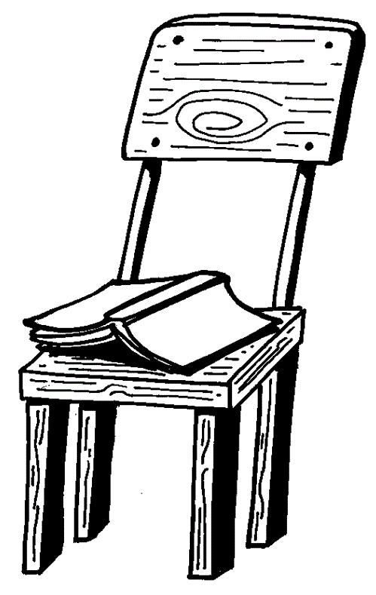
- Write the correct preposition.
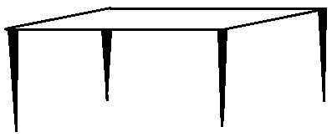




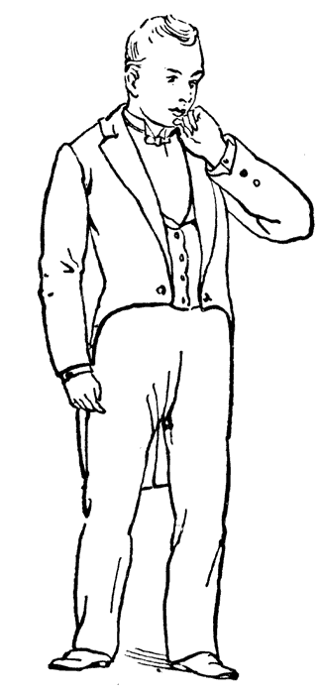
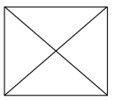



(near, between, in, under, on)

- Match the same and name
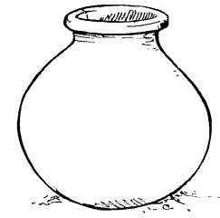________
_______
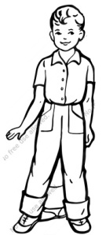 _________

__________

________
(sun, pot, tree, boy, bag)

- Copy the numbers.

man
0 1 2 3 4 5 6 7 8 9

11 12 13 14 15 16 17 18 19 20

- Count and write.



-End-

