SECTION | MARKS
A
B
TOTAL
TRINITY PRIMARY AND PRESCHOOL
REVISION WORK
CLASS : P.1
SUBJECT : ENGLISH
Name:_______________________________________
Date: ________________________________________
- Fill in the missing letters.


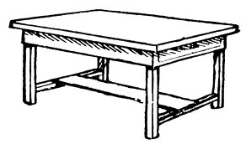
t______ble
c____p

- Fill in a or an.
It is ________ egg.
Pat has _______ bag.
________ elephant has big ears.
That is ______ pot.
- Write these words in capital letters.
tree __________________________
mat ___________________________
- Name the pictures.
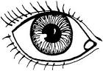 | 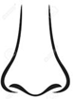

- Give the plural of the underlined words.
I have a red flower. ________________________________________
Can I have a ruler please? ________________________________________
The book is in the box. _________________________________________
The baby is crying. _________________________________________
- Answer Yes, it is or No, it is not
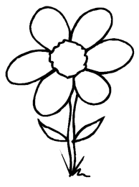
Is this a chalkboard?

________________________________
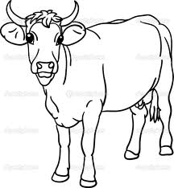
Is this a cow?
_________________________________
- Form a small word from a big one.
teacher _____________________
classroom ___________________

- Write the sentence correctly.
book is This a. __________________________________________
your name What is? ___________________________________________
playing She is. ____________________________________________

- Arrange in ABC order.
k, a, p, b ____________________________________________
cat, fish, eggs ___________________________________________
- Make a sentence using these words.
sitting: ___________________________________________
eating: __________________________________________

SECTION B
- Read the conversation and answer the questions in full.
Paul: Good morning Dan
Dan: Good morning Paul
Paul: His your new class?
Dan: Primary one class is good. There are chairs
tables, pencils, colours and story books in my
class.
Paul: Oh! That’s good. Who is your class teacher?
Dan: My class teacher is Mrs. Ddamba.

Questions
- How many people are talking? ___________________________________________
- In which class is Dan? ____________________________________________
- Who talked first? _____________________________________________
- Draw and name two things in Dan’s class.

- (a) March correctly.
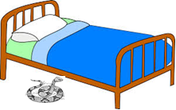
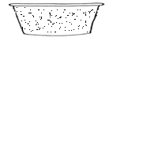
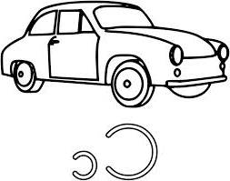
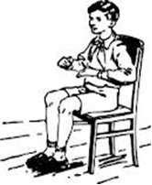

The snake is under my bed.

The tin is near the car.

He is sitting on the chair.

There is water in the basin .

b) Who am I?
I live at home
My youngone is a calf
I give people meat and nilk
I have four legs
Who am I?
You are a _______________________________

- Make five sentences from the table.
They  I  Mary  He | am  is  are | going to school  playing football  cooking food

- ______________________________________________
- ______________________________________________
- ______________________________________________
- ______________________________________________
- ______________________________________________

- Read and draw.
A ball and a tree | She is sweeping
- Re arrange the sentences to make a good story.
- I buy food and ice cream.
- Every Saturday, I go for shopping.
- Then I go back home.
- ________________________________________________
- ________________________________________________
- _________________________________________________

- Use the words in the box to complete the story.
Dress, bible, church, chair, shoes
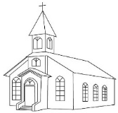
My name is Joan. I go to ____________

every Sunday.
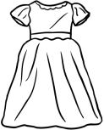
I put on my white ________________________

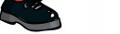
and black ___________________________.
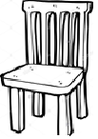
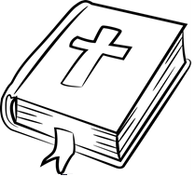
When I reach church, I sit on the ______________

and read my ___________________.

end

