SECTION | MARKS
A
B
TOTAL
TRINITY PRIMARY AND PRESCHOOL
REVISION WORK
CLASS : P.1
SUBJECT : LITERACY
Name:_______________________________________
Date: ________________________________________
SECTION A
- Write the name of our school. _______________________________________________________________
- Name this item found in our classroom.


__________________________________________________
- Mention one member in the nuclear family. _______________________________________________________________
- What does the doctor do in the hospital?
_______________________________________________________________
- Mention one way we care for our teeth. ______________________________________________________________
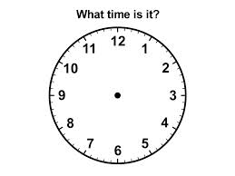
- Give the use of the item shown in the classroom.

_____________________________________________________________________________________________
- Name one basic need of a family. ______________________________________________________________
- Why do you go to school? ______________________________________________________________
- Mention one way of controlling common diseases. ______________________________________________________________
- Why do you put on a school uniform? _____________________________________________________________
- State one building in your school. ______________________________________________________________
- Mention one activity done at school. ______________________________________________________________
- Give one use of water at home. ______________________________________________________________
- Draw these people in our community.
Policeman | Teacher

- Give the use of a dustbin in the school. _____________________________________________________________
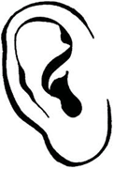
- Name this body organ.

________________________________________________________________________

- Mention one bird that gives us eggs at home. ______________________________________________________________
- Give the role of a dog at home. ______________________________________________________________
- Mention one symbol of a school. _______________________________________________________________
- How can a P.1 child care for his/her hair? _______________________________________________________________

SECTION B
- Match correctly.
doctor airport
teachers police station
policeofficers hospitals
pilot school
- Draw these things made out of wood.
chair | table
- Give two items used to keep the toilet clean.
- ________________________________________________________
- ________________________________________________________

- _________________________ is the place where animals or people live.
- How do the following animals move?
- Fish _____________________________________________________
- Bird _____________________________________________________

- Name these basic needs.
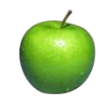  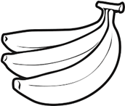  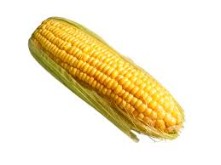 | 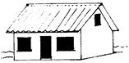

- Name the place where food is cooked from at school. _______________________________________________________________

- Write the homes of the following.
- Lion _____________________________________________________
- Man _____________________________________________________
- Name one part of a house. ______________________________________________________________
- Give one use of fire at home. ______________________________________________________________
- Draw these items used to keep the body clean.
Sponge | razorblade
- Write two materials used for building. (i)__________________________ (ii)______________________________
- Mention one place where you go to get water from at home. _____________________________________________________________
- Name these sources of light.
 | 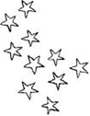
- (a) Mention two things people get from the garden. (i)__________________________ (ii)________________________
- Write three things found in the bedroom.

(i)________________ (ii)_______________ (iii)______________
END

