TRINITY PRIMARY AND PRESCHOOL - BUKOTO
REVISION WORK
Name…………………………………………… Stream:……………
- How do you come to school?
_______________________________________________________
- Write any two things found in the classroom.
(i)___________________________
(ii)_____________________________
- Who heads a school?
____________________________________________________
- Name these things used to clean the body.
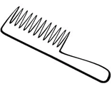 | 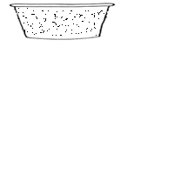 | 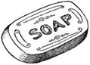

- Name one example of a house.
____________________________________________________
- What is a school?
__________________________________________

- Draw these school symbols
School flag | School signpost
- A…………………….is the place where people or animals live.
- Write two people found at home.
- ___________________________
- ___________________________

SECTION B
- Match people to their work in the community.
Policeman drives cars
Driver treats sick people
doctor keeps law and order
- Name these parts of the house.

(Window, roof, ventilators, door)
- Write two animals without legs.
- _________________________________
- _________________________________
- Name this food we eat at home.
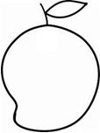 | 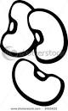 | 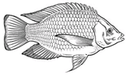

- Write two parts of the head.
- ______________________
- ______________________
- Mention two things used to clean the school.
- ___________________________
- ___________________________
- Name this item used at school.
___________________________________

- Give one colour of your school uniform.
_____________________________________
- Write two animals found at home.
- _______________________
- _______________________
- Write the use of the following body parts.
- Nose ___________________________
- Eyes____________________________
- Ears____________________________
- Mention two things found on your school badge.
- _________________________
- _________________________
- Which animal guards our home?
_____________________________________________
- Draw these important places in the community.
mosque | church | hospital

- Write two activities done at school.
- _____________________________
- _____________________________
- Mention the young ones of these animals.
- Cow ___________________
- Pig ____________________
- Goat __________________
- How are these people useful to us?
- Mother ___________________________
- Teacher __________________________
- Write one room found in the house.
__________________________________

