TRINITY PRIMARY SCHOOL – BUKOTO
SECTION | MARKS
A
B
TOTAL
REVISION WORK
CLASS : P.2
LEARNING AREA : R.E
Name: _______________________________
Date: ________________________________________
- On which day do Christians go to church?
__________________________________________________
- Which animal tempted Eve to sin?
__________________________________________________
- How useful are the eyes to your body?
__________________________________________________
- Who was the father of Jesus?
__________________________________________________
- Draw these living things God created.
birds | plants | people

- Match correctly.
father looks after animals
mother mops the house
brother pays school fees
sister cooks food
- Name these things God created to give us light.
 |  | 

- Circle the Christian name for.
Sarah Aisha Jane Joy Juma
- Mention one use of a cow at home.
__________________________________________________
- Mention two gifts of God found on your body.
(i) ______________________ (ii) ______________________
- Name these Christian symbols.
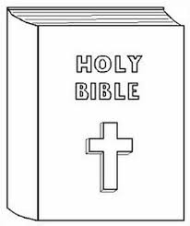 |  | 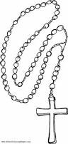

- Match these Christian names to their meaning.
Peter saviour
Moses laughter
Jesus the rock
Isaac got from water
- Name the disciple who denied Jesus.
____________________________________________
- Tick the role of the father of Jesus.
( teacher , carpenter , potter )
- (a) Jesus had ______________________ disciples.
(b)Underline the disciples of Jesus.
Joan , Simon Peter , John , Judas Iscariot , Alex
- Write down two animals God created.
(i) ______________________ (ii) ______________________
- ____________________________ heads a family.
- Draw these things we use to clean our body.
sponge | soap | water

- Name these foods God created for us.
- 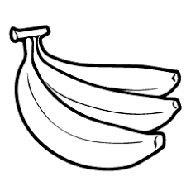______________________
- 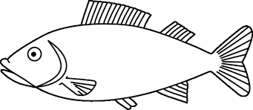______________________
- (a) Who baptized Jesus Christ? (James, John the Baptist)
____________________________________________
(b) Name the river on which Jesus was baptized from.(River Nile, River Jordan)
____________________________________________

- Mention any two non-living things that God created.
(i) ______________________ (ii) ______________________
- (a) Mention two reasons why we pray.
- ____________________________________________
- ____________________________________________
(b) Name two groups of people that we pray for.
(i) ____________________________________________
(ii) ____________________________________________
- Draw yourself praying to God.

