Musiye primary school
END OF TERM II EXAMINATIONS 2019
CLASS : P.I
SUBJECT : MATHEMATICS
DURATION : 2 ¼ HOURS
Name ________________________________________________
Stream _______________________________________________
- Avoid unnecessary crossing of work.
- Write well.
- Wrong spellings will lead to loss of marks.
SECTION A1
- Add:5 + 7 = ___

- Write the number word.
17 _______________________________________________

- Read and draw
A set of 5 pots

- Name this shape

______________________________
- Eight take away three is equal to _________________________

- How many groups of 2s are in 8?

- Add the fraction
1 + 2 =
5 5
- Complete correctly
5 tens = ______
- Write the number shown on the abacus
T O
7 2

- Count in threes
6, 9, 12, ____

- Complete correctly
3 + 4 is the same as ____ + _____ = _____

- Write the shaded part

- Add: 8
+ 6
___
- Fill in the missing numbers
41, 42, ____, 44

- Take away 1 3
- 6
_____
- Multiply:
4
X 3
_____

- Write the number before
_____, 56

- Count in tens and ones. 52
____ tens and _____ ones make ______
- Join the sets
+ =

5 + ____ = 9
- 5 groups of 3s are equal to ______

SECTION B
- Write the number for the word
- Eight-______
- Seventeen-_______

- a) Add:
1 0
+ 1 2
______

b) Jane has 6 sweets and Sarah has 4 sweets. How many sweets do they have altogether?

- 2 + 2 + 2 + 2 + 2 + 2 = ___
- a) Write the place values.
9 7
_________
_________

b) Fill in correctly.
38 = ____ tens and ____ ones
- a) Write the fractions
A half

A quarter

b) Shade 1
3

- a) 8 girls have ___ legs

b) Multiply :
1 2
X 3
______
c) 4 threes is the same as ___ x ___ = _____

- Draw tens and ones
- 42 = b) 60 =

- a) Tell the time
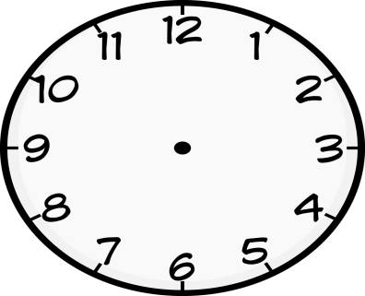 _________________

- Show the given time on the clock face.
It is 7 O’clock
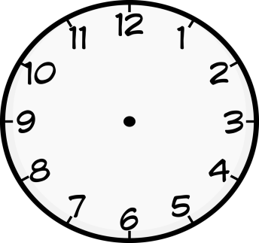
- Subtract
- Tens ones
2 8
- 2 5
____________
b) Maria had 9 balls. Joy removed 5 balls. How many balls remained?

- Use a numberline to work out
a) 6 + 2 =

b) 5 – 3 =

- Find the missing number in the puzzle
+2

6
2
1
4

- Draw the shapes
triangle | oval | rectangle

- 3 children have balls as shown below
Don | Mary | Bob


  - Who has three balls?

  - How many balls does Mary have?

  - How many balls do they have altogether?

END

