
LIGHT ACADEMY PRIMARY SCHOOL
P.1 ENGLISH HOMEWORK EXERCISE TERM I 2020

My name is ____________________________Stream____________
1. Fill in the gaps with “a” or “ an”.
 _____ egg 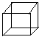 ____ box

_____umbrella ____envelope
 ____flower 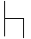 ______chair
2. Complete the sentences with “a” or “an.
a. Bring me ________apple with ______knife.
b. _____aeroplane is a means of transport.
c. _____ teacher teaches pupils.
d. It is _______ school.
3. Change these nouns into plural.
Singular ( one) Plural ( many)
- School schools
- pencil ________________
- office ________________
- kitchen ________________
- pen ________________
- flag ________________
- badge ________________

LIGHT ACADEMY PRIMARY SCHOOL
P.1 ENGLISH HOMEWORK EXERCISE TERM I 2020

Name: ________________________________________ Stream ____
My school is :________________________________________________
1. Give the plural form of the nouns in brackets.
a. Put the ___________________in the basket. ( tomato)
b. The _________________are in the kitchen. ( cook)
c. Juma put eight _____________ in the cupboard. ( plate)
d. All my __________________ are torn. ( dress)
e. ____________________are fruits. ( apple)
f. They have broken all the ___________________ . ( bench)

2. Complete the sentences with “is” or “are”.
a. _________________these garden tools?
b. There _______________very many fruits in the market.
c. The boys ____________________playing football.
d. _____________________this a gatekeeper?

3. Write their plural form.
Singular ( one) plural ( many)
a. fox __________________ b. bus ____________________
c. box __________________ d. girl ____________________
e. tomato _______________ f. child __________________

LIGHT ACADEMY PRIMARY SCHOOL
P.1 ENGLISH HOMEWORK TERM I 2020
Name: ________________________________________ Stream ____
1. Complete the sentences.
a. Jane has a _______________
b. Here is a _______________
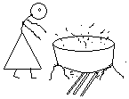
2. Answer correctly using (No, she is not or Yes, she is )
a. Is she a cook?
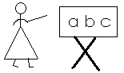
____________________________________
b. Is she a nurse ?
___________________________________
3. Fill in the missing letters.
t__acher do__ tor d__ __ver
4. Write these words correctly.
a. ncilpe - _____________________
b. ookb - _____________________
c. airch - _____________________

LIGHT ACADEMY PRIMARY SCHOOL
P.1 LITERACY I HOMEWORK TERM I 2020
Name: _____________________________________ Stream ____
- ________________ is the way we keep our bodies clean. (sanitation, personal hygiene)
- Name any one example of a body exercise.
_________________________________________________________
- We wash our hands to remove_________________.(germs, sweets)
- We do body exercise to be ______________________.(weak, strong)
- Write yes or no
- a broom is used for sweeping___________________.
- A comb is used for eating________________________.
- We iron our uniforms to kill germs._________________
- Draw the following items we use to keep our classroom clean.
water | broom | soap

LIGHT ACADEMY PRIMARY SCHOOL
P.1LITERACY I HOMEWORK EXERCISES TERM I 2020
Name: ______________________________________ Stream __

- We get __________________ and ________________________ from a cow.
- Draw the following animals we keep at home.
cat | dog | cow

- A hen gives us _____________________________.
- We wash our hands to remove_____________________________.
- A dirty home has ________________________________.
- Name this item that gives us light.
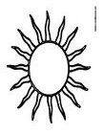


LIGHT ACADEMY PRIMARY SCHOOL
P.1 HOMEWORK EXERCISE TERM I 2020
Literacy I
- Write down only common diseases from the list below.
Flu ______________________
Polio ______________________
Malaria ______________________
Cough ______________________
2. __________________spread diseases. ( food, germs)
3. How do we protect ourselves from mosquito bites?
_________________________________________________________
4. Tick ways of keeping the home clean.
by sweeping
by eating dirty food
by covering the toilet
5. Why do we cut our fingernails short?
_________________________________________________________
6. Circle immunisable diseases.
Measles, flu, polio, cough, tetanus
7. Which immunisable disease makes us lame.
________________________________________________________
8. Draw a child suffering from polio.

LIGHT ACADEMY PRIMARY SCHOOL
P.1 ENGLISH HOMEWORK EXERCISE TERM I 2020
Name: ________________________________________ Stream ____
1. Circle the verbs.
a. He plays football every day.
b. She walks to town every day.
c. Girls put on dresses.
d. We are sleeping now.
e. They danced well yesterday.
2. Use the given verbs in present continuous tense.
a. I am ______________________my teeth. ( brush)
b. Daddy is _____________________a car. ( drive)
c. We are __________________ very fast. ( move)
d. Are they _________________food. ( eat)
e. The water is _______________now. ( boil)
f. Mummy is ___________________ a cake. ( bake)
Make three sentences from the table below.
You  She  Mary  He  I | has  have | a red doll.  many books  nice bags  mangoes and oranges
a. _________________________________________________________
b. _________________________________________________________
c. _________________________________________________________
LIGHT ACADEMY PRIMARY SCHOOL
P.1 NUMBER HOMEWORK TERM I 2020
Name: ________________________________________ Stream ____
My school is ________________________________________________

1a. Arrange the numbers starting from the smallest to the biggest.
a. 3, 5, 2, 4 ______________________
b. 40, 20, 30, 10 ______________________
c. 12, 10, 11, 15 ______________________
2. Write the number names correctly.
a. hteig - _____________ b. ntytwe - ______________
c. teenfif - _____________ d. tythir - ______________
e. tow - _____________
3. Arrange numbers starting from the biggest to the smallest.
a. 7, 8, 1, 3 ______________________________
b. 15, 20, 19 ______________________________
c. 30, 10, 50, 20 ______________________________

LIGHT ACADEMY PRIMARY SCHOOL
P.1NUMBER HOMEWORK EXERCISES TERM I 2020
My name is ________________________________________________
My school is ________________________________________________
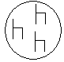

1. Name these sets.
a. A set of ___________ b. ______________

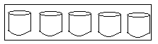
c. A set of ___________________

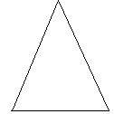
2. Read and draw the sets.

a. b.

A set of 2 balls. A set of 4 sweets.
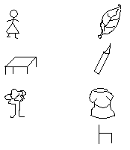
3. Match the related.



4. Use the words to complete correctly.
Empty elements set
a. A group of objects is __________________________
b. Things found in a set are called _____________________
c. A set with no members is an ________________________
LIGHT ACADEMY PRIMARY SCHOOL
P.1 MATHEMATICS II HOME WORK EXERCISES TERM I 2020
Name: ________________________________________ Stream ___
1. Join these sets.
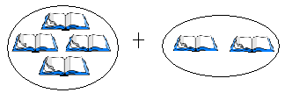
a.
=

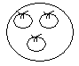

b. plus equals
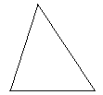
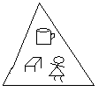
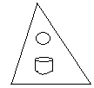

c. and make
2. Form a big set from small sets.
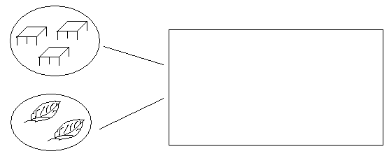
3. Make new sets.
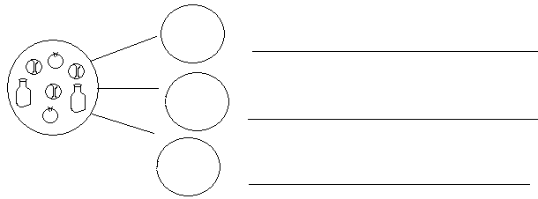

LIGHT ACADEMY PRIMARY SCHOOL
P.1 LITERACY II HOME WORK EXERCISES TERM I 2020 NO. 6
Name: ________________________________________ Stream ____
My school is :_________________________________________________
- ___________________ are things man cannot live without.(people, Basic needs)
- Name the four basic needs of man.
___________________________ ___________________________
__________________________ ___________________________
- What is a home?
_______________________________________________________________
- Mention any three activities done at home.
_____________________________________________________________________________________________________________________________________________________________________________________________
- Give one role of a
- father _______________________________________________
- mother ______________________________________________
- Draw and name any four things found in a home.

LIGHT ACADEMY PRIMARY SCHOOL
P.1LITERACY II HOME WORK TERM I 2020
Name: ________________________________________ Stream ____
School:____________________________________________________________________
- What is a home?
___________________________________________________________________
- Name any two rooms found in a house.
______________________________________________________________________________________________________________________________________
- Mention any three activities done at home.
_________________________________________________________________________________________________________________________________________________________________________________________________________
- Give one role of a father at home.
__________________________________________________________________
- A good house must have a ________________________________________.

- List down any four things found in a kitchen.
____________________________________________________________________________________________________________________________________________________________________________________________________________________________________________________________________________

LIGHT ACADEMY PRIMARY SCHOOL
P.1 LITERACY II HOMEWORK EXERCISES TERM I 2020

Name:_____________________________________________ stream:__________
- A _____________________ is a group of people living and working together. (home, community)
- Name any four people found in the community.
_________________________________________ _______________________________
________________________________________ ________________________________
- Draw these basic needs.
food | water | shelter | clothes

- Circle the weak building materials.
grass, cement, sticks, nails
- Give one role of children at home.
_______________________________________________________________
- Draw these examples of houses.
flat | hut

