LOHANA SCHOOLS
P.1ENGLISH REVISION WORK ACTIVITY ONE: 2020
Name:……………………………………..Stream:………..….
- Fill in the missing letters.
s___r t___ach___r n___rse
Pr___ncipal H___adt___acher
c___ ___ks cl___aners dr___ver
s___cretary g___tek___ ___per
- Circle the correct word.
cokos cooks ckoos
cleaners claners clenears
cecritary setary secretary
driver draiver drever
- Name the things found in our school.
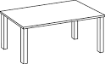 | 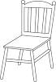 | 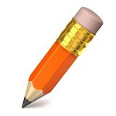

LOHANA SCHOOLS
P.1MATHS REVISION WORK ACTIVITY ONE: 2020
Name:……………………………..…………..……………..Stream:………..…..
- Write in words.
8 ____________________ 6 ____________________
9 ____________________ 2 ____________________
5 ____________________
- Form new sets.

P.1 READING REVISION WORK ACTIVITY ONE: 2020
Name:……………………………..…………..……………..Stream:………..…..
- Write the correct vowel to make a correct word.
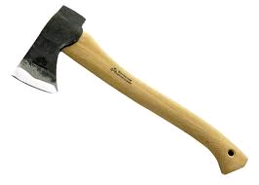

________xe | _______gg
 | 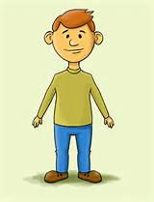
______nkpot | _______ncle
- Write the letters below in order.
c a b d _____________________________________________
g h f e _____________________________________________
j i n m k ___________________________________________
- Write the words correctly:
tma = mat
ttelke = ______________________________
oyb = _______________________________

P.1 RELIGIOUS EDUCATION REVISION WORK ACTIVITY ONE: 2020
Name:……………………………..…………..……………..Stream:………..…….
- Write R.E in full. ___________________________________________________
- What is your religious name? ___________________________________________________
- Name the places of worship.
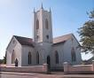

(mosque, church, school)
- _____________________ knows us all by name. (Jesus, God, Joseph)

P.1 LITERACY REVISION WORK ACTIVITY ONE: 2020
Name:……………………………..…………..……………..Stream:………..…….
- Match these people who help us at school.
Teacher heads a school
Head teacher cook our food
Cooks types exams and letters
Bursar cares for us when we are sick
Secretary collects money for the school
Nurse teach us.
- Draw the people we find in a school.
headteacher | pupils

