TRINITY PRIMARY SCHOOL – BUKOTO
SECTION | MARKS
A
B
TOTAL
Revision work
CLASS : P.2
LEARNING AREA : ENGLISH
Name: ___________________________
Date: _________________________________
- Name the pictures.
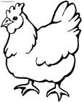 | 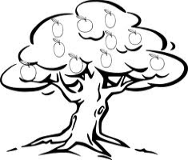 | 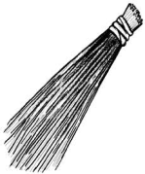 | 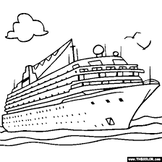

- Write in capital letters.
- leg ______________
- plate ______________
- Fill in “has” and “have”.
- I ______________ measles.
- The policeman ______________ a gun.
- She ______________ my school bag.
- They ______________ made two pots.
- Arrange in ABC order.
- lorry , boat , car , ferry
__________________________________________
- man , axe , bag , pot
__________________________________________
- Use the verbs in brackets to complete the gaps correctly.
- Mother is ______________ food. (cook)
- Iam ______________ to church. (go)
- Kato ______________ the class everyday. (mop)
- She ______________ her uniform yesterday. (wash)
- Read and draw.
There are two pencils in the tin.

- Give the plural of the underlines words.
- That ball is mine.
__________________________________________
- My dress is lost.
__________________________________________
- The man is fat.
__________________________________________
- Form a sentences about the pictures.
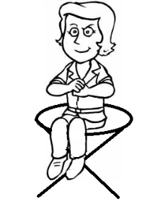__________________________________________
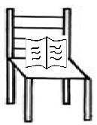__________________________________________
- Write in full.
- isn’t ______________
- Fri ______________
- Form a small word from a big one.
- mango ______________
- teacher ______________
- Give the opposites of these words.
- good ______________
- happy ______________
- small ______________
- Tick the correct spelling.
- ainr , rain , inra , rian
- desk , eskd , keds , sedk
- Join using………..and………
I have a mango. I have an orange.
________________________________________________________
- Join using……….but……….)
- I have a pencil. Iam not writing.
__________________________________________
- John can sing. He cannot dance.
__________________________________________
- Join using ……because……..
He did not come to school. It was raining.
__________________________________________

- How many are there?
- 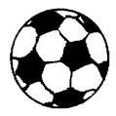 There are ___________ eggs.

- 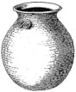 There are ___________ pots.
- Write these sentences correctly.
- food is She eating.
__________________________________________
- a red car He has.
__________________________________________
- your name What is?
__________________________________________

SECTION B
- Read the story and answer the questions.

THE BABY AND THE BIRD
Baby Tinah is looking at the bird. The bird is sitting on the tree. It is yellow in colour. The baby is pointing to the bird. She is showing it to his father.

Questions
- Where is the bird sitting?
_______________________________________________
- Who is looking at the bird?
_______________________________________________
- Write the colour of the bird.
_______________________________________________
- What is the baby pointing to?
_______________________________________________
- Draw the bird on the tree.

- Match correctly.
fish 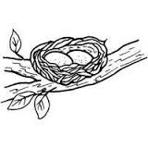
man 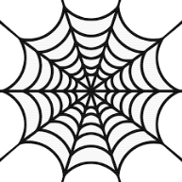
cow 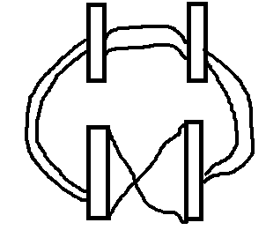
bird 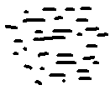
spider 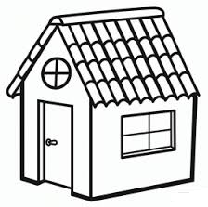
- Re-arrange the sentences to make a good story.
- Amos was sent to the market.
- A man picked him.
- On his way, he got lost.
- She took him back home.
- Last evening.
- _______________________________________________
- _______________________________________________
- _______________________________________________
- _______________________________________________
- _______________________________________________
- Form four sentences from the table.

Mark  I  They  She | am  is  are | driving a car  carrying a basket  playing football

- _______________________________________________
- _______________________________________________
- _______________________________________________
- _______________________________________________
- Who am i?
Iam a mean of water transport
I move on water
Who am i?
You are a _____________________
- Complete the puzzle.
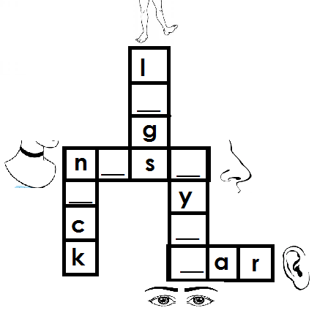
- Complete the story.
Stella is a 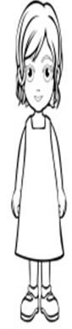_____________. She is in Primary one. He sits near the teacher’s 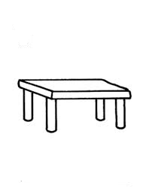_______________. He has two 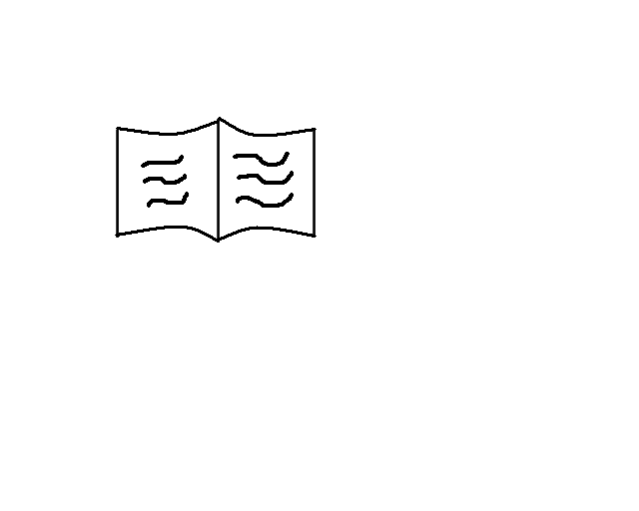_____________ and a 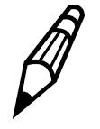____________. He puts them in the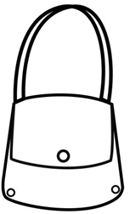 ______________ after school.

