TRINITY PRIMARY SCHOOL-BUKOTO
REVISION WORK
CLASS: P.2
LEARNING AREA: RELIGIOUS EDUCATION
TIME ALLOWED: 1HOUR 30 MINUTES

Name ________________________________Stream __________
SECTION A: 40MARKS
- Who created the world?
____________________________________________________________
- Name the animal God created that guards our homes.
____________________________________________________________
- Name any two people found at school.
(i) ___________________________(ii) _____________________________
- Identify one way pupils can help other people in the community.
______________________________________________________________
- Who cooks food at home? (father, mother)
________________________________________________________________
- Name these things created by God.


- Identify one way we can care for a sick person.
_____________________________________________________________
- Underline the two miracles performed by Jesus.
Healed the sick, Killed people, Rose the dead, Beat people.
- Mention two things created by God that give us light at night.
(i)_______________________________ (ii) ________________________
- Why do people pray?
_______________________________________________________________
- Name any one animal which stays in water.
_________________________________________________________________
- Who heads a school?
__________________________________________________________________
- Name one domestic animal that gives us milk?
________________________________________________________________
- How is the sun useful to people?
_______________________________________________________________
- Which name means rock?
_________________________________________________________________
SECTION B: 60 MARKS
- Name the gifts God gave us for;
- Seeing__________________________________________________
- Walking ________________________________________________
- talking __________________________________________________
- Clapping _______________________________________________
- (a)Name two places where we can get water from.
(i) ____________________________________________________________ (ii) _____________________________________________________________
(b) Who changed water into wine? _______________________________
(John, Jesus, Satan)
- (a)Mention two things we get from plants.
- ________________________________________________________
- _______________________________________________________
(b) Name one plant that gives us fruits.
___________________________________________________________
- Draw and name three things used to keep our school clean.

- Tick two ways of showing respect to people.
Kneeling , abusing, greeting
- Name these things that were used to kill Jesus.
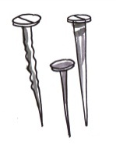 | 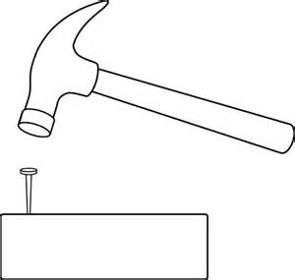

(cross, nails, hammer)
- Give two needs of God’s people.
- __________________________________________________
- __________________________________________________
- (a) Who were the first two people to be created by God?
- _______________________________________________________
- _______________________________________________________
(b) Adam and Eve lived in the garden of ____________________
(Eden, Trinity )
- Match the body part and how we keep it clean
Hair by brushing
Teeth by bathing
Body by combing
- (a)Identify two persons who preach the word of God.
- _________________________________________________________
- ________________________________________________________
(b) Name these places of worship.
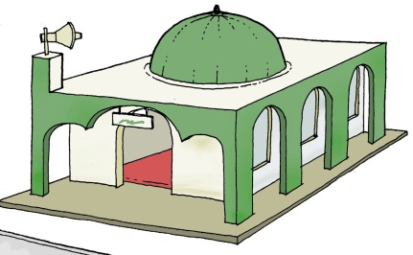 | 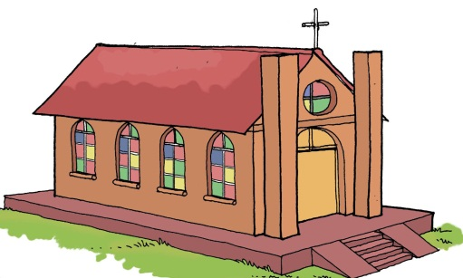

(church, mosque)

END

