TRINITY PRIMARY SCHOOL – BUKOTO
SECTION | MARKS
A
B
TOTAL
REVISION WORK
CLASS : P.2
LEARNING AREA: Mathematics
Name: ________________________________
Date: ________________________________________
SECTION A
- Add: 5 + 3 =

- Name this set symbol.
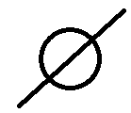
- Count and write in words.

_________________________

- Subtract. shs 5 0 0
- shs 1 0 0
shs
- Name this shape.
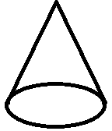
- Which fraction is shaded?

- Multiply;

4 groups of 2 = _____________
- Three girls read story books. Who read more story books?

4
3
2
1
0
Jolly Joy Janet
- Find the missing number.

+ 2 = 7

-  Which pencil is longer?
A B ____________________________
- Fill in the missing numbers.

______ tens ______ ones
- Add: $\frac{2}{10}$ + $\frac{3}{10}$

- Tell the time.
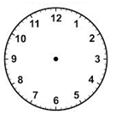It is ______________ o’clock

- How many numbers are in this set?
____________________________________
- Count in twos.

0 , 2 , 4 , 6 , ____ , 10 , 12

- Add 4kg + 5kg = _________kg

- Add: 5 + 2 = ________

0 1 2 3 4 5 6 7 8 9
- Write the missing months of the year.
January , February , March , _____________ , May
- I had an orange. I ate $\frac{1}{2}$ of it. What fraction remained?

- Divide: 12 ÷ 2 = ____________

SECTION B
- D C
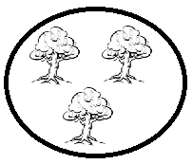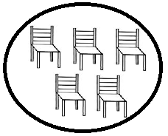
- Which set has more members?

- Set D has _________ members and set C has _________ members.
- There are ____________ members altogether.
- Study the shopping list.
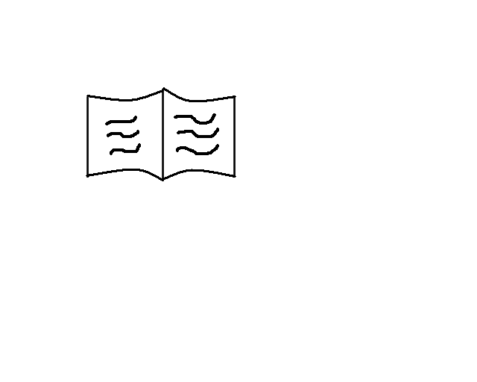 A book shs 500
 A sweet shs 100
A pencil shs 300
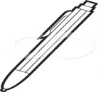 A pen shs 500
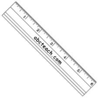 A ruler shs 600
- How many items are on the shopping list?

- Which is the cheapest item?

- (a) Draw these beads on the abacus to show 24.
T O

(b) Expand 28.

28 = _______ + ________
- Find the missing number.

+ 5 = 9
6 - = 6
- (a) Draw the shapes.
square | circle
(b) Name these shapes.

- Mary Ruth
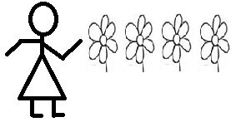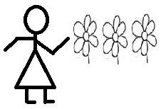
- How many flowers do they have altogether?

- If Mary loses three flowers, how many flowers will she remain with?

- A B
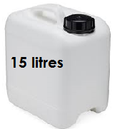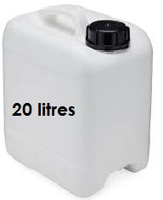
- Which jerrycan has less water?

- How many litres are there in two jerrycans altogether?

- (a) Arrange these numbers starting with the biggest.
5 , 1 , 6 , 15 , 12
________________________________________
(b) Write in figures.
(i) thirteen ______________
(ii) twenty seven ______________
- (a) Which fraction is bigger?

(b) Subtract: $\frac{7}{8}$ - $\frac{3}{8}$ =

- (a) 2 groups of 10 =

(b) Share 12 bananas equally among 3 boys. How many bananas will each get?

- Fill in the missing numbers.
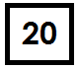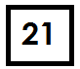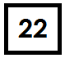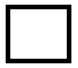
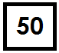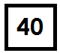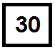

- Study the graph and answer the questions.
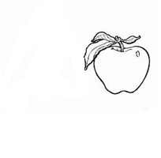
Aziza Mayo Ddamba Fred Christine
- Who got more apples?

- Who got the least number of apples?

- ________________ and ________________ got the same number of apples.
- Who got two apples?

