TRINITY PRIMARY SCHOOL-BUKOTO
For examiner’s use only
A
B
TOTAL
REVISION WORK
CLASS: P.3
LEARNING AREA: MATHEMATICS
TIME ALLOWED: 2HOURS 30 MINUTES

Name __________________________________________Stream __________
SECTION A: (40 MARKS)

- Take away: 6 - 2 =

- Name the set below.
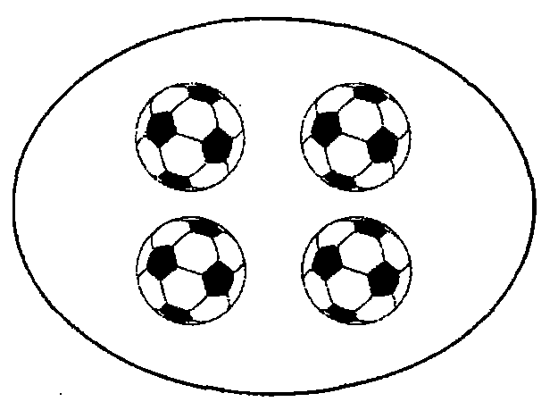

- Fill in the next number.
11, 12, 13, 14, 15, ______

- Write 11 in words.

- Shade $\frac{1}{4}$ of the diagram.

- A sweet costs shs. 200. Find the cost of 2 sweets.

- Find the missing number.

6 + = 8

- Count and write the number name.

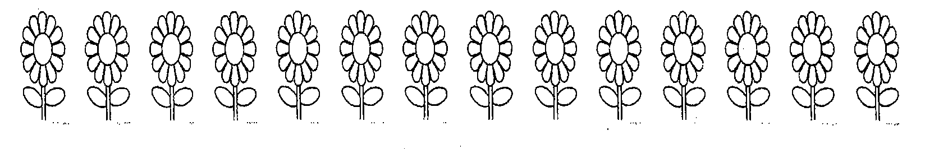

- A girl had 12 books. She was given 8 more books. How
Many books did she have altogether?

- Name the shape below.
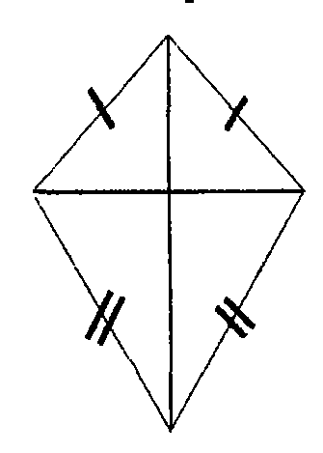

11. Fill in correctly.

1 2 4 = __________ hundreds _____ tens _____ ones

12. Workout 5 + 3 using the numberline below.

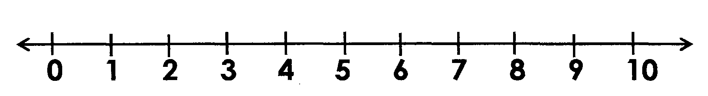

13. Tell the time shown on the clock face.
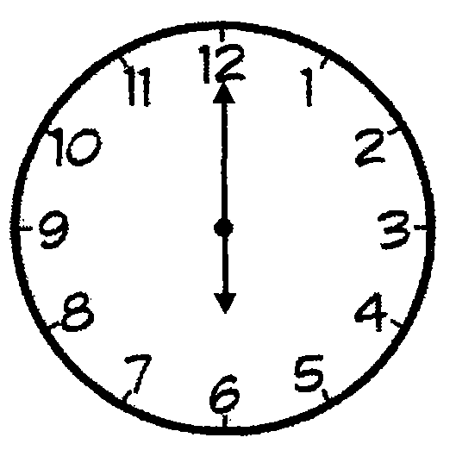_____________________________________

14. Join the two sets.


+ =

15. Fill in the missing day of the week.

______________________, Monday, Tuesday, Wednesday.

16. Multiply: 3 x 6 =

17. Arrange the numbers from the smallest to the biggest.
202, 220, 212, 200

18. Compare the ropes below and complete correctly.

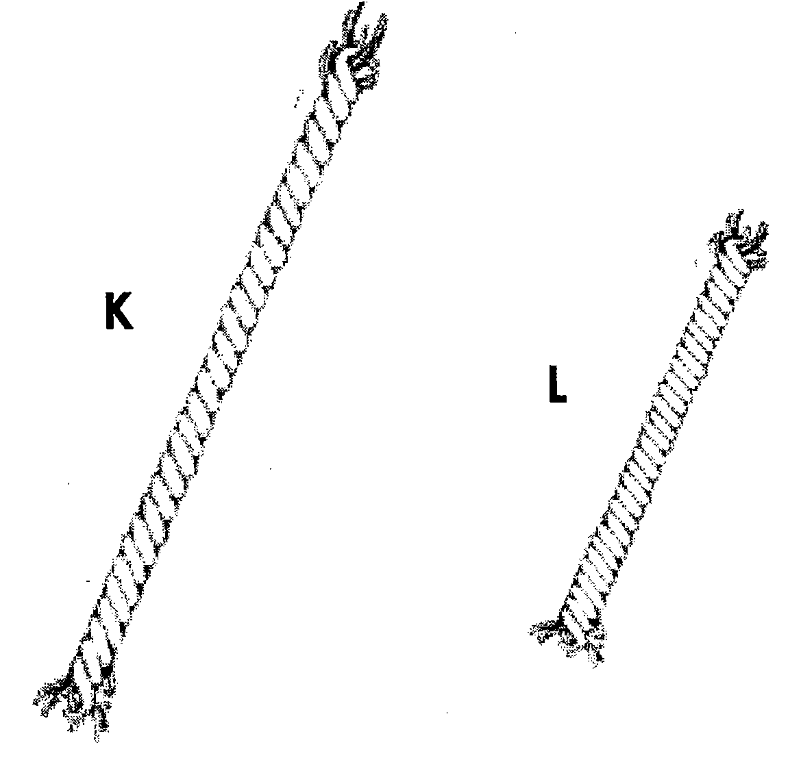
Rope ________________is shorter than _____________ rope

19. Write the number shown on the abacus.
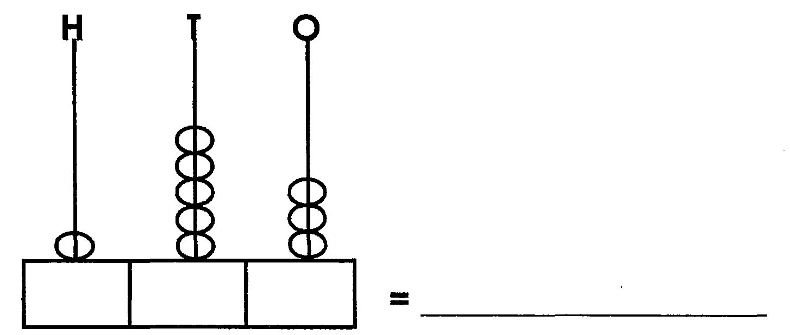

20. Bosco scored the following marks in end of term one exam.
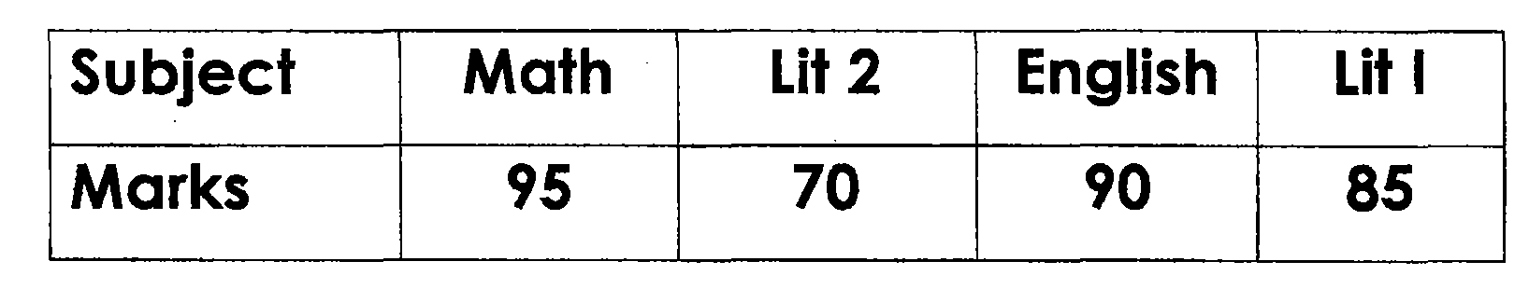
What was his best subject?

SECTION B: (60 MARKS)

21. Name the sets below.
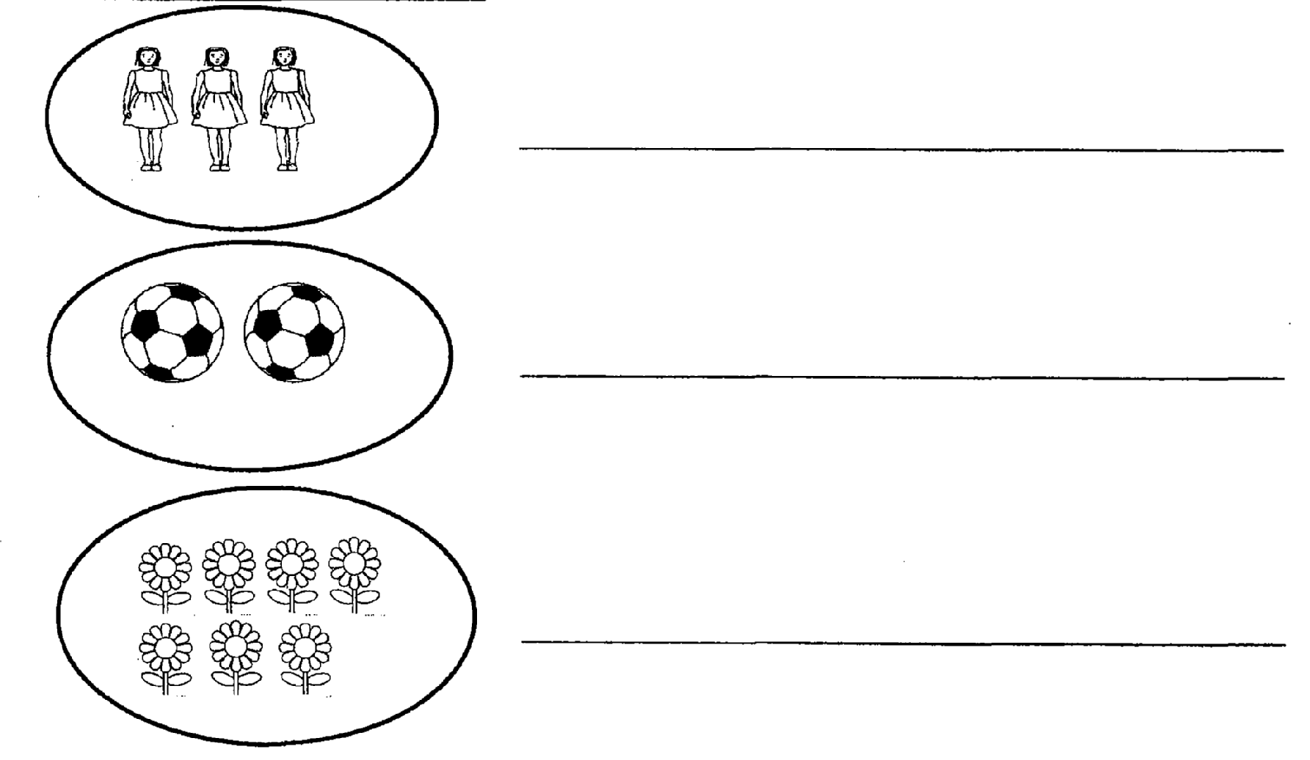
22. Complete the table correctly.
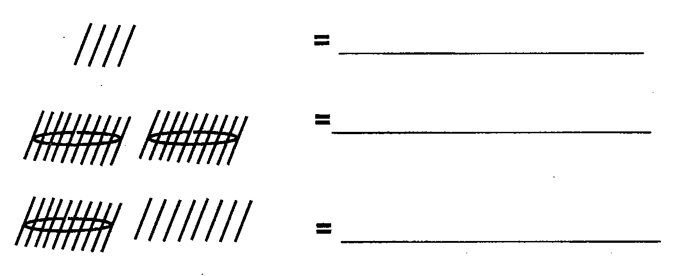

23. Work out:
(a) 5 8 (b) 2 4 6 c ) 6 ÷ 3 =______
+ 2 8 - 1 2 4

24. Fill in the missing numbers.

+ 3 = 7

- 6 = 4

2 x = 8

25. Work out.
3 + 1 =
5 5

3 - 2 =
7 7

26. Count and match correctly.
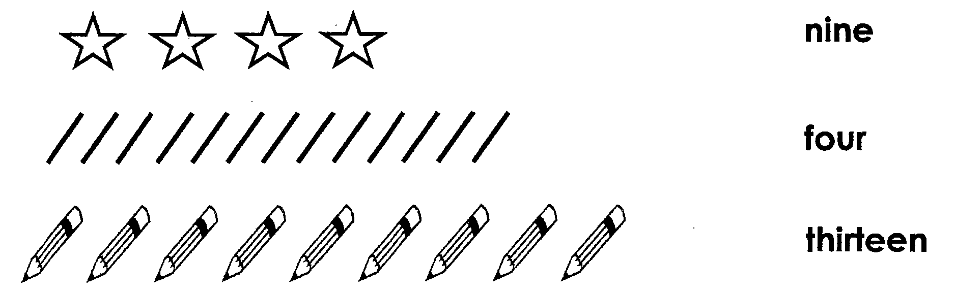

27. Study the table below.
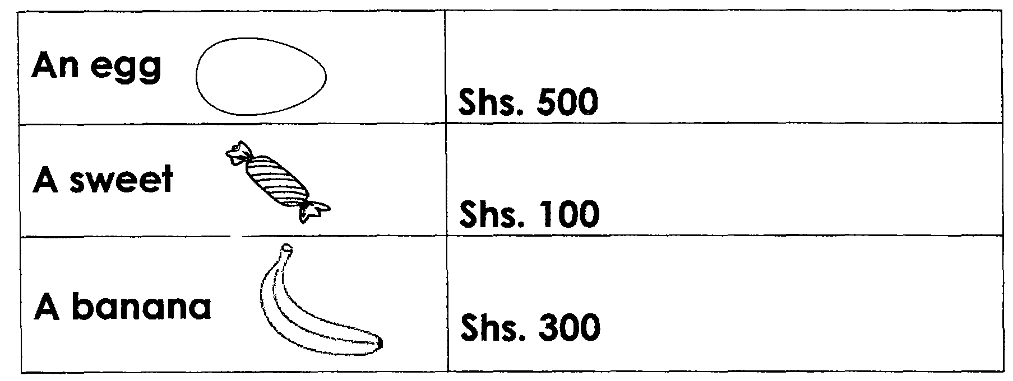
- How many items are on the above table?

- Which item costs one hundred shillings?

- Find the total cost of an egg and a banana.

28. Fill in the missing numbers correctly.
_______ + ______ = 10
_______ + ______ = 10
_______ + ______ = 10

29. Draw the shapes below.
Square | Circle

30. There are seven days in a week.
- How many days are in 2 weeks?

- Write one day of the week with letter M.

- How many months make a year?

31. Mary weighs 40kg and Peter weighs 35kg.
- Who is lighter?

- Find their total mass

32. Study the graph below and use it to answer the questions thatfollow.

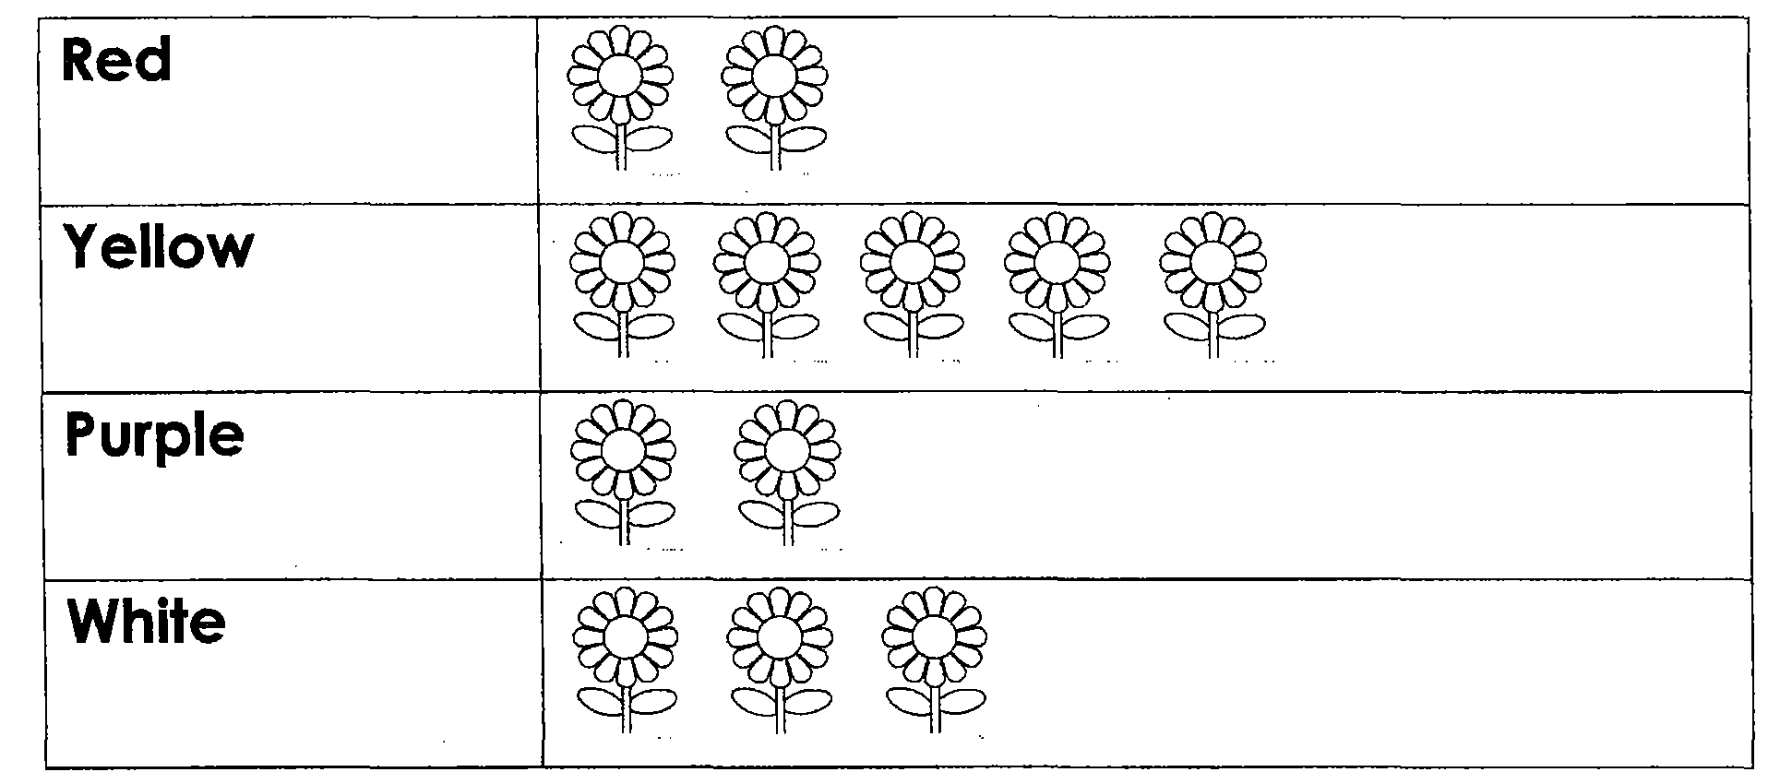

- Which colours have the same number of flowers?

- How many yellow flowers are shown on the graph?

- Which colour has 3 flowers?

END

