TRINITY PRIMARY AND PRESCHOOL - BUKOTO
REVISION WORK
Name…………………………………… Stream: …………
- Name the body part God gave us for seeing. _________________________________________________
- On which day do Christian go to church? (Friday, Sunday) ___________________________________________
- How is a dog useful in our home? _______________________________________________
- Who heads a family? ________________________________________________
- Name this thing God created to give us water.
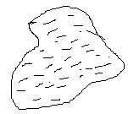
__________________________________

- Which name means a rock? _________________________________________________
- Give one use of the sun at home. _________________________________________________
- Who created the world? _________________________________________________
- Name these places of worship.
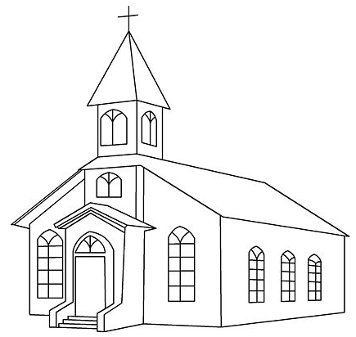

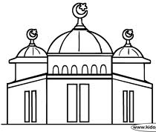

______________________________________ ___________________________
- Give one role of a mother at home. _________________________________________________
- What is the work of a school nurse? ________________________________________________
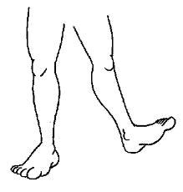

What is the use of this body part god gave us as a gift? ____________________________________
- How do we call the animals we keep at home? ____________________________ (wild animals, domestic animals)
- Give the holy book for Christians. _____________________________________________
- Write your religious name. ________________________________________________
- Write Religious Education in short. ______________________________________________
- Mention this needy person.
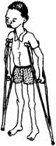

___________________________

- Who died for our sins? ________________________________________________
- How do moslems call God?
- A ______________________ preaches the word of God. (pastor, barber)

SECTION B
- Draw these things used to clean our bodies.

water | towel | sponge | soap

- Underline Christian names for boys.

David Mary Joseph Jane

Sarah John Betty Paul
- Name these things God created.
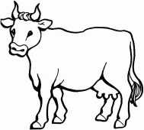  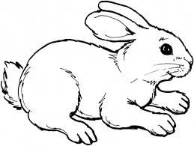  ______________ | ________________
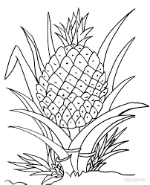  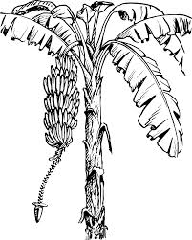  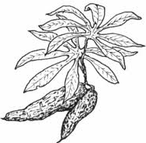  ________________________ | 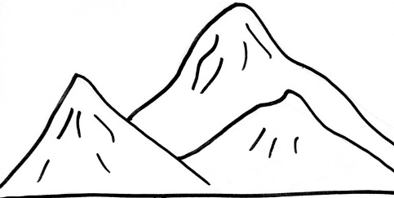  _____________________
- Match people to their work God gave us.
Shopkeeper treats sick people
Policeman flies an aeroplane
Doctor sells things in a shop
Pilot keeps law and order
- Name these things found in the church.
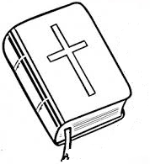 | 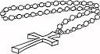 | 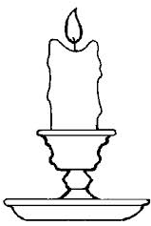 | 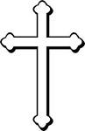

- Give any four uses of water. (i)_________________________________________
(ii) ________________________________________
(iii)________________________________________
(iv)________________________________________
- Give the name which means
Got from water __________________________
Laughter ________________________________
God is with us ___________________________
A rock ___________________________________
- Name the people at home.
i)________________________ ii)___________________ iii)_______________________ iv)_____________________
29. Draw these things we get from animal skins.
belt | bag | drum | jacket

- Name any members of an extended family.
i)______________________ ii)___________________ iii)______________________ iv) __________________
31. Mention any four domestic animals. i)________________ ii)__________________ iii)_________________ iv)________________
- Draw and name the things God created to give us light.

- Give any two roles of children at home. (i)______________________________________
(ii)______________________________________
(b) Name any two things we use in a classroom. (i)_________________________ (ii)___________________

34. Name these things God created without life.

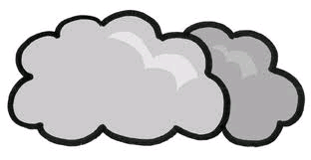 | 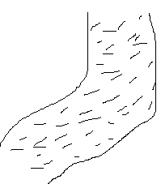 | 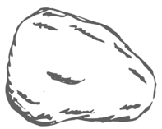 | 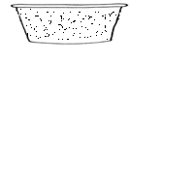

- Tick the people found at school.
barber teacher carpenter cooks matron

mechanic pupils cobbler

