SECTION | MARKS
A
B
TOTAL
TRINITY PRIMARY SCHOOL – BUKOTO
REVISION WORK
CLASS : P.3
LEARNING AREA : MATHEMATICS
Name: _________________________________
Date: ________________________________________________
SECTION A:
      - Subtract 3
- 3

      - Name the set.
_____________________________________
      - What is the place value of 2 in 320?

      - Draw the shape of a kite.

      - Find the missing numbers.
0 , 3 , 6 , 9 , ________

      - Shade the fraction $\frac{3}{5}$ .

      - Work out: T O
4 7
+ 1 8

      - Use a number line to subtract.
7 – 2 =

0 1 2 3 4 5 6 7 8
      - If 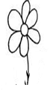represents 2 flowers. How many flowers are represented by?

      - A pen cots shs. 300. What is the cost of 3 pens?

      - Fill in the tens and ones.
________ tens _________ ones = 46
      - Tell the time.
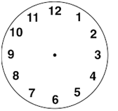
      - Add: $\frac{5}{11}$ + $\frac{3}{11}$

      - Which pot holds more water?
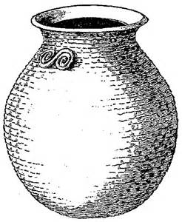
C D
      - Draw a set symbol to show A set of goats that fly.

      - Find the missing number.
+ 5 = 11
      - A baby slept at 9 o’clock and woke up at 9 o’clock. For how long did the baby sleep?

      - Share 24 mangoes equally among 3 girls. How many mangoes will each get?

      - Find the perimeter of the square below.
5cm
5cm 5cm

5cm

      - Subtract $\frac{7}{9}$ - $\frac{5}{9}$

SECTION B
      - Use the sets below to answer the questions.
A B
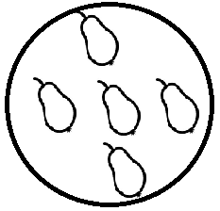
- Which set has more members?

- Which set has 4 members?

- How many more members are in set B than set A?

      - (a) Expand 24.

(b) Draw beads to represent 305 on the abacus below.
H T O

      - (a) Arrange these fractions starting with the smallest.
$\frac{1}{4}$ , $\frac{1}{2}$ , $\frac{1}{3}$
(b) Mother gave Tom a full cup of milk. Tom drunk $\frac{1}{2}$ of it. What fraction remained?

      - Study the shopping list below.
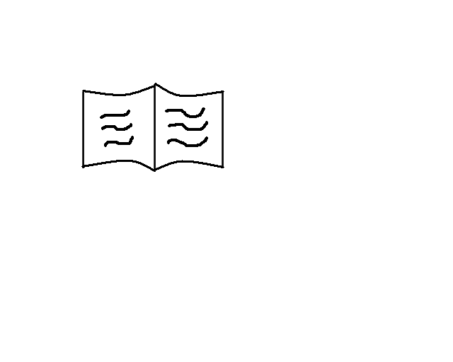 a book shs 500
 a pencil shs 200
 an egg shs 400
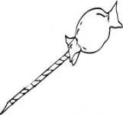 a sweet shs 300
- What is the cheapest item?

- What is the total cost of a sweet and an egg?

- If Fred had shs 900 and bought a book. How much money did he remain with?

      - Find the missing numbers.
÷ 2 = 4
X 3 = 15
- 1 = 10
      - (a) Write in figures: two hundred sixty three

(b) Which number has been expanded to give,
900 + 20 + 7 =

      - (a) Name these shapes.
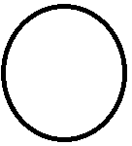 | 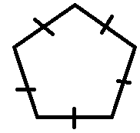

(b) Draw these shapes.
kite | cylinder

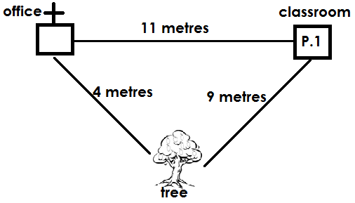
        - What is the distance from the office to the classroom?

        - Which is the shortest distance?

        - Add all the distances.

      - (a) Work out: 5 1
- 9

(b) A cat has 4 legs. How many legs do 6 cats have?

      - Complete the table.
+ | 2 | 3
6
4 |  | 7
1

      - Mayo is 17 years old. Brenda is 11 years.
        - Who is older?

        - Find their total age?

      - Study the bar graph and answer the questions. Four pupils picked some mangoes.

        - How many mangoes did Abdul pick?

        - Who picked the highest number of mangoes?

        - Olive picked the same number of mangoes as ___________

        - Find the total number of mangoes picked by all the four pupils.

