SECTION | MARKS
A
B
TOTAL
TRINITY PRIMARY SCHOOL – BUKOTO
REVISION WORK
CLASS : P.3
LEARNING AREA : LITERACY
Name: _______________________________________
Date: ________________________________________
SECTION A
- Mention the place where we go to learn.
____________________________________________________________
- State any one use of a cow at home.
____________________________________________________________
- Underline the duty of a doctor in our community.
Stealing , farming , treating , fighting
- Draw one item used to manage the rainy weather.

- Name one material used in keeping our bodies clean.
____________________________________________________________
- What is the name of the dangerous object shown below?
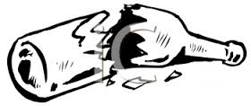___________________________________
- Tick the place where people keep their money safely.
water , bank , soil
- Give one reason why people keep dogs at home?
____________________________________________________________
- Name the body organ shown below.
___________________________________
- How do you keep your classroom clean?
____________________________________________________________
- Why do family members boil water for drinking
- Write down any one means of road transport.
____________________________________________________________
- Give the use of this tool below.
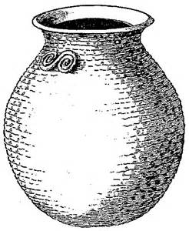____________________________
- How many days make up a week?
____________________________________________________________
- Write down any one meal commonly eaten at school.
____________________________________________________________
- State one way of caring for animals at home.
____________________________________________________________
- Circle one way how children are abused.
rapping , praying , sweeping
- Mention one way of keeping our eyes clean.
____________________________________________________________
- Why do people go to church?
____________________________________________________________
- Name one element of weather.
____________________________________________________________

SECTION B
- (a) Name these means of transport.
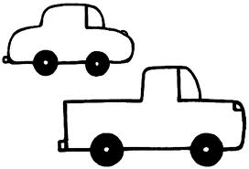 | 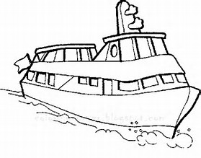

(b) Mention two animals used for transport.
(i) __________________________________________________
(ii) __________________________________________________
- (a) Give two uses of food in our bodies.
- _____________________________________________________
- _____________________________________________________
(b) Mention one place where people in town get food from.
(i) _____________________________________________________
(ii) _____________________________________________________
- Match the animals with their young ones.
sheep puppy
cat calf
elephant kitten
dog lamb
- (a) What is a nuclear family?
A nuclear family is a family where we find _______________, _______________ and _________________
(b) Mention two members of an extended family.
(i) ____________________________________
(ii)_____________________________________
- Name the items below, made from animal skins and hides.
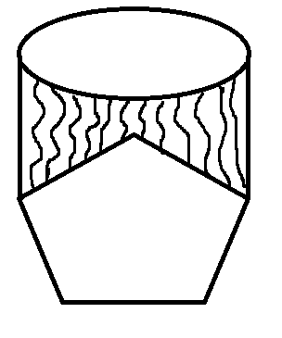 | 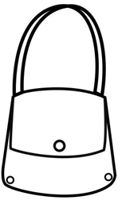 | 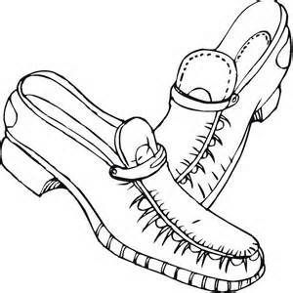

- (a) Give names of the road signs below.
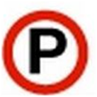________________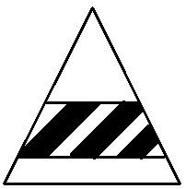__________________
(b) Which colour of the traffic lights tells drivers to get ready?
_____________________________________________________
- (a) Name one immunisable disease.
_____________________________________________________
(b) Give two places where people take children for immunuisation.
_____________________________________________________
- State the materials we use to make the following items.
 |  | 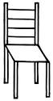

- (a)In which season do farmers carry out the following?
- planting ___________________ season
- harvesting ___________________ season
(b) Name the garden tool used for watering crops.
_____________________________________________________
- (a) Name two examples of domestic animals.
(b) Which domestic animal guards our home?
_____________________________________________________

