
LIGHT ACADEMY PRIMARY SCHOOL
P.4 HOME WORK EXERCISES TERM I 2020
ENGLISH
Complete the sentences with a suitable word or group of words.
1. My aunt left…………………..Nairobi yesterday.
2. She is good…………………..playing volley ball.
3. Male is suffering…………………Tuberculosis.
4. Mr. Musoke listens…………………………news every morning.
5. The teacher told us not to lean…………………..the wall.
6. I am interested………………………watching soccer than playing it.
7. Read the letter below carefully and answer the questions that follow.
AMA GROUP LIMITED,
P.O. BOX 240,
KAMPALA.
20TH JULY, 2013
Dear John,
How are you? How is work? I hope things are okay. I have written this letter to tell you that the man you told to do the work has not done anything. However, he wants me to give him money before he does the work. I therefore request you to come and talk to him personally.
I will be happy if you come quickly.
Your sincere friend,
Tom
Questions
1. Who wrote the letter?
2. When was the letter written?
3. To whom was the letter written?
4. In which district is AMA group limited found?
5. Write the box number of the writer.
6. Why was the letter written?
7. Why do you think Tow should not give the man money before he does the work?
LIGHT ACADEMY PRIMARY SCHOOL
HOMEWORK FOR P.4 TERM 1 2020

2. Read the dialogue below and answer in full sentences the questions that follow.
John: Excuse me teacher, may I come in?
Teacher: Come in, please.
John: Good morning teacher.
Teacher: Good morning John. Why are you late today?
John: Mother told me to first fetch water before I come to school.
Teacher: You mean you do that everyday?
John: Yes, teacher.
Teacher: Alright, I will talk to your mother. Go and sit down.
Questions
1. How many people are taking part in the conversation?
2. Who talked first?
3. In which part of the day did the conversation take place?
4. Did the teacher allow John in class?
5. Why was John late for school that day?
6. Who sent John to fetch water?
7. What do you think John should do to avoid coming late again?
Rewrite the given sentences giving the plural form of the underlined words.
8. The thief killed the servants.
9. The baby spoilt my books.
10. She picked the mango from the basket.
11. An orange is sweeter than honey.
12. He broke the table.

LIGHT ACADEMY PRIMARY SCHOOL
HOMEWORK FOR P.4 TERM 1 2020
English
Rewrite the given sentences as instructed in the brackets.
1. Ruth is a very beautiful girl. (Rewrite beginning. What …….!)
2. Keith is a soldier. Nathanal is also a soldier. (Begin: Both…….)
3. Lule ate posho. Lule ate rice. (Join the sentences using……..either……..)
4. Cate did not pay. Joan did not play. (Begin: Neither………..)
5. Shivan is very old. She can go to the well alone. (Use……..enough……..)
6. Annet is more beautiful than Amina. (Rewrite using …….not as ….as…….)
7. The table is very heavy. Aninga can’t carry it alone. (Use ….too….for….to…)
8. She prefers singing to dancing. (Rewrite using …..more than…..)
9. The porridge is very hot. The baby cannot eat it. (Join the sentences using so….that…….)
10. Musa was invited to the party. Musa did not attend. (Re-write beginning; Although……..)
11. That shirt belongs to me. (Re-write ending ………..mine)
12. An aeroplane is very fast. A boat is fast. (Re-write using …than…)
13. A fly fell in to my food. I was eating. (Join the two sentences using……while……)
14. The queen is very beautiful. All people admire her. (Re-write as one sentence using: ….such a ….that…..)
THE GREAT THIEVES
Once upon a time, there lived two great thieves. These were the rat and the mouse. They used to steal food from people’s houses at night.
Rats and mice are very bad because they carry fleas. Fleas spread diseases like typhoid and plague.
We can avoid these thieves and vectors by killing them using traps and poison.
Questions.
1. What is the story about?
2. Who are the two great thieves in the story?
3. Where did the thieves live?
4. Where do you think the rats and mice hide during the day?
5. What did the great thieves steal at night?
6. Why are the rats and mice bad?
7. Give the singular form of mice.
8. What can we use to avoid the great thieves?
9. What is the title of the story?
10. Name one disease spread by rats and mice.
LIGHT ACADEMY PRIMARY SCHOOL
HOMEWORK FOR P.4 TERM 1 2020
Name: ……………………………………………. Stream: ……………………............
SCIENCE HOMEWORK EXERCISE
1. How does a snail protect itself?
2. Why would you classify a butterfly as an insect?
3. How useful is a trowel to a crop farmer?
4. If a guava tree has yellow leaves instead of green, what substance is missing in the leaves?
5. Give one way a farmer can preserve moisture in the soil.
6. State the use of splints in giving first aid to an accident victim.
7. Mention the type of venation in the leaf of a maize plant.
8. In the space provided draw a compound trifoliate leaf.
9. Identify the disease that is common in Uganda today and has no cure yet.
10. Which words mean the arrangement of soil layers?
11. How can farmers control soil erosion in the garden?
12. Give one characteristic common n dicotyledonous seeds.
13. Mention one condition necessary for a seed to germinate.
14. How is transpiration important to the environment?
15. Give an example of insect pollination.
16. What are leguminous crops?
17. Give an example of an aquatic yellow fever.
18. Name the mosquito that transmits yellow fever.
19. Why do we brush our teeth?


LIGHT ACADEMY PRIMARY SCHOOL
HOMEWORKFOR P.4 TERM I 2020
Stream: …………………………………
Name: …………………………………………………………………………………….

SCIENCE
1. What is germination?
2. Name any one type of germination.
3. State the function of a micropyle to a bean seed.
4. Mention one function of a stem to a plant.
5. Give any one example of an insect pollinator.
6. Name the gas needed for germination to take place.
7. Suggest any one example of a root tuber.
8. What is leaf venation?
9. Mention any one type of pollination.
10. Why are petals of a flower brightly coloured?
11. What happens to metals on hot days?
12. How many pairs of legs does a housefly have?
13. What is the use of a thermometer?
14. Besides cassava, give any other example of a root crop.
15. What are annual crops?
16. What scientific term is given to a young rabbit?
17. Name the garden tool used for turning manure?
18. What is the first step taken in growing crops?
19. What is seed viability?
20. Give one advantage of row cropping over broad casting method.

LIGHT ACADEMY PRIMARY SCHOOL
HOMEWORKFOR P.4 TERM I 2020
SCIENCE
- How is the endosperm different from the cotyledon in their functions on a maize grain?
- Write down one example of the following;
- cereals ……… b) leguminous seeds ………
- State any one use of leaves to plants.
- Identify the type of germination shown below.
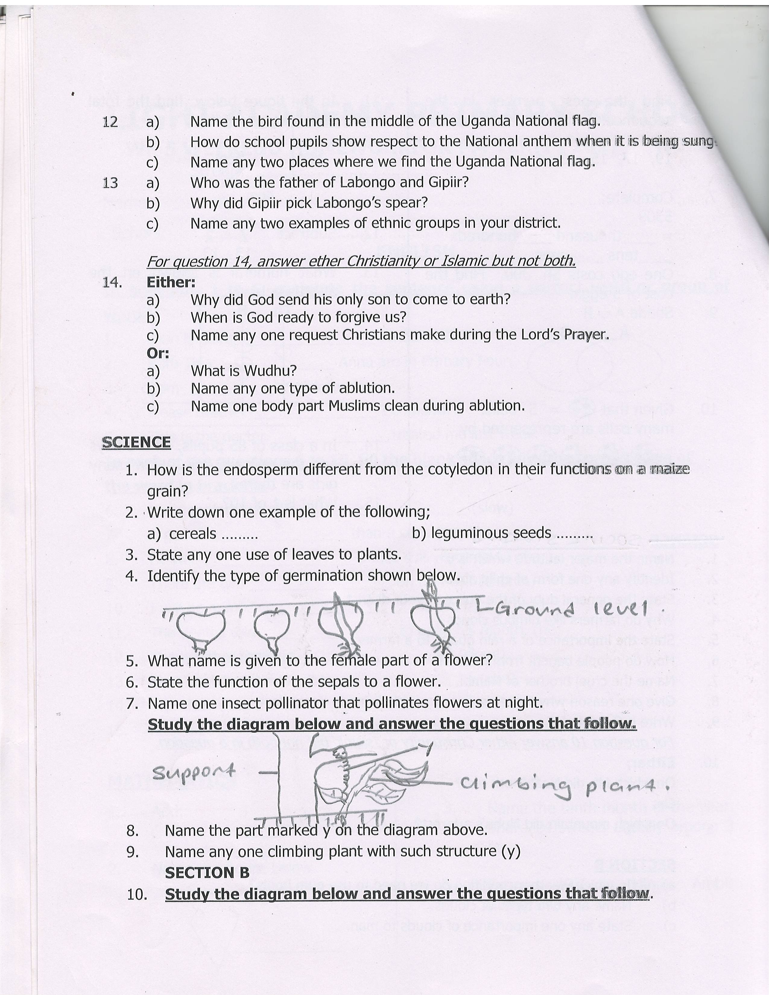

- What name is given to the female part of a flower?
- State the function of the sepals to a flower.
- Name one insect pollinator that pollinates flowers at night.
Study the diagram below and answer the questions that follow.

- Name the part marked y on the diagram above.
- Name any one climbing plant with such structure (y)
- Give any one material used to clean our homes.
- Name the body organ that enables pupils to hear the bell at break time.
- Name the system of a flowering plant that grows above the ground.
- Give the component of soil that contains most of the soil fertility.
- Mention any one example of food that provides proteins to our body.
- State any one characteristic of insects.
- Mention the best season for farmers to harvest their ready cereal crops.
- Identify any one use of trees in our environment.
LIGHT ACADEMY PRIMARY SCHOOL
HOMEWORK FOR P.4 TERM 1 2020
Name: ………………………………………. Stream: ……………………............
SST
- Why do people keep their money in banks?
- Give one reason why air transport is used by few people in Uganda?
- Give one reason why schools have trees in their compounds.
- State the importance of sunshine to man.
- How many people make up local council one executive committee?
- State any one right of children.
- According to the story of Kintu, what does the name Kakama mean?
- What type of education did early man get?
- Name the tool early man used to make bark cloth.
Answer either Christianity or Islam but not both.
- Either: How did Jesus show His love to people?
Or: Where will Allah take His good people?
- Either: How many apostles did Jesus have?
Or: Why do Moslems fast?
- Either: What should we do to those who wrong us?
Or: What does a good Moslem do after sinning?

LIGHT ACADEMY PRIMARY SCHOOL
HOMEWORK FOR P.4 TERM 1 2020
Name: ……………………………………. Stream: ……………………............
SST
1. State the general duty of the police in your district.
2. Why do farmers like nimbus clouds?
3. State the importance of a rain gauge to a farmer.
4. How do people benefit from forests?
5. Name the cruel brother of Nambi.
6. Give one reason why there are many people living in Kampala.
7. Write K.C.C.A in full.
For question 8 answer either Christianity or Islamic but not both in a question.
8. Either;
On which Mt. did Noah’s ark rest?
Or:
On which mountain did Nuhu’s ark rest?
9. What is a swamp?
11. Give any one crop that grows well in swamps.
12. State any one reason why man destroys swamps in their areas.
13. Why is it bad to live near swamps?
14. Identify the type of fish commonly found in swamps.
15. Which bank prints and makes new bank notes in Uganda?
16. Why do we need local councils in our villages?
17. Who was Bukuku?
18. From which mountain did the first Bagisu come?
19. Give the traditional name for lake Victoria.
Answer either Christianity or Islam but not both.
20. Either: How important is Good Friday to Christians?
Or: Why do Moslems pray?
21. Either: On which day did Jesus rise from the dead?
Or: Identify any one group of people who should not fast during Ramadan.
LIGHT ACADEMY PRIMARY SCHOOL
HOMEWORK FOR P.4 TERM I 2020
Name: …………………………………………………………………..stream: ……………………………..

maths
- Change to Roman Numerals
- 15
- 29
- 44
- 63
- 22
- Change to Hindu Arabic Numerals.
- XXVI
- CLX
- XIX
- LXXXV
- LXXXVIII
- Workout
- XXV + XXI
- XXX - XIV
4. Round off these numerals as instructed in brackets. (2 marks each)
a) 92 (nearest tens)
b) 96 (nearest tens)
c) 436 (nearest hundreds)
d) 149 (nearest hundreds)
e) 995 (nearest tens)
5. Round off 7608 to the nearest hundreds.
6. Round off 180 to the nearest tens.

LIGHT ACADEMY PRIMARY SCHOOL
HOMEWORK FOR P.4 TERM I 2020
Name: …………………………………………………………………..stream: ……………………………..

MATHEMATICS
1. A pen cost shs 400. Find the cost of 2 similar pens.
2. What is the product of 6 and 20?
3. How many pairs can be formed in 18 mangoes?
4. Write two hundred forty six in figures.
5. Write the next number in the sequence.
0, 5, 10, 15, 20……..,………...
6. Simplify: 3 - 1
5 5
7. Draw and name these solid shapes.
a) Cone b) Triangle c) Trapezium
8. Simplify: y – 3 = 4

9. One egg costs Sh. 300. Find the cost of 5 eggs.
10. Shade A ∪ B
A B

11. Given that = 5 balls. How many balls are represented by

12. In the figure below, find the total distance around it.

3cm 5cm

4cm

LIGHT ACADEMY PRIMARY SCHOOL
HOMEWORK FOR P.4 TERM I 2020
Name: …………………………………………………………………..stream: ……………………………..
MATHEMATICS
- Name the figure below.

____________
2. Name the tenth month of the year.
3. Share 24 sweets equally among 3 boys.

4. Express XIV in Hindu Arabic numerals.

5. Find the next number in the sequence:

19, 17, 15, 13, 11, _____

6. Complete:
5309
= ____thousand ____hundreds
____tens ____ones
7. Subtract 7 - 5
13 13
8. What numeral is shown on the abacus below?
Th H T O

9. In a class of 85 pupils, 44 are boys and the rest are girls. How many girls are there?
10. What is $\frac{1}{2}$ of 10?
11. Write 101 in words
12. Tell the time in the evening

13. Given that a = 4 and b = 6, find a x b (1 mark)

