
LIGHT ACADEMY PRIMARY SCHOOL
HOMEWORKFOR P.5 TERM I 2020

ENGLISH
Use the correct form of the words given in the brackets.
1. The shepherd was found ____________the sheep. (beat)
2. He has some ____________about his disappearance. (inform)
3. His wife gave birth to _______________. (triple)
4. The ______________ was a kind woman. (drive)
5. The boy ____________ answered the teacher. (rude)
Fill in the blank spaces with the correct word or group of words.
6. This is the shop from ____________ I bought a teddy bear.
7. The helicopter flew _____________our house last night.
8. Puppy is to dog as _____________is to elephant.
9. The girl travelled ____________foot when going back.
10. The man to ______________you gave a letter is my uncle.
- Make sentences to show that you know the meaning of the given word.
heir Hare
12. Re-write the sentences giving the plural form of the words given in brackets.
Do you have any baby’s-toy in stock?
She bought a very expensive equipment
I wasn’t given any water to drink.
Use the correct form of the words given in the brackets.
- Sarah has the _____________handwriting in the whole class. (good)
- What is the _______________of that bag of coffee? (weigh)
- Trevor is ______________careful than his brother Bob. (much)
- He was badly ______________by his elder brother. (beat)
- The story was ____________written. (poor)
Arrange the words in alphabetical order.
- bud, budget, build, buffalo
- ran, railway, rate, rare
LIGHT ACADEMY PRIMARY SCHOOL
HOMEWORKFOR P.5 TERM I 2020
Fill in the blank spaces with the suitable word or group of words.
- The letter was written ____________girl.
- He travelled ______________bus to Nairobi.
- The journalist wrote a good story in the Monitor ___________
- Some of the roads in Uganda are _____________ while others are narrow.
- He drives his new car by _______________
Read the following information carefully and answer the questions that follow.
MINISTRY OF HEALTH
MULAGO HOSPITAL, KAMPALA
This is to inform our dear patients and those taking care of them that our services are free to all. You should not pay any money to any medical officer. This is against the law. Should any of the officers ask for money from you, report to the casuality police post. You can also call the public relations officer on 0854493240 or call the security department on 0414 264 856
MANAGEMENT
14th February, 2013
Questions:
- What is the information about?
- To whom was the information addressed?
- Why shouldn’t the patients pay any money?
- Whom shouldn’t the patients pay money to?
- Where should the officers be reported if caught?
- Which hospital has put up the information?
- Where can one find Mulago hospital?
- Who wrote the information above?
- When was the above information written?
- Write Dept. in full.

In questions 1 – 5, fill in the blank space with ‘will’ or ‘shall’
- I _______________ tell Stella about it.
- You _______________prepare the visitors dinner.
- They _______________ask you a few questions.
- We ________________mop this room next Friday.
- Richard _______________ read with Marc.

LIGHT ACADEMY PRIMARY SCHOOL


HOMEWORK FOR P.5 TERM I 2020

ENGLISH

In questions 6 – 10, change sentences to N (Negative) and I (Interrogative)
- He had eaten supper.
- Peter has cleaned our room.
- She saw the robbers.
- Bukenya will fetch the water.
- Oluka can run like a deer.
Re-write as instructed.
- A dog has a tail. (Begin: Dogs…………)
- This is the garden. My mother planted beans in this garden. (Use:..where..)
- We should be obedient to our parents. This is very important. (Begin: It is…)
- John sells old furniture. (Begin: Does…………)
- December is the last month of the year. (Use:…….twelfth……..)
- Jimmy can write a letter, can’t he? (End……….can he?)
- He is very poor. He can’t pay his children’s fees. (Use:…..so…..that…….)
- She is an intelligent girl. (Begin: What………!)
- The box is very heavy. Sam can’t lift it. (Use:……too……to…….)
- She was sick. She attended the party. (Begin: Although…….)
Re-write the sentences below as instructed in brackets.
- We went for lunch after finishing work. (Begin: Having………)
- She sits infront but she cannot read. (Begin: Although………)
- Our books were collected by Jolly. (Re-write ending books …………..books.)
- It started raining. We stopped playing immediately. (Begin: As soon as………)
- He has a new donkey. (Change the sentence to plural form)
- they will go to bukoto next thursday. (Punctuate correctly)
- Suzan cannot dance. Sandra cannot dance. (Begin: Neither………)
- If the trainer doesn’t come, we shall not practice. (Use:…….unless……….)

LIGHT ACADEMY PRIMARY SCHOOL
HOMEWORKFOR P.5 TERM I 2020

maths

1. Study the Venn diagram below and answer the questions that follow.
P Q
calf
pen cat kid

- Find (i) P ∩ Q (ii) Q - P
- How many elements are in set P.

2. Add: 2 3 8
+ 8 2

_________
3. Write 1392 in expanded form.
4. Write 29 in Roman numerals.
5. Express in figures “Four hundred eighty nine thousand, two hundred six”
6. Solve: 3m = 18
7. A factory produces 50 bags of nails a day. If each bag has 800 nails, how many nails does this factory produce in a day?
8. Draw a symbol for an empty set.
9. Change 11five to base ten.
10. A man had sh. 38500 and used sh. 29500 to pay for his daughter’s dress. How much did he remain with?
11. Work out: m cm
4 82
+ 3 37

12. Given the numeral 3476
13. Work out: 3 – 8 + 7
14. Find the average of 0, 5 and 4

LIGHT ACADEMY PRIMARY SCHOOL
HOMEWORKFOR P.5 TERM I 2020

maths

1. Musa went to the market with Shs. 10,000 and bought the following items:
- 2kg of salt at Shs. 700
- 3 litres of paraffin at Shs. 5,000
- 4kg of irish potatoes at Shs. 500
a) How much money did he spend altogether?
b) How much money did he remain with?
2. Complete the above table correctly (show all the working clearly).
3. Find the cost of 2½ litres of cooking oil at Shs. 4,000 per kg
4. Shade K’
K M

5. Find the L.C.M of 6 and 7.

6. Which number has been expanded to give:
(4 x 10³) + (3 x 10¹) + (4 x 10⁰)
7. Add: 2 3 4five
+ 1 4five
8. Solve: 2k – 3 = 9
9. The radius of a circle is 7cm. Find its diameter

LIGHT ACADEMY PRIMARY SCHOOL
HOMEWORKFOR P.5 TERM I 2020

MATHEMATICS
1. When a coin is tossed once, what is the probability that;
(i) a head will show up?
(ii) a tail will show up?
2. When a dice is rolled once, what is the probability of scoring;
(i) a prime number?
(ii) an even number?
(iii) a number less than five?
3. There are 4 blue pens, 5 red pens and 1 black pen in a box. What is the probability of picking from the box;
(i) a red pen? (ii) a black pen?
(iii) a blue pen?
4. Okello is going to Jinja next week, what is the probability that he will go on a day that begins with letter “T”?
5. Draw a line segment AB of length 6cm.
6. Find the value of angles marked by letters
(a) (b)

x
135⁰
60⁰ y

(c) m

70⁰ 55⁰

LIGHT ACADEMY PRIMARY SCHOOL
WEEKEND HOMEWORKFOR P.5 TERM I 2020
SCIENCE
1. Name the type of simple leaf shown.
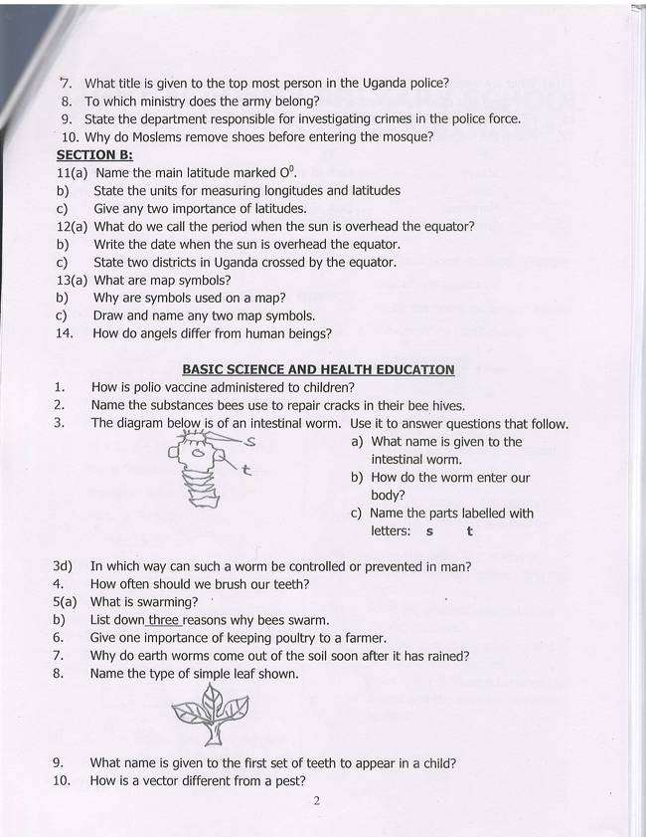

2. What name is given to the first set of teeth to appear in a child?
3. How is a vector different from a pest?
4. How is polio vaccine administered to children?
5. Name the substances bees use to repair cracks in their bee hives.
The diagram below is of an intestinal worm. Use it to answer questions that follow.

8. Explain the word incubation.
9. Name the section of the bird’s reproductive system where the egg gets its oval shape.
10. Geoffrey’s birds lay eggs with a soft egg shell, name the problem affected by the birds.
11. Name the part in the bird’s digestive system where digestion of food takes place.
12. Identify any one item found in a poultry house.
13. What is an off layer bird?

LIGHT ACADEMY PRIMARY SCHOOL
HOMEWORKFOR P.5 TERM I 2020
Name: ……………………………………………………………………………
- Suggest any one advantage of keeping exotic breeds of poultry.
- Explain the word a breed of poultry.
- What are communicable diseases?
- State any one example of the diseases above .
- What is the difference between a germ and a vector?
- Study the diagram of a thermometer below and answer questions that follow:
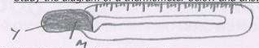

- Name the type of thermometer drawn above.
- Name part labelled Y.
- Why is liquid M commonly used in such thermometers?
- Why does a doctor first shake the above thermometer before using it on a patient?
7.(a) What are social insects?
b) Give two examples of social insects.
c) Write down any one disadvantage of insects to man.
3. Which part of the body dues trachoma attack?
8. (a) Name the instrument drawn below
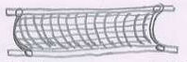

b) How useful is the instrument name in 8(a) above when giving first aid.
c) Give any reasons why we give first aid to casualties.

LIGHT ACADEMY PRIMARY SCHOOL
WEEKEND HOMEWORKFOR P.5 TERM I 2020 NO.9
science

1. State the function of canine teeth.
2. How are prop roots important to a maize plant?
3. Why do some objects like stones sink in water?
4. Identify the mineral which makes our bones of teeth strong.
5. What causes tooth decay?
6. Identify the plant response shown below
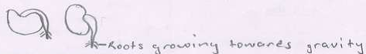

8. State the use of propolis to bees.
9. Define the following terms as used in bee keeping

Apiary
Swarming
Stocking

10. Name the female sterile bee in a hive.
11. What type of metamorphosis do bees under go?
12. Suggest two reasons why bees swarm.
13. Write down two types of bee hives

LIGHT ACADEMY PRIMARY SCHOOL
WEEKEND HOMEWORKFOR P.5 TERM I 2020 NO.9

SOCIAL STUDIES
- Name the longitude marked 180⁰ East/West of the Greenwich.
- What do we call lines drawn on a map running from East to west?
- What is the direction of Kenya from Uganda?
- What are cardinal points of a compass?
- What are imports?
- Who was the first European to see Lake Victoria?
- In which way is Lake Katwe useful to Ugandans?
- How useful is Kampala as a city to the people of Uganda?
- Give one reason why Kampala is highly populated.
- What does the term Sabbath mean?
- (a) What is child abuse?
(b) State any two forms of child abuse.
(c) Give any one cause of child abuse in our community.
- (a) How was mountain Rwenzori formed?
(b) Why is crop growing not possible on top of mountain Rwenzori?
(c) Who was the first European to see mountain Rwenzori?
(d) What legendary name did the above European give to mountain Rwenzori?
- (a) Define the following terms:
Population (ii) Population census
(b) Identify any two reasons why the government carries out population census.
LIGHT ACADEMY PRIMARY SCHOOL
WEEKEND HOMEWORKFOR P.5 TERM I 2020 NO.9

SOCIAL STUDIES
- Who was the first European explorer to see Mt. Elgon?
- Which type of coffee is grown on the slopes of mountain Elgon?
- Why is human settlement impossible on tops of mountains?
- How is the formation of Mt. Elgon different from that of Mr. Rwenzori?
- Suggest any two problems faced by people living in mountainous areas.
- Name the mountain found in North Eastern Uganda.
- Name the two underground forces that led to the formation of the rift valley.
- Which new land was Abraham told to go to?
- How many Surahs make up the Holy Qur’an?
- Name any one block mountain in Uganda.
- How is soil erosion controlled in hilly areas?
- Why is road construction difficult in Bundibugyo and Kapchorwa districts.
- How is a donkey useful to the people who live in hilly areas?
- Why is terracing method not commonly used in Buganda region?
- Which type of rainfall is received in the following areas:

- hilly areas
- near large water bodies and thick vegetation

- flat areas

LIGHT ACADEMY PRIMARY SCHOOL
WEEKEND HOMEWORKFOR P.5 TERM I 2020 NO.9

SOCIAL STUDIES

SOCIAL STUDIES

- Name the channel that separates Lake George and Edward.
- What is the major tourist attraction on the channel mentioned above?
- Which lake in Uganda has crude oil?
- Define the following terms:
delta
tributary
distributary
- Why does R. Nile flow northwards?
- Name any two inland ports on Lake Victoria.
- Give any two punishments that were given to the Egyptians when they had refused to release the Israelites
- Which Crater Lake in Uganda is a source of salt?
- What do we call the steep side of a rift valley?
- Which arm of the rift valley is found in Uganda?
- What is the largest fish caught in lakes of Uganda?
- How is mountain Elgon similar to mountain Moroto?
- How is river Nile useful to Kenyans and Uganda?
- Who is the current Prime Minister of Uganda?
- Write CIID in full.

