BUDO JUNIOR SCHOOL
REMEDIAL WORK FOR TERM 1 2020 - SET TWO
PRIMARY SIX

ENGLISH:
Use the correct form of the word given in brackets to complete the sentences below.
1. The school children ___________crossed the road. (hurry)
2. The motorist drives ___________while at the black spot. (carefully)
3. Your driver follows the road signs _______than mine. (well)
4. The traffic officer has ________my uncle to stop the vehicle. ( order)
5. No sooner had the cyclist ______the bicycle than he got an accident. ( ride)
6. The main speakers raised their ______clearly. (argue)
7. Whoever speaks in a debate, must get _______from their chairperson .( permit)
8. Many people in Masaka use ______to go to their workplaces. ( taxi)
9. The motorcyclists _____knocked the pedestrian yesterday. ( accidental)
10. The motorist turned left after ____ the corner. ( negotiate)

Fill in the blank space with the most suitable word or group of words.
11. Pedestrians should cross busy roads at the ___________.
12. Our school has an attractive signpost, ____________________?
13. The traffic police ware ______disorganized that they lost all the files.
14. I must follow the road signs so that I _______avoid accidents.
15. There was some _____jam on Bombo road yesterday.
16. Unless the motorist checks on the mechanical condition of the vehicle,
he _______ drive it today.
17. Joy prefers travelling to Masaka ______Mbale.
18. Hellen lost _______the helmet and the driving mirror.
19. They have not fastened the seat belts and ______have we.
20. The vehicle is old _____it looks nice.

Form the comparative and superlative degree of the adjectives below.
Positive Comparative Superlative
e.g. high higher highest
21. near _______ _______
22. light _______ _______
23. young _______ _______
24. big _______ _______
25. thin _______ _______
26. fat _______ _______
27. sad _______ _______
28. happy _______ _______
29. lazy _______ _______
30. dirty _______ _______
31. active _______ _______
32. beautiful _______ _______
33. difficult _______ _______
34. nice _______ _______
35. polite _______ _______
36. humble _______ _______
37. able _______ _______
38. good _______ _______
39. ill _______ _______
40. little _______ _______

Rewrite the sentences as instructed in brackets.
41. My mother is very humble. She cannot talk to her boss rudely.
( Rewrite using:…so…that…)
42. His vehicle was very old. It could not drive to Arua. (Rewrite using:…enough…)
43. Tom does not have a car. Tom is a very rich man. (Begin: Although…)
44. The opposers made research on the motion. They wanted to win the debate. (Rewrite using:…..in order to…)
45. The taxi was very full. Mark decided to board a motorcycle. (Rewrite using:…so)
46. The motion is very tricky most of the floor speakers cannot interpret it. (Rewrite using:..to..to…)
47. Male did not come by car. Ssozi did not come by car.
(Rewrite beginning: Neither…nor…)
48. They were very tough traffic police men . (Begin: What….)
49. This seat belt is very good. (Rewrite in plural form)
50. Unless I buy a vehicle. I will not run my business well. (Rewrite using:…if….)

Construct a meaningful sentence using each of the word s below.
51. heavy 52. cross 54. black spot
55. cyclist 56. helmet 57. taxi
58. tax 60. night
Give the plural forms of the following.
61. bus 62. seat 63. taxi
64. city 65. chief 66. officer – in – charge
67. vehicle 68. father-in-law 69. Head-of-department
70. roof
Write the given abbreviations in full.
71. Hon. 72. Sec. 73. hr. 74. Rd.
75. via 76. viz. 77. P.T.O 78. Rev.
79. Hm. 80. etc.
81. Re-arrange the sentence below to form a correct story.
1. This is seen first of all when they invite.
2. I like my school very much.
3. done there which help us to improve.
4. on academic, social and spiritual behaviour
5. simply because there are activities
6. Our parents for class meetings.
7. to air out their concerns.
8. During these meetings a lot is discussed.
9. which helps the staff to improve on the standard of the school.
10. and here the parents get a chance.

82. Write a composition of not more than two hundred words with a title COVID-19 BREAK OUT IN UGANDA.
N.B Ensure that your composition has a title and the following paragraphs:
- introduction
- body
- conclusion
In the introductory paragraph you may talk about: - What COVID-19 is
- How and when the disease was known about
- How it’s spread
- etc
The body paragraph / Paragraphs:
- How the disease has affected / is affecting
- people
- schools / pupils / education
- parents
- business / shops / economy
- transport
- health ministry
- the government / the president and the cabinet
- Life at home / lock down / curfew / quarantine
- etc.
Conclusion: - Your feeling / thinking / opinion about what you have written
- suggestion
- piece of advice
- appeal
- summary of what you have written
- your fear / stand
- the next step / way forward according to what you have written.

Remember: Every pupil’s composition expresses their thinking which is very GREAT.

MATHEMATICS – P.6
Exercise I:
1. Given the Sets below:
M = { 2, 3 , 5 , 7 } , K = { a, b, c , d , e } ,
L = { 0, 2, 3, 4, 5 } , A = { 5, 7, 2, 3 }
- Which of the above sets are:
- Equal (b) Equivalent
- Find: (a) n(M) (b) n(L)

2. Write the set symbol which represents a universal set.
3. Given that Set P = { 2, 3, 5, 7, 11} and Set Q = { 3, 5, 7, 9 }.
a) Find (PnQ)
b) What is (PnQ)^{1 ?}
c) List down the members in P – Q.

4. a) Describe the given sets below.
P
q

b) Set W = { G, O, A , T }. How many subsets can be obtained from Set W?

5. In a class of 90 pupils, 65 play hockey (H), 50 plays Tennis (T) and y play both
Tennis and Hockey.
- Represent the above information on a Venn diagram.
- How many pupils play both games?
- Find the number of pupils who play hockey only.

Exercise II:
1. a) What is the place value of 6 in 746,532?
b) Using 746, 532, find the value of 5.

2. a) Expand, 34821 using values.
b) Expand 321901 using powers of 10.
c) Which number has been expanded to give (7 x 10³) + ( 2 x 10¹) + ( 8 x 10⁻²)
3. Write the following numbers in words.
a) 44,287 (b) 303,202 (c) 1,111,111 (d) 900,900
4. Write One million hundred forty eight thousand six hundred twenty seven in figures.

5. Express the following numbers in Hindu Arabic numerals.
a) DCCLXXVII (b) CMXLVI

6. Round off the following as instructed in brackets.
a) 257 ( to nearest tens) (b) 1 2 3 8 ( to nearest hundreds)
c) 4 2 7 0 4 ( to nearest thousands)

7. Work out the following:
a) 25 + ( 4 x 6) - 7 (b) 48 ÷ ( 19 – 7)
c) $\frac{1}{7 }$ of 35 + 6 x 3 - 1 (d) ( 2 x 3) + 6 - 2 x 3

Exercise III:
1. Add: 46 .5 + 14 . 201
2. In a school, there are 451 girls and 711 boys. How many pupils are in the school altogether?
3. Enjaru had 2000 hens on his farm but could collect 1,457 eggs every day.
How many hens were unable to lay eggs every day?

4. Multiply: 5 6 3
X 1 5
__________
5. The taxi fare from Kampala to Budo is sh. 2500. How much will a taxi conductor collect from 14 passengers who travel the same journey?
6. Share sh. 250,000 among 5 P.6 pupils.

7. Work out the following:
(a) 25 + ( 4 x 6 ) - 7 (b) 48 ÷ ( 19 - 7)
(c) $\frac{1}{7}$ of 35 + 6 x 3 - 1 (d) (2 x 3 ) + 6 - 2 x 3

Exercise IV:
1. a) List down the odd number between 12 and 18.
b) Work out the sum of the number formed in (a) above.

2. Find the next numbers in the sequences below.
a) 3, 5, 7, 9 , 12, 15 , ________ (b) 27, 22, 17, _______
c) 1, 8 , 27, 64, _______ (d) 100, 81, 64, 49, ______

3. a) Find the L.C.M of 20 and 15.
b) Work out the G.C.F of 30 and 35.

4. Prime factorize the following numbers:
i) 38 (ii) 54 (iii) 1 4 5 (iv) 3 6 0

5. Study the Venn diagram below and answer questions that follow.
F_{n} F_{p} a) Find the value of :
i) n (ii) P
2₁
2₂ 5₁ 3₁
7₁ b) Work out the L.C.M of n and P.
c) Find the G.C.F of n and P.

SOCIAL STUDIES – P.6

ACTIVITY I
- What is an ethnic group of people?
- State any one source of history.
- How important was fire to early man during the Stone age period.
- Mention any one of the five ethnic groups of people in East Africa.
- Where did the Highland Nilotes come from into East Africa?
- Which reason made the Bantu migrate to the areas where they are now?
- How did the migration of Bantu affect the people in the area they settled?
- Why did the Bantu settle in areas where they area.
- Give an example of the River lake Nilotes in East Africa.
- In which area in Uganda did the River –Lake Nilotics settle after arriving from their
original homeland?

ACTIVITY II:
- Draw a map of East Africa and show the following kingdoms:
  - Buganda
  - Bunyoro
  - Ankole
  - Tooro
  - Karagwe
  - Wanga
Chief down:
- Busoga
- Nyamwezi
- Chagga
b) What is a kingdom?
c) Give two examples of Empires in East Africa.

Activity III:
East African Community:
- Name the states that make up the current East African Community.
- Write down the organs of current East African Community.
- Write at least two challenges faced by the east African Community.
- Mention the six colours that make up the East African Flag.
- List down four major symbols of East African Community.
- a) Draw the East African Coat of Arms’ showing the main features.
b) Give the meaning of at least five features shown on the East African Coat of Arms.

SCIENCE – P.6
ACTIVITY I :
- Name two main groups of animals.
Study the table below carefully and use it to answer questions below.
VERTEBRATES

Birds Amphibians K Y Mammal

- Identify the groups of vertebrates represented by letter K and Y.
- Explain the following terms;
  - Homoeothermic
  - Poikilothermic
- Apart from mammals, name any other warm blooded vertebrates.
- Give two reasons why animals move.
- What is classification?

ACTIVITY II:
- Why is a vulture called a scavenger bird?
- Apart from vultures and crow birds, name any other two scavenger birds.
- Why is it not advisable to kill scavenger birds in the environment?
Below is a structure of a foot of a certain bird. Study it carefully and answer questions.
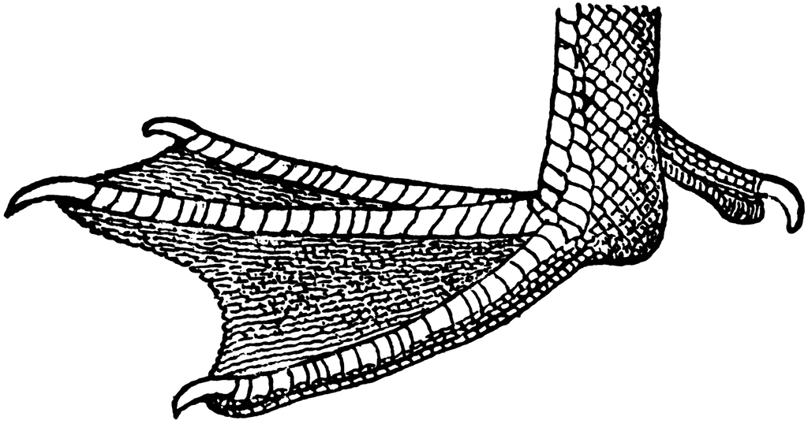

- Describe the nature of the foot above.
- What type of environment does the bird with that kind of foot live?
- How is the bird adapted to living in the environment named apart from looking at the nature of the foot?
- How is the foot useful to such a bird?
- Name any three examples of birds with such a kind of foot.

Activity III:
- Why do birds have streamlined bodies?
- How is the nictitating membrane useful to birds during flight?
- Why do birds which fly have hollow bones?
- State two disadvantages of birds to people.
- Give any two importances of birds to people.
- State the difference between birds of prey and scavenger birds.

Activity IV:
- Why are bats called mammals?
- Give two types of bats.
- How do bats reproduce?
- How do bats move?
- Why is a bat referred to as nocturnal mammals?
- Give the difference between nocturnal and diurnals.
- Suggest one reason why bats produce high pitched sound at night.
- Give one similarity between a bat and a bird.
- Of what importance are echoes to bats?

Activity V:
- Mention any two examples of amphibians.
- Give any two similarities between fish and amphibians.
- How do amphibians’ reproduce?
- State any two functions of a jelly like substance which is found in eggs of frogs and toads.
- In which way is a whale different from a frog yet they all live in water.
- How is a frog adapted to living on both land and in water?
- Give one way a tadpole is similar to fish.

Activity VI:
- Explain the meaning of the term reptile.
- State any one example of a reptile in your surroundings.
- Name any one main group of reptiles.
- Write down one way through which reptiles move.
- How do reptiles reproduce?
- Mention any two similarities between reptiles and birds.
- Suggest any one difference between mammals and reptiles.
- Give a reason why reptiles are called cold blooded animals.
- What type of fertilization do reptiles under go?

Activity VII:
- Give one example of insects which undergo complete metamorphosis.
- Name any one example of insects that undergo incomplete metamorphosis.
- Hat name is given to the larva stage of the following insects;
  - Mosquitoes.
  - Housefly.
  - Butterfly.
- What name is given to the adult stage of a housefly?
- Mention any two diseases spread by houseflies to people.
- Apart from houseflies, mention any other two insects which are vectors.

Activity VIII:
- How is the eardrum adapted to its function?
- What general name is given to the three bones found in the ear?
- State the function of each of the following part;
  - Eardrum. b. Semi – circular canal
- Which of the three bones in ear is the smallest?
- What part of the ear balances the air pressure between there and atmospheric pressure?
- What is the main function of the auditory canal?
- Indent the part of the ear where the sound vibrations are converted into nerve impulses.
- State the difference between semi-circular canal and Eustachian tube.
- State any one importance of wax in the ear.
- Which part of the ear helps to balance the body in its right posture?
- State one danger of too much wax accumulating in the ear.

Activity IX:
- How many chambers make up the human heart?
- Name the muscles that are located in the heart.
- State the main function of the human heart.
- Identify the part of the skeletal system that protects the heart.
- Apart from the heart, identify any two component of the circulatory system.
- State any one disorder of the heart.

Activity X:
- How is blood handled by the right hand side of the heart different from that in the left hand side?
- State two reasons why blood goes to the lungs.
- How is the function of the pulmonary artery different from that of one pulmonary vein?
- What kind of blood is carried in the aorta?
- Name the artery that carries de-oxygenated blood from the heart to the lungs.
- How useful is the septum to the heart during blood circulation.
- Name the biggest artery in the heart.
- State two heart diseases.

