SECTION A
- State one use of trees in our environment.
______________________________________________________________________________
- Identify any one sign of pest damage in crops.
______________________________________________________________________________
- How is BCG vaccine different from polio vaccine in the way they are administered?
______________________________________________________________________________
- Which part of a fish detects sound waves in water?
______________________________________________________________________________
- Give one importance of wind to plants.
______________________________________________________________________________
- Identify the product got from cattle whose body shape is shown below.

- Why is a bat classified under mammals?
______________________________________________________________________________
- Name the component of blood responsible for clotting blood in cuts.
______________________________________________________________________________
- Why is burning of wood to ash called a chemical change?
______________________________________________________________________________
- What do the eggs of a cockroach hatch into?
______________________________________________________________________________
- Which element of PHC is promoted through proper disposal of rubbish?
______________________________________________________________________________
- Name the deficiency disease caused by lack of vitamin Ain the diet.
______________________________________________________________________________
- Identify any one method of harvesting root crops from the garden.
______________________________________________________________________________
- Which part of a flower has the same role as the testicles of a bull?
______________________________________________________________________________
- Give a reason why worker bees are not able to lay eggs.
______________________________________________________________________________
- In which one state of matter does heat travel by convection?
______________________________________________________________________________
- Why should we tepid sponge someone with fever?
______________________________________________________________________________
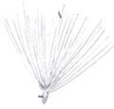
- How is the seed shown below dispersed?
_________________________________________________________
_________________________________________________________

- Why are green plants unable to make food at night?
______________________________________________________________________________
- Give one example of a living resource in the environment.
______________________________________________________________________________
- Identify one poultry disease caused by protozoa.
______________________________________________________________________________
- In which way is a mushroom similar to a moss plant?
______________________________________________________________________________
- Give one importance of cilia in the nostrils of mammals.
______________________________________________________________________________
- Mention one example of a stem tuber.
______________________________________________________________________________
- Write down any one device used to store sound.
______________________________________________________________________________
- State one way water gets contaminated at the source.
______________________________________________________________________________
- Identify any one example of a plant fibre.
______________________________________________________________________________
- Why does a medical worker dip a clinical thermometer in spirit before using it on another person?
______________________________________________________________________________
- Why is sugar used in the making of ORS?
______________________________________________________________________________
- Name one body organ severely damaged by excessive consumption of alcohol.
______________________________________________________________________________
- Mention one example of a disease that is spread through droplet infection.

- Identify the type of tropism shown below.
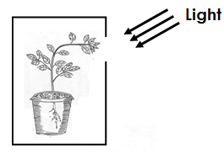

___________________________________________________________
- State one danger of hook worm infestation to the human body.
___________________________________________________________

- Give one way in which animals depend on plants.
______________________________________________________________________________
- Suggest one way a crop farmer can control pests without using chemicals.
______________________________________________________________________________
- Name one by product of respiration.
______________________________________________________________________________
- State one way in which a child gets natural immunity.
______________________________________________________________________________
- Identify one example of a water habitat disease.
______________________________________________________________________________
- How is blood carried by the pulmonary vein different from that carried by the pulmonary artery?
______________________________________________________________________________
______________________________________________________________________________
- Give one importance of a school health committee.
______________________________________________________________________________

SECTION B
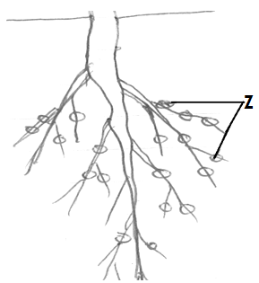
- Study the diagram below and use it to answer questions that follow.
- Name the type of root system shown above.
__________________________________________________________
- Which group of crops has such roots?
_________________________________________________________
- State the function of structures marked Z.
_________________________________________________________
- How is osmosis important to plants?
_________________________________________________________________________
- a) Give any two advantages of keeping local breeds of cattle.
i) _____________________________________________________________________________
ii)_____________________________________________________________________________
b) Name the fuel obtained from cow dung.
______________________________________________________________________________
c) Why do farmers mainly rear Friesian breed of cattle?
______________________________________________________________________________
- a) How are insects like moths able to locate flowers at night?
______________________________________________________________________________
b) Mention any two living agents of pollination.
i) _____________________________________________________________________________
ii)_____________________________________________________________________________
c) What happens when pollen grains land on the stigma?
______________________________________________________________________________
- a) Identify the groups of vertebrates to which the following animals belong.
i) snake _____________________________________________________________________
ii) Toad______________________________________________________________________
iii) Whale____________________________________________________________________
b) How is the reproduction of a whale similar to that of a snake?
______________________________________________________________________________
______________________________________________________________________________

- a) Mention any one cause of soil erosion.
______________________________________________________________________________
b) Suggest two ways of controlling soil erosion in a hilly area.
i) _____________________________________________________________________________
ii)_____________________________________________________________________________
c) Identify any one agent of soil erosion.
______________________________________________________________________________
- a) Name the type of teeth used for:
i) Biting food _________________________________________________________________
ii) Tearing flesh________________________________________________________________
b) Why should food be chewed properly before being swallowed?
______________________________________________________________________________
c) Which disorder of the digestive system leads to blockage of food movement along
the alimentary canal?
______________________________________________________________________________
- Study the diagram below and use it to answer questions that follow.
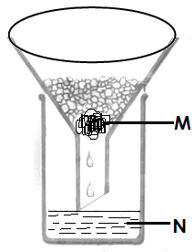
- Identify the method of obtaining clean water shown in the diagram
______________________________________________________________
- Give the scientific name given to substance marked;
- M__________________________________________________
- N ___________________________________________________

- Why is water got through the above method not safe for drinking?
______________________________________________________________________________
- a) Which part of the human body is affected by the following diseases?
i)scabies ____________________________________________________________________
ii) conjunctivitis_______________________________________________________________
b) Name the vector that spreads rabies.
______________________________________________________________________________
- Identify one disease likely to breakout in an area due to poor sanitation.
______________________________________________________________________________
- Study the table below and fill in the missing information
Sources of food | Food value | Deficiency disease
Fruits | Vitamin C | __________________________
Beans | ______________________ | Kwashiorkor
Iodised salt | Iodine | _________________________
_____________________ | Carbohydrates | marasmus
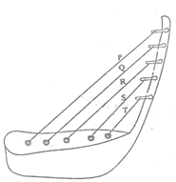
- Use the diagram of a musical instrument shown below to answer questions that follow.

- To which group of instruments does the above shown instrument belong?
______________________________________________________________________________
- How is the above instrument played?
______________________________________________________________________________
- Which string will produce the highest pitched sound?
______________________________________________________________________________
- How are echoes reduced in cinema halls?
______________________________________________________________________________
- a) State the difference between a burn and scald.
______________________________________________________________________________
______________________________________________________________________________
b) Which First Aid is given in case of each of the following;
i) Burns and scalds ____________________________________________________________
ii) Fractures__________________________________________________________________
iii) Snake bite_________________________________________________________________
- a) State any two reasons why people smoke.
i) _____________________________________________________________________________
ii)_____________________________________________________________________________
b) Give one danger of smoking to a pregnant woman.
______________________________________________________________________________
c) Besides smoking, give any other way how drugs are introduced into the body.
______________________________________________________________________________
- a) How is each of the following plants propagated;
i) Sugar canes?_________________________________________________________________
ii) Onions?_____________________________________________________________________
iii) Bananas?__________________________________________________________________
b) State one advantage of growing crops vegetatively over seeds.
______________________________________________________________________________
- a) Give one example of each of the following
i) Renewable resources _________________________________________________________
ii) Non-renewable resources _____________________________________________________
b) Suggest two ways of conserving resources in the environment.
i) _____________________________________________________________________________
ii) ____________________________________________________________________________
- a) State the function of the heart in the human body.
______________________________________________________________________________
b) Give the functions of the following components of blood in the body.
i) White blood cells
______________________________________________________________________________
ii) Red blood cells
______________________________________________________________________________
c) Why do arteries have thicker muscular walls than veins?
______________________________________________________________________________

SECTION A
- Name the first set of teeth to appear in a human.
____________________________________________________________________________
- Give one reason why farmers rear birds.
____________________________________________________________________________
- How useful is an echo to a pilot?
____________________________________________________________________________
- Which property of air enables one to spray perfume on the body?
____________________________________________________________________________
- State one process that helps in soil formation.
____________________________________________________________________________
- How is the tool below useful to a farmer?
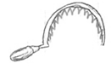
______________________________________________________
______________________________________________________

- Which type of weather drives wind mills?
____________________________________________________________________________
- Why does a butterfly die when its abdomen is covered with cassava flour?
____________________________________________________________________________
- Name one exotic breed of rabbit reared in Uganda.
____________________________________________________________________________
- By which process do plants absorb water from the soil?
____________________________________________________________________________
- Identify one method of applying fertilizers in the soil.
____________________________________________________________________________
- State one effect of alcoholism to the family.
____________________________________________________________________________
- In which way is a burn similar to a scald?
____________________________________________________________________________
- Calculate the density of the figure below if its mass is 84g..
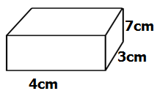

- Suggest one way P.6 pupil can promote sanitation in his/her classroom.
____________________________________________________________________________
- Why do small drums produce high pitched sound?
____________________________________________________________________________
- Name the digestive juice produced in the stomach.
____________________________________________________________________________
- Write down one example of a sea mammal.
____________________________________________________________________________
- State one effect of heat on matter.
____________________________________________________________________________
- What do we call the blood vessels that carry blood away from the heart?
____________________________________________________________________________
- How is sugar helpful to a dehydrated child?
____________________________________________________________________________
- Name the fungus that helps in fermentation of alcohol.
____________________________________________________________________________
- How does the cork of a vacuum flask control heat loss?
____________________________________________________________________________
- Identify any one quality of a good first aider.
____________________________________________________________________________
- How is a housefly adapted to spreading disease germs?
____________________________________________________________________________
- Why do farmers dock the female sheep?
____________________________________________________________________________
- State the importance of a latrine in a clean home.
____________________________________________________________________________
- How can a farmer improve upon his local breeds of goats?
____________________________________________________________________________
- In the space below draw a leaf with parallel venation.

- Why do worker bees visit flowers?
____________________________________________________________________________
- Identify one way in which drugs are taken into the body.
____________________________________________________________________________
- Name one vertebrate that uses a shell for protection?
____________________________________________________________________________
- Why do doctors dip a clinical thermometer in alcohol before using it on another patient?
____________________________________________________________________________
- How do bacteria reproduce?
____________________________________________________________________________
- Why is a rain gauge placed in an open place?
____________________________________________________________________________
- Which vitamin improves upon our vision?
____________________________________________________________________________
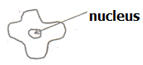
- State the function of the blood cell below in the body.
_________________________________________________________________________________________________________________________________
- Identify the body system that is severely destroyed by smoking.
____________________________________________________________________________
- Give one condition that may force a mother to bottle feed her baby.
____________________________________________________________________________
- Mention one cause of soil exhaustion.
____________________________________________________________________________
SECTION B
- a) Why is cholera regarded as a communicable disease?
____________________________________________________________________________
b) Besides cholera, mention two other communicable diseases.
i) _________________________________________________________________________
ii) _________________________________________________________________________
c) Suggest one way of controlling the spread of cholera.
____________________________________________________________________________
- a) State any two reasons why people smoke.
i) _________________________________________________________________________
ii) _________________________________________________________________________
b) Name one disease caused by smoking.
____________________________________________________________________________
c) How is passive smoking different from active smoking?
____________________________________________________________________________
____________________________________________________________________________
- a) Name any two examples of root crops.
i) _________________________________________________________________________
ii) _________________________________________________________________________
b) Mention one pest that attacks root crops.
____________________________________________________________________________
c) Suggest one way of caring for crops in the garden.
____________________________________________________________________________
- a) Name one biological change that occurs in both plants and animals.
____________________________________________________________________________
b) Give one example of each of the following;
i) Chemical change___________________________________________________________
ii) Physical change__________________________________________________________
c) Mention one human activity that spoils the environment.
____________________________________________________________________________
- a) State two ways in which pineapples are propagated.
i) _________________________________________________________________________
ii) _________________________________________________________________________
b) Mention one crop which can be propagated in the same way like a pineapple.
____________________________________________________________________________
c) Identify one common pest of pineapple.
____________________________________________________________________________
- a) State any two components of air besides carbondioxide.
i) _________________________________________________________________________
ii) _________________________________________________________________________
b) Why is carbondioxide used in fire extinguishers?
____________________________________________________________________________
c) How is wind different from air?
____________________________________________________________________________
____________________________________________________________________________
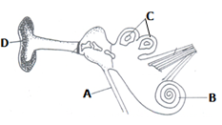
- Study the diagram below and use it to answer questions that follow.

- Name the parts labeled:
i) D_________________________________ ii) A_______________________________
- State the function of part C.
__________________________________________________________________________
- Name one disease that attacks the human ear.
__________________________________________________________________________
- a) Why is a scorpion called an invertebrate?
__________________________________________________________________________
b) To which group of vertebrates does a frog belong?
__________________________________________________________________________
- Why is a fish called a cold blooded animal?
__________________________________________________________________________
d) State one similarity between birds and mammals.
__________________________________________________________________________
- Use the diagram below to answer questions that follow.
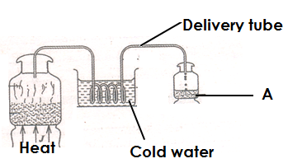

- Name the method of making alcohol shown above.
__________________________________________________________________________
- What role is played by cold water in the above process?
__________________________________________________________________________
- State the scientific name given to the liquid in container A.
__________________________________________________________________________
- State any one use of alcohol to people.
__________________________________________________________________________
- a) Besides egg eating, name any other poultry vice.
__________________________________________________________________________
b) Give one cause of egg eating in poultry.
__________________________________________________________________________
c) Suggest two ways of controlling vices in poultry.
i) _________________________________________________________________________
ii) _________________________________________________________________________
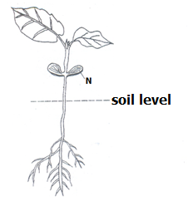
- Study the diagram below and use it to answer questions that follow.
- What type of germination is shown in the diagram?
_________________________________________________
- Identify any one seed that undergoes the above mentioned type of germination.
_________________________________________________
- Name part marked N.__________ _____________________
- Give one factor that may make a seed fail to germinate when all conditions are present.
__________________________________________________________________________________________________

- Match the following weather instruments to their function
A B
Hygrometer speed of wind
Barometer amount of rainfall received
Rain gauge atmospheric pressure
Anemometer strength of wind.
Amount of water vapour in the atmosphere
- Hygrometer______________________________________________________________
- Barometer_______________________________________________________________
- Rain gauge_______________________________________________________________
- Anemometer______________________________________________________________
- a) Name the component of soil that increases its fertility.
__________________________________________________________________________
b) Write down two ways of maintaining soil fertility.
i) _________________________________________________________________________
ii) _________________________________________________________________________
c) How does bush burning cause soil erosion.
__________________________________________________________________________
- a) What do we call the sudden happening that causes injury to the body?
__________________________________________________________________________
b) Give two reasons why people with injuries should be given First Aid.
i) _________________________________________________________________________
ii) _________________________________________________________________________
c) Why should we tie slightly above the bitten part when giving First Aid for a snake
bite?
__________________________________________________________________________
- Write down any three requirements needed when starting a farm.
i) _________________________________________________________________________
ii) _________________________________________________________________________
iii) _________________________________________________________________________
b) Mention any one tick borne disease in farm animals.
__________________________________________________________________________
***Good luck***

SECTION A
- Name the best soil for modeling.
____________________________________________________________________________
- Identify one enzyme found in the stomach.
____________________________________________________________________________
- Mention an invertebrate that defends itself by withdrawing into its shell.
____________________________________________________________________________
- Give one cause of soil erosion.
____________________________________________________________________________
- How does heat travel through liquids and gases?
____________________________________________________________________________
Below is a diagram showing the roots of a monocot.
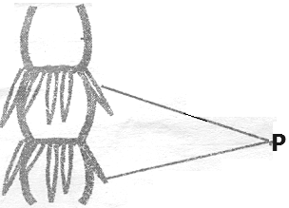

- State the use of the roots marked P to the plant.
____________________________________________________________________________
- Why do electricity wires appear tight on poles on cold days?
____________________________________________________________________________
- State any one cause of dehydration.
____________________________________________________________________________
- In which way are irish potatoes propagated?
____________________________________________________________________________
- Why are theatre halls usually covered with soft boards?
____________________________________________________________________________
- Give one importance of the tongue during digestion.
____________________________________________________________________________
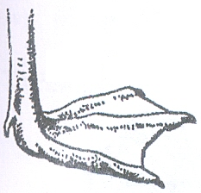
- Below is a diagram showing the foot of a bird. Mention one example of a bird with such a foot.
_____________________________________

- Why should materials made of iron be painted?
____________________________________________________________________________
- Why is a P.6 pupil advised to cut finger nails short?
____________________________________________________________________________
- Name the plant’s response towards light.
____________________________________________________________________________
- Why is a spider not an insect?
____________________________________________________________________________
- What is shearing as used in sheep keeping?
____________________________________________________________________________
- State the digestive juice produced by the stomach walls.
____________________________________________________________________________
- In the space below, draw a diagram showing fibrous root system.

- How are sunbirds and bees useful to flowers?
____________________________________________________________________________
- Give any one reason why we give First Aid to accident victims.
____________________________________________________________________________
- State any one sign of a goat on heat.
____________________________________________________________________________
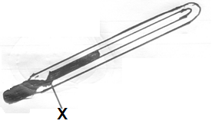
The diagram below shows an instrument. Use it to answer questions 23 and 24.
- Name the instrument shown in the diagram
_____________________________________________
- How is part marked X useful in the instrument above?
______________________________________________
______________________________________________
- What gas do legume plants need to make proteins?
____________________________________________________________________________
- Mention one way in which vaccines are introduced into our bodies?
____________________________________________________________________________
- Why is ice called matter?
____________________________________________________________________________
- Give any one example of a chemical change.
____________________________________________________________________________
- State any one reason why people drink alcohol.
____________________________________________________________________________
- How does mulching keep moisture in the soil?
____________________________________________________________________________
- Of what use is a dustbin in the school compound?
____________________________________________________________________________
- State the reason why bees sometimes swarm.
____________________________________________________________________________
- Why do people keep rabbits in their homes?
____________________________________________________________________________
- Give one activity a community can do to reduce road accidents.
____________________________________________________________________________
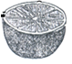
- To which group of succulent fruits does the fruit in the diagram below belong?

_________________________________________

- Give one way in fungi are useful to people.
____________________________________________________________________________
- By what process does smoke move through the chimney?
____________________________________________________________________________
- State the use of water during seed germination.
____________________________________________________________________________
- Calculate the density of an object which has a mass of 60 grams and volume of 6cm³.

____________________________________________________________________________
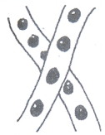
- Name the amphibian that lays eggs shown in the diagram below.

_________________________________________________________

SECTION B
- Below are steps used to recover salt with mixed sand, re-arrange the steps
correctly.
- Filter the mixture.
- Add water and stir to dissolve the salt.
- Boil the filtrate until it evaporates to dryness.
- Collect the mixture and put it into the container.

- _______________________________________________________________________
- _______________________________________________________________________
- _______________________________________________________________________
- _______________________________________________________________________
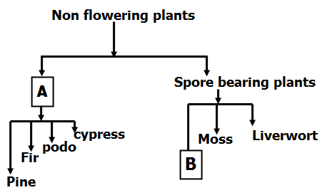
- Study the diagram below and answer questions.

a) Name parts marked A and B.
i) A________________________________ii) B_______________________________
b) How can plants depend on animals?
__________________________________________________________________________
c) How do plants in A obtain their food?
_________________________________________________________________________
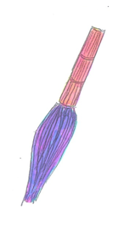
- a) Which element of Primary Health Care is promoted by using the maternal shown in the
diagram below.

_________________________________

b) Apart from the element of PHC you have mentioned in (a) above, state two other elements
of PHC..
i) _________________________________________________________________________
ii) _________________________________________________________________________
c) Give one way in which a community can promote Primary Health Care.
____________________________________________________________________________
- a) Mention two vulnerable groups of people involved in breastfeeding.
i)____________________________________(ii)_____________________________________
b) Give one advantage of breastfeeding.
____________________________________________________________________________
c) Write down one disadvantage of bottle feeding.
____________________________________________________________________________
- a) Name the muscles that make up the heart. ____________________________________________________________________________
b) Why is the left ventricle of the heart thick walled?
____________________________________________________________________________
c) Write down any two functions of blood in the body.
i) _________________________________________________________________________
ii) _________________________________________________________________________
- Match the instruments in A to what they measure (show) in B
A | B
Hygrometer | Speed of wind
Wind vane | Amount of water vapour.
Barometer | Direction of wind.
Anemometer | Atmospheric pressure.

i) | Hygrometer | ___________________________________________________________
ii) | Wind vane | ___________________________________________________________
iii) | Barometer | ___________________________________________________________
iv) | Anemometer | ___________________________________________________________
- a) State the type of smoking where one inhales smoke indirectly from an active smoke.
__________________________________________________________________________
b) Give one disease of the lungs caused by smoking __________________________________
c) Suggest two ways in which an individual can avoid drug dependence.
i) _________________________________________________________________________
ii) _________________________________________________________________________
- a) Mention one product got from cattle that protect children from kwashiorkor.
__________________________________________________________________________
b) How is a strip cup useful to a cattle keeper?
__________________________________________________________________________
c) Identify the diseases of cattle spread by ticks.
i)__________________________________(ii)____________________________________
- The diagram below shows three drums. Use it to answer questions below.
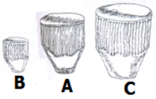
- Which drum will produce sound with:-
- The lowest pitch___________________________
- The highest pitch___________________________

b) How does a drum produce sound?
__________________________________________________________________________
c) Give one reason why sound is stored.
__________________________________________________________________________
- a) Give two characteristics of living things.
i) _________________________________________________________________________
ii) _________________________________________________________________________
- State the difference between plants and animals.
__________________________________________________________________________
__________________________________________________________________________
- How do pupils benefit from orange plants in the school compound?
__________________________________________________________________________
- a) What are social insects?
__________________________________________________________________________
b) Give two examples of social insects.
i) _______________________________________________________________________
ii) _______________________________________________________________________
c) In which one way are insects useful to people?
__________________________________________________________________________
- Oil and water were mixed in a glass as shown below.
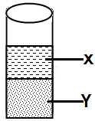

a) Name the liquids X and Y.
X____________________________________________________________________
Y ____________________________________________________________________
b) Why does liquid X settle on top of liquid Y?
__________________________________________________________________________________________________________________________________________________
c) When is displacement method applied in Science?
__________________________________________________________________________
- a) What causes tooth decay?
__________________________________________________________________________
b) State the use of each of the following types of teeth;
i) Molars ___________________________________________________________________
ii) Canines _________________________________________________________________
c) Suggest one way of caring for our teeth.
__________________________________________________________________________
- a) What term refers to all domestic birds? __________________________________________
b) State two types of chicken.
i) _______________________________ ii) _______________________________
c) State the system of keeping birds that is common in rural areas.
__________________________________________________________________________
- Study the diagram below and answer questions that follow.
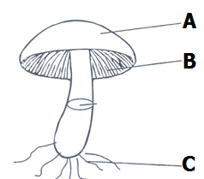

- Name the organism shown in the diagram _______________________________________
- To which kingdom of living things does it belong? _________________________________________________________________________
- Name the part marked A.____________________________________________________
- State the use of part B to the organism above.
_________________________________________________________________________
SECTION A:
- In which state of matter is ice?
___________________________________________________________________________
- Why are expectant mothers called vulnerable groups of people?
___________________________________________________________________________
113. State one duty of worker bees in the hive.
___________________________________________________________________________
114. How do green plants benefit from the process of respiration in animals?
___________________________________________________________________________
115. Name the class of food which protects our bodies from infection
___________________________________________________________________________
116. State one reason why we should boil drinking water.
___________________________________________________________________________
117. Which element of PHC controls the spread of immunisable diseases among infants?
___________________________________________________________________________
118. In which way is the reproduction of yeast different from other fungi?
___________________________________________________________________________
___________________________________________________________________________
119. How important is dustbin in our classroom?
___________________________________________________________________________
120. Identify the property of air shown below.
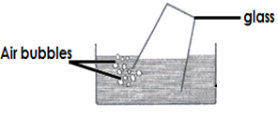

_______________________________________________

121. Give one example of a stem tuber
___________________________________________________________________________
122. Why is a dog referred to as a living thing?
___________________________________________________________________________
123. Mention one way in which our bodies acquire immunity.
___________________________________________________________________________
124. Give one poultry disease caused by a virus.
___________________________________________________________________________
125. Name one dairy breed of goats reared in Uganda.
___________________________________________________________________________
126. How is the life cycle of locusts different from that of butterflies?
___________________________________________________________________________
___________________________________________________________________________
127. Name the liquid metal which is commonly used in thermometers.
___________________________________________________________________________
128. Mention one similarity between fungi and bacteria..
___________________________________________________________________________
129. Why is evaporation of water to steam called a physical change?
___________________________________________________________________________
130. Explain the term kindling as usedin rabbit keeping.
___________________________________________________________________________
Below is a diagram of a plant with a running stem, use it to answer questions 21 and 22.
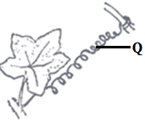
131. Name part labeled Q on the plant above?
_____________________________________________________2132. Give one reason why plants with such stems climb other
plants?
_____________________________________________________
_____________________________________________________
133. Identify one local method of preserving food.
_____________________________________________________
134. How does a crop farmer benefit from the action of worker bees visiting his tomato garden?
___________________________________________________________________________
135. Give one way of preventing burns while lifting hot objects.
___________________________________________________________________________
136. Why are poultry farmer encouraged to mix crushed bones of fish in poultry mash?
___________________________________________________________________________
137. Besides plants and animals, mention any other kingdom of living things.
___________________________________________________________________________
138. State one importance of heat to man.
___________________________________________________________________________
139. Give one importance of litter on a poultry house.
___________________________________________________________________________
140. Name one condition necessary for rusting to occur.
___________________________________________________________________________
141. Why is the space left in the bottle of soda below?
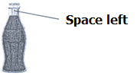
________________________________________________________________________
________________________________________________________________________

142. A part from the sun, identify any other natural source of heat energy.
___________________________________________________________________________
143. Why is a bat called a mammal yet it flies like birds?
___________________________________________________________________________
144. Name the most sensitive part of the tooth.
___________________________________________________________________________
145. How useful is an Anemometer at a weather station?
___________________________________________________________________________
146. Identify any one raw material for Photosynthesis
___________________________________________________________________________
147. In which part of the alimentary canal of man is alcohol absorbed?
___________________________________________________________________________
148. Why should pit latrines be smoked regularly?
___________________________________________________________________________
149. How is sleep and rest important for our well being?
___________________________________________________________________________
150. Mention one vaccine given to babies at 6, 10 and 14 weeks.
___________________________________________________________________________

SECTION B,
151.a) What are vertebrates?
___________________________________________________________________________
b) Besides birds, mention two other groups of vertebrates.
i)___________________________________ii)_____________________________________
c) Why are birds referred to as warm blooded vertebrates?
___________________________________________________________________________
152. Below are roots of a monocotyledons plant, use the diagram to answer questions
that follow.
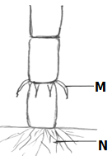

- Name the part labeled N.
__________________________________________
- How useful are roots marked M to the above plant?
____________________________________________
____________________________________________
c) Name any two plants with the root marked M above.
i)_____________________________________ii)___________________________________
153. How do the following animals protect themselves against enemies?
a) Caterpillars: _______________________________________________________________
b) Porcupines: _______________________________________________________________
c) Snakes: _______________________________________________________________
d) Chameleons: _______________________________________________________________
154.a) Which method of heat transfer enables a farmer to dry his harvested bean seeds?
__________________________________________________________________________
b) Identify any two examples of heat insulators.
i)__________________________________ii)_____________________________________
c) Why do electric wires appear tight during cold weather?
__________________________________________________________________________
155.a) How useful is Royal jelly in a bee hive?
__________________________________________________________________________
b) State one advantage of a modern bee hives over a traditional hives.
__________________________________________________________________________
__________________________________________________________________________
c) Name two products got from bees.
i)_____________________________________ii)___________________________________
156.a) Mention one example of each of the following :
i) Chemical change - ________________________________________________________
i) Biological change - _______________________________________________________
b) State one major similarity between chemical and biological changes.
___________________________________________________________________________
c) Which physical change leads to change of state from liquids to solids?
___________________________________________________________________________
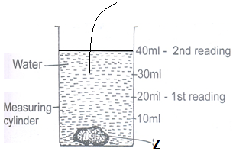
157. Study the experiment below and use it to answer questions that follow.

a) Name the method of finding volume shown above.
___________________________________________________________________________
b) What scientific name is given to the object marked Z?
___________________________________________________________________________
c) Calculate the volume of the object marked Z in the diagram above.

__________________________________________________________________________
d) When is such a method of finding volume used?
__________________________________________________________________________
158.a) Name one exotic breed of sheep reared for wool production.
__________________________________________________________________________
b) Identify any one product made from wool. _______________________________________
c) How is docking an important practice in sheep management?
___________________________________________________________________________
d) Why is it not advisable for a farmer to live in the same house with domestic animals?
___________________________________________________________________________
159. Study the diagram showing part of the digestive system of man and use it to
answer questions that follow.
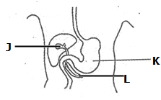
a) Name parts labeled J andL. i) J__________________________________
ii) L _________________________________
b) Which enzyme clots proteins in the milk of
babies in part labeled K?
_____________________________________
c) Suggest one way of keeping the digestive system in a good working condition.
___________________________________________________________________________
160. Match the diseases in list A to the germs that cause them in list B
A B
a) Malaria chlamydia
b) Typhoid HIV
c) AIDS Salmonella typhi
d) Trachoma Plasmodia

a) Malaria ____________________________
b) Typhoid ____________________________
c) AIDS ____________________________
d) Trachoma ____________________________
161. a) Name the thermometer used to measure the highest and lowest temperatures of the day.
__________________________________________________________________________
b) Give a reason why mercury is commonly used in most thermometers.
__________________________________________________________________________
c) How is BCG vaccine different from polio vaccine in the way they are administered?
___________________________________________________________________________
d) In which units is temperature measured?
___________________________________________________________________________
162.a) What is meant by the term immunity?
___________________________________________________________________________
b) Write down two ways in which our bodies acquire immunity.
i)__________________________________________________________________________
ii)__________________________________________________________________________
c) Mention one type of immunity.
___________________________________________________________________________
163.a) Mention any two components of soil.
i) _______________________________ ii) ______________________________________
b) Which type of soil is useful in pottery industry?
__________________________________________________________________________
c) Apart from pottery, give one other importance of soil to man.
___________________________________________________________________________
164. The graph below shows the components of air. Use it to answer questions that
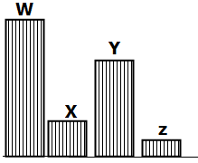
follow.
- Which part of air is represented by the following
letters:
i) W _____________________
ii) Z _____________________
iii) Y _____________________
b) State any one use of gas labeled Z to man.
___________________________________________________________________________
165.a) Identify any one cause of road traffic accident in Uganda.
___________________________________________________________________________
b) Give one reason why casualties should be given First Aid.
___________________________________________________________________________
c) Name any two items which can be found in First Aid box.
i) __________________________________ ii)_________________________________
-END-

