TRINITY PRIMARY SCHOOL-BUKOTO
REVISION WORK SET VII
PRIMARY SEVEN
INTEGRATED SCIENCE

Time allowed: 2 hours 15 minutes
Index number

Student’s Name: ………………………………………………………………………………………….
Student’s Signature: ……………………………………………………………………………………..
School Name: ………………………………………………………………………………………………..
District Name: ………………………………………………………………………………………………..
FOR EXAMINER’S USE ONLY

Read the following instructions carefully:
- The paper has two sections: A and
FOR EXAMINER’S USE ONLY
Qn. No | MARK | SIGN
1 – 16
17– 26
27 – 35
36 – 44
45 – 50
51 – 52
53
54
55
TOTAL

- Section A has 40 questions (40 marks)
- Section B has 15 questions (60 marks)
- Answer ALL questions. All answers to both Sections A
and B must be written in the spaces provided.
- All answers must be written using a blue or black ball
point pen or ink. Diagrams should be drawn in pencil.
- Unnecessary alteration of work may lead to loss of marks.
- Any handwriting that cannot be easily read may lead to
loss of marks.
- Do not fill anything in the boxes indicated for Examiner’s
use only.

SECTION A (40MARKS)
1. Name the domestic animal that helps to guard our homes.
………………………………………………………………………………………..............
2. Which vector is involved in the 4Fs germ path?
………………………………………………………………………………………..............
3. How are nimbus clouds important?
………………………………………………………………………………………..............
4. Why are gaps left between the rails during railway line construction?
……………………………………………………………………………………….............
5. Name the instrument used to measure the human body temperature.
……………………………………………………………………………………….............
6. Give any one difference between green plants and animals.
………………………………………………………………………………………..............
7. State one use of blood in the human body.
……………………………………………………………………………………….............
8. Why do some flowers have bright colours?
……………………………………………………………………………………….............
9. In which way is burning similar to rusting?
………………………………………………………………………………………..............
10. What are vertebrates?
……………………………………………………………………………………….............
Use the diagram below to answer question 11.
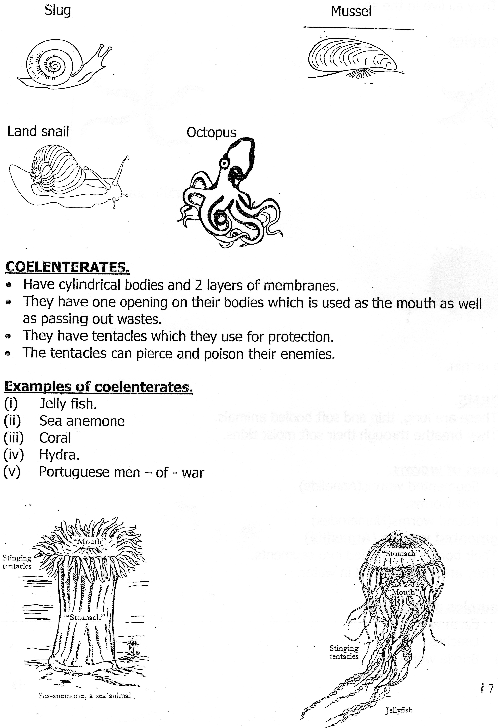

11. To which group of invertebrates does the above animal belong?
.....................................................................................................................................

12. With out using medicine, how else can we keep our bodies healthy?
………………………………………………………………………………………..............
13. Give any one example of a social insect.
………………………………………………………………………………………..............
14. Identify any one product from milk.
………………………………………………………………………………….....................
15. How do people in Uganda benefit from wind?
………………………………………………………………………………………..............
16. Where does alcohol get absorbed during process of food digestion?
....................................................................................................................................
17. Write down the most feared STD in Uganda.
………………………………………………………………………………………..............
18. Give a reason why the disease you have named in NO 17 above is most feared.
……………………………………………………………………………………….......
19. Of what importance is chlorophyll to plants?
……………………………………………………………………………………….......
20. State any one secondary sex characteristic which occur in both males and females.
………………………………………………………………………………………........
21. How is sound produced?
..............................................................................................................................
22. Study the diagram of a plant below and answer the questions that follow.
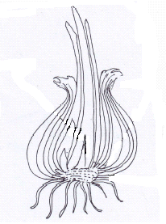

State the type of root system the above plant has.
………………………………………………………………………………………..............

23. Why is the proper disposal of human of human wastes very important in our
community?
………………………………………………………………………………………..............
24. How can kwashiorkor be prevented in human beings?
………………………………………………………………………………………..............
25. Besides hearing, state any other function of a mammalian ear.
………………………………………………………………………………………..............
26. In the space provided below, Calculate the density of an object whose mass is 50g
and volume is 5cc.
………………………………………………………………………………………..............
27. Write one way of controlling the spread of diarrhoeal diseases in a community.
………………………………………………………………………………………...............
28. How can the health of teeth be maintained?
………………………………………………………………………………………................
29. What is the use of a stretcher in giving first aid?
………………………………………………………………………………………................
30. How is a frog similar to a fish in the way they reproduce?
.......................................................................................................................................
31. Which type of blood is carried by arteries?
………………………………………………………………………………………..............
32. Identify any one Immunisable water borne disease in Uganda.
………………………………………………………………………………………..............
33. Which part of the seed develops into a shoot system?
………………………………………………………………………………………..............
34. What name is given to the breathing organs of an insect?
………………………………………………………………………………………...............
35. Why is it not advisable to keep goats in a house where people live?
………………………………………………………………………………………..............
36. What causes malaria?
………………………………………………………………………………………...............
37. Why is it important to cross breed exotic animals with local ones?
………………………………………………………………………………………...............
38. Why do hens sometimes lay eggs with soft shells?
………………………………………………………………………………………................
39. What is the danger of taking drugs without a medical worker’s prescription?
………………………………………………………………………………………...............
40. Apart from sweeping, suggest any other activity used in reducing dust in a
classroom.
………………………………………………………………………………………...............
SECTION B
- a) Write PHC in full.
.....................................................................................................................................
- Give any two elements of PHC.
(i)...................................................................................................................................
(ii)..................................................................................................................................
- Which element of PHC is promoted when we eat a balanced diet?
.....................................................................................................................................
42. a) Apart from floods, give other two natural causes of environmental degradation.
(i).......................................................................
(ii)......................................................................
b) Suggest any two dangers of drought to people.
(i)....................................................................................................................................
(ii)....................................................................................................................................
43. a) In one sentence, write the meaning of family planning.
........................................................................................................................................
b) Identify any two natural methods of family planning.
(i)......................................................................................................................................
(ii).....................................................................................................................................
c) In which way is family planning useful to the mother?
.........................................................................................................................................

44. Use the diagram of an egg below to answer questions that follow.
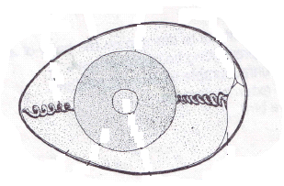
W R

T
- Name the parts labeled;
- R .............................................................
- W ............................................................
b) How is part T adapted to allow exchange of gases?
……………………………………………………………………………………....................
c) Give one function of part R.
.........................................................................................................................................
- a) What is the difference between a burn and a scald?
………………………………………………………………………………………................
......................................................................................................................................
b) Why is it important to give first aid to casualties?
………………………………………………………………………………………................
c) What first aid can be given to a person who has just near drowned?
………………………………………………………………………………….......................
- The diagram below show shows part of a flowering plant. Study it and answer the
questions which follows.
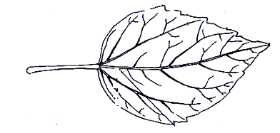 X

N
- Name part marked N.
......................................................................................................................................
- Give the use of part labeled X to the leaf.
......................................................................................................................................
- By use of an arrow, show the midrib.
......................................................................................................................................
- Why is the above shown part useful to plants?
......................................................................................................................................
47. a) What is seed dispersal?
......................................................................................................................................
b) Identify any two agents of seed dispersal.
(i).................................................................................................................................
(ii).................................................................................................................................
- How is seed dispersal important in our environment?
…………………………………………………………………………………...........
- Match the organs in list A to the diseases in list B correctly.
A B
Heart scabies
Eyes emphysema
Skin Trachoma
Lungs Heart attack
- Heart .................................................................................
- Eyes ...................................................................................
- Skin ..................................................................................
- Lungs ..............................................................................
- . a) Give any two uses of worker bees in a hive.
- ……………………………………………………………………………......................
- ...............................................................................................................................
b) Why do bees swarm?
.....................................................................................................................................

c) How do farmers prevent their bees from swarming?
.........................................................................................................................................
50. a) What is dehydration?
………………………………………………………………………………………...............
- Write any two sign of a dehydrated child.
(i)................................................................. (ii).............................................................
c) How do family members care for a dehydrated person in their home?
………………………………………………………………………………………..............
51. a) Give the use of soap when washing clothes.
………………………………………………………………………………………...............
b) Write any two activities involved in cleaning clothes.
(i)……………………………………………………………………………………................
(ii)...................................................................................................................................
c) What is the danger of putting on dirty clothes to a person?
……………………………………………………………………………………...................
52. a) Name any three classes of food that make up a balanced diet.
(i)........................................................................
(ii).......................................................................
(iii).......................................................................
b) Why is calcium included in our diet?
...................................................................................................................................... 53. a) Which gas is commonly used in fire extinguisher?
.......................................................................................................................................
- What plant process uses the same gas you have mentioned in (a) above?
.......................................................................................................................................
- Identify one condition needed for the process you have mentioned in (b) above.
.......................................................................................................................................
- How do animals benefit from the process you have mentioned in (b) above?
........................................................................................................................................

54. Define the following terms in relation to sound.
a) Echo...........................................................................................................................
b) Pitch ..........................................................................................................................
c) Volume ......................................................................................................................
d) Frequency.................................................................................................................
55. The diagram below shows an experiment done on heat. Study it and use it to answer
the questions that follows.

a) By what process does heat more from point E to point B?
………………………………………………………………………………………................
b) At what point will the wax melt first?
………………………………………………………………………………………...............
c) Give the reason to support your answer in (b) above.
......................................................................................................................................
d) How does heat from the sun reach the earth?
........................................................................................................................................

*Read Hard for the Bright Future*

