

SEETA JUNIOR SCHOOL EXAMINATIONS COMMITTEE
SET TWO TERM II EXAMINATIONS
2018
MATHEMATICS
PRIMARY SEVEN
Time Allowed: 2 hours 30 minutes

Index No. :
Candidate’s Name : …………………………………………………………………………………………
Candidate’s Signature : …………………………………………………………………………………………
School Name : …………………………………………………………………………………………
District Name : …………………………………………………………………………………………
DO NOT OPEN THIS BOOKLET UNTIL YOU ARE TOLD TO DO SO.
Read the following instructions carefully:
FOR EXAMINERS’
USE ONLY
Qn. No. MARKS EXRS’ IN.
1 – 5
6 – 10
11 – 15
16 – 20
21 – 22
23 – 24
25 – 26
27 – 28
29 – 30
31 – 32
- This paper has two sections: A and B.

- All the working for both sections A and B must be shown
in the spaces provided.

- All working must be done using a blue or black ball-point
pen or fountain pen. Any work done in pencil other than
graphs, pictures and diagrams will not be marked.

- No calculators are allowed in the examination room.

- Unnecessary changes of work may lead to loss of marks.

- Any handwriting that cannot easily be read may lead to
loss of marks.

- Do not fill anything in the boxes indicated:
“For Examiners’ Use Only”

SECTION A (40marks)
- Subtract: $254 - 46$

- Simplify: ⁻12 – ⁺9

- Convert 5 base ten to a binary system.

- Multiply: 106 $×$4

- Find the size of angle marked y in the diagram.

59$°$
63$°$
y

- Solve: 8 – 3r = 14

- Workout the square root of $20\frac{1}{4}$

- Find the value of numeral expanded below: (4$×$ 10²) + (7 $×$ 10¹) + (9 $×$ 10⁰) + (5 $×$ 10⁻²)

- The cost of four books is 5,000 shillings. How many books will James buy if he has 8750 shillings.

- Jogo walked 2.3km from his home to his daughter’s house. Express his distance in metres.

- Subtract: 2$x$ + 4$y$ from 3$x$ – 2$y$

- In the space below construct an angle of 75$°$.

- Calculate the number of subsets in a set having 4 elements.

- Simplify: 3m – (2 + m)

- Workout the area of the figure below:
D
A
C
B
5m
12m
3m

- Factorise completely: 6$x$²$-$ 12 $×y+$ 9$x$

- Calculate the value of P in the figure below:
4p
5p

- Given that $y =$⁻$4$, $p = 3$. Workout the value of $3y$²$- 5py$

For questions 19 and 20, use the graph below that shows number of trays of eggs Joshua collects in his farm per week.
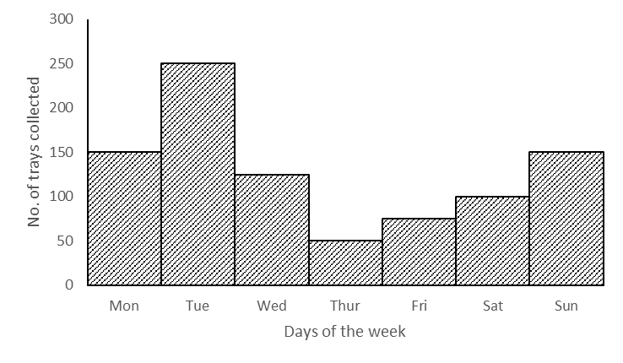

- On which day did he receive the greatest increase in the number of trays collected?

- How many trays does he collect in a week?

SECTION B (60marks)
- (a) Workout: $\frac{0.3-0.1}{0.04}$ $(3marks)$

(b) The price of a goat increased from 64,000 shillings to 72,000 shillings, find the percentage increase in the price of a goat. $(3marks)$

- In a class of 72 students, all the students like French (F), 41 students like French and Mathematics (M), 32 students like French and English (E), 9 students like all the three subjects while y students like French only.
- Use the above data to complete the Venn diagram below. $(3marks)$
$n\left(\right)=$ 72
$n\left(M\right)$=41
$n\left(E\right)$= 32
____
$$9$$
____
____
$$n\left(F\right)=$$

- How many students like only French? $(2marks)$

- The average age of five boys is 12years, when their teacher joins them their average age becomes 15 years. Calculate the age of their teacher. $(4marks)$

- (a) Solve: 2(p – 3) – 6 = 2 $(3marks)$

(b) Workout: $\frac{2x+1}{3}=\frac{x+8}{2}$ $(2marks)$

- A lorry driver drove his vehicles at a speed of 60km/hr. for one hour and 30 minutes, from Mbarara to Kasese. He made a return journey at a speed of 45km/hr.
- Calculate the distance from Mbarara to Kasese. $(2marks)$

- How long did he take for the whole journey? (to and fro) $(3marks)$

- A poultry farmer had 300 chickens, he sold $\frac{1}{6}$of them to Kiiza,$\frac{3}{5}$of the remainder to Josephine and the rest to Peter.
- How many chicken did Josephine buy? $(3marks)$

- If the cost of one chicken is 4000sh. How much did Peter pay for his chicken? $(2marks)$

- (a) Using a ruler, a pair of compasses and a pencil only construct a triangle ABC where AB =
6cm, BC = 5cm and AC = 4cm in the space below. $(4marks)$

(b) From your accurate diagram measure angle BAC in degrees. $(1mark)$

- Ekapel went to a local market and bought the following items:
−2kg of rice at sh. 2400 per kg.
−$1\frac{1}{2}$kg of posho at sh. 3000 each kg.
−500gms of salt at sh. 800 per kg.
−One loaf of breadat sh. 1000 each loaf.
- Calculate his total expenditure if he was given a 10% discount for all the items he bought. $(5marks)$

- Juliet made circular table mats of diameter 7cm and of a rectangular sheet of cloth that measures 500cm long by 34cm wide as shown in the figure below:
34cm
50cm
7cm

- How many circular table mats, did she make from the piece of cloth? $(3marks)$

- Calculate the area of the piece of cloth used to make out circular table mats. $(2marks)$

20$°$
62$°$
136$°$
2$x$
$$y$$

- Study the diagram below carefully.

- Find the size of angle $y$. $(3marks)$

- Workout the value of $x$. $(2marks)$

- (a) Plot the following co-ordinates on the grid below: P(⁺1,2), Q(⁺4,0), R(⁺1,2), S(⁻4,0)
$(4marks)$
⁺4
⁺5
⁻4
⁻3
⁻2
⁻1
⁻1
⁻2
⁻3
⁻4
⁺4
⁺3
⁺2
⁺1
⁺5
0
⁺1
⁺2
⁺3

(b) Join the points and name the figure formed. $(1mark)$

($2x-10$)$°$
($2x+30$)$°$
($x-80$)$°$
B
A
C
D

- Study the figure below carefully and answer the questions below.

- Find the value of x. $(3marks)$

- Workout the size of angle BCA in degrees. $(2marks)$

***END***

