TWALIBAH ISLAMIC PRIMARY SCHOOL
PLE-MOCK EXAMINATION 2019
PRIMARY SEVEN
SOCIAL STUDIES AND RELIGIOUS EDUCATION
Time allowed: 2 hours 15 minutes

Index No.

Candidate’s Name: _____________________________________________________
Candidate’s Signature: __________________________________________________
School Name: _________________________________________________________
FOR EXAMINER’S USE ONLY
Read the following instructions carefully:
- The paper has two sections: A and B
- Section A has 40 questions (40 marks)
FOR EXAMINER’S USE ONLY

Qn. No | MARK | SIGN
1 – 10
11 – 20
21 – 30
31 – 40
41 – 43
44 – 46
47 – 49
50 – 52
53 – 55
TOTAL

- Section B has 15 questions (60 marks)
- Answer ALL questions. All answers to both Sections A
and B must be written in the spaces provided.
- All answers must be written using a blue or black ball
point pen or ink. Diagrams should be drawn in pencil.
- Unnecessary crossing of work may lead to loss of marks.
- Any handwriting that cannot be easily read may lead to
loss of marks.
- Do not fill anything in the boxes indicated;
For Examiner’s use only.
Turn over

SECTION A
- Give one basic need of man?
_______________________________________________________________
- On which river are Victoria Falls located?
_______________________________________________________________
- Why is mechanized farming commonly practiced in central Uganda?
_______________________________________________________________
- Who was the Ugandan founder of the first East African Community?
_______________________________________________________________
- Give any one way how your family is important to you.
_______________________________________________________________
- Which Ministry is responsible for refugee problems in Uganda?
_______________________________________________________________
- Give a reason why some parts of river Nile are navigable.
_______________________________________________________________
- Write ECOMOG in full.
______________________________________________________________________________________________________________________________
- How are polythene bags / papers a danger to our environment?
______________________________________________________________________________________________________________________________
- What type of trade replaced barter trade?
_______________________________________________________________
- How is Uganda trying to promote peace in its neighbouring countries?
_______________________________________________________________
- How does the government of Uganda gain from foreign tourists?
_______________________________________________________________
- Which was the first European Country to get a colony in Africa?
_______________________________________________________________
- Why was Mt. Rwenzori referred to as the “Mountains of the moon”?
______________________________________________________________________________________________________________________________
- Suggest any one way the government of Uganda can improve on its labour force.
______________________________________________________________________________________________________________________________
- Give any one reason why the colonial government introduced taxes.
______________________________________________________________________________________________________________________________
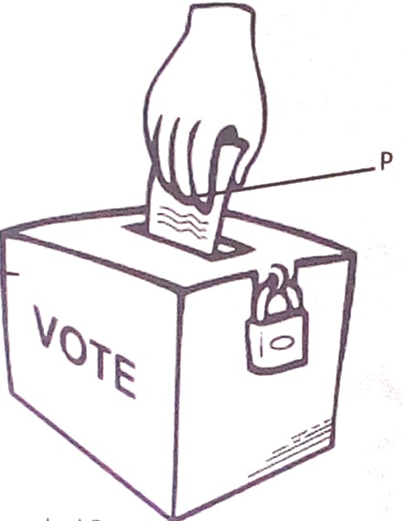

Name the voting item marked with letter P.
________________________________________________________________________________
- Give any one danger of land fragmentation.
_______________________________________________________________
- How did L. Victoria contribute to the rise and expansion of Buganda Kingdom?
______________________________________________________________________________________________________________________________
- How does the climate in the Sahara desert influence people’s ways of dressing?
______________________________________________________________________________________________________________________________
- Give one factor that qualifies Uganda to be a member of the East African Community?
_______________________________________________________________
- How did Slave trade affect food production in E. Africa?
_______________________________________________________________
- State the importance of having one local language in East Africa.
_______________________________________________________________
- Give any one advantage of good feeder roads.
______________________________________________________________________________________________________________________________
- How is a Post office useful to a community?
_______________________________________________________________
- How did Captain F.D Lugard solve the problem of religious wars in Uganda?
______________________________________________________________________________________________________________________________
- Why do some people fail to meet their needs?
_______________________________________________________________
- Name any one man-made cause of environmental degradation.
_______________________________________________________________
- Give any one way in which climate influences economic activities.
______________________________________________________________________________________________________________________________
- Identify any one social activity that unites people in a community.
_______________________________________________________________
- State one factor that led to the building of a factory at Hima.
_______________________________________________________________
- Why is the government of Uganda encouraging people to grow non-traditional cash crops?
______________________________________________________________________________________________________________________________
- Why is the equatorial Climate described as hot and wet?
________________________________________________________________
- Who was the founder of Bunyoro-Kitara Kingdom?
_______________________________________________________________
- Mention any one product got from natural forests.
_______________________________________________________________

For questions 36-40, answer Christianity or Islamic questions but NOT both in a number.
- Either: Why did the three wise men give gifts to baby Jesus?
____________________________________________________________
Or: Why did early Muslims face Jerusalem while praying?
______________________________________________________
- Either: Why do Christians work?
______________________________________________________
Or: Why do Muslims work?
______________________________________________________
- Either: Why do Christians take the Bible to be a holy book?
____________________________________________________________
Or: Why do Muslims take the Quran to be a holy book?
______________________________________________________
- Either: Who was the first disciple to be called by Jesus?
______________________________________________________
Or: Who was the first person to convert to Islam
____________________________________________________________
- Either: Who was the last prophet according to the Bible?
_____________________________________________________________
Or: Who was the last Prophet according to the Quran?
_____________________________________________________________

SECTION B (60 MARKS)
- a) What title is given to the highest elected leader in a district local council?
___________________________________________________________
b) Identify any two duties of Local Councils?
- ___________________________________________________________
- ___________________________________________________________
c) Give any one duty of a sub-county Chief.
___________________________________________________________

- a) How is Uganda’s fish for export preserved?
____________________________________________________________
b) How does fish poisoning affect Uganda’s fish exports?
____________________________________________________________
c) Give any two problems that fish face in Uganda’s lakes.
- ___________________________________________________________
- ___________________________________________________________

- a) State the difference between internal trade and bilateral trade.
____________________________________________________________
____________________________________________________________
b) Give any two problems facing traders in Uganda.
i) ____________________________________________________________
ii) ___________________________________________________________
c) How has the government of Uganda tried to solve any of the given
problems (in 43.b)
____________________________________________________________
- a) Name the agreement which introduced hut and gun tax.
____________________________________________________________
b) Which group of people were supposed to pay each of these taxes?
i) Hut tax : ____________________________________________________
ii) Gun tax. ____________________________________________________
c) How did the Agreement named in (a) above affect Toro Kingdom?
____________________________________________________________
____________________________________________________________
- a) Which National game park in Uganda is famous for zebras?
___________________________________________________________
b) Identify any two problems faced by people living near National Game Parks.
i) ___________________________________________________________
ii) ___________________________________________________________
- How can tourism be a disadvantage to a country’s security?
____________________________________________________________
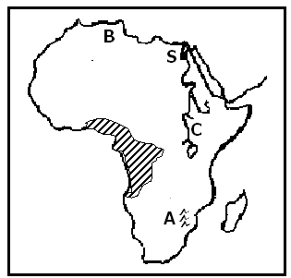
- Use the map of Africa below to answer the questions that follow.

Name the city marked S.

__________________________________________________________

Name mountain ranges marked A.

_________________________________________________________

c) Why does river marked C flow northwards?

___________________________________________________________

___________________________________________________________

d) Why are forests in area shaded ever green?
_____________________________________________________
- Sudan is one country in Africa that largely depends on irrigation farming.
- State any two advantages of growing crops by irrigation.
- ___________________________________________________________
- ___________________________________________________________
- Mention any two problems faced by farmers on the Gezira Irrigation
Scheme.
i) ___________________________________________________________
ii) ___________________________________________________________
- a) Give one reason why government provides social services to its people.
____________________________________________________________
____________________________________________________________
- Mention any two problems government faces as it provides social services
to its people.
i) ____________________________________________________________
ii) ____________________________________________________________
- What does the word development mean?
___________________________________________________________
___________________________________________________________

- a) How did Rwanda join the Common Wealth yet it was not colonized by
Britain?
____________________________________________________________
____________________________________________________________
b) Why were each of these countries at one time suspended from the
Common Wealth?
- South Africa: ________________________________________________
___________________________________________________________
- Nigeria : ____________________________________________________
__________________________________________________________
c) How does Uganda benefit from the activities of the Common Wealth?
___________________________________________________________
___________________________________________________________

- Study the picture below and use it to answer question 50.

B
A


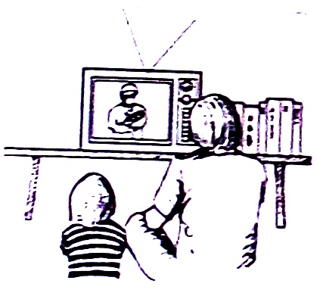

D
C

a) Which means of communication is shown in picture,
- A _____________________________________________________
- C _____________________________________________________
b) Why is communication means in picture D commonly used by most people
in Uganda today?
___________________________________________________________
___________________________________________________________
c) Give one disadvantage of the government would face if it uses
communication means C when sending information to its citizens.
__________________________________________________________
__________________________________________________________

For questions 51 to 55, answer either Christianity or Islamic but not both.
- Either:
a) What is the first sacrament according to Christianity?
___________________________________________________________
b) Mention the symbol for the mentioned Sacrament (in 51. a)
___________________________________________________________
c) State two benefits of the sacrament mentioned in (51. a)
- ___________________________________________________________
- ___________________________________________________________
Or:
a) What is the second pillar in Islam?
___________________________________________________________
b) Give any two ways Muslim believers benefit from this pillar.
- __________________________________________________________
ii) __________________________________________________________
c) How do believers prepare for this pillar?
__________________________________________________________

- Either:
a) Name the Prophet who survived floods.
__________________________________________________________
b) Why did God send floods?
__________________________________________________________
c) Why did the named Prophet (in 52. a) survive the floods?
__________________________________________________________
- How many people survived the floods?
__________________________________________________________
Or:
a) Name the Prophet who survived floods.
____________________________________________________________
b) Why did Allah send floods?
___________________________________________________________
c) Why did the named Prophet in (52.a) survive the floods?
____________________________________________________________
- How many people survived the floods?
____________________________________________________________

- Either:
a) Why did God give Commandments to the Israelites?
____________________________________________________________
b) Mention two greatest commandments of God as taught by Jesus Christ.
- ____________________________________________________________
ii) ___________________________________________________________
c) What was the last commandment that Jesus gave to his disciples?
___________________________________________________________
Or:
a) Give any two ways a Muslim should keep the Qur’an.
i) ___________________________________________________________
ii) ___________________________________________________________
b) Mention any two kinds of people who should not touch the Qur’an.
i) ___________________________________________________________
ii) ___________________________________________________________
- Either:
a) Who led the Israelites across R. Jordan?
__________________________________________________________
b) Why was it necessary for Moses to rescue the Israelites?
___________________________________________________________

- Why were the Israelites’ baby boys being killed by the authorities in
Egypt?
__________________________________________________________
__________________________________________________________
d) Where in Egypt were the Israelites staying?
__________________________________________________________
Or:
- Who led the Banu - Israelites across the Red Sea?
__________________________________________________________
b) Why was it necessary for Musa to rescue the Israelites?
__________________________________________________________
c) Why were the Israelites’ baby boys being killed by the authorities in
Egypt?
__________________________________________________________
d) Where in Egypt were the Israelites staying?
__________________________________________________________

FOR BOTH.
- Name the Prophet in Islam / Christianity remembered for;
- Deliverance: ______________________________________________
- Great rule of wisdom: ______________________________________
- Endurance and Perseverance: ________________________________
- Seal of Prophets: __________________________________________

GOOD LUCK

