

NAME: INDEX NUMBER: EMIS NUMBER: DISTRICT NAME:
SCIENCE SECTION A
- Give any one common root vegetable used in the preparation of sauce at home.

- How is the work of a switch different from that of a fuse in an electric circuit?

- Sanitation is the general cleanliness of an area. State any one material / item used in keeping the environment clean.

Maria’s parents put a potted plant in their sitting room as shown below
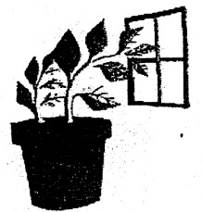
- What attracted the plant towards the window?

- State any one way in which people can use cow dung and animal urine at home.

- How is a guitar as a musical instrument different from the xylophones?

- Name any one problem of poor feeding that is common in many rich families in the city / urban areas.

- Apart from tree planting, identify any one income generating project at home.

- How are houseflies dangerous to the sense of sight?

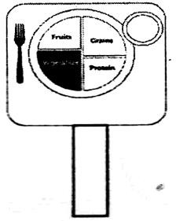
The sign post below was found in a school compound
- What does the message on the sign post encourage people in the school community to do?

- The water hyacinth is a weed that is dangerous on our lakes. State any one danger of this weed.
_
- How is comparing of prices a good factor to consider before spending money on any goods or services?

The diagram below shows a property of Air.

- 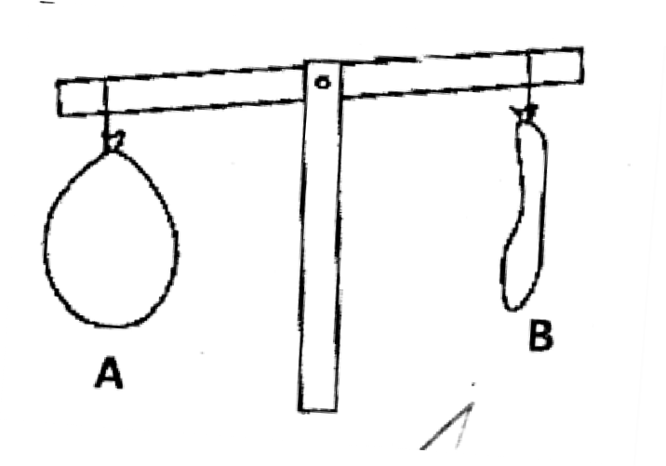Which of the balloons has more matter?

- Give any one advantage of lightning in the environment.

In the space provided below, draw a blood cell that is affected by Malaria parasites.

- Identify any one perennial crop in Uganda.

- There are four types of teeth in human beings. Name the two types which have a similar function.

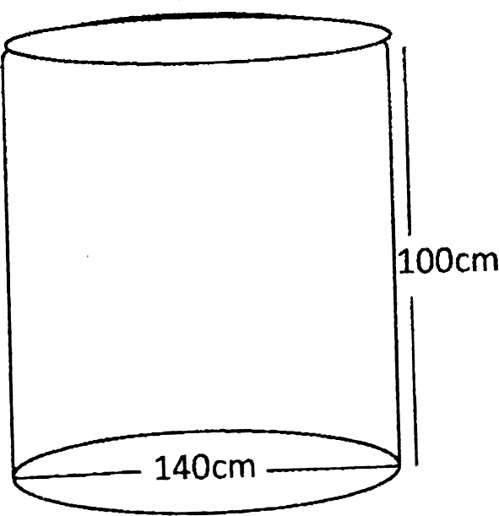
ii) The diagram below is of a cylindrical tank

- How many litres of water can fill the above tank to the brim?

- Identify the fungi that helps local people in our community in the brewing of alcohol from sugar and water.

- State any one economic importance of insects such as mosquitoes. houseflies, cockroaches and tsetse flies.

- State any one thing that can go wrong if we do not keep our bodies clean.

The diagram below shows the path of a soccer ball as it travels from Mess to Neymar Jr.
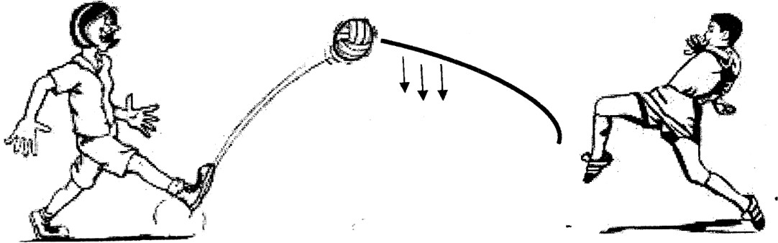
- Which force is represented by the arrows?

- State any one effect of deforestation to wild birds and animals.

- Name the instrument that you would best use to measure the volume of a liquid.

- In the space provided below, draw a seed dispersed by wind

- Give any one function of the stomach in humans.

- What is hibernation?

- There are several pests that attack and destroy root crops in our garden. State any one method of controlling such pests.

- State any one property of water

When a glass with cold water with ice was put on a table, water droplets were seen on the outside of the glass.
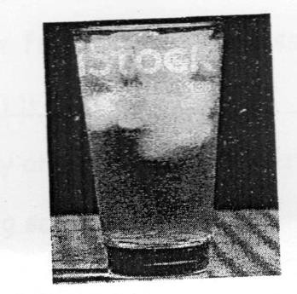
- Which process causes the water droplets on the outside of the glass?

- Give any one common use of shadows to people and other animals.

- In which state of matter is ghee at room temperature?

The diagram below is of a bean seed.

- 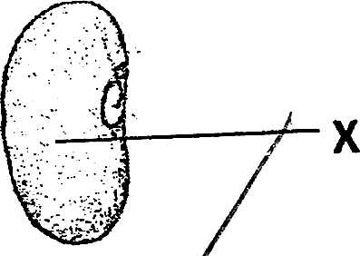Name the part marked X.

- State the type of weather that people usually manage by wearing gumboots.

- A safety pin is one common item found in a first aid box. Give any one use of this item when giving first aid.

- Identify the group of birds that commonly keep our environment clean and free from rotting carcasses.

- Identify any one life skill that may guard you against drug abuse in a boarding school.

- State any one difference between a frog and a toad.

- Give any one condition that influences the rate of transpiration in plants.

- Name the raw material from which local salt can be made.

SECTION B (60 MARKS)
- a) Give any two ways in which you can be involved in keeping the school environment clean.
  - _ ii)
b) Explain any one way school children can put to good use polythene bags that have been picked from the school compound.

 | c) |  | Why is it important for the sports teacher to plant grass in patched areas on the field or play ground?
42. | a) |  | What is the cause of the following immunizable diseases?  - Hepatitis B  _  - Haemophilus Influenza b.  _
 | b) |  | Name the major body organ that is affected by Hepatitis B.
 | c) |  | Which vaccine is given to babies to protect them against Haemophilus
 |  |  | influenza b?
 |  |  | _
43. | a)  b)  c) |  | There are several processes through which we prepare clean and safe water for drinking and washing.  Name any two of these processes.  i) ii) Identify any one common water impurity.  _  Why is it important for one to sort clothes before washing them?

- a) Give any one example of each of the following:-
  - antisocial behaviour
_
  - sexual deviations
_
b) Give any two community and health problems among young people today.

ii)

The diagram below shows a tool we use to keep ourselves clean
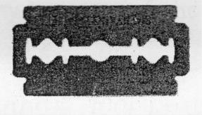
- How is the tool above used in keeping ourselves clean?
_
- In the absence of the above, what else can you use for the same task?
_
- State any two possible dangers of using the above tool at school.

- a) A girl used a plastic comb to make her long hair. Name the electricity she is likely to produce in the process.
_
- Name the installation in schools that is used to prevent the electricity in (a) above from killing students.

- Give any two ways in which electricity can be used to solve everyday problems.
  - ii)

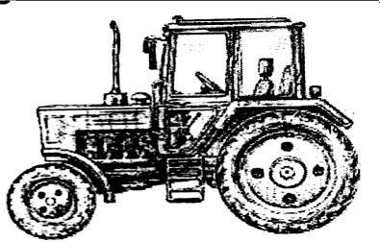
The diagram below shows a modern garden tool.
- Name it
- Give any two uses of the above tool on a farm.

- State any one advantage of the above compared to the other local tools.
_
- a) State any one similarity between coal and petroleum as energy resources.
_
  - Give any one use of each of the above energy resources to people.
    - Petroleum

    - Coal

  - Write down one use of biogas at home.
_
- a) State any two disadvantages of air.
  - _ ii)
- Why is it important for a family to harvest water?
_
- Mention any one danger of rain on soil
_
_
- a) Give any two domestic animals that neither give us milk nor meat.

- State any one importance of keeping any of the animals you have given in (a) above.

- Name one wild hoofed animal with an even number of toes.

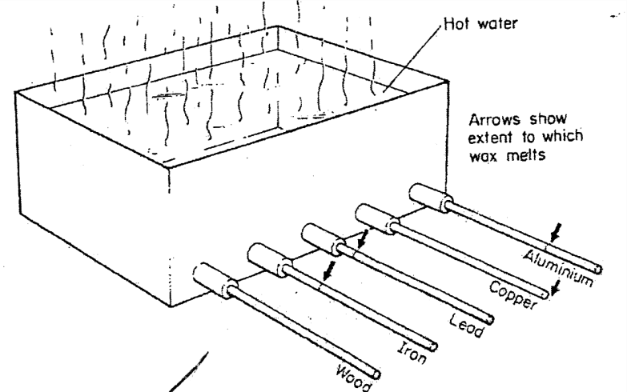
Rods made of different materials were fixed into a trough with hot water. The rods has wax on them and the arrows show the extent to which wax melts.

- Which of the rods is the best conductor of heat?

- Which rod is the lowest conductor of heat?
_
- What does the above experiment show?
_
- How do people in your community use conduction of heat to solve their day to day problems?

- Some people in Uganda keep rabbits to get income and meat.
- Give any two ways in which the farmers can keep these rabbits healthy i) _ ii)
- Why do farmers keep records about their rabbits on the farm?

- How can you care for any of the groups of people you have given in (b) above?
  - _

- a) Identify any one suitable lifestyle / good health practice done by individuals in your community.
_
- Name any two groups of people with special needs in your community.
  - _ ii)
- How can you care for any of the groups of people you have given in (b)
above?
_

The illustration below shows a food chain
Grass Caterpillar hen cat

- Which of the above living things is both a predator and a prey?
_
- What do the arrows represent in the illustration above?
_
- What general name is given to the caterpillar, hen and the cat in the illustration above?

- Why is grass said to be a producer?

- Respiration is necessary for human life
- Name any one end product and by-product of respiration
  - end-product

  - by-product

- State any one campaign you would participate in to keep other people’s respiratory systems in good working conditions.

- Identify one disorder of the respiratory system.
_

END

