PU PIL’S COMPLETE INDEX NUMBER
CITY/PROVINCE DISTRICT SECTOR SCHOOL STUDENT

Sur Name:.....................................................................................................
Other Name: .................................................................................................
DURATION: 2 HOURS
- This paper has two sections A and B
- Read each question carefully before answering it.
- Poor hand writing may led to loss of marks
- Use blue or black ball point pens
SECTION A
  - Name the type of bees which visit flower.
………………………………………………………………………………………………………………………………………
  - Which blood vessel takes away blood from the right ventricle of the heart?
………………………………………………………………………………………………………………….
  - Of what importance are cilia found in the trachea?
………………………………………………………………………………………………………
  - What is the main function of white blood cell in the body?
…………………………………………………………………………………………………………………………
  - Why milk is called a complete diet?
……………………………………………………………………………………………………………………..
  - What is the sense organ for tasting?
……………………………………………………………………………………………………………………
  - Give one use of electricity in our homes.
…………………………………………………………………………………………………………………..
  - What name is given to the three small bones found in the ear?
…………………………………………………………………………………………………………………..
  - Give one reason why is it important to give first aid?
……………………………………………………………………………………………………………………..
  - Write the function of iris in the human eye.
…………………………………………………………………………………………………………………….
  - Define respiration.
…………………………………………………………………………………………………………………………….
  - Give one process by which candle wax will be made to be melt by heat?
………………………………………………………………………………………………………………………..
  - How is government of Rwanda controlling the spread of polio?
………………………………………………………………………………………………………………………..
  - Which part of the skeleton protects the brain?
…………………………………………………………………………………………………………………….
  - Which blood group is universal donor?
……………………………………………………………………………………………………………………
  - A change from solid to gas is called…………………………………………………………
  - How does heat travel through light?
…………………………………………………………………………………………………………………………….
  - Give the function of the heart.
……………………………………………………………………………………………………………………………
  - Write AIDS in full.
……………………………………………………………………………………………………………………….
  - What vitamin do we get from the sun?
…………………………………………………………………………………………………………………….
  - Mention one use f roots to plant.
…………………………………………………………………………………………………………………..
  - What does a fish use for breathing?
……………………………………………………………………………………………………………………………
  - How is mulching important to farmers?
………………………………………………………………………………………………………………………..
  - The natural source of water is……………………………………………………………………………..
  - Water change into ice that process is called…………………………………………………………….
  - Why is a moon not a true source of light?
…………………………………………………………………………………………………………………………..
  - What is a flower?
…………………………………………………………………………………………………………………………..
  - What is a seed?
…………………………………………………………………………………………………………………………
  - What is a fruit?……………………………………………………………………………………………………………………..
  - Which type of gas plants breath out?
…………………………………………………………………………………………………………………………….
  - Which group of mammals do cat belong?
………………………………………………………………………………………………………………………….
  - What are cash crops?
…………………………………………………………………………………………………………………………..
  - Explain the grafting.
………………………………………………………………………………………………………………………….
  - What is advertising?
………………………………………………………………………………………………………………….
  - Give one reason why people plant trees around the houses.
………………………………………………………………………………………………………………………..
SECTION B
  - Name the parts of the skin.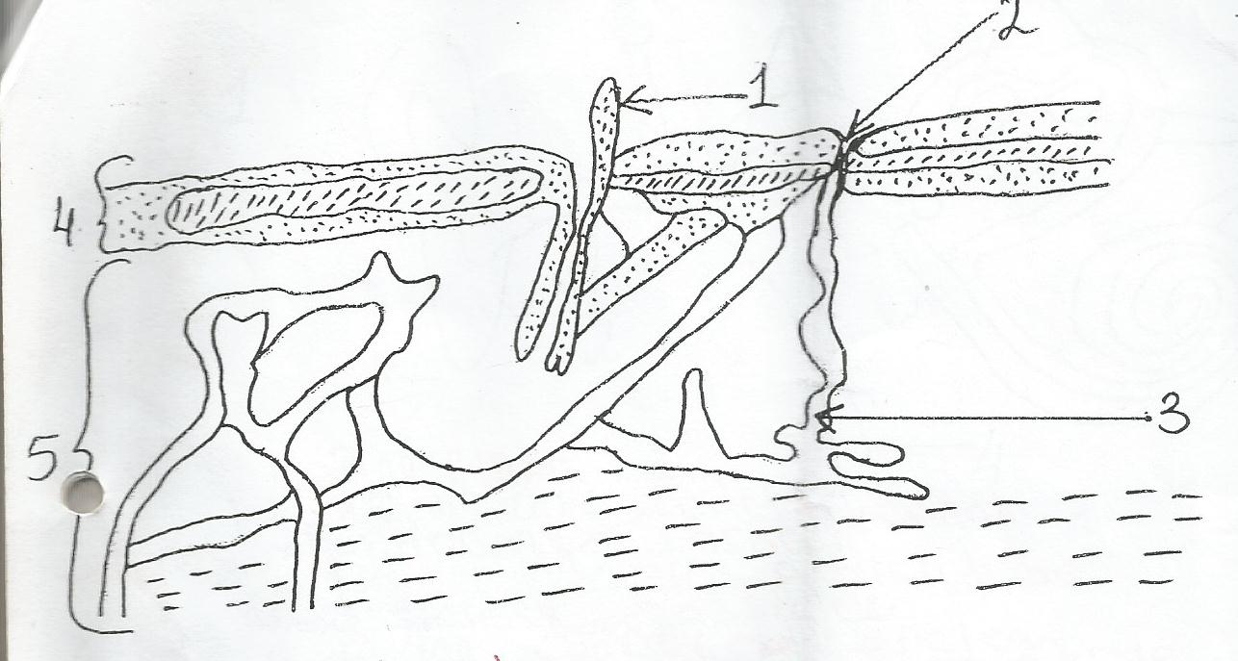
1……………………………………………………………
2……………………………………………………………
3………………………………………………………….
4………………………………………………………..
5……………………………………………………….
  - Show is the process involved in water cycle.
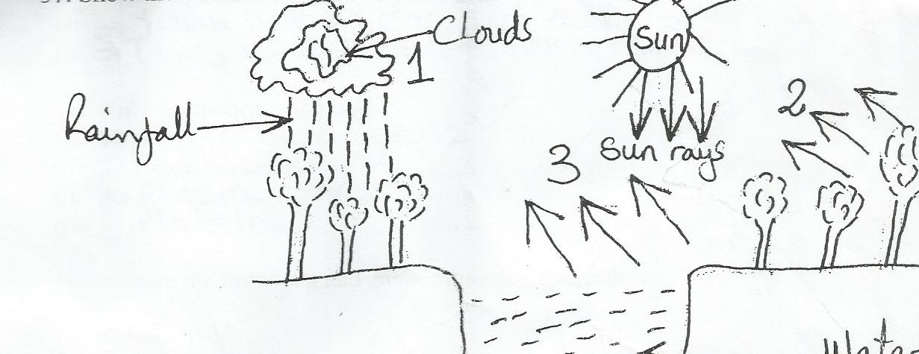

1………………………………………………………………………
2……………………………………………………………………..
3……………………………………………………………………
38.Use the human ear diagram to answer the parts.
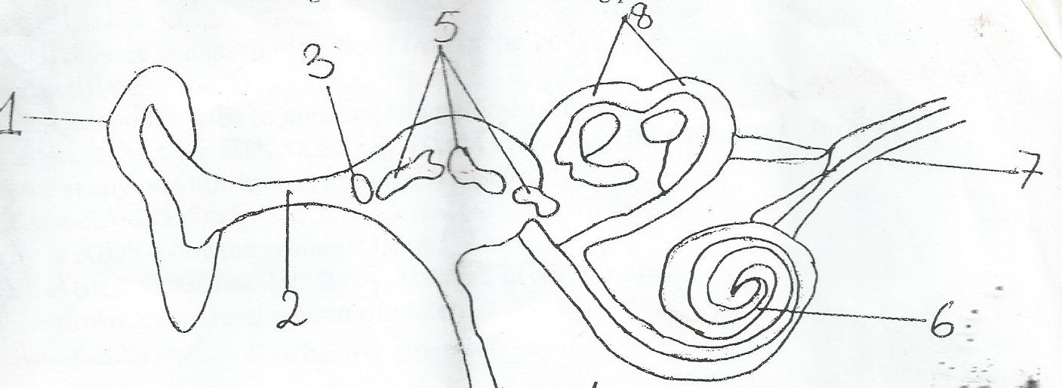
1……………………………………………………….
2………………………………………………………..
3……………………………………………………..
4……………………………………………………………
5……………………………………………………………
6………………………………………………………………….
7…………………………………………………………………………
8………………………………………………………………………
  - Give two methods of advertising goods.
i…………………………………………………………..……ii……………………………………………………….
  - Give two effects of advertising goods.
i………………………………………………………….…….ii…………………………………………………………………….
  - Write four components of blood.
i……………………………………………………………ii……………………………………………………………..
ii…………………………………………………………..iv………………………………………………………….
  - What is the temperature of normal person?
………………………………………………………………………………………………………………………….
  - Mention the virus that causes AIDS.
……………………………………………………………………………………………………………………………..
  - When a bone break and comes out of the skin is called…………………………………………….
  - What name is given to anything that burn and give heat and light?
…………………………………………………………………………………………………………………………………
  - Why are flat iron handles made of wood or plastics?
…………………………………………………………………………………………………………………………………….
  - Give one example of alcoholic beverages.
……………………………………………………………………………………………………………………………….
  - What is the work of the cortex?
……………………………………………………………………………………………………………………………….
  - In which state of matter does sound travel faster?
……………………………………………………………………………………………………………………………..
  - Why is AIDS a day today major issue?
…………………………………………………………………………………………………………………………………
  - Mention one nutritional deficiency disease.
……………………………………………………………………………………………………………………………………
  - Which disease is caused by lack of iron in the body?
…………………………………………………………………………………………………………………………………
  - Which method is used to measure the volume of irregular objects?
…………………………………………………………………………………………………………………………………..
  - Define the term matter.
…………………………………………………………………………………………………………………………………………
b)Name three states of matter.
i…………………………………………………………………….ii……………………………………iii………………………………..
  - Define the term sound
………………………………………………………………………………………………………………………………
b)Outlineone artificial source of sound.
…………………………………………………………………………………………………………………………………..
c)State one device which can store sound.
………………………………………………………………………………………………………………………………….
d)How is sound produced?
…………………………………………………………………………………………………………………………………..
e)Define the following terms in sound
Pitch…………………………………………………………………………………………………………………………..
Echo …………………………………………………………………………………………………………………………
f)Give one importance of echo.
………………………………………………………………………………………………………………………………….
g)Sound travel by means of……………………………………………………………………………………

  - What is a magnet?
………………………………………………………………………………………………………………………………….
b)State any one material attracted by magnet.
…………………………………………………………………………………………………………………………………
c)State three properties of magnets.
  - Write five stages of digestion in human being.
i………………………………………………………………ii………………………………………………………….........
iii…………………………………………………………….iv……………………………………v…………………………..
  - Name three stages of life cycle of coca roach
i……………………………………………………….…..ii…………………………………………………….
iii………………………………………………………………………………………………..
  - Name the stage of housefly which is dormant.
……………………………………………………………………………………………………………………….
  - What is digestion?
………………………………………………………………………………………………………………………..
b)Name two types of digestion.
i……………………………………………………………ii………………………………………………..
c)Where does absorption of water take place?
………………………………………………………………………………………………………………..
  - Why is a mosquito regarded as a vector?
………………………………………………………………………………………………………………..

END

