SECTION A
- Name the gas which occupies the largest percentage in the atmosphere.
_______________________________________________________________________
- Name the advantage of breast feeding to mother.
_______________________________________________________________________
- Give one reason why a bulb may fail to light.
_______________________________________________________________________
- In which way is a dirty environment harmful to man?
_______________________________________________________________________
_______________________________________________________________________
- Why is food digested in the human body?
_______________________________________________________________________
______________________________________________________________________
- Which vaccine is administered on the right upper arm?
_______________________________________________________________________
- Why is the earth referred to as a natural magnet?
_______________________________________________________________________
_______________________________________________________________________
- Which structure in the foot of a duck enables it to swim in water?
_______________________________________________________________________
- How do plants benefit from others?
_______________________________________________________________________
_______________________________________________________________________
- State one way you can reduce the risk of getting malaria in your bedroom.
_______________________________________________________________________
- Give one example of a root tuber.
_______________________________________________________________________
- Why is blood pumped to the lungs before it is circulated to all body parts?
_______________________________________________________________________
_______________________________________________________________________
- Give one example of animals that move by leaping.
_______________________________________________________________________
- Mention any one natural source of sound in the environment.
_______________________________________________________________________
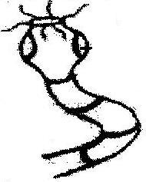
- Identify the type of worm shown below.
___________________________________________
___________________________________________

- Which health habit is practiced by most people after visiting a latrine?
_______________________________________________________________________
______________________________________________________________________
- State any one advantage of using electricity over wood fuel.
_______________________________________________________________________
- Which type of movable joint allows movement in all direction?
_______________________________________________________________________
______________________________________________________________________
- Apart from water, give other condition required for rusting of metals.
_______________________________________________________________________
- Give one example of a ruminant animal.
_______________________________________________________________________
- How can a P.7 candidate find the volume of a mango fruit?
_______________________________________________________________________
_______________________________________________________________________
- How does bathing with soap help to control skin diseases?
_______________________________________________________________________
_______________________________________________________________________
- Give one local breed of cattle.
_______________________________________________________________________
- State one way in which a short circuit can be dangerous.
_______________________________________________________________________
- Identify one way a pupil can help to improve sanitation in a class.
_______________________________________________________________________
- Why is smoking of cigarette dangerous to human health?
_______________________________________________________________________
_______________________________________________________________________
- In which state of matter does sound travel fastest?
_______________________________________________________________________
- State any one method of weed control.
_______________________________________________________________________
- Mention one item you can use to keep your body clean.
_______________________________________________________________________
- Which property of magnet is shown in the diagram below?
______________________________________________________________________

- How does the fish help on the prevention of Kwashiorkor in children?
_______________________________________________________________________
- State the farm animal which is affected by the ear cancer.
_______________________________________________________________________
- Give the importance of collecting plastic materials in the environment.
_______________________________________________________________________
- State an advantage of a VIP latrine over convectional pit latrine.
_______________________________________________________________________
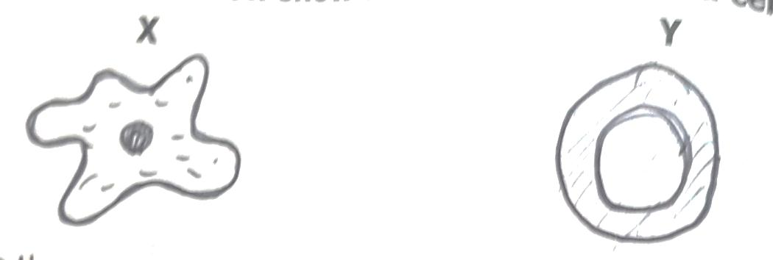
Use the diagram below to answer the questions that follow.

- Which sexually transmitted diseases destroy blood cell Y?
_______________________________________________________________________
- Name the blood cells x.
_______________________________________________________________________
- Give any one way of preventing the spread of scabies.
_______________________________________________________________________
- How does a fuse work?
_______________________________________________________________________
_______________________________________________________________________
- In which state of matter is chalk?
_______________________________________________________________________
- How does man use animals as energy resource?
_______________________________________________________________________
_______________________________________________________________________

SECTION B (60 MARKS)
- (a) In which way is heat energy similar to light energy?
_______________________________________________________________________
_______________________________________________________________________
- How is Sound produced?
_______________________________________________________________________
- What is the difference between volume and pitch of sound?
_______________________________________________________________________
_______________________________________________________________________

- Name the organ in mammals which detects sound waves.
_______________________________________________________________________
- (a) State one reason why some farmers prefer keeping goats to cattle.
_______________________________________________________________________
- Give one dairy breed of goats.
_______________________________________________________________________

- Mention any one disease which attacks goats.
_______________________________________________________________________
- Give the importance of housing goats.
_______________________________________________________________________

- Below is a structure of an egg. Use it to answer the questions that follow.
Q
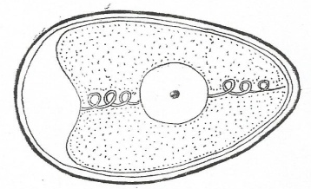
S
T

R

- Name the part marked T.
_______________________________________________________________________
- Give the function of part R.
_______________________________________________________________________
- Why is part Q porous?
_______________________________________________________________________
- Which part of an egg grows into a chick?
_______________________________________________________________________
- (a) What do the following animals use to protect themselves against their enemies?
- Wasp _______________________________________________________
- Cat _______________________________________________________
- Caterpillar _______________________________________________________
- Cow _______________________________________________________
- (a) What type of pollination occurs in a flower with long filaments than the style?
_______________________________________________________________________
_______________________________________________________________________
- State two living agents of pollination.
- _______________________________________________________________________
- _______________________________________________________________________
- In which part of a flower does fertilization take place?
_______________________________________________________________________
- (a) State the basic unit for measuring the following;
- Mass _______________________________________________________
- Weight _______________________________________________________

- Give one reason why paraffin floats in water.
_______________________________________________________________________
- Mention any one object that sinks in water.
_______________________________________________________________________
- (a) A good house must have windows, ventilators and door. State the role of the following items in a house.
- Roof _______________________________________________________
- Window _______________________________________________________
- Doors _______________________________________________________
- Ventilators _______________________________________________________
- (a) What are communicable diseases?
______________________________________________________________________________________________________________________________________________
- Give one example of communicable diseases that affects.
- Eyes ____________________________________________________________
- Skin ____________________________________________________________
- Why is scurvy classified as a non-communicable disease?
_______________________________________________________________________
_______________________________________________________________________
- Match items in A with those in B.
A B
Pig byre
Fish nest
Cow water
Bird sty

- (a) Write STDs in full.
_______________________________________________________________________
- Give any two STDs caused by virus.
- _______________________________________________________________________
- _______________________________________________________________________
- How best can P.7 pupils prevent STDs?
_______________________________________________________________________
- (a) Give the meaning of photosynthesis.
_______________________________________________________________________
- Mention any two raw materials needed for photosynthesis.
- ______________________________________________________________________
- ______________________________________________________________________
- Which gas is given off during photosynthesis?.
_____________________________________________________________________

- The diagram below shows changes of states of matter. Study it carefully and
answer the questions that follow.

D
A
C
B
E

- Name the processes A and E.
A _________________________________________________________________
E _________________________________________________________________
- What type of change is shown above?
______________________________________________________________________
- State the effect of heat on matter.
______________________________________________________________________
- A skeleton has many roles in the human body including protection.
- Name any one body organ protected by;
- Rib cage _______________________________________________________
- Vertebral column _______________________________________________________
- Mention the diseases which affect both the skeleton and respiratory system.
______________________________________________________________________
- How can you maintain skeletal and muscular system in a good working condition?
______________________________________________________________________
- (a) What type of venation does rice have?
_______________________________________________________________________
- How does germination of a bean plant differ from that of rice?
______________________________________________________________________
______________________________________________________________________
- State the similarity between a bean plant and rice.
____________________________________________________________________________________________________________________________________________
- What food value does one get from eating rice?
______________________________________________________________________

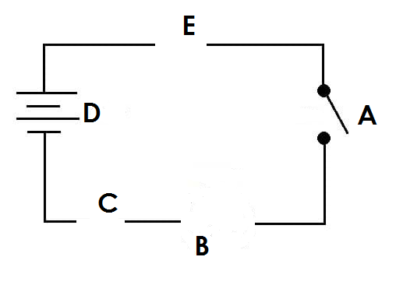
- Use the diagram of a simple circuit below to answer the questions that follow.



- Name the parts marked C and E.
C ____________________________________________________________________
E ____________________________________________________________________
- What happens to B when A is closed?
______________________________________________________________________
- How does E safe guard the appliances?
______________________________________________________________________

END

