KAMPALA JUNIOR SCHOOLS
TERM I 2020
SCIENCE FOR P.7 SET 2
Time allowed: 2 hours 15 minutes

Name: …………………………………………………………………………………………….

Class: ……………………………………………………………………………………………
FOR EXAMINERS’ USE ONLY

Read the following instructions carefully:

- The paper has two sections: A and B.
- Section A has 50 questions (50 marks)

- Section B has 5 questions. (50 marks)

- Answer all questions. All answers to both sections A and B must be written in the spaces provided.

- All answers must be written using a blue or black ball point pen or ink. Diagrams should be drawn in pencil.

- Unnecessary alteration of work may lead to loss of marks.

- Any handwriting that cannot easily be read may lead to loss of marks.

- Do not fill any thing in the boxes.
They are for examiners’’ use ONLY

FOR EXAMINERS’ USE ONLY
Qn No. | MARKS | SIGN
1 – 10
11 – 20
21 – 30
31 – 40
41 – 50
51
52
53
54
55
TOTAL

SECTION: A
- Give one example of crops which are grown from suckers.
…………………………………………………………………………………………………………………
- Name the best soil for farming.
…………………………………………………………………………………………………………………
- What poultry vice is controlled by debeaking?
………………………………………………………………………………………………………………..
- Give one example of a dicotyledonous plant.
………………………………………………………………………………………………………………..
- Which part of blood is affected by malaria?
………………………………………………………………………………………………………………..
- Name any one disease vector.
………………………………………………………………………………………………………………..
- What state of matter transmits sound waves fastest?
………………………………………………………………………………….………….…………………
- Which killer disease is said to be water borne disease?
…………………………………………………………………………………………………..……………
- Write down any one type of sound.
………………………………………………………………………………………………………………..
- Why is a bat not regarded as a bird?
………………………………………………………………………………………………………………..
- Name one example of amphibian.
………………………………………………………………………………………………………………..
- Which part of the ear is responsible for balance and posture?
………………………………………………………………………………………………………………..
- Mention one disease which is prevented by DPT vaccine.
………………………………………………………………………………………………………………..
- Write down any one example of a percussion music instrument.
………………………………………………………………………………………………………………..
- How is a fish similar to a tadpole?
………………………………………………………………………………………………………………
- Which gas is given off as a waste product during photosynthesis?
…………………………………………………………………………………………………………………
- How is an eagle bird adapted to its feeding habit?
………………………………………………………………………………………………………………..

- What are the female reproductive cells of a flower?
………………………………………………………………………………………………………………..
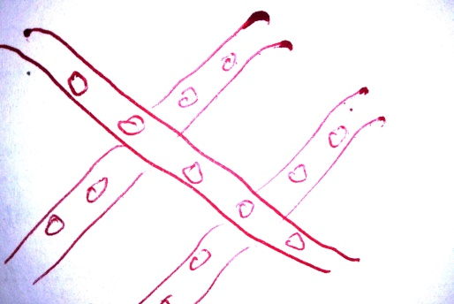
- Name the amphibian that lays eggs as shown below.

- Name one example of gnawing mammal.
………………………………………………………………………………………………………………..
- Name one type of food mostly required by workers in construction.
……………………………………………………………………………………..
- Why do insects visit flowers?
………………………………………………………………………………………………………………..
- How is a swim bladder useful to a fish?
………………………………………………………………………………………………………………..
- Apart from eyes, name any one sense organ of man.
…………………………………………………………………………………………………………………
- Give one use of cow dung to farmers.
…………………………………………………………………………………………………………………
- Why is it bad to cut off your finger nails using teeth?
…………………………………………………………………………………………………………………
- State one use importance of prescription of drugs.
………………………………………………………………………………………………………………..
- Why is it bad to put off petrol fire using water?
………………………………………………………………………………………………………………..
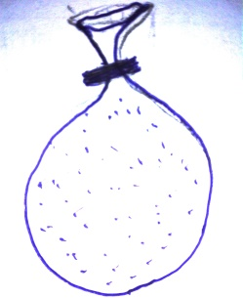
- Name the property of air shown below.

- Name one example of a non-renewable resource.
………………………………………………………………………………………………………………..
- Name one condition necessary for seed germination.
………………………………………………………………………………………………………………..
- Identify one disorder of the digestive system.
………………………………………………………………………………………………………………..
- A stone of mass 12gm completely sinks in water. If its density is 3gm/cc. find its volume.
………………………………………………………………………………………………………………..
- Name one type of germination.
………………………………………………………………………………………………………………..
- What element of PHC is practiced when children receive BCG vaccine?
………………………………………………………………………………………………………………..
- How does heat from a fire place reach a person sitting one meter away?
………………………………………………………………………………………………………………..
- Why do farmers dip their cattle in acaricides.
………………………………………………………………………………………………………………..
- State a primary sex characteristic in boys that promotes multiplication of human beings.
………………………………………………………………………………………………………………..
- Which part of a VIP latrine is used to let out bad smelling air?
………………………………………………………………………………………………………………..
- Explain the way the process of process of photosynthesis makes the environment or atmosphere clean.
………………………………………………………………………………………………………………..
SECTION: B
- Write two effects of heat gain to objects.
- ………………………………………………………………………………………………………...
- …………………………………………………………………………………………………………
- What happens to water when it loses heat up to 0$°$ c?
……………………………………………………………………………………………………………
- Why do people who cook steamed matoke cover it with banana leaves during cooking?
……………………………………………………………………………….....................................
- Use the pie chart below to answer the questions that follow.
D0.97$\%$
A 21$\%$
C 0.03$\%$
78$\%$

a)Which gas supports germination?
………………………………………………………………………………………………………………..
- What is the percentage of the gas that stops burning?
…………….……..…………………………………………………………………………………………..
c).Name any two gasses in portion D.

- ……………………………………
- ……………………………………

- The table below shows a balanced diet. Complete the table.
(ii)
Beans
Greans
(iii)
(iv)
Honey
Vitamins
Proteins
(i)
Balanced diet

- ………………………………………..
- ………………………………………..
- ………………………………………. .

- ………………………………………...

- The table below shows a farm record. Use it to answer the questions that follow.
Date | Animal | Disease | Action taken.
28-08-22017 | Calf no.4 | Stomach pain | Provision of soft food
05-09-2017 | Sheep no.19 | Pneumonia | Treated with antibiotics
13-10-2017 | Cow no.6 | Foot and mouth | Buried the carcass
27-10-2017 | Cattle |  | Spraying with acaricides

a)Name the farm record above.
……………………………………………………………………………………………
b)Which animal was treated with tetracycline?
…………………………………………………………………………………………………………….
- Apart from burying the carcass, how else can foot and mouth infected animals be disposed?
……………………………………………………………………………………………………………..
- Which parasites are controlled using acaracides?
……………………………………………………………………………………………………………
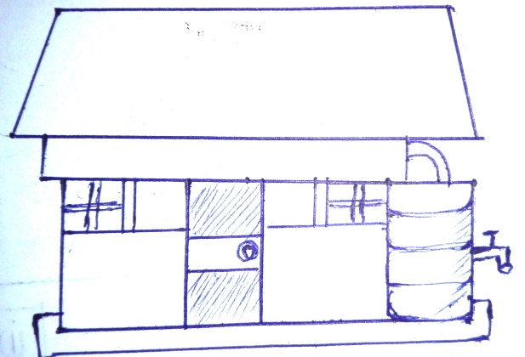
- The diagram below shows a way of harvesting water. Use it to answer the questions that follow.

X

a)Name the material used to make part X.
…………………………………………………………………………………………………………
b)What is the main source of water in the diagram above?
……………………………………………………………………………………………………………..
- How can the water from the above source be made safe for drinking?
………………………………………………………………………………………………………….
- Which vector is likely to breed in the part marked X?
…………………………………………………………………………………………………………
- Apart from green manure and farm yard manure. Name any other type of manure.
………………………………………………………………………………………………………….
- Mention any two materials used to make the above type of manure.
- ……………………………………………………………………………………………………
- ……………………………………………………………………………………………………
- Why is water added to the above type of manure?
…………………………………………………………………………………………………………….
- a) Name the type of soil with the finest particles.
……………………………………………………………………………………………………………
b) Mention any two uses of the above type of soil
- ……………………………………………………………………………………………………
- ……………………………………………………………………………………………..........
- Which component of soil supports germination?
……………………………………………………………………………………………………………
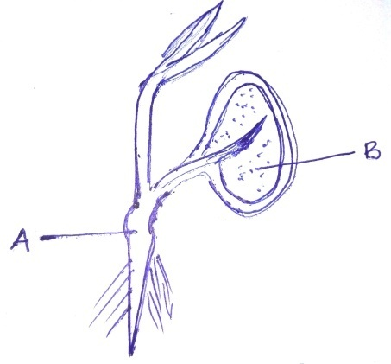
- The diagram below shows a germinating bean seed. Study it carefully and use it to answer the questions that follow.

a)Name the part marked with letter A.
….………………………………………………………………………………………………………..
b)What is the function of the part marked B at this stage?
……………………………………………………………………………………………………………
- Which part of a bean seed develops into a new plant?
……………………………………………………………………………………………………………
- Give one difference between the type of germination shown above and that of a maize grain.
…………………………………………………………………………………………………………….
- a) What is drug abuse?
………………………………………………………………………………………………………………
b)Name any one common example of drug dependence.
….……………………………………………………………………………………………………………
- State one effect of drug dependence on the society.
……………………………………………………………………………………………………………
- What is the major cause of child poisoning in families?
…………………………………………………………………………………………………………….

- Match the items in A with the correct ones in B
A B
Hydrometer strip cup
Hygrometer conception
Uterus Density of liquids
Mastitis Humidity
- Hydrometer …………………………………………………………
- Hygrometer ………………………………………………………….
- Uterus …………………………………………………………
- Mastitis …………………………………………………………

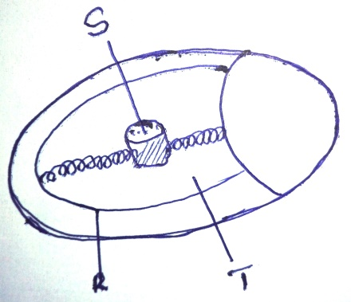
- The diagram below shows a fertilized egg of a hen. Carefully use it to answer the questions that follow.

- Name the part marked S.
…………………………………………………………………………………………………………………
- What is the function of the part marked T.
………………………………………………………………………………………………………………
- Besides protection, state any one other function of part marked R.
……….………………………………………………………………………………………………………
- Why would an egg from a layer not hatch into a chick after incubation?
……………………………………………………….……………………………………………………..
- Give the two vaccines given to babies at birth.
- ………………………………………………………………………………………………………
- ………………………………………………………………………………………………………
- At what age is a child immunized against measles.
…………………………………………………………………………………………………………………
- How is the vaccine for Polio administered?
……………………………………………………………………………………………………………
- What does the term dehydration mean?
………………………………………………………………………………………………………………..
b)Name one major cause of dehydration in babies.
…………………………………………………………………………………………………………
- Give two common signs of dehydration in babies.
- ……………………………………………………………………………………………………
- ……………………………………………………………………………………………………
- a)Name the liquid food component from goats that protects young children from kwashiorkor.
.................................................................................................................................................
- How supportive are goats to the leather industry?
………………………………………………………………………………………………………..……….
- Why are goats not termed as omnivorous?
……………………………………………………………………………………………………………..
- Suggest one waste from goats that is beneficial to soil.
……………………………………………………………………………………………………………..
- Rewrite the steps taken when making ORS correctly.
- Stir the mixture until salt and sugar dissolve.
- Measure one liter of clean water and put in a clean container.
- Wash your hands with clean water and soap.
- Measure eight level tea spoonfuls of sugar and add one spoonful of salt and add them to the measured water.
- ………………………………………………………………………………………………………….
- ………………………………………………………………………………………………………….
- ………………………………………………………………………………………………………….
- ………………………………………………………………………………………………………….

