KAMPALA JUNIOR SCHOOLS
TERM I 2020
SCIENCE FOR P.7 SET 3
Time allowed: 2 hours 15 minutes

Name: …………………………………………………………………………………………….

Class: ……………………………………………………………………………………………
FOR EXAMINERS’ USE ONLY

Read the following instructions carefully:

- The paper has two sections: A and B.
- Section A has 50 questions (50 marks)

- Section B has 5 questions. (50 marks)

- Answer all questions. All answers to both sections A and B must be written in the spaces provided.

- All answers must be written using a blue or black ball point pen or ink. Diagrams should be drawn in pencil.

- Unnecessary alteration of work may lead to loss of marks.

- Any handwriting that cannot easily be read may lead to loss of marks.

- Do not fill any thing in the boxes.
They are for examiners’’ use ONLY

FOR EXAMINERS’ USE ONLY
Qn No. | MARKS | SIGN
1 – 10
11 – 20
21 – 30
31 – 40
41 – 50
51
52
53
54
55
TOTAL

SECTION: A
- State any one reason why a first aid kit is important during the school’s athletics completion.
…………………………………………………………………………………………………………………
- What is the use of small stones in the food of birds?
…………………………………………………………………………………………………………………
- What is the use of root hairs to a plant?
………………………………………………………………………………………………………………..
- What is the main method through which AIDs can be spread from one person to another?
………………………………………………………………………………………………………………..
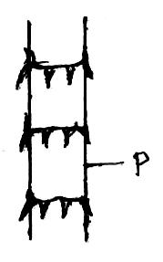
- Below is a sugar cane stem

What is the importance of part P to a plant?
………………………………………………………………………………………………………………..
- In which harmful way is a mosquito similar to a housefly?
………………………………………………………………………………………………………………..
- How does mulching control soil erosion in a garden?
……………………………………………………………………………………………
- Mention one danger of throwing polythene bags in gardens.
……………………………………………………………………………………………
- Name one reptile in Uganda that lives both on land and in water.
………………………………………………………………………………………………………………..
- The school administration put dustbins in each classroom. Of what importance is this to the sanitation of the school?
………………………………………………………………………………………………………………..
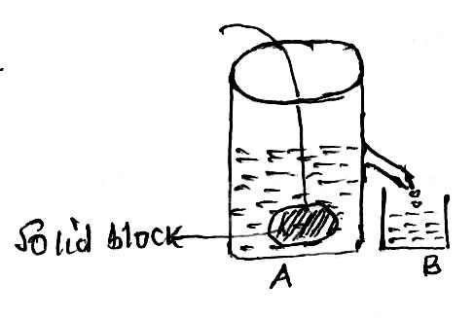
A solid block was lowered into an overflow can with water as shown. The displaced water was collected in a cylinder B. use the information given to answer questions 11 and 12.

- In the diagram what does the water in B equal to?
………………………………………………………………………………………………………………..
- How would you confirm your answer in question 11?
………………………………………………………………………………………………………………..
- Why must babies be introduced to other foods other than breast milk after the age of 4 months?
………………………………………………………………………………………………………………..
- How long is the gestation period of an Ewe.
………………………………………………………………………………………………………………..
- Why are gaps left between the sections of railway lines?
………………………………………………………………………………………………………………
- What happens to the air we breathe in before it enters the lungs?
…………………………………………………………………………………………………………………
- Why should pit latrines be built far away from the water source?
………………………………………………………………………………………………………………..
- Aman facing a cliff, fires a pistol and he hears an echo after 6 seconds. If the speed of sound is 330m/sec. how far is the manfrom the cliff?

- Name any one common drug that causes dependency.
…………………………………………………………………………………………………………………
- Where in the human body does conception take place?
………………………………………………………………………………………………………………..
- Name the part of an insect which has the same function as the gills of a fish.
………………………………………………………………………………………………………………...
- How is the strip cup important to a dairyfarmer.
………………………………………………………………………………………………………………..
- What features enables a housefly to spread germs.
………………………………………………………………………………………………………………..

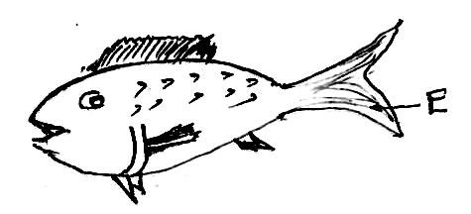
- How is part E useful to the Fish?

…………………………………………………………………………………………………………………
- Apart from protection, why does a chameleon change colour?
…………………………………………………………………………………………………………………
- Define the term drug abuse.
…………………………………………………………………………………………………………………
- In which part of a flowering plant does Osmosis take place?
………………………………………………………………………………………………………………..
- What process should one use to recover salt which has been dissolved in water.
………………………………………………………………………………………………………………..
- How does a tadpole differ from an adult frog in the way it takes in oxygen?
………………………………………………………………………………………………………………..
- Which element of primary health care helps to prevent deficiency diseases in children?
………………………………………………………………………………………………………………..
- How does a bat differ from all other mammals?
………………………………………………………………………………………………………………..
- Change $10 ℃$ to the Fahrenheit scale.

………………………………………………………………………………………………………………..
- Which gas is used for both germination and respiration?
………………………………………………………………………………………………………………..
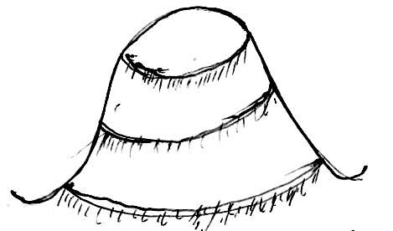
- The diagram below shows a type of environment. Mention one natural hazard that can lead to degradation in such area.

………………………………………………………………………………………………………………..
- Mention the secondary sex characteristic which takes place in both boys and girls.
………………………………………………………………………………………………………………..
- How has the discovery of solar energy helped to conserve the natural environment?
………………………………………………………………………………………………………………..
- What is the best way of protecting cattle from foot and mouth disease?
………………………………………………………………………………………………………………..
- Give the reason why cross breeding is important in dairy farming.
………………………………………………………………………………………………………………..
- Apart from a child health card, how else can one tell that a child was immunized against measles?
………………………………………………………………………………………………………………..
- A stone whose mass is 36kg was dropped in a water container and it displaced water whose volume measured 3 liters, find the density of the stone.

SECTION: B
- Define the word poultry…………………………………………………………………………………..
……………………………………………………………………………………………………………….
b)Name the most common system of rearing poultry in Uganda.
………………………………………………………………………………………………………………..
- Give any two examples of poultry vices.

- …………………………………………
- …………………………………………

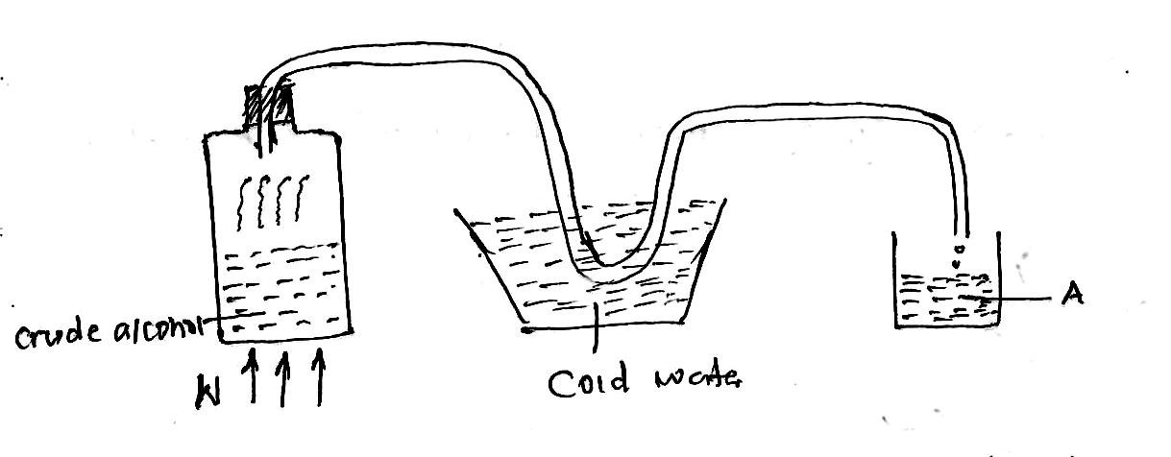
- Study the diagram below and answer the questions that follow.

a)What method of making alcohol is shown in the diagram above?
………………………………………………………………………………………………………………..
- State the importance of cold water in the diagram.
…………….……..…………………………………………………………………………………………..
c).Name the substance collected at A.
……………………………………………………………………………………………………………….
- Give one form of energy produced at part w.
……………………………………………………………………………………………………………….
- a)Write VIP in full in relation to sanitation.
……………………………………………………………………………………………………………….
b) Give two advantages of using a VIP latrine over an ordinary latrine.
……………………………………………………………………………………………………………….
- What is the recommended distance a pit latrine should be from a public well?
……………………………………………………………………………………………………………….
- Study the table below and use it to answer the questions that follow.
W | X | Y | Z
Snail | Python | Rat | Toad

a)In which way are animals X,Y and Z similar
……………………………………………………………………………………………………………
b)How does reproduction of animal Y differ from that of the other animals?
…………………………………………………………………………………………………………….
- To which class of animals does animal X belong?
……………………………………………………………………………………………………………..
- How does animal W protect itself against enemies?
……………………………………………………………………………………………………………..
- a)Give the difference between a burn and a scald.
…………………………………………………………………………………………………………
b)Mention one cause of burns at home.
……………………………………………………………………………………………………………
- How can burns and scalds be avoided?
………………………………………………………………………………………………………….
- What first aid would you give someone with a fist degree burn?
………………………………………………………………………………………………………….
- What is dehydration? …………………………………………………………………………………..
……………………………………………………………………………………………………………..
- Give two causes of dehydration.
…………………………………………………………………………………………………………
- Identify any one sign of a dehydrated child.
…………………………………………………………………………………………………………
- Match the items in list A with those in list B correctly by completing the table below.
List A | List B
Measles vaccine | Right upper thigh
BCG | Mouth
Polio vaccine | Right upper arm
Polio Vaccine | Right upper thigh
DPT | Left upper arm

Measles vaccine ……………………………………….
BCG ………………………………………..
Polio Vaccine ………………………………………..
DPT ………………………………………..
- a)State one example of fungi.
….………………………………………………………………………………………………………..
b)In which one way are fungi similar to bacteria in a food chain?
……………………………………………………………………………………………………………
- State one economic importance of fungi.
……………………………………………………………………………………………………………
- Give one danger of fungi to human beings.
…………………………………………………………………………………………………………….

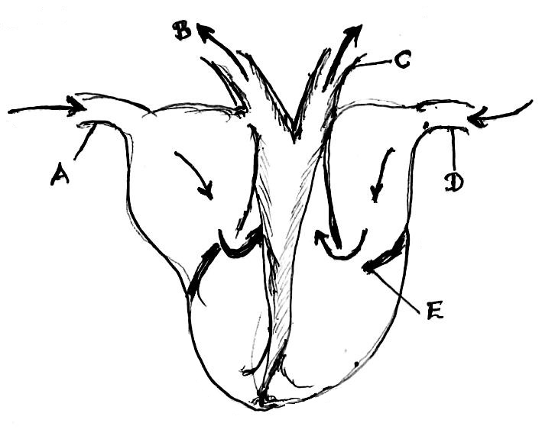
The diagram below is of a cross–section through the human heart and answer the questions that follow.
- (a) Name the blood vessel B in the diagram.
……………………………………………………………
b)What is the function of part E in the diagram?
….…………………………………………………………
- Why do you think the left ventricle is thicker than the right ventricle of the heart?
……………………………………………………………
- Write down the best way of keeping the above organ healthy.
……………………………………………………………
- What is soil erosion?................……………………………………………………………………………
……………………………………………………………………………………………………………..
- How is soil erosion a danger to the soil?
……………………………………………………………………………………………………………
- State the importance of terracing. ……………………………………………………………………………………………..………….
- Why should farmers adopt correct farming methods?
…………………………………………………………………………………………………………
- How does a guitar string produce sound when it is plucked?
………………………………………………………………………………………………………………
- Why is it that during thunderstorm, we see light before hearing thunder?
………………………………………………………………………………………………………………
- State any two devices used to store sound for future use.
i) ……….…………………………………… ii) ………………………………………………………
- Why are bees called social insects?
………………………………………………………………………………………………………………..
- List down any two characteristics of insects pollinated flowers.
- ……………………………………………………………………………………………………………
- ……………………………………………………………………………………………………………
- Which type of bee is responsible for collecting pollen grains from the flowers?
……………………………………………………………………………………………………………
- The diagram below is of a pit latrine. Study it and answer the questions about it.
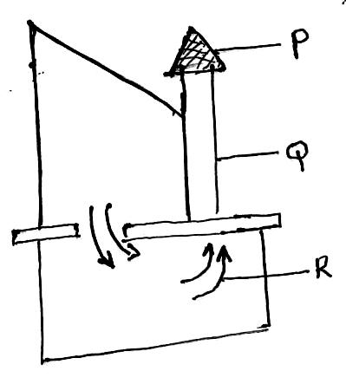
- Name the part marked Q.
……………………………………………………………
- State the function of the part marked P.
………………………………………………………………………
- The arrows marked R show movement of air inside the pit latrine. By what process does air move into and out of the pit of the latrine.
………………………………………………………………………
- Why is it not advisable to use disinfectants very often while cleaning the pit latrine?
………………………………………………………………………
- The diagram shows a blood cell.
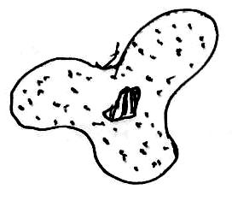
a)Name the blood cell.
................................................................................................
- What is its function?
……………………………………………………………………….
- Name the organism which has the same shape as this blood cell.
………………………………………………………………………
- Give any one disease which affects blood.
………………………………………………………………………
- a)Give two reasons why we should carry out first aid.
- …………………………………………………………………………………………………………….
- …………………………………………………………………………………………………………….
- Under what condition should a kiss of life be carried out during First Aid.
………………………………………………………….……………………………………………………..
- Why is it not good to put sugar on a burn?
…………………………………………………………………………………………………………………

