KAMPALA JUNIOR SCHOOLS
TERM I 2020
SCIENCE FOR P.7 SET 4
Time allowed: 2 hours 15 minutes

Name: …………………………………………………………………………………………….

Class: ……………………………………………………………………………………………
FOR EXAMINERS’ USE ONLY

Read the following instructions carefully:

- The paper has two sections: A and B.
- Section A has 50 questions (50 marks)

- Section B has 5 questions. (50 marks)

- Answer all questions. All answers to both sections A and B must be written in the spaces provided.

- All answers must be written using a blue or black ball point pen or ink. Diagrams should be drawn in pencil.

- Unnecessary alteration of work may lead to loss of marks.

- Any handwriting that cannot easily be read may lead to loss of marks.

- Do not fill any thing in the boxes.
They are for examiners’’ use ONLY

FOR EXAMINERS’ USE ONLY
Qn No. | MARKS | SIGN
1 – 10
11 – 20
21 – 30
31 – 40
41 – 50
51
52
53
54
55
TOTAL

SECTION: A
- Name the disease spread by a female anopheles mosquito.
…………………………………………………………………………………………………………………
- Write down the by-product of photosynthesis.
…………………………………………………………………………………………………………………
- What type of skeleton does a cockroach possess?
………………………………………………………………………………………………………………..
- Write down any one example of a plants fibre.
………………………………………………………………………………………………………………..
- The diagram below is of a leaf. Which group of plants have such leaf.
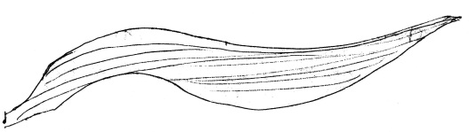
_______________________________

- Mention any one importance of blood in the human body.
………………………………………………………………………………………………………………..
- Write down one similarity between birds and mammals.
………………………………………………………………………………………………………………
- How useful is the pinna on the human ear.
………………………………………………………………………………………………………………..
- Suggest any one use of a strip cup on dairy farm.
………………………………………………………………………………………………………………..
- State the importance of saliva in the process of digestion
………………………………………………………………………………………………………………..
- Which element of P.H.C is promoted by sweeping the classroom?
………………………………………………………………………………………………………………..
- By what process odes smoke move up the chimney?
………………………………………………………………………………………………………………..
- Suggest how a primary six pupil can easily identify a poisonous snake.
………………………………………………………………………………………………………………..
- Using the formula:$℉=\left(℃×\frac{9}{5}\right)+32$. Convert 55$℃$ to $℉$

- Identify the mineral required for poultry to lay eggs with lard shells.
………………………………………………………………………………………………………………
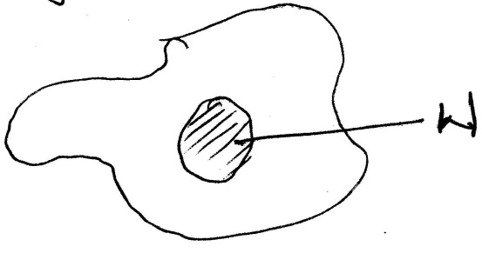
- The diagram below shows a blood cell. Use it to answer the questions that follow.

- How is the above cell important in the body?
……………………………………………………………………………………………………………
- Name part W of the drawn cell.
………………………………………………………………………………………………………………..
- How are the gills of a fish similar to the stomata of plants in funtion?
………………………………………………………………………………………………………………..
- How useful are physical exercises to school children?
………………………………………………………………………………………………………………..
- To which group of invertebrates do insects belong?
………………………………………………………………………………………………………………..
- How does a drum produce sound?
……………………………………………………………………………………..
- Write any one danger of mulching banana plantation.
………………………………………………………………………………………………………………..
- State any one process by which soil is formed.
………………………………………………………………………………………………………………..
- How are nostrils useful to a tilapia fish?
………………………………………………………………………………………………..
- How useful are leguminous plants in crop rotation cycle?
…………………………………………………………………………………………………………………
- Draw a simple leaf in the space provided.

- Give the reason why farmers keep Friesian cattle.
………………………………………………………………………………………………………………..
- State the use of chlorophyll during photosynthesis.
………………………………………………………………………………………………………………..
- Of what value are ventilators in a living room?
………………………………………………………………………………………………………………..
- Write one characteristic of wind pollinated flowers
………………………………………………………………………………………………………………..
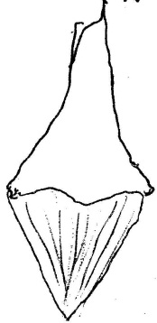
- Below is a type of tooth. Use it to answer questions 31 and 32
Name the type of tooth drawn above.

______________________________________________________________

- How is the above tooth adapted to its function?
………………………………………………………………………………………………………………..
- Write the use of a clinical thermometer to our school nurse
………………………………………………………………………………………………………………..
- Name the poisonous gas found in the tobacco smoke.
………………………………………………………………………………………………………………..
- Write down any one farm operation that can be carried out in a cattle crush.
………………………………………………………………………………………………………………..
- Mention any one drug that is commonly abused
………………………………………………………………………………………………………………..
- State how echoes are of great help to sailors.
………………………………………………………………………………………………………………..
- Briefly explain a “resource”.
………………………………………………………………………………………………………………..
- Name any one body organ that can be greatly affected by alcohol.
………………………………………………………………………………………………………………..
- State how earth worms improve on soil aeration.
SECTION: B
- a)Write a non-living component of the environment where crop growing is carried out.
………………………………………………………………………………………………………………..
- Mention any two types of soil.
- ………………………………………………………………………………………………………..
- ………………………………………………………………………………………………………..

- Suggest any one way of conserving soil as a resource.
……………………………………………………………………………….....................................
- a)Give any one example of a monocotyledonous seed.
………………………………………………………………………………………………………………..
- Briefly state what you know about venation and root system of a bean seed.
- Venation……..…………………………………………………………………………………………..
…………………………………………………………………………………………………………….
- Root system………………………………………………………………………………………………
…………………………………………………………………………………………………………….
c).Write down any one cereal that can be used in production of yeast locally.
……………………………………………………………………………………………………………
- a)Write two conditions needed for seed germination
- ……………………………………………………………………………………………………………
- ……………………………………………………………………………………………………………
b) Give a reason why photosynthesis takes place during day time.
- ……………………………………………………………………………………………………………
- ……………………………………………………………………………………………………………
- What is the end product of photosynthesis?
……………………………………………………………………………………………………………
- a)Write one way how a mammalian heart is useful.
………………………………………………………………………………………………………………..
b)Mention any two types of blood vessels.
- …………………………………………………………………………………………………………….
- …………………………………………………………………………………………………………….
- Name the type of blood carried by pulmonary vein.
……………………………………………………………………………………………………………..
- a)How does a moth promote multiplication of plants in an area?
…………………………………………………………………………………………………………………
…………………………………………………………………………………………………………………
b) Name two types of pollination.
- ……………………………………………………………………………………………………………
- ……………………………………………………………………………………………………………

- The table below shows different groups of vertebrates. Use it to answer the given questions.
A | B | C
Reptiles | Birds | Mammals

- To which group of vertebrates does each of the following belong?
- Penguin……………….…………………………………………………………………………………
- Bat………………………………………………………………………………………………………..
- Suggest one way in which the reproduction of animal in A is different to that of animal C
……………………………………………………………………………………………………………
- Write any other group of vertebrates missing from the drawn table.
…………………………………………………………………………………………………………….
- a) Why is a cassava plant referred to as root tuber?
……………………………………………………………………………………………………………
b) Name any other examples of a root tuber besides cassava.
……………………………………………………………………………………………………………
- How are roots propagated?
……………………………………………………………………………………………………………
- Identify any one common pest of root crops
……………………………………………………………………………………………………………
- a)How does water get contaminated?
….………………………………………………………………………………………………………..
b)Write two ways of keeping water safe from contamination.
- ……………………………………………………………………………………………………………
- ……………………………………………………………………………………………………………
- Identify any one example of water borne diseases caused by virus.
……………………………………………………………………………………………………………
- a) Write down one characteristic of seeds dispersed by animals.
- ……………………………………………………………………………………………………………
- ……………………………………………………………………………………………………………
b)Write down two agents of fruits dispersal.
- ……………………………………………………………………………………………………………
- ……………………………………………………………………………………………………………
- Cite out one advantage of a fruit and seed dispersal.
……………………………………………………………………………………………………………

- The chart below shows the percentages of different gases that make up air.
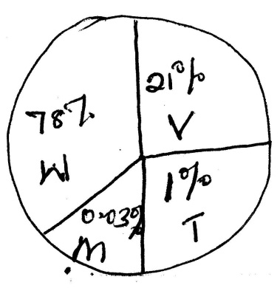
- Name the gases marked with letters.
T…………………………………………………………………
V…………………………………………………………………
- How is gas marked with letter M useful to man?
……………………………………………………………………
- Which letter shows the gas which helps to improve on soil fertility? ………………………………………………………………………….
- Match the items in A with those in B
 | A | B
a) | Auditory nerve | Amplifies sound waves
b) | Ear drum | Balances the air pressure between the two sides of the drum
c) | Eustachian tube | Balances the body
d) | Semi-circular canals | Takes nerve signals to the brain

- Auditory nerves …………………………………………………………………………………………
- Ear drum……….…………………………………………………………………………………………
- Eustachian tube…………………………………………………………………………………………..
- Semi-circular canals………………………………………………………………………………………
- a) Name the structure where chick between 1 day and 8 weeks are given special care.
- Suggest two items that are provided to chick in the above named structure.
- ……………………………………………………………………………………………………………
- ……………………………………………………………………………………………………………
- Name any two conditions needed for the process above to take place.
- ……………………………………………………………………………………………………………
- ……………………………………………………………………………………………………………
- In case the chicks looked after in the above structure were broilers, why does a farmer rear them?…………………………………………………………………………………………………….

- The diagram of a fish. Use it to answer questions that follow.
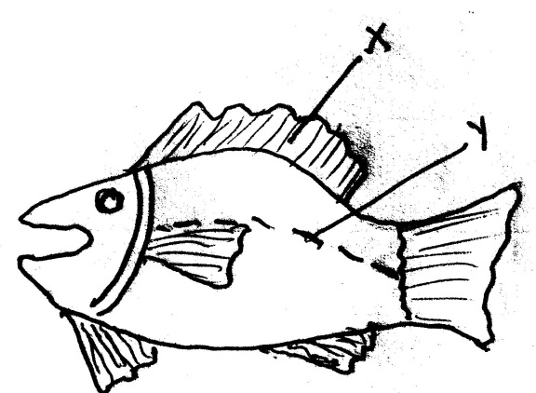
- Name the parts of a fish marked with letter
- X…………………………………………………………
- Y…………………………………………………………
b)Which food value is got from the animal show above?
…………………………………………………………………………………………………………
- How useful are the gills to a fish?
…………………………………………………………………………………………………………
- a)What is dehydration?............................................................................................................
.................................................................................................................................................
- Write down any two signs of a dehydrated person.
- ………………………………………………………………………………………………..……….
- ……………………………………………………………………………………………………….
- a)Besides the mouth, what else can one keep clean in personal hygiene?
……………………………………………………………………………………………………….
- Write a way how each of the following is used to promote personal hygiene.
- A towel……………………………………….……………………………………………………..
- A razor blade……………………………………………………………………………………….
- Identify one danger of not keeping your body clean all thetime.
………………………………………………………………………………………………………..

