KAMPALA JUNIOR SCHOOLS
TERM I 2020
SOCIAL STUDIES FOR P.7 SET 3
Time allowed: 2 hours 15 minutes

Name: …………………………………………………………………………………………….

Stream: ……………………………………………………………………………………………
FOR EXAMINERS’ USE ONLY

Read the following instructions carefully:

- The paper has two sections: A and B.
- Section A has 40 questions (40 marks)

- Section B has 15 questions. (60 marks)

- Answer all questions. All answers to both sections A and B must be written in the spaces provided.

- All answers must be written using a blue or black ball point pen or ink. Diagrams should be drawn in pencil.

- Unnecessary alteration of work may lead to loss of marks.

- Any handwriting that cannot easily be read may lead to loss of marks.

- Do not fill any thing in the boxes.
They are for examiners’’ use ONLY

FOR EXAMINERS’ USE ONLY
Qn No. | MARKS | SIGN
1 – 10
11 – 20
21 – 30
31 – 40
41 – 50
51
52
53
54
55
TOTAL

SECTION A:
- Jane was going to school early in the morning and she saw her shadow on her right hand side.
Which direction was the school?
..........................................................................................................................................
- Mention any one element of a good map.
..........................................................................................................................................
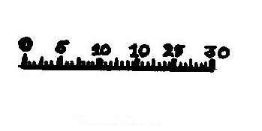
- Which type of scale is drawn?
........................................................................................................
- Name the game park in Uganda which is famous for ostriches.
..........................................................................................................................................
- Who is the current president of Uganda?
..........................................................................................................................................
- Give the organ of government that makes laws.
..........................................................................................................................................
- Name stage of the river where waterfalls are found.
..........................................................................................................................................
- Who were the founders of Bunyoro- Kitara Empire?
..........................................................................................................................................
- How did Sir William Mackinnon contribute to the development of transport in East Africa?
..........................................................................................................................................
- Give any one way how semei Kakungulu was helpful to the British colonialists in Uganda.
..........................................................................................................................................
- Write LEGCO in full.
..........................................................................................................................................
- How are feeder roads important to the rural farmers?
..........................................................................................................................................
- State the way how mangrove trees are important in the fishing industry.
..........................................................................................................................................
- Give one reason why Karamoja is not good for growing perennial crops.
..........................................................................................................................................
- Why does River Nile Flow Northwards?
..........................................................................................................................................
- Name the important line of latitude marked 23$\frac{1}{2}°s$.
..........................................................................................................................................
- How did Kiswahili language come into existence in East Africa?
..........................................................................................................................................
- Name the first group of foreigners to come to East Africa.
..........................................................................................................................................
- How is a timetable important in a classroom?
..........................................................................................................................................
- In which way is poaching dangerous to the tourism industry?
..........................................................................................................................................
- What is barter trade?
..........................................................................................................................................
- State the way how construction of the Uganda railway helped to stop slave trade.
..........................................................................................................................................
- Mention any one crop that grows well in swamps.
…………………………………………………………………………………………

- Why is mechanization of agriculture difficult in kabala district?
..........................................................................................................................................
- Identify the nationalist who united Tanganyika and Zanzibar to form the Republic of Tanzania.
..........................................................................................................................................
- Name the economic grouping that unites all the East African countries.
..........................................................................................................................................
- Name the African country that attempted to colonize Uganda.
..........................................................................................................................................
- Mention any one physical feature that was used by the colonialists to fix boundaries.
…………………………………………………………………………………………..
- How important is Lake Albert politically?
..........................................................................................................................................
- Who was the first European explorer to come to Uganda?
..........................................................................................................................................
- Identify the organization that sent most European explorers to East Africa.
..........................................................................................................................................
- Name the European country that colonized Uganda.
..........................................................................................................................................
- Mention any one discovery made by early man.
..........................................................................................................................................
- Name the first mission station to be established by the missionaries in East Africa.
..........................................................................................................................................
- Identify the first railway line to be built in East Africa.
..........................................................................................................................................
In questions 36 – 40 answer Either Christianity Or Islam but not both alternatives in a number in a number.
- Either:What does the word Amen mean?
..........................................................................................................................................
Or: what does the word Allah Akbar mean?
..........................................................................................................................................
- Either: Why did Jesus wash his disciple’s feet?
..........................................................................................................................................
Or: How did Prophet Muhammad show love to his caliphs?
..........................................................................................................................................
- Either:Mention the first person who committed the first murder in Bible.
..........................................................................................................................................
Or: Name the first martyr in Islam.
..........................................................................................................................................
- Either:Which sacrament initiates a person into God’s family?
..........................................................................................................................................
Or: How does a person become a Muslim?
..........................................................................................................................................
- Either: Who is a disciple?
..........................................................................................................................................
Or: who is a caliph?
…………………………………………………………………………………………..

SECTION B: 60 MARKS
- Study the map below and answer the questions that follow.
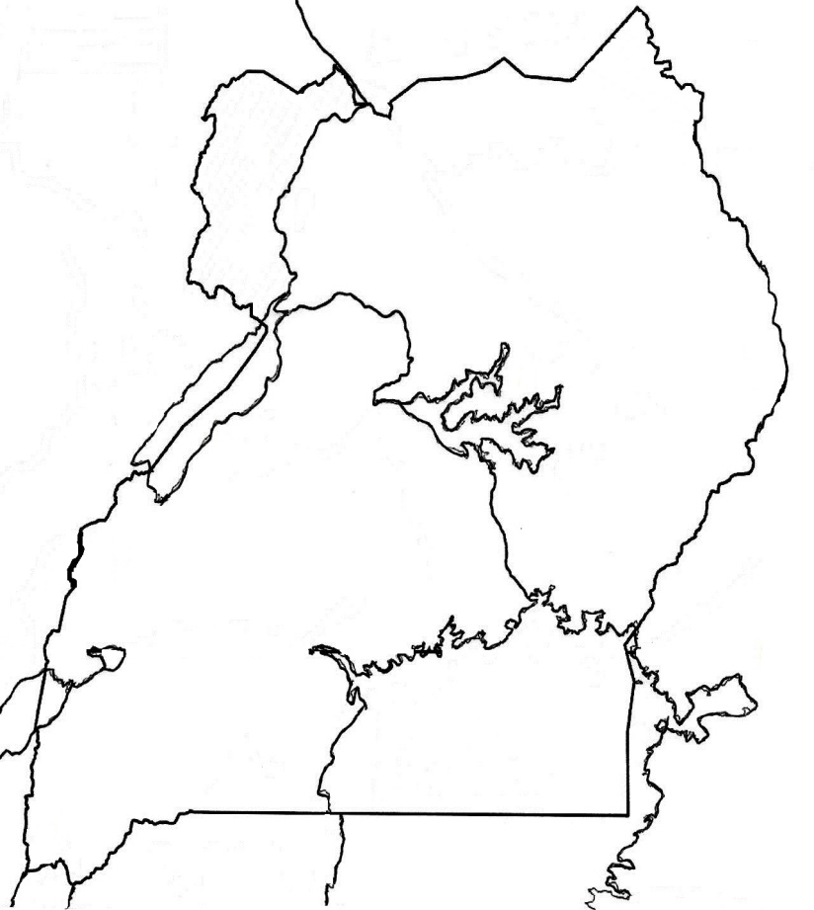
N

K
P
M

a)Mention the lake marked K
..........................................................................................................................................
b)Give one feature on river marked M that makes water transport hard.
..........................................................................................................................................
c)Explain how feature labeled P was formed.
..........................................................................................................................................
- Name the economic activity that is carried out by people found in the shaded region.
………………………………………………………………………………………
- a)Mention any two groups of foreigners who came to East Africa.
- ...............................................................................................................................
- ………………………………………………………………………………….
b)Name the first Arab trader to come to Uganda.
..........................................................................................................................................
c)Which religion was introduced by the Arabs to east Africa?
..........................................................................................................................................
- Name any two symbols of Uganda as a nation.
- …………………………………………………………………………………………………………………………
- …………………………………………………………………………………………………………………………
b)Who composed the Uganda National Anthem?
…....................................................................................................................................
- Name the political event that took place in Uganda in 1894.
..................................................................................................................................
- a) How were basin Lakes formed?
..........................................................................................................................................
b) Mention any two examples of basin lakes.
- ...............................................................................................................................
- …………………………………………………………………………………..
c) Write any one characteristic of basin lakes.
.........................................................................................................................................
- a)write EAC in full
..........................................................................................................................................
b) Give any two organs of the EAC.
- ...............................................................................................................................
- ...............................................................................................................................
c) Name the organ of the EAC that sets laws for the member states of the EAC.
..........................................................................................................................................
- What are traditional cash crops?
……………………………………………………………………………………….....
..........................................................................................................................................
- Mention any two examples of traditional cash crops.
- ...............................................................................................................................
- ………………………………………………………………………………….
- State any one problem facing the farmers of East Africa.
………………………………………………………………………………………
- a) What is a national budget?
..........................................................................................................................................

- State any two reasons why people make a budget.
- ...............................................................................................................................
- ………………………………………………………………………………….
c)Name the type of budget where the income is less than the expenditure.
..........................................................................................................................................
- a) Identify the process that led to the formation of Block Mountains.
..........................................................................................................................................
b) Give any two examples of Block Mountains in East Africa.
- ...............................................................................................................................
- …………………………………………………………………………………
c) How do mountains modify the climate of an area?
..........................................................................................................................................
- Give the meaning of the term fishing.
..........................................................................................................................................
………………………………………………………………………………………….
- Mention any two examples of bad fishing methods
- ...............................................................................................................................
- ...............................................................................................................................
- Name the largest type of fish caught in East Africa.
……………………………………………………………………………………….
- a) Who is a missionary?
..........................................................................................................................................
b) State any two reasons why Kabaka Muteesa I invited the missionaries to Uganda.
- ...............................................................................................................................
- …………………………………………………………………………………..
c) Mention any one reason why Kabaka Muteesa I turned against the missionaries.
..........................................................................................................................................
…………………………………………………………………………………………..

For questions 51 – 55, answer Either Christianity Or Islam but not Bothalternatives in a number.
- a) Either:What is a sacrament?
....................................................................................................................................
b) Mention any two examples of a sacrament received by a Christian.
..........................................................................................................................................
..........................................................................................................................................
- How is confirmation important to a Christian?
………………………………………………………………………………………
………………………………………………………………………………………
OR:a)Give any two reasons why Muslims fast.
- ...............................................................................................................................
- ..............................................................................................................................
- Name any two groups off Muslims who are excused from fasting.
- ……………………………………………………………………………………..
- ……………………………………………………………………………………..
- a) Either: State any two ways Abraham demonstrated his faith to God.
- ....................................................................................................................................
- ……………………………………………………………………………………..
- Name the son of Abraham that he accepted to sacrifice to God.
…………………………………………………………………………………………
- Give one reason why Isaac blessed Jacob instead of Esau.
…………………………………………………………………………………………
OR:a)Mention two ways Prophet Ibrahim showed his faith to Allah.
- ...............................................................................................................................
- ………………………………………………………………………………….
- Name the son of prophet Ibrahim that he wanted to sacrifice to Allah.
…………………………………………………………………………………………..
- Who was the first caliph of Prophet Mohammad?
…………………………………………………………………………………………..
- a)Either: Give any two fruits of the Holy Spirit in the life of a Christian...........................................................................................................................................
..........................................................................................................................................
b)Identify any two fruits of the Holy Spirit.
- ...............................................................................................................................
- ...............................................................................................................................
OR:a) Identify two ceremonies important in a Muslim Life.
- ...............................................................................................................................
- ...............................................................................................................................
- Give any reasons why Muslims pay Zakat.
…………………………………………………………………………………………
- a) Either: How was Adam’s creation different from other creation?
..........................................................................................................................................
- Where did Adam live before disobeying God?
..........................................................................................................................................
- How did Adam disobey God?
…………………………………………………………………………………………..
- What immediate punishment was Adam given for disobeying God?
…………………………………………………………………………………………..
OR:
- How was Adam’s creation different from that of other creation?
....................................................................................................................................
- Name the place where Adam lived before disobeying Allah.
......................................................................................................................................
- What immediate punishment was Adam and Hawa given for disobeying Allah?
………………………………………………………………………………………
- In which way did Adam and Hawa disobey Allah?
………………………………………………………………………………………..
- For both
Name any two Holy books used by Different religious groups.
- ...............................................................................................................................
- ...............................................................................................................................
b) State any two similarities between Christians and Muslims.
- ...............................................................................................................................
- ...............................................................................................................................

