KAMPALA JUNIOR SCHOOLS
TERM I 2020
SOCIAL STUDIES FOR P.7 SET 4
Time allowed: 2 hours 15 minutes

Name: …………………………………………………………………………………………….

Stream: ……………………………………………………………………………………………
FOR EXAMINERS’ USE ONLY

Read the following instructions carefully:

- The paper has two sections: A and B.
- Section A has 50 questions (50 marks)

- Section B has 5 questions. (50 marks)

- Answer all questions. All answers to both sections A and B must be written in the spaces provided.

- All answers must be written using a blue or black ball point pen or ink. Diagrams should be drawn in pencil.

- Unnecessary alteration of work may lead to loss of marks.

- Any handwriting that cannot easily be read may lead to loss of marks.

- Do not fill any thing in the boxes.
They are for examiners’’ use ONLY

FOR EXAMINERS’ USE ONLY
Qn No. | MARKS | SIGN
1 – 10
11 – 20
21 – 30
31 – 40
41 – 50
51
52
53
54
55
TOTAL

SECTION A:
- Name anyone element of a good map.
..........................................................................................................................................
- What is a plateau?...........................................................................................................
..........................................................................................................................................
- Which physical feature covers the largest area in East Africa?
..........................................................................................................................................
- Who designed the independence monument of Uganda?
..........................................................................................................................................
- Which was the first east African country to gain independence?
..........................................................................................................................................
- Which country borders Uganda to the south West?
..........................................................................................................................................
- State the current ruling political party in Uganda.
..........................................................................................................................................
- Who was the first ceremonial president of Uganda?
..........................................................................................................................................
- Who declared Uganda as a British Protectorate?
..........................................................................................................................................
- State any one symbol of a school?
..........................................................................................................................................
- How is a time table important in a class?
..........................................................................................................................................
- When did Uganda get her independence?
..........................................................................................................................................
- Name the current ruling political party in Uganda?
..........................................................................................................................................
- Draw a map symbol of a dam in the space below.

- Jane was standing while facing the North direction, she later turned 90⁰ anti-clockwise. What is her new direction?
..........................................................................................................................................
- Why is Hasende who is 15 years old not allowed to vote in Uganda?
..........................................................................................................................................
- What is the political importance of River Ruvuma?
..........................................................................................................................................
- State one reason why children wear school uniform.
..........................................................................................................................................
- How was the formation of Mt. Rwenzori different from Mt. Mufumbiro?
..........................................................................................................................................
- Where did the River lake Nilotes settle when they first arrived in Uganda?
..........................................................................................................................................
- Mention any one benefit enjoyed by non-landlocked countries. ..........................................................................................................................................
- Who is the political head of the district?
..........................................................................................................................................
- Name the best type of transport for transporting glasses.
..........................................................................................................................................
- Name the ministry in charge of roads in Uganda.
..........................................................................................................................................
- Why are mangrove forests important in the fishing industry?
..........................................................................................................................................
- What is land fragmentation? ...........................................................................................
..........................................................................................................................................
- How important are traffic police?
..........................................................................................................................................

- Name the map symbol drawn below.

- State any one duty of the electoral commission in Uganda.
..........................................................................................................................................
- How many members make up the local council one committee?
..........................................................................................................................................
- Why is population census in Uganda carried out after every ten years?
..........................................................................................................................................
- Why is the Stevenson screen made out of wood?
..........................................................................................................................................
- What is mixed farming?..................................................................................................
..........................................................................................................................................
- Which means of transport did the Arabs use when coming to Uganda?
..........................................................................................................................................
- What is Transport? ..........................................................................................................
..........................................................................................................................................
For questions 36 – 40 answer Either Christianity Or Islam but not both.
- Either:Name the son of Adam who killed his brother.
..........................................................................................................................................
Or: Name the son of Adam who killed his brother.
..........................................................................................................................................
- Either: How did Abraham show his faith to God?
..........................................................................................................................................
Or: How did prophet Ibrahim show his faith to God?
..........................................................................................................................................
- Either:What was the work of Mathew before he became an apostle?
..........................................................................................................................................
Or: What was the work of Khadijah the wife of Prophet Muhammad?
..........................................................................................................................................
- Either:Why is the Bible called the Holy book?
..........................................................................................................................................
Or: Why is the Quran called the Holy book?
..........................................................................................................................................
- Either: Who is the founder of Christianity?
..........................................................................................................................................
Or:Who is the founder of Islam?
..........................................................................................................................................

SECTION B: 60 MARKS
- a) Differentiate between scramble for East Africa and partition of East Africa.
..........................................................................................................................................
..........................................................................................................................................
b) State the two European countries that partitionedEast Africa.
..........................................................................................................................................
..........................................................................................................................................
c) Why did European countries partition East Africa?
..........................................................................................................................................
- a)Write EAC in full.
..........................................................................................................................................
b) Name any two founder member states of EAC.
..........................................................................................................................................
..........................................................................................................................................
c) Where are the headquarters of the EAC?
..........................................................................................................................................
- Study the sketch map of East Africa below and answer the questions that follow.
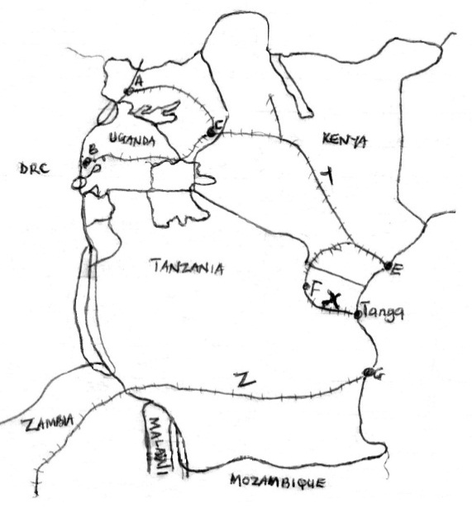Name the railway lines labeled.
N
i) Y...........................................................
ii) X ..........................................................
iii) Z.........................................................
b)Which was the first railway line to be built in East Africa?
..................................................................
- a) Mention the two European explorers who made two journeys to East Africa.
i)............................................................................ii)...........................................................................
b) Why did Henry Morton Stanley Circumnavigate Lake Victoria?
..........................................................................................................................................

c) State any one effect of the coming of explorers to East Africa.
..........................................................................................................................................
- a)What is population?......................................................................................................
..........................................................................................................................................
b) Give any two importance of having high population to a country like Uganda.
..........................................................................................................................................
c) Mention one danger of having high population to a country.
..........................................................................................................................................
- a) What title is given to the highest civil servant in a district?
..........................................................................................................................................
b) How important are leaders in our community?
..........................................................................................................................................
- a) State any two symbols of Uganda as an independent nation.
..........................................................................................................................................
..........................................................................................................................................
b) Why does Uganda use English as her official language?
..........................................................................................................................................
c) Why doesn’t Uganda have a national language?
.........................................................................................................................................
- a) What is communication?..............................................................................................
..........................................................................................................................................
b) Why are newspapers not read by many people in Uganda?
..........................................................................................................................................
c) Write down any one disadvantage of television as a means of communication.
..........................................................................................................................................
- a) What is an ethnic group?.............................................................................................
..........................................................................................................................................
b) Name the last Bantu tribe to enterEast Africa.
..........................................................................................................................................
c) State any two reasons why people migrate today.
..........................................................................................................................................
..........................................................................................................................................

- a) What is fishing?......................................................................................................
..........................................................................................................................................
b) Mention any two examples of fish caught in East Africa.
..........................................................................................................................................
..........................................................................................................................................
c) Which is biggest type of fish caught in East Africa.
..........................................................................................................................................
For questions 51 – 55, answer Either Christianity Or Islam but no Both on the same question
- a) Either: Differentiate between marriage and Holy Matrimony.
..........................................................................................................................................
b) State any two types of Marriage
..........................................................................................................................................
..........................................................................................................................................
c) Why do People marry?
.........................................................................................................................................
OR:a)Differentiate between marriage and Holy matrimony.
..........................................................................................................................................
..........................................................................................................................................
b) State any two types of marriage
..........................................................................................................................................
..........................................................................................................................................
c)Why do people marry? ................................................................................................
.........................................................................................................................................
- a) Either: What is prayer? ..............................................................................................
..........................................................................................................................................
b) Apart from prayer, name any other two ways how people communicate to God.
.........................................................................................................................................
..........................................................................................................................................
c)How does God communicate to people?
..........................................................................................................................................
OR:a)What is prayer?..........................................................................................................
..........................................................................................................................................
b)Apart from prayer, name any other two ways how people communicate to Allah
..........................................................................................................................................
..........................................................................................................................................
c) How does Allah communicate to Muslims?
..........................................................................................................................................
- a)Either: What is a sacrament? ......................................................................................
..........................................................................................................................................
b) Write down any two sacraments received by the Christians?
..........................................................................................................................................
..........................................................................................................................................
c) Which is the first sacrament to be received by a Christian?
..........................................................................................................................................
OR:a) Which pillar of Islam brings the rich and the poor together?
.........................................................................................................................................
b) Give the two types of the pillars you have named in (a) above.
..........................................................................................................................................
..........................................................................................................................................
c) What is the importance of the pillar you have mentioned in (a) above?
..........................................................................................................................................
- a) Either: Why do we remember the following days?
a) Ash Wednesday............................................................................................................
b) Lent..............................................................................................................................
c) Good Friday..................................................................................................................
D) Palm Sunday................................................................................................................
OR: ‘’There is no god except Allah. Death really causes pain. Oh God! Cover me with your forgiveness and mercy.’’ (Reported by: Abu Hurairat)
- Who said these words?
....................................................................................................................................
- Who was the most beloved wife of the person you have named in (a) above?
....................................................................................................................................

- Mention any two things which you learn from the person you have named in (a) above.
....................................................................................................................................
....................................................................................................................................
- a) Either: Which was the first foreign religion to be introduced to East Africa?
..........................................................................................................................................
b) Name the group of people who introduced the religion you have mentioned in (a) above.
..........................................................................................................................................
- Apart from Christianity and Islam, name any other two religions found in East Africa.
....................................................................................................................................
....................................................................................................................................
OR: Which was the first foreign religion to be introduced to East Africa?
..........................................................................................................................................
b) Name the group of people who introduced the religion you have mentioned in (a) above.
..........................................................................................................................................
c) Apart from Christianity and Islam, name any other two religions found in East Africa.
..........................................................................................................................................
..........................................................................................................................................

END
TJS-2018©

