BIOLOGY
Biology is a word derived from two Greek words i.e.“Bios” and “logos” where Bios means life and logos means knowledge.
Therefore Biology is a branch of science which deals with the study of life or living things. All living things are called organisms.

BRANCHES OF BIOLOGY
- Botany, the study of plants.
- Zoology, the study of animals.
- Anatomy, the study of the structure of living things.
- Nutrition, the study of food and how living things feed.
- Ecology, the study of how organisms are related to their environment / surrounding.
- Mycology, the study of fungi.
- Virology, the study of virus.
- Bacteriology, the study of bacteria.
- Entomology, the study of insects.
- Microbiology, the study of microorganisms.
- Physiology, the study of process and functioning of the body parts.
- Genetics, the study of inheritance.
- Taxonomy, the study of classification of organisms
- Ornithology, the study of birds.
- Ichthyology, the study of fish.

WHY DO WE STUDY BIOLOGY? (IMPORTANCE OF STUDYING BIOLOGY)
- To get knowledge on how to treat the sick
- To get knowledge needed to become doctors, and nurses
- To get knowledge on how to manufacture drugs
- To get knowledge on how to conserve the environment
- To know how our body functions.

CHARACTERISTICS OF LIVING THINGS
- Nutrition/feeding
It’s a process by which living things obtain food.
All living things take in food from which they obtain materials for energy production, body growth, and Repair.
Green plants and some bacteria make their own food while the rest obtain already made food from the environment.
- Respiration
This is the breakdown of food to release energy in the body needed for different life processes. Like growing, and muscle contraction.
- Excretion
Is the process by which waste products of metabolism are removed from the body e.g. urea in urine, carbon dioxide, etc.
- Reproduction
This is the ability of an organism to give rise to new organisms.
- Movement
This is the ability of an organism to transfer its body from one place to another. They move in search for food, water, shelter, mates, and running away from predators.
- Growth
Growth is a permanent increase in size of an organism. It is followed by development.
- Irritability / sensitivity
It is the ability of an organism to respond to changes in its environment.

DIFFERENCES BETWEEN PLANTS AND ANIMALS
Plants | Animals
- Have cell wall. | Lack cell wall.
- Have chlorophyll. | Lack chlorophyll.
- Movement is by growth of plant parts. | Movement involves the whole organism.
- They make their own food by photosynthesis. | Feed on already made food.
- Respond to stimulus slowly since it involves growth. | Quick / immediate response to stimulus.
- Growth occurs throughout life | Growth is up to maturity and no further growth after.
- Growth occurs in particular plant parts | Growth occurs all over the body.

TOOLS USED TO STUDY BIOLOGY
- HAND LENS:
A normal hand lens is a convex lens mounted in a frame. It is placed a shorter distance of about 5cm from the eye and the object.
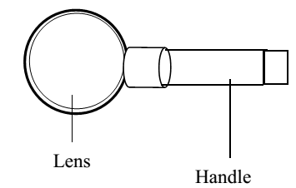
Determination of magnification using a hand lens
Magnification refers to how much larger the object appears compared to its real size.


Example
Calculate the magnification of an object, which is 10cm tall whose image appears to be 20cm tall.

Solution
Using the formula
Size of image/drawing
Size of object
Magnification =
20 cm
10 cm
=
=× 2
( more examples on calculations)

- MICROSCOPES
There are two types of microscopes i.e.
- The electron microscope which uses a beam of electrons.
- The compound light microscope.

THE COMPOUND LIGHT MICROSCOPE
It is called so because it uses a beam of light to view objects and has more than one convex lens.it is used in hospitals, schools and some industries.

Structure of a compound light microscope
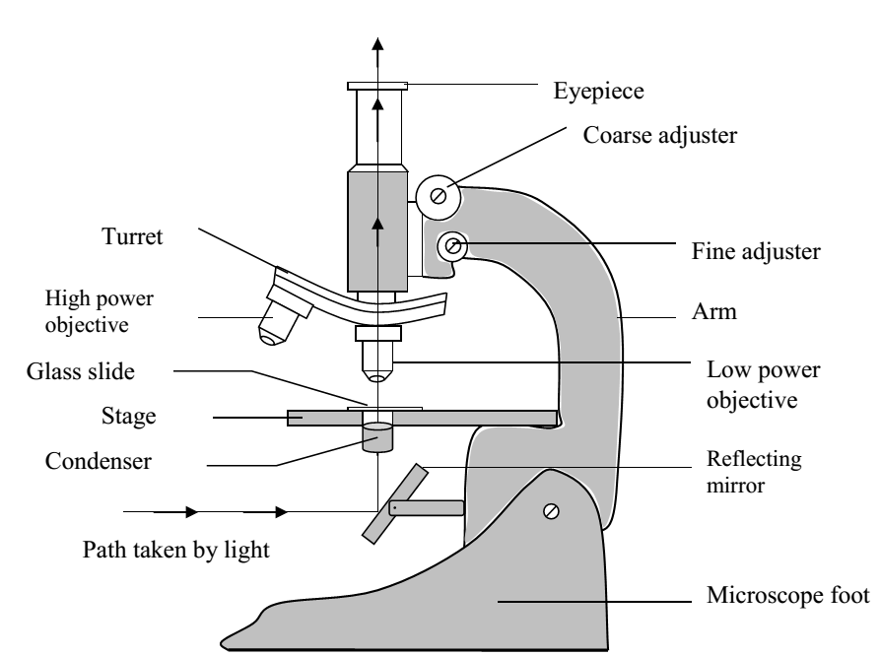

FUNCTIONS OF THE DIFFERENT PARTS
  - Eye Piece:
- Enables one to view the specimen
- It magnifies the image from the objective lens.
  - Barrel:
- Provides support for the eye piece and objective lens.
  - Nose piece/ turret/:
- It holds the objective lenses in position
- Can be rotated to position a particular lens required for a particular magnification.
  - Stage:
- It is where a prepared slide is placed for observation.
  - Mirror:
- It reflects light from external source through the specimen.
  - Stand / Base:
- Supports instrument in on a flat surface.
  - Diaphragm:
- Regulates the amount of light passing throughthe specimen.
  - Condenser:
- Concentrates the light reflected by the mirror through the object / specimen on the stage.
  - Arm:
- Used for carrying the instrument.
  - Clip:
- Keeps the slide firmly on the stage.
  - Coarse adjustment knob:
- Used for focusing of the object under study.
  - Fine adjustment knob:
- Brings specimen into a sharp clearer focus (final focusing).
  - Objective lens:
- Magnifies the specimen under study. They are normally two or three. Low power (shortest), medium power and high power (longest).

Care of a microscope
The microscope is very delicate, expensive instrument which is very useful in the study of biology. Thus it should be handled carefully doing the following;
- It should be carried with both hands.
- Should never be dropped.
- Always kept in an upright position
- Only wipe the lens with soft lens tissue.
- It should always be kept in its special designed box.

Determination of magnification of a microscope
Magnification refers to how much larger the object appears compared to its real size.
Magnification = magnification of the eye piece lens X magnification of the objective lens.

Example:
If the eye piece is marked x10 and the magnification of the objective lens is x40, what is the total magnification of a microscope?
Magnification = magnification of the eye piece lens x magnification of the objective lens.
=10 x 40=400
The specimen was magnified x400

Let magnifying objective lens. (x4)
Complete the table below
Eye piece lens | Objective lens | Magnification
X15 | X7
X60 |  | X240
 | X17 | X340
X25 | X8

THE CELL
The cell is the smallest basic unit of life.
Unicellular organisms are only made up of a single cell e.g. amoeba, paramecium.
Multicellular organisms are made up of many cells e.g. man, cows, bean plant, etc.

THE ORIGIN OF NEW CELLS
New cells are formed from already existing cells by a process called cell division. The already existing cell is called a parent/ mother cell and the new cells formed are called daughter cells.

Structure of an animal cell

STRUCTURE OF A PLANT CELL
Cell wall
Middle lamella
Starch granules
Cell membrane
Nucleus
Cytoplasm
Chloroplast
Sap vacuole

CELL ORGANELLES
Parts of cell and their functions
- Cell Membrane
Is the outer living part of a cell and it is found in all cells.
Its semi permeable i.e. has tiny holes through which only very small molecules like water can pass through.
Functions
- It allows movement of materials of in and out of the cell.
- It regulates the shape and strength of a cell.
- It protects the / inner parts of the cell.
- Binds protoplasm/ cytoplasm.

- Cell Walls
It is found in plant cells and it is made up of cellulose, which gives it its rigidity and tough nature.

Functions
- It gives the plant cell its shape.
- Protects the inner parts of the cell cellular.
- Allows movement of materials in and out of the cell.
- It offers mechanical strength to the cell.

- Nucleus
It is surrounded by double membrane called the nuclear membrane.
Functions of a nucleus
- Controls cell activities.
- Controls cell division
- Stores the genetic material of a cell
- Plays an active role in protein synthesis.
Functions of the nuclear membrane
- Binds the nucleus
- Separates the nucleus plasma from the cytoplasm.
- Allows for the exchange of materials between the nucleus and the cytoplasm.

- Cell Vacuole
Contains a watery substance called cell sap and is surrounded by a single membrane called the tonoplast.
Each Plant cell possesses one large permanent central vacuole while each animal cell has many temporary vacuoles.
Functions
- Stores waste materials before they are expelled.
- It is a temporary food store.

- Cytoplasm
It is a fluid material that contains many organelles e.g. mitochondria, nucleus etc.
Functions
- Site for cell activities i.e. metabolic reactions.
- Site for storage of energy producing materials e.g. starch and glycogen.

- Mitochondria
It is the cell power house and its function is to release energy through respiration.

- Chloroplast
Found only in green plant cells
- Contains a green pigment called chlorophyll that traps sunlight for photosynthesis.

- Golgi body
- Involved in cell secretions i.e. secretes enzymes.
- It transports materials in cells.

- Lysosome
It secretes hydrolytic enzymes i.e. breaking down enzymes e.g. help in destruction of old or worn out cells and germs.

COMPARING A PLANT AND ANIMAL CELL
Differences:
Plant cell | Animal cell
- Regular in shape | Irregular in shape
- Has a cellulose cell wall. | Lacks a cellulose call wall.
- Has chloroplast. | Lacks chloroplast.
- Large vacuole centrally located. | Cell vacuole very small and positioned at the side.
- Has a middle lamella. | Lacks a middle lamella.
- Nucleus is positioned at one side. | Nucleus centrally located.
- Store food as starch granules. | Store food as glycogen granules.
- Has a tonoplast around the vacuole | Has no tonoplast
- Has a Thin layer of cytoplasm | Has a thick layer of cytoplasm

SIMILARITIES:
Plant cell and animal cell
- Both have a nucleus.
- Both have mitochondria.
- Both have a Golgi body.
- Both have a vacuole.
- Both have a cytoplasm.
- Both have a cell membrane.

SPECIALISED CELLS
These are cells modified to perform a particular function. They become suited or adapted for particular functions by modifying either their size, or shape, etc.
Examples of specialized cells in animals
- Red blood cells in blood
These transport oxygen in our bodies. Mature red blood cells do not have nucleus increasing space for carrying oxygen.
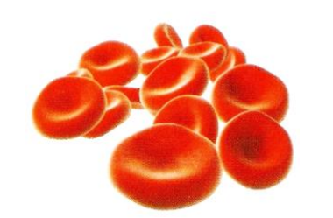
- Sperm cells
These fuses with the ovum to form a zygote during fertilization

- Ovum or egg
This is the female reproductive cell that fuses with a sperm to form a zygote.

- White blood cells
This defends the body against infections and diseases

- Platelets
These are used for blood clotting.
Examples of specialized cells in plants
- Root hair cells
They are found in plant roots
They absorb water and mineral salts from the soil
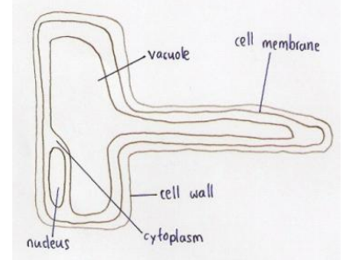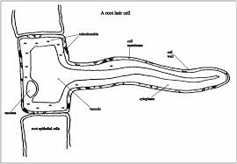
- Palisade cells
These are found in leaves of green plants
They carry out the process of photosynthesis
- Guard cells
They are found in green leaves
They control the opening and closing of stomata in leaves

LEVELS OF ORGANISATION
Cell Tissue Organs Organ systems Organism
TISSUE
A tissue is a group of similar cells linked together to perform a particular function.
A tissue may be made up of single type of cell or may comprise of different types of cells.E.g.
- Blood tissue made up of red blood cells, white blood cells and platelets. Blood transports materials in the body and offers protection.
- Nervous tissue made up of nerve cells. It transmits impulses in the body.
- Muscular tissue made up of muscle cells which cause movement of body parts
- Photosynthetic tissue made of palisade cells for photosynthesis.

ORGAN(S)
An organ is a collection of tissues specialized in carrying out a specific function. An organ is made up of different types of cells grouped together as a unit e.g.
- eye for sight
- Heart for pumping blood
- Ear for hearing
- Kidney for purifying blood
- Leaves for photosynthesis
- Roots for absorbing water and mineral salts

ORGAN SYSTEM
An organ system is a collection of different organs performing a specific function(s) e.g.
- nervous system (Brain, Spinal cord),
- Circulatory system (Heart, blood and Blood vessels).
- Digestive system (gullet, stomach, small intestines etc.).
- Shoot system (leaves stems, flowers etc.).
- Root system (roots root nodules etc.).

AN ORGANISM
A collection of organ systems working together efficiently as a unit. E.g. man, cow, banana plant, an insect etc.

