Name: …………………………………………………………… Adm No: ………………………………
Class: …………………………………………………………. Candidate’s Sign: …………………….
Date: ………………………………………………………….

AGRICULTURE

TIME: 2 HOURS

2019 MID-TERM 2 EXAM
Agriculture
FORM 1

Agriculture

INSTRUCTIONS TO CANDIDATES:
- Write your name and Index number and sign in the spaces provided above.
- Answer ALL the questions in section A and B in the spaces provided in this booklet.
- Answer any two questions in section C in the spaces provided after the last question.

For Examiner’s Use Only:

SECTION | QUESTIONS | MAXIMUM SCORE | CANDIDATES SCORE
A | 1-14 | 30
B | 15-17 | 20
C | 18- 20 | 40
 | TOTAL | 90

SECTION A (30marks).
Answer all Questions in this section.
1. Agriculture is derived from two Latin terms state them and explain their meaning. (4mks)
………………………………………………………………………………………………………………….
………………………………………………………………………………………………………………….
………………………………………………………………………………………………………………….
………………………………………………………………………………………………………………….
………………………………………………………………………………………………………………….
………………………………………………………………………………………………………………….
2. Define the term Agriculture. (1mk)
………………………………………………………………………………………………………………….
………………………………………………………………………………………………………………….
3. State four factors that make agriculture an art subject. (4mks)
………………………………………………………………………………………………………………….
………………………………………………………………………………………………………………….
………………………………………………………………………………………………………………….
………………………………………………………………………………………………………………….
………………………………………………………………………………………………………………….
4. Name three reasons why students should learn agriculture subject in schools. (3mks)
………………………………………………………………………………………………………………….
………………………………………………………………………………………………………………….
………………………………………………………………………………………………………………….
………………………………………………………………………………………………………………….
………………………………………………………………………………………………………………….
5. State the meaning of the following terms as used in agricultural production. (5mks)
i) Soil science
………………………………………………………………………………………………………………….
………………………………………………………………………………………………………………….
ii) Entomology
………………………………………………………………………………………………………………….
………………………………………………………………………………………………………………….
iii) Crop pathology
………………………………………………………………………………………………………………….
………………………………………………………………………………………………………………….
iv) Apiculture
………………………………………………………………………………………………………………….
………………………………………………………………………………………………………………….
v) Aquaculture
………………………………………………………………………………………………………………….
………………………………………………………………………………………………………………….
6. State four branches of agriculture. (4mks)
………………………………………………………………………………………………………………….
………………………………………………………………………………………………………………….
………………………………………………………………………………………………………………….
………………………………………………………………………………………………………………….
7. Name four animals that are categorized as mammalian livestock. (4mks)
………………………………………………………………………………………………………………….
………………………………………………………………………………………………………………….
………………………………………………………………………………………………………………….
………………………………………………………………………………………………………………….
8. State the difference between plantation farming and ranching. (2mks)
………………………………………………………………………………………………………………….
………………………………………………………………………………………………………………….
………………………………………………………………………………………………………………….
………………………………………………………………………………………………………………….
9. List three methods a farmer can use to practice farming in Kenya. (3mks)
………………………………………………………………………………………………………………….
………………………………………………………………………………………………………………….
………………………………………………………………………………………………………………….
………………………………………………………………………………………………………………….
10. State two advantages of practicing agroforestry in a farm. (2mks)
………………………………………………………………………………………………………………….
………………………………………………………………………………………………………………….
………………………………………………………………………………………………………………….
11. State four factors that influence agriculture farming in Kenya. (4mks)
………………………………………………………………………………………………………………….
………………………………………………………………………………………………………………….
………………………………………………………………………………………………………………….
………………………………………………………………………………………………………………….
………………………………………………………………………………………………………………….
12. Name two ways through which HIV/AIDS affect agriculture negatively. (2mks)
………………………………………………………………………………………………………………….
………………………………………………………………………………………………………………….
………………………………………………………………………………………………………………….
13. Name two effects of wind on crop production. (2mks)
………………………………………………………………………………………………………………….
………………………………………………………………………………………………………………….
………………………………………………………………………………………………………………….
SECTION B (20 MARKS)
Answer all questions in B.
14. Study the diagram below and answer the questions that follow.
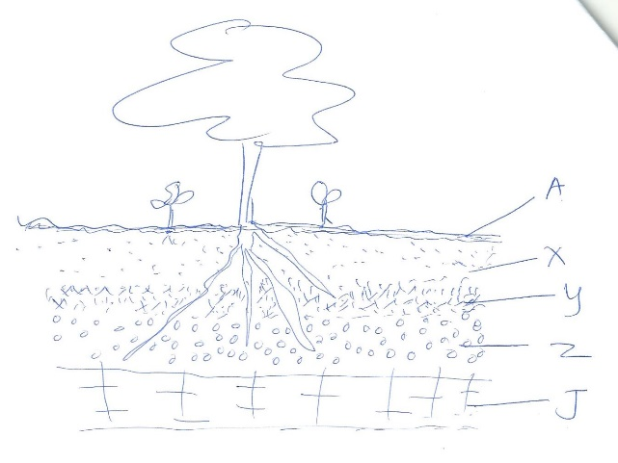
a) Identify the soil layers A, X, Y, Z, J in the diagram above. (5mks)
………………………………………………………………………………………………………………….
………………………………………………………………………………………………………………….
………………………………………………………………………………………………………………….
………………………………………………………………………………………………………………….
………………………………………………………………………………………………………………….
………………………………………………………………………………………………………………….
b) Define the term soil profile. (1mk)
………………………………………………………………………………………………………………….
………………………………………………………………………………………………………………….
c) State the name given to the zone found between any two bordering soil layers. (1mk)
………………………………………………………………………………………………………………….
………………………………………………………………………………………………………………….
d) State five components that make up soil. (5mks)
………………………………………………………………………………………………………………….
………………………………………………………………………………………………………………….
………………………………………………………………………………………………………………….
………………………………………………………………………………………………………………….
………………………………………………………………………………………………………………….
………………………………………………………………………………………………………………….
5. Study the diagrams below and answer the questions that follow.

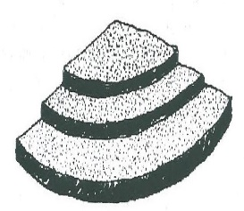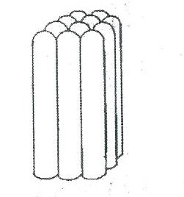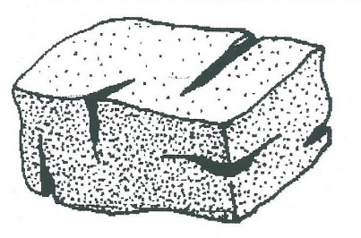
K
L
M

a) Identify the diagram K, L, M above. (3mks)
………………………………………………………………………………………………………………….
………………………………………………………………………………………………………………….
………………………………………………………………………………………………………………….
………………………………………………………………………………………………………………….
b) State two reasons why soil structure K is not good for crop production. (2mks)
………………………………………………………………………………………………………………….
………………………………………………………………………………………………………………….
………………………………………………………………………………………………………………….
………………………………………………………………………………………………………………….
16. Identify the farm tools and equipment shown below. (3mks)
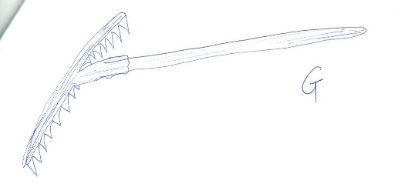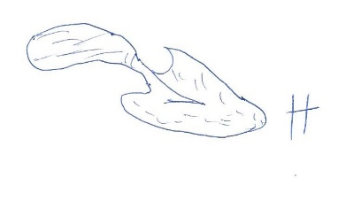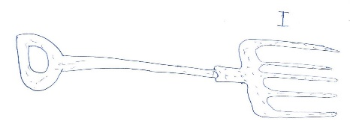

………………………………………………………………………………………………………………….
………………………………………………………………………………………………………………….
………………………………………………………………………………………………………………….
………………………………………………………………………………………………………………….
………………………………………………………………………………………………………………….
………………………………………………………………………………………………………………….

SECTION C (40 marks)
Answer only two questions in this section
17. a) State and explain five roles of agriculture in Kenyan economy today. (10mks)
b) State and explain five biotic factors that affect agricultural farming. (10mks)

18 a) Explain four aspects of rainfall that influence crop production. (8mks)
b) Explain four factors influencing soil formation. (8mks)
c) Name four effects of temperature on crops. (4mks)

19 a) Explain three aspects of light that influence crop farming. (6mks)
b) List four uses of water to crops. (4mks)
c) Giving an example in each, state five categories of farm tools and equipment. (10mks)

………………………………………………………………………………………………………………….
………………………………………………………………………………………………………………….
………………………………………………………………………………………………………………….
………………………………………………………………………………………………………………….
………………………………………………………………………………………………………………….
………………………………………………………………………………………………………………….
………………………………………………………………………………………………………………….
………………………………………………………………………………………………………………….
………………………………………………………………………………………………………………….
………………………………………………………………………………………………………………….
………………………………………………………………………………………………………………….
………………………………………………………………………………………………………………….
………………………………………………………………………………………………………………….
………………………………………………………………………………………………………………….
…………………………………………………………………………………………………………………………………………………………………………………………………………………………………….………………………………………………………………………………………………………………….………………………………………………………………………………………………………………….
…………………………………………………………………………………………………………………………………………………………………………………………………………………………………….
…………………………………………………………………………………………………………………………………………………………………………………………………………………………………….
………………………………………………………………………………………………………………….
………………………………………………………………………………………………………………….
………………………………………………………………………………………………………………….
………………………………………………………………………………………………………………….
………………………………………………………………………………………………………………….
………………………………………………………………………………………………………………….
………………………………………………………………………………………………………………….
………………………………………………………………………………………………………………….
………………………………………………………………………………………………………………….
………………………………………………………………………………………………………………….
………………………………………………………………………………………………………………….
………………………………………………………………………………………………………………….
………………………………………………………………………………………………………………….
………………………………………………………………………………………………………………….
………………………………………………………………………………………………………………….
………………………………………………………………………………………………………………….
………………………………………………………………………………………………………………….
………………………………………………………………………………………………………………….
………………………………………………………………………………………………………………….
………………………………………………………………………………………………………………….
………………………………………………………………………………………………………………….
………………………………………………………………………………………………………………….
………………………………………………………………………………………………………………….
………………………………………………………………………………………………………………….
………………………………………………………………………………………………………………….
………………………………………………………………………………………………………………….
………………………………………………………………………………………………………………….
………………………………………………………………………………………………………………….
………………………………………………………………………………………………………………….
………………………………………………………………………………………………………………….
………………………………………………………………………………………………………………….
………………………………………………………………………………………………………………….
………………………………………………………………………………………………………………….
………………………………………………………………………………………………………………….
………………………………………………………………………………………………………………….
………………………………………………………………………………………………………………….
………………………………………………………………………………………………………………….
………………………………………………………………………………………………………………….
………………………………………………………………………………………………………………….
………………………………………………………………………………………………………………….
………………………………………………………………………………………………………………….
………………………………………………………………………………………………………………….
………………………………………………………………………………………………………………….
………………………………………………………………………………………………………………….
………………………………………………………………………………………………………………….
………………………………………………………………………………………………………………….
………………………………………………………………………………………………………………….
………………………………………………………………………………………………………………….
………………………………………………………………………………………………………………….
………………………………………………………………………………………………………………….
………………………………………………………………………………………………………………….
………………………………………………………………………………………………………………….
………………………………………………………………………………………………………………….
………………………………………………………………………………………………………………….
………………………………………………………………………………………………………………….
………………………………………………………………………………………………………………….
………………………………………………………………………………………………………………….
………………………………………………………………………………………………………………….
………………………………………………………………………………………………………………….
………………………………………………………………………………………………………………….
………………………………………………………………………………………………………………….
………………………………………………………………………………………………………………….
………………………………………………………………………………………………………………….
………………………………………………………………………………………………………………….
………………………………………………………………………………………………………………….
………………………………………………………………………………………………………………….
………………………………………………………………………………………………………………….
………………………………………………………………………………………………………………….
………………………………………………………………………………………………………………….
………………………………………………………………………………………………………………….
………………………………………………………………………………………………………………….
………………………………………………………………………………………………………………….
………………………………………………………………………………………………………………….
………………………………………………………………………………………………………………….
………………………………………………………………………………………………………………….

