Name…….…………………………………………………………Adm.No.…………………
Date:…..……………..…………………………………….Class……………………………….

FORM ONE CHEMISTRY EXAMINATION,
TERM TWO, JUNE 2018.
TIME: 2 HOURS

MATUGA GIRLS HIGH SCHOOL EVALUATION EXAM

INSTRUCTIONS TO CANDIDATES:

- Write your name and admission number in the spaces provided above.
- Answer All the questions in the spaces provided below each question.
- This paper consists of 8 printed pages.
- Candidates should check to ascertain that all pages are printed as indicated and that no questions are missing.

For Examiner’s Use Only
Question | Maximum score | Candidate’s score
1- 22 | 70

1. Chemistry knowledge has contributed immensely to the development in the growth of economy in Kenya. Highlight any three areas in which chemistry knowledge has done so.(3mks)
……………………………………………………………………………………………………………………………………………………
……………………………………………………………………………………………………………………………………………………
……………………………………………………………………………………………………………………………………………………
…………………………………………………………………………………………………………………………………………………...
2. Explain the following observations with reference to the flames produced by the Bunsen burner: (2mks)
a) Luminous flame is yellow in colour.
…………………………………………………………………………………………………………………………………………………….
..........................................................................................................................................................
b) Non luminous flame is preferred for heating
……………………………………………………………………………………………………………………………………………………
3. Name any three laboratory apparatus which can be used to measure accurate volume of liquids. (3mks)
……………………………………………………………………………………………………………………………………………………
……………………………………………………………………………………………………………………………………………………
…………………………………………………………………………………………………………………………………………………….
4. State any four laboratory safety rules and regulations. (4mks)
……………………………………………………………………………………………………………………………………………………
……………………………………………………………………………………………………………………………………………………
……………………………………………………………………………………………………………………………………………………
…………………………………………………………………………………………………………………………………………………….
5. ) With the aid of a simple diagram show that almost colourless zone of the non-luminous flame consists of unburnt gas particles. (2mks)

6. State the functions of the following laboratory apparatus. (3mks)
a)Crucible
……………………………………………………………………………………………………………………………………………………
b) Desiccator
……………………………………………………………………………………………………………………………………………………
c) Gas jar
…………………………………………………………………………………………………………………………………………………….
7(a) What is a drug? (1mk)
…………………………………………………………………………………………………………………………………………………………………
…………………………………………………………………………………………………………………………………………………………………. (b) Give two drugs that are commonly abused by the youths. (2mks)
…………………………………………………………………………………………………………………………………………………………………
………………………………………………………………………………………………………………………………………………………………….8.By use of a well labelled diagram only show how a mixture of common table salt and ammonium chloride can be separated. (3mks)

9. What is meant by melting point and boiling point of a substance? (2mks)
…………………………………………………………………………………………………………………………………………………………………
…………………………………………………………………………………………………………………………………………………………………
………………………………………………………………………………………………………………………………………………………………….

10. The set-up below was used to separate a mixture:-

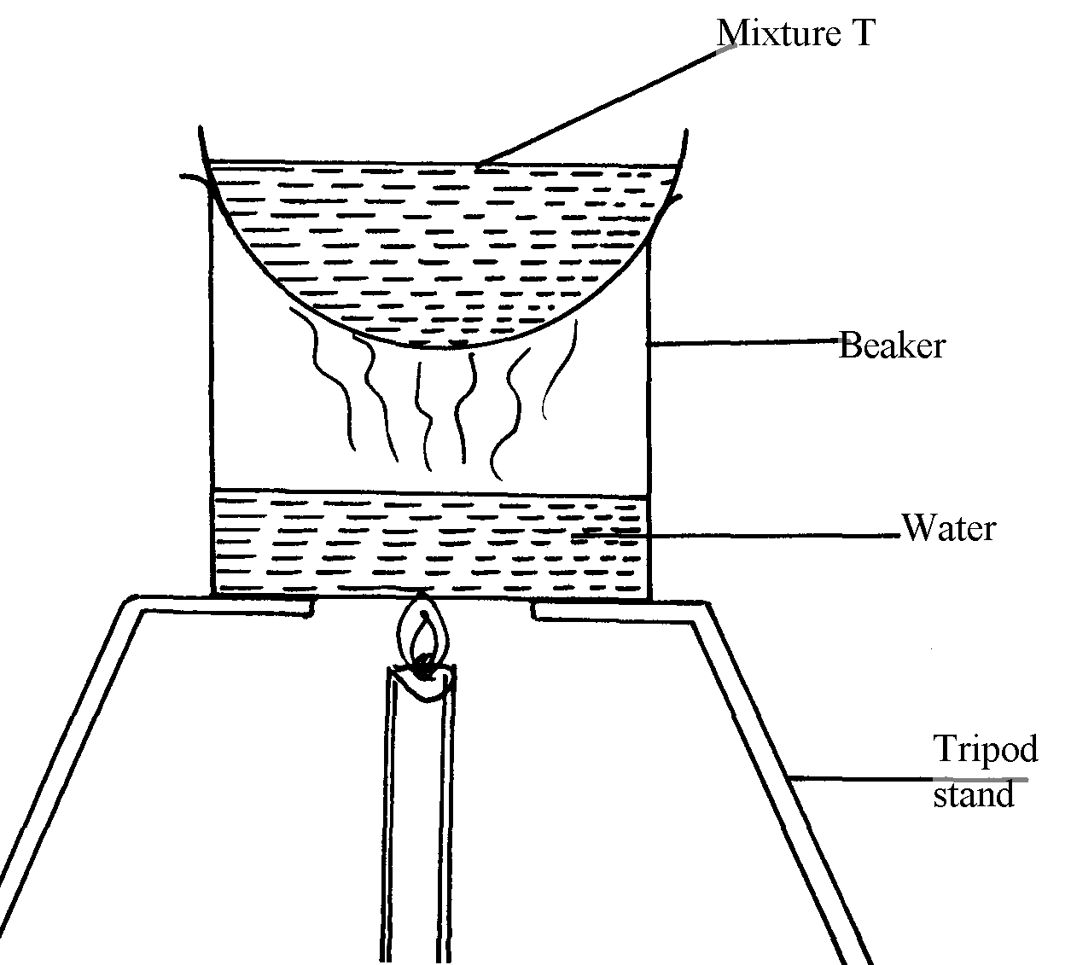

(a) Name the apparatus missing in the set-up (1mk)
………………………………………………………………………………………………………………………………………………………………… (b) Give one example of mixture T (1mk)
…………………………………………………………………………………………………………………………………………………………….. (c) What is the name of this method of separation? (1mk)
…………………………………………………………………………………………………………………………………………………………………
11. The chromatography below shows the constituents of a flower extract using an organic solvent:-
Yellow
Red
Blue
M
•
•
•
•

(a) (i) Name a possible organic solvent you can use for this experiment. (1mk)

(ii) State two properties that makes the red pigment to move the furthest distance from M. (1mk)
…………………………………………………………………………………………………………………………………………………………………
………………………………………………………………………………………………………………………………………………………………….
(iii) Describe how one could get a sample of yellow pigment. (2mks)
…………………………………………………………………………………………………………………………………………………………………
…………………………………………………………………………………………………………………………………………………………………
…………………………………………………………………………………………………………………………………………………………………. (iv) On the diagram indicate solvent front and baseline (1mk)
(b) State any two applications of chromatography. (2mks)
…………………………………………………………………………………………………………………………………………………………………
…………………………………………………………………………………………………………………………………………………………………
…………………………………………………………………………………………………………………………………………………………….......
…………………………………………………………………………………………………………………………………………………………………12. The following data gives the PH value of solution P, Q , R and S.
Solution | PH value
P | 13.6
Q | 1.3
R | 8.5
S | 5.2
a) Classify the following solutions as either strongly acidic, weakly acidic, strongly basic or weakly basic. (4mks)
P
Q
R
S
b) What would be the colour of solution “P” after adding a few drops of phenolphthalein indicator? (1mk)
………………………………………………………………………………………………………………………………………………………………….
c) Select any pair that react to give a solution whose PH values is 7.0. (1mk)
…………………………………………………………………………………………………………………………………………………………………. 13.Describe how one can obtain oil from groundnuts. (3mks)
…………………………………………………………………………………………………………………………………………………………………
…………………………………………………………………………………………………………………………………………………………………
…………………………………………………………………………………………………………………………………………………………………
…………………………………………………………………………………………………………………………………………………………………
…………………………………………………………………………………………………………………………………………………………………
…………………………………………………………………………………………………………………………………………………………………
…………………………………………………………………………………………………………………………………………………………………. 14.Write the word equations for the reaction between the following: (5mks)
a) Sodium and hydrochloric acid

b) Magnesium carbonate and Nitric acid

c) Zinc oxide and sulphuric acid

d)Potassium hydroxide and hydrochloric acid

e) Aluminum and oxygen

15. The table below shows the PH values of certain solutions
Solution | A | B | C | D
PH values | 8 | 5 | 7 | 11

Which of the solutions is most likely to be solutions of
i) Common salt (1mk)
ii) Lime water (1mk)
iii) Orange juice (1mk)
iv) Household soap (1mk)
16. When a student was stung by a wasp, a teacher applied an aqueous solution of ammonia to the affected area of the skin and the student was relieved of pain. Explain. (2mks
…………………………………………………………………………………………………………………………………………………………………
…………………………………………………………………………………………………………………………………………………………………
………………………………………………………………………………………………………………………………………………………………….
17. The PH of a sample of soil was found to be 5.0. An agricultural officer recommended the addition of calcium oxide in the soil. Explain. (2mks)
…………………………………………………………………………………………………………………………………………………………………
…………………………………………………………………………………………………………………………………………………………………
………………………………………………………………………………………………………………………………………………………………….
18. When solid A was heated strongly, it gave off water and a white residue. When water was added to the solid residue, the original solid A was formed.
a)What is the name given to the water given out? (1mk)
………………………………………………………………………………………………………………………………………………………………….
b)what name is given to the process described above? (1mk)
………………………………………………………………………………………………………………………………………………………………….
c) Give one example of solid A? (1mk)
………………………………………………………………………………………………………………………………………………………………….
19. How is the purity of sodium chloride crystals be determined? (2mks)
…………………………………………………………………………………………………………………………………………………………………
…………………………………………………………………………………………………………………………………………………………………
20. Two solutions X and Y of equal concentration and volume have the PH values of 1.5 and 13.3 respectively. Two drops of phenolphthalein indicator solution was added to solution Y then followed by addition of solution X to form solution M.
a) State the observation made in colour change when phenolphthalein indicator solution was added to solution Y. (1mk)
…………………………………………………………………………………………………………………………………………………………………. b) Suggest the PH value of solution M. (1mk)
…………………………………………………………………………………………………………………………………………………………………. c) What is the name given to the reaction between solution X and Y? (1mk)
……………………………………………………………………………………………………………………………………………………. 21. Classify the following processes as chemical changes or physical changes. (3mks)
Process physical or chemical
Neutralization …………………………………………………………………………………………………………………………………
Sublimation ……………………………………………………………………………………………………………………………………
Simple distillation ……………………………………………………………………………………………………………………………..
22. Define the following terms: (2mks)
a) Atom
…………………………………………………………………………………………………………………………………………………………………
………………………………………………………………………………………………………………………………………………………………….
b) Element
…………………………………………………………………………………………………………………………………………………………………
………………………………………………………………………………………………………………………………………………………………….

