Name: ……………………………………………..………………… Adm. No…………………………………Class……………………………..………
ANESTAR SCHOOLS
MID TERM 2 2017 EXAM
FORM ONE
PHYSICS
1HR 30MIN
INSTRUCTIONS TO STUDENTS
- This paper consists of 16 questions.
- Answer ALL the questions in the spaces provided.
- ALL working MUST be clearly shown.
- ALL numerical answers MUST be expressed in decimal forms.
Answer all questions in this paper
1. State any two ways by which frictional force between two surfaces can be reduced. (2mks)
- oiling
- greasing
- using rollers
- smoothening
2. Explain why large mercury drops form oval ball on a glass slide (2mks)
This is because cohesive forces between mercury molecules are stronger than adhesive force between molecules of mercury and glass.
3. Name two physical quantities that can be derived from length. (2 marks)
Area and volume
4. State two Precautions When Using a Density Bottle (2 mark)
The bottle should be held by the neck when wiping it. This is to prevent it from expanding due to body warmth when held by sides by using hands.
The outside of the bottle must be wiped dry carefully.
There should be no air bubbles when the bottle is filled with liquid.

5. Advantage of Force Pump over the lift pump 2mks
It enables a continuous flow of water.
The height to which it can raise does not depend on atmospheric

6. The height, h of a water manometer is 20 cm when used to measure pressure of a gas.
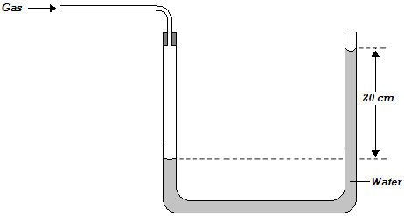
- Determine the pressure due to gas, If atmospheric pressure is 103000N/m².
    - $P_{g}=hρg+Pa$
- $=0.20 m×1000 kg/m^{3}×10N/kg+103000N/m^{2}$
- $=105000N/m^{2}$
7. A boy 150 cm tall forms a shadow of length 200cm. A tree nearby forms a shadow of length
800cm as shown in the figure. Calculate the height of the tree (3mks)

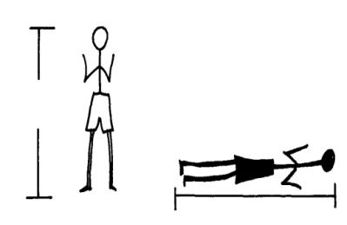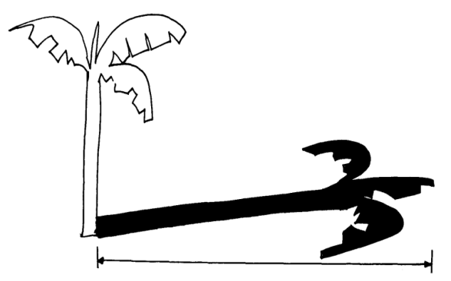
200cm
800cm

Height of tree = length of the shadow of the tree
Height of the body length of the boy’s shadow
H tree = 800cm
150cm 200cm
Height of tree x 200 = 150 x 800
Height of tree = 150 x 800 = 600cm
200
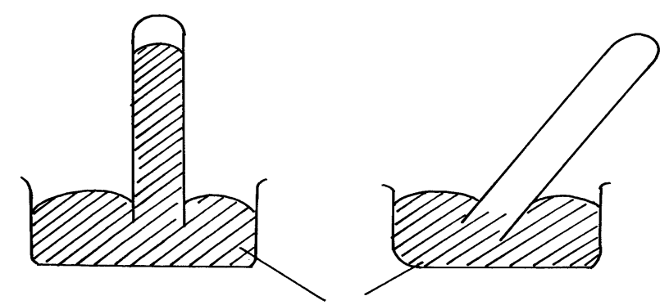8. The figure below shows a simple mercury barometer when straight in (a) and when tilted in (b). Mark the level of mercury in tilted tube. (1mk)
Mercury
(a)
(b)

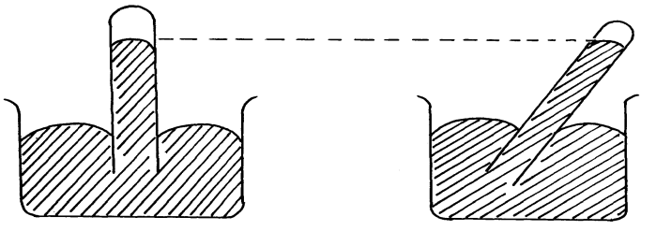
(a)
(b)

9. The figure shows the relationship between the three states of matter.
SOLID
LIQUID
GAS
B

C
C

C
D

C
A

C
F

C
E

C

Name the processes A, B, C, D, E, and F (3mks)
A…………………………………………. B………………………………………….....
C………………………………………… D……………………………………………
E………………………………………… F…………………………………………...
A – melting B- evaporation
C – condensation D- freezing
E – Sublimation F- Sublimation
10. A manometer containing water shows a difference in level of 10cm when connected to a laboratory gas. Calculate the pressure exerted by the gas supply
(Atmospheric pressure = 100,000N/m²) (4mks)
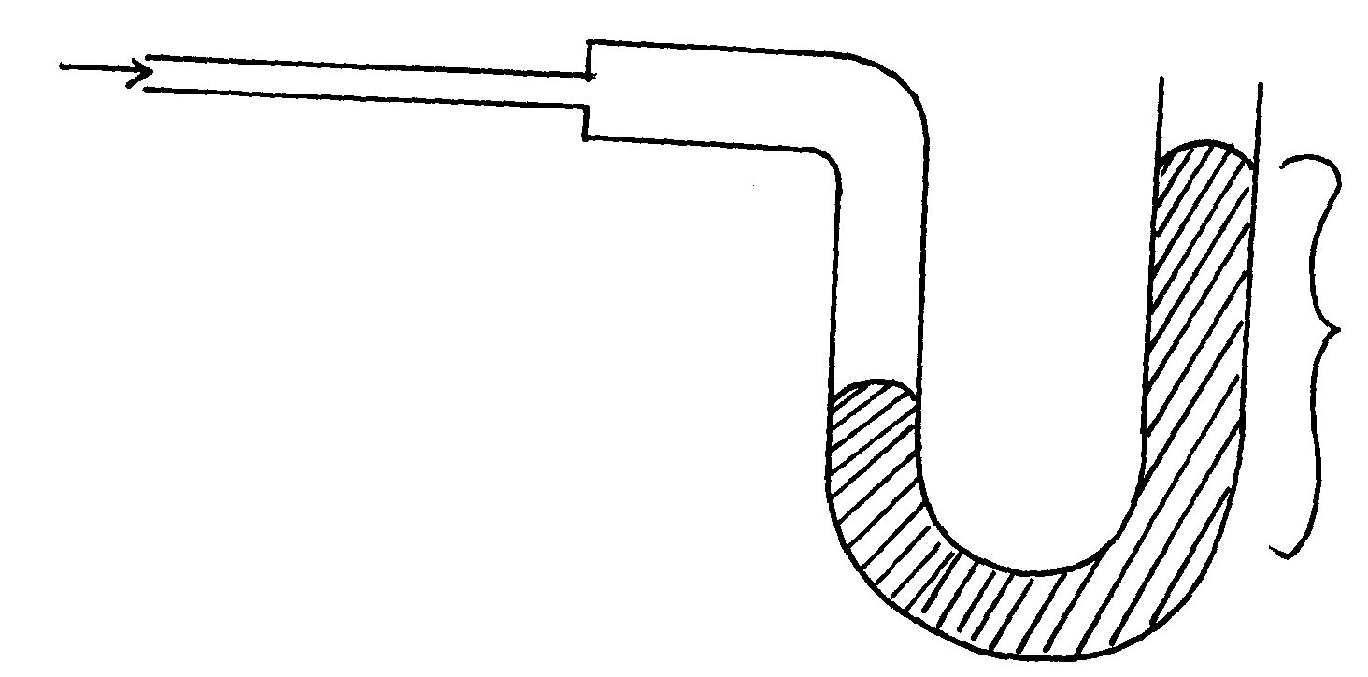
10cm
Gas in

. P =ρgh
H = 10cm = 0.1m
Gas pressure = hϑg + atmospheric pressure
= 0.1 x 1000 x 10 + 100,000
= 1000 + 100,000 = 101,000N/m³

11. The figure is of a clinical thermometer.

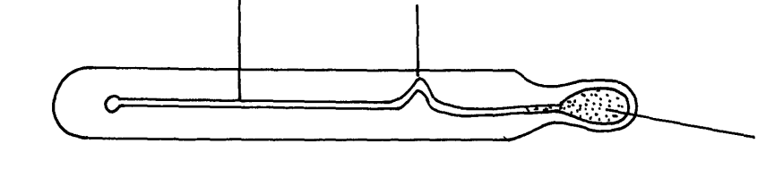
Tube
Bulb
Constriction

Explain why;
(i) There is a constriction on the tube (1mk)
To prevent the liquid which has gone past from returning back into the bulb and therefore allows time for the temperature to be ready.
(ii) The bulb glass is thin (1mk)
The bulb is thin for effective heat transmission between the liquid and the body whose temperature is to be taken.
(iii) The tube is thin (1mk)
The tube is thin for high degree of accuracy or high degree of sensitivity r for small changes in temperature to be shown.
12 (a) Name four features of liquids to be used in a thermometer. (4 mks)
- should not wet glass
- should have high rate of expansion
- should expand regularly
- should be a good conductor of heat
- should be opaque and readily visible
- should have high b.p and low m.p

(b) Name three applications of thermal expansion. (3 mks)
- riveting of metals
- bimetallic strip
- loosening metal lids
- railway lines
- electric cables
- construction of metal bridges
- tarmacking roads

13. Distinguish between Brownian motion and diffusion as follows:-
(i) Brownian motion – is the random movement of particles suspended in a medium resulting from their bombardment by molecules in the surrounding medium (1 mk)

(ii) Diffusion – is the movement of molecular of a substance from a region of higher concentration to that of lower concentration. (1 mk)

- (a) State the kinetic theory of matter (2 mk)

The kinetic theory of matter states that matter is made up of tiny particles which are in a
constant random motion
(b) State two reasons why gas particles diffuse faster than solid particles (2 mk)
-Gas particles have low cohesive forces
- Gas particles have high kinetic energy
- Gas particles have low density,
- Explain the cause of random motion of smoke particles as observed in Brownian motion (1 mk)
experiment using a smoke cell
Air molecules/particles which were in a state of continuous random motion collided with
smoke particles
(a) Sate two liquids which are used in thermometer. (2 mk) -Alcohol.
-Mercury
(b) With a reason, state which of the two liquids in (a) above is used to measure temperature in
Areas where temperatures are: (2 mk)
. (i) Below -40⁰C -– Alcohol because it has a low freezing point of –115ºc.
(ii)Above 150⁰C -- Mercury. It has a high boiling point of 357º, alcohol boils at 78ºc.

- The figure below shows a bimetallic strip made of brass and iron.
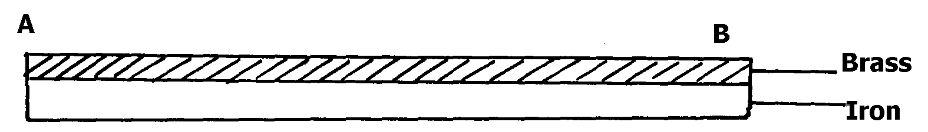
fig

Sketch what will be observed when the bimetallic strip is strongly cooled. (2 mk)
On cooling, the brass contracts more than iron, hence become shorter than iron and forms upwards curve.

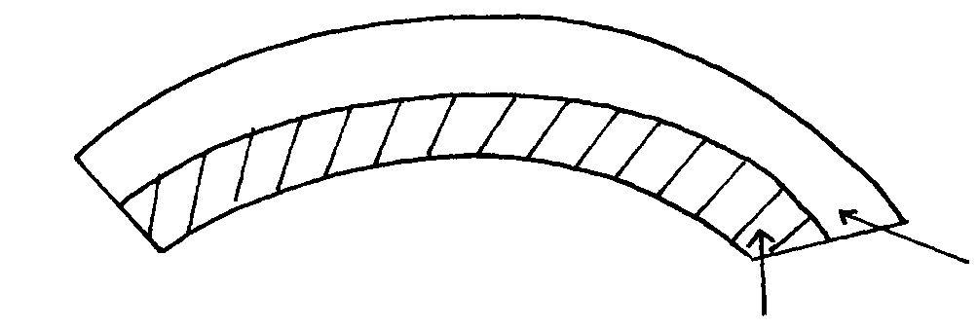

17. A metal bin was observed to float on the surface of pure water. However the pin sank when a few drops of soap solution were added to the water. Explain this observation. 2mks
Soap solution is an impurity. When added to water, it lowers the surface tension (by dissolving) of water making the needle to sink.
- Give a reason why a concrete beam reinforced with steel does not crack when subjected to Changes in temperature. (1mk)
Both concrete and steel have same rates of expansion.
- Effects of Anomalous Expansion of Water
- Support Aquatic Life in Polar Countries During Winter
- During winter water freezers into ice. Ice being less dense than water floats on water. Since ice is a poor conductor of heat, it insulates the water below against heat loss to air above it.

- Anomalous expansion of water leads to formation of ice bags which pose a great danger to ships.
- It causes weathering of rocks since when water trapped in freezes; it expands thus breaking rocks into small pieces.
- It causes bursting of water pipes when water freezers in them.

20.Differences between Heat and Temperature 3mks
HEAT | TEMPERATURE
Form of energy that flows due to temperature difference. | Degree of hotness or coldness of a body in some chosen scale.
The flow of heat cannot be measured precisely. | Can be measured accurately using a thermometer.
SI unit and joules (J). | SI unit is Kelvin (k).
- Applications of Good and Poor Conductors of Heat (4mks)
- Cooking utensils and boilers are made of metals that conduct heat rapidly while their handles are made of insulators (poor conductors).
- Modern buildings are made of double walls with an insulator between the walls to minimize heat loss from the house and therefore maintain stable temperature.
- Fire fighters put on suits made of asbestos which is a poor conductor of heat to keep them safe while putting off fire.
- Birds flap their wings after getting wet to introduce air pockets within their feathers this helps to minimize heat loss from their bodies.
- In experiments involving heating liquids in glass vessel. The vessel is placed on a wire gauge because the gauge is a good conductor of heat it therefore spreads the heat to a large area of the vessel.
- Explain the function of sivered wall and vaccum in a thermos flask 2mks
Silvered wall prevents heat loss through radiation since the shinny surface is a poor radiator and emitter of heat.
Vacuum prevent heat loss through conduction and convection since the two modes of heat transfer require material medium for transfer of heat.
- State 3 Properties of a Good Thermometric Liquid 3mks
- It should not wet glass.
- It should expand uniformly (regularly).
- It should be a good conductor of heat.
- It should be visible.
- It should have high boiling point.
- It should have low freezing point.
- Convert each of the following from Celsius to Kelvin $(Hint:use T\left(K\right)=θ\left(℃\right)+273.)$
- 10⁰C
$$T=10+273=283K$$
- -273⁰C $T=-273+273=0K$
- Convert each of the following from Kelvin to ⁰C $(Hint: use θ\left(℃\right)=T\left(K\right)-273.)$
- 167K
$$θ=167-273={-106}^{0}C$$
- 283K
$$θ=283-273=10℃$$

