REVISION QUESTIONS
INTRODUCTION TO PHYSICS
- (a) Define the following terms.
(i) Physics.
(ii) Matter.
(b) (i) Write the three states of matter.
(ii) Give an example to each of the states of matter.
(iii) Distinguish between fundamental quantities and derived quantities.
(iv) Outline examples of derived quantities and state their S.I unit.
(v) State the basic quantities with their SI units.
(c) Round off the following:
(i) 18.672 to 1 dp
(ii) 0.365 to 2 dp.
(d) Write the following in standard form.
(i) 100
(ii) 73.621
(iii) 0.529
(iv) 0.340
(e) Express the following in scientific notation (scientific form)
(i) 100
(ii) 73.621
(iii) 0.529
(iv) 0.067
(f) Convert the following.
(i) 25kg to g
(ii) 0.04kg to g
(iii) 10kg to g
(iv) 3m to cm
(v) 10g to kg
(vi) 2.5g to kg
(vii) 0.04g to kg
(viii) 15m to cm
(g) Outline the different devices used to measure length and what each measures.
(h) Define the term volume and state its SI unit.
(i) Name the instruments used to measure the following.
(i) Diameter of a wire.
(ii) Diameter of a test tube.
(iii) Length of a football pitch.
(iv) Width of a desk.
(j) Describe an experiment to determine the volume of an irregular object using displacement method.
(k) Describe an experiment to determine the volume of an irregular object using an overflow can method.

DENSITY
- (a) (i) Define the term density and its SI unit.
(ii) State the formula for density.
(b) (i) Calculate the density of a substance with mass 50kg and volume 20m³.
(ii) Calculate the density of a liquid with mass 120kg and dimensions 2m by 3m by 4m.
(iii) Calculate the density of a cube with mass 270g and side of 3cm.
(c) Find the density of a substance of mass 100g and volume 50cm³ in
(i) gcm⁻³
(ii) kgm⁻³
(d) Describe an experiment to determine the density of an irregular object using displacement method.
- (a) A piece of stone of mass 100g was immersed in water in a measuring cylinder. The water
level rised from 10cm³ to 25cm³. Calculate the density of a stone.
(b) A block of density 10gcm⁻³ is dropped into a measuring cylinder containing a liquid. If the level of a liquid rises from 25cm³ to 30cm³, calculate the mass of the block in grams.
(c) A box of mass 80kg was dropped in a cylinder containing a liquid. If the liquid rised from 20cm³ to 60cm³, calculate the density.
- (a) 20cm³ of sea water of mass 20g is mixed with 20cm³ of fresh water of mass 40g. Calculate
the density of a mixture.
(b) 4g of liquid X and density of 2gcm⁻³ is mixed with 8g of liquid Y and density 1gcm⁻³.
(i) Find the volume of liquid X.
(ii) Find the volume of liquid Y.
(iii) Calculate the density of a mixture.
(c) Liquid Y of density 400kgm⁻³ and volume of 0.30m³ is mixed with liquid Z of density 300kgm⁻³ and volume 0.20m³. Find
(i) The mass of Y.
(ii) The mass of Z.
(iii) The volume of the mixture.
(iv) The mass of the mixture.
(v) The density of a mixture.

- (a) Define the term relative density.
(b) Calculate relative density of mercury if the density of mercury is 13600kgm⁻³ and density of water being 1000kgm⁻³.
(c) Calculate the relative density of a stone if the weight of a stone is 80N and the weight of water being 20N.
(d) Calculate the relative density of a body given that the mass of the body being 120kg and the mass of water 100kg.
(e) Calculate the relative density of a substance of density 0.8gcm⁻³ and density of water = 1gcm⁻³.

- (a) A density bottle with volume 10m³ has mass of 100kg when empty and 200kg when filled
with water. Calculate the density of the bottle.
(b) A beaker of mass 50g has mass of 82g when filled with 40cm³ of a liquid. Find the density of a liquid.
(c) A beaker of 20cm³ has a mass of 40g when empty and 80g when filled with a liquid. Calculate the density of the liquid.
(d) Outline the factors that affect density.
(e) Explain why a ship floats in water although it is made up of metal.
- (a) A density bottle has mass 75g when empty, 95g when full of water and 99g when full of a
liquid. Calculate
(i) Relative density of the liquid.
(ii) Density of a liquid if the density of water is 1000kgm⁻³.
(b) A density bottle weighs 20g when empty, 45g when filled with water and 360g when filled with mercury. Calculate
(i) The relative density of a liquid.
(ii) The density of mercury if the density of water is 1gcm⁻³.
(c) A bottle full of water has mass of 45g when full of mercury, the mass is 360g. If the mass of the empty bottle is 20g, calculate
(i) The relative density of mercury.
(ii) The density of the mercury if the density of water is 1000kgm⁻³.
(d) The mass of density bottle is 18.00g when empty, 44.00g when full of water and 39.84g when full of oil. Calculate
(i) The relative density of the oil.
(ii) Density of oil if the density of water is 1000kgm⁻³

SCALAR QUANTITY, VECTOR QUANTITY AND RESULTANT FORCE
- (a) Distinguish between scalar quantity and vector quantity.
(b) Give four examples of scalar quantity and four examples of vector quantity.

- (a) Calculate the resultant force of the following system.
2N
(i) (ii)
8N
3N
8N
5N

7N
5N
6N
4N
10N
(iii) (iv)

4N
3N
2N
5N
(v) (vi)
3N

(b) Resultant force at right angle.
6N
8N
3N
(i) (ii)

10N
4N
10N
(iii) (iv)

6N
8N
12N

18N
7N

(c) (i) Find the resultant force ,F, on the body if the acceleration iis3ms⁻²
15N
6N
2kg
6N
7N
2N
10N
(ii)

A body of mass 2kg is acted upon by four forces 10N, 2N, 7N and 6N as shown above. Calculate;
(i) Resultant force.
(ii) Acceleration due to gravity.

FORCES
- (a) (i) Define the term force and its S.I unit.
(ii) Define the tern a Newton.
(iii) Calculate the force needed to give a mass of 500kg an acceleration of 2ms⁻².
(iv) Calculate the force required to raise a mass of 20kg with an acceleration of 4ms⁻².
(v) A body of mass 15kg moves with an acceleration of 6ms⁻². Calculate the force applied on the body.
(b) (i) Outline the different types of forces.
(ii) Calculate the weight of the body given that mass of the body is 25kg and gravity 10ms⁻².
(iii) The gravity of a body on the moon is $${\frac{1}{6}}^{th}$$of that on earth. Determine the weight of a body of mass 10kg
(i) On earth.
(ii) On the moon.
(c) Find the mass of body of the following take g=10m/s²
(i) 250N.
(ii) 13N.
(d) Give three differences between mass and weight.

- (a) (i) Define the term friction and its SI unit.
ams⁻²
(ii)
2kg
10N
4N

Find the acceleration with which a body moves.
2ms⁻²
(iii)
19N
7N
Body

Find the mass of the body.
(b) (i) State the different types of friction.
(ii) Describe an experiment to determine the limiting friction (static friction)
(iii) Outline four advantages of friction.
(iv) Outline four disadvantages of friction.
(v) Give ways of reducing friction.
(vi) State the laws of friction.
(vii) Give the factors affecting friction.
(c) (i) Define the term coefficient of friction.
(ii)
3kg
6N
12N
mg

Calculate the coefficient of friction given that g=10m/s²
(iii)
2kg
4N
7N
mg

Calculate the coefficient of friction given that g=10m/s².
WORK, POWER AND ENERGY
- (a) Define the following terms and state the SI unit to each.
(i) Work.
(ii) Power.
(iii) Energy.
(iv) Joule.
(b) Calculate the work done when a force of 5N is used to lift a load through a distance of 2m.
(c) Calculate the work done when a force of 6N pull a box through a distance of 3m.
(d) A body of mass 20kg is raised through a height of 40m. (Take gravity g=10ms⁻²).
Calculate
(i) The weight of the body.
(ii) The work done.

- (a) Define the following terms.
(i) Energy.
(ii) Potential energy.
(iii) Kinetic energy.
(b) (i) State the law of conservation of energy.
(ii) Outline the different forms of energy.
(c) A body of mass 5kg falls from a height 3m. Calculate the potential energy.
(Take g=10ms⁻²)
(d) A box of mass 20kg is raised from the ground to a height of 5m above the ground. Find the gain in the potential energy. (If g = 10ms⁻²)
(e) Calculate the kinetic energy of a 4kg trolley travelling at a velocity of 3ms⁻¹
(f) Calculate the kinetic energy of a body of mass 6kg moving at a velocity of 2ms⁻¹.
(g) An air craft of mass 50kg is flying with a velocity of 3ms⁻¹ at a height of 4m above the ground. (Take g=10ms⁻²). Calculate
(i) Kinetic energy.
(ii) Potential energy.
(iii) Mechanical energy.
(h) A body falls freely through 3m. Calculate the velocity with which it hits the ground.
(Take g = 10ms⁻²).
(i) A 20kg ball falls from a height at 0.2m. Calculate the kinetic energy just before it hits the ground. (Take g = 10ms⁻²)
(j) A block of mass 2kg falls freely from rest through a distance of 3m. Find the kinetic energy of the block. Take g = 10ms⁻².
(k) A ball of mass 0.1kg falls from a height of 1.8m on a plate and rebounds to a height of 1.25m. Find;
(i) Kinetic energy of the ball before the fall.
(ii) The kinetic energy as it hits the plate.
(iii) The velocity with which it hits the plate.
(iv) The kinetic energy as it leaves the plate on rebouncing.
(v) The velocity of rebounds.

PARTICULATE NATURE OF MATTER
- (a) Define the term matter.
(b) State the kinetic theory of matter.
(c) Outline the states of matter.
(d) Outline the properties or characteristics of;
(i) Solid state.
(ii) Gas state.
(e) Name the changes that occur in the following states
(i) Between solids and gases.
(ii) Between liquid and gases.

- (a) Define the term Brownian motion.
(b) Describe an experiment to determine Brownian motion.
(c) (i) Explain what is observed when smoke enclosed in an illuminated transparent cell is
viewed through a microscope.
(ii) State what is observed in (c) (i) when the cell is placed on the ice block and give a reason for your answer.
(d) State the importance of the following in Brownian motion.
(i) Light source.
(ii) The converging lens.
(iii) Microscope.
(e) Give the effect of the following on Brownian motion.
(i) Temperature.
(ii) Thin glass cover.
(iii) Source of light.

- (a) Define the term diffusion.
(b) State the factors affecting the rate of diffusion.
(c) Describe an experiment to demonstrate diffusion in
(i) Gases.
(ii) Liquids.

- (a) Define the term surface tension.
(b) State the factors that affect surface tension/reduction of surface tension.
(c) Describe an experiment to demonstrate surface tension.
(d) Explain why when a detergent is added to clean water surface, a needle floating on the water surface sinks.

- (a) Define the following
(i) Intermolecular forces.
(ii) Cohesion forces with examples.
(iii) Adhesion forces with examples.
(b) Give the difference between cohesion forces and adhesion forces.

- (a) Define the term capillarity or capillary action.
(b) (i) Draw a diagram and explain the causes of the rise of water in the capillary tube. (ii) Draw a diagram and explain the causes of depression of the mercury in the capillary
tube.
(c) Give a reason why water spreads over a glass surface when poured on it.
(d) Give some application of capillarity.
(e) Explain why when water and mercury are poured on a glass surface water wets the glass while mercury does not.

- (a) Describe an experiment to explain the oil drop experiment.
(b) Outline the assumptions made in the oil drop experiment.
(c) In an oil drop experiment the radius of the oil was found to be 10cm and the volume of the used oil drop was 1.1x10⁻⁵cm³. Calculate
(i) The diameter of the oil film.
(ii) The thickness of the oil patch.
(iii) The size of the molecule.
(d) If 1.8x10⁻⁴cm³ of oil spreads to form an oil patch of area 150cm^{2.} Calculate the thickness of the oil patch.
MACHINES
- (a) Define the following terms as used in machines.
(i) Mechanical advantage.
(ii) Velocity ratio.
(iii) Efficiency.
(b) (i) When is the mechanical advantage greater than one?
(ii) When it the mechanical advantage less than one.
(c) Calculate the mechanical advantage when an effort of 20N is used to lift a load of 120N.
(d) A force of 40N is used to lift a load of 240N. Calculate the mechanical advantage.
(a) A load of 200N is lifted through 5m when an effort of 50N moves through a distance of 25m. Calculate
(i) Mechanical advantage.
(ii) Velocity ratio.
(iii) Efficiency of the system.
(f) A simple machine of velocity ratio 4 needs an effort of 50N to raise a load of 150N. Calculate;
(i) Mechanical advantage.
(ii) Efficiency.
(iii) Sketch a graph of mechanical advantage against load.
(g) An effort of 250N moves a load of 500N through 10m. If the effort moved through 30m, calculate
(i) The work done by the load.
(ii) The work done by the effort.
(iii) The efficiency of the system.
(h) Give reasons why the efficiency of a machine is less than 100%.
(i) Give the ways of increasing the efficiency of a machine.
- (a) (i) Outline the examples of first class lever.
(ii) Outline the examples of second class lever.
(b) Give some applications of pulleys.
(c) (i) Give reasons why efficiency of pulley system is less than 100%.
(ii) Give ways of improving efficiency of a pulley system.
(d) Draw the following pulley systems.
(i) 2 pulley system.
(ii) 3 pulley system.
Efficiency

100%
(iii) 5 pulley system.
(e)

A

0 Load

Explain the behaviour of the curve.
(i) Between OA
(ii) At A.
(f) An effort of 50N is required to lift a load of 150N using a pulley system of V.R 4.
(i) Draw a diagram to show the pulley system.
(ii) Find the efficiency.
(iii) Calculate the work wasted when the load is raised through 8m.

(g)

Effort = 100N

L = 400N

A load of 400N is lifted using an effort of 100N find
(i) Efficiency of the system.
(ii) Work wasted when the load is raised through 3m.

- (a) A lorry of 100N is pulled up on an inclined plane through a distance 3m. if the effort
moved through a distance of 15m and efficiency of a system being 80%, calculate
(i) Velocity ratio.
(ii) Mechanical advantage.
(b)

50N
12m
3m
150N

$$α$$

A load of 150N is raised on an inclined plane through a distance of 3m by an effort of 50N that moves through a distance of 12m. Calculate
(i) Velocity ratio.
(ii) Mechanical advantage.
(iii) Efficiency.
(c) A load of 120N is raised through a height of 6m by an effort of 30N. If the load was 8m from the vertical plane before it was raised, calculate
(i) Mechanical advantage.
(ii) Velocity ratio.
(iii) Efficiency of the system.

- (a) An hydraulic machine has 150teeth in driven gear and 50teeth in the driving gear.
Calculate
(i) Velocity ratio.
(ii) Mechanical advantage if the efficiency of the system is 75%.
(b) A car has a driving gear with 6teeth and a driven gear with 24teeth. If a force of 60N is used to drive a load of 180

- (a)
24m

6m

L=750N

E=250N

Calculate;
(i) Velocity ratio.
(ii) Mechanical advantage.
(iii) Energy wasted.
(b) The diameter of the wheel and axle are 60cm and 10cm respectively. If the effort of 300N was used to raise a load of 1350N, calculate
(i) Velocity ratio.
(ii) Mechanical advantage.
(iii) Efficiency.

- (a) Define the term pitch.
(b) A screw jack with a lever arm of 56cm and a pitch of 2.5mm was used to raise a load of 800N. If its efficiency is 25%, find
(i) Velocity ratio
(ii) Mechanical advantage.
(c) A car of mass 1600kg is raised using a screw jack of efficiency of 40%. If the pitch of the screw is 2mm and the turning bar is 30cm long. (Take g=10ms⁻²). Calculate
(i) Velocity ratio.
(ii) Mechanical advantage.
(iii) Effort applied.
(d) An effort 20N is rotated to lift a load of 7500N in one turn of 80cm. If the pitch of the screw is 5mm, calculate
(i) Mechanical advantage.
(ii) Velocity ratio.
(iii) Efficiency.
(e) A force of 300N is used to drive a load of 75N. If the car has driving gear with 24 teeth and a driven gear with 8 teeth, calculate
(i) Mechanical advantage.
(ii) Efficiency of the system.

- (a) The efficiency of the hydraulic press is 60%. If the effort of 200N is applied on the piston
of radius 5cm and the load is pressed on the piston of radius 30cm, calculate
(i) Velocity ratio.
(ii) Mechanical advantage.
(iii) The load raised.
(b) An hydraulic press has a main cylinder diameter of 30cm and a pump cylinder diameter of 1cm. calculate
(i) Velocity ratio.
(ii) Mechanical advantage if the force applied on the piston pump is 70N and efficiency is 80%.

MECHANICAL PROPERTIES OF MATERIALS
- (a) Define the following terms as used in mechanical properties of material.
(i) Strength.
(ii) Stiffness.
(iii) Ductility.
(iv) Elasticity.
(v) Brittleness.
(vi) Plasticity.
(b) State Hooke’s law.
(c) (i) A spring increases its length from 2m to 6m when a force 20N is applied on the
string. Calculate the spring constant.
(ii) A spring increase its length from 5cm to 10cm when a force of 12N is applied on the string. Calculate the spring constant.
(iii) Calculate the force applied when the length of spring changes from 3m to 5m and the spring constant being 20Nm⁻¹.
(iv) A force of 10N caused an extension of 2m when applied on a spring. Calculate the spring constant.
(v) A force of 5N causes an extension of 3m when stretched. Calculate the extension produced when a force of 29N is applied on a spring.
(vi) A force of 6N causes an extension of 2m when stretched. Calculate the force that causes an extension 3m in the spring.

- (a) Describe an experiment to verify Hook’s law.
(b) A graph below shows the variation of extension against load.
Extension (m)

E
D
C
B
A

0
Load (N)
Name the points
(i) Point A
(ii) Point B
(iii) Point C
(iv) point D.
- Explain the features of the graph at the following points.
(i) Point A
(ii) Point B
(iii) Point C
(iv) point D.

- (a) Define the following terms
(i) Tensile stress.
(ii) Tensile strain.
(iii) Young’s modulus.
(b) A wire increases in length from 2m to 8m when a force is applied. Calculate the tensile strain.
(c) Calculate the tensile strain as the length of a wire changes from 3cm to 24cm when a force of 20N is applied.
(d) Calculate the tensile stress when a force of 30N acts on a wire of cross sectional area of 10m².
(e) A wire of cross sectional 4m² increases in length from 6m to 18m when a force of 20N is applied. Calculate
(i) Tensile strain,
(ii) Tensile stress,
(iii) Young’s modulus.

- (a) Define the following terms.
(i) A girder.
(ii) Shear force.
(iii) A strut.
(iv) A tie.
(b) Give two applications of girders.
B C
(c)

E
A D

Name the girder that occurs
(i) Between AE
(ii) Between AB
(iii) Between EC

- (a) Define the term notch.
(b) Explain how a beam with a notch on one side can be placed in making a bridge so as to obtain a stronger bridge.
(c) Give the method of reducing notch effect.
(d) Define the term concrete.
(e) Outline the characteristics of concrete which makes it a desirable material for building.
(f) Give the advantage of reinforced concrete.

PRESSURE
- (a) Define the term pressure and state its S.I unit.
(b) (i) Explain why a tractor can easily move in muddy areas than the bicycle.
(ii) Explain why one feels more pain when pinched with a needle than a nail.
(c) State the assumption of pressure made in solids.
(d) A force of 20N is exerted on an object of cross sectional area 2m². Calculate the pressure exerted on the object.
(e) A force of 50N is exerted on a ball of cross sectional area 4m². Calculate the pressure.
(f) The pressure exerted on an object of 5cm² is 100Nm⁻². Calculate the force exerted on the object.
(g) A box measures 5m by 2m by 1m and has a weight of 40N. Calculate
(i) Minimum pressure.
(ii) Maximum pressure.

(h)
1m

2m
3m
If the force exerted on a box is 24N. Calculate
(i) Minimum pressure.
(ii) Maximum pressure.
(i) Explain why it is easier to cut meat with a sharp knife than with a blunt edge.

- (a) Show that the pressure in liquids is given by $$pressure=δhg$$.
(b) State the factors affecting pressure in liquids.
(c) A liquid of density 100kgm⁻³ was poured in a container to a depth of 20m.
(Take g = 10ms⁻¹). Calculate the pressure the liquid exerts at the bottom of the container.
2m
3m
Water
Mercury
A

(d)

If the density of mercury is 13600kgm⁻³ and the density of water being 1000kgm⁻³. Calculate the pressure exerted at point A.
(e) (i) Describe an experiment to show that pressure in liquids increases with increase in
depth.
(ii) Describe an experiment to show that pressure is independent of the cross sectional area.
(iii) Describe an experiment to show that pressure is equally transmitted through out the liquid.
(f) State Pascal’s principle or law of liquid pressure.
(g) State the assumption of Pascal’s principle.

- (a) Outline the applications of Pascal’s principle.
(b)
F = 20N
load
Piston B
A = 10m²

Piston A
Area = 4m²

Calculate the weight of the load.
(c) Calculate the weight, W, raised by a force of 40N applied on a small piston area of 10m² and the large piston having area of 20m².
(d) A force of 100N applied on a piston of area 5m² is used to lift a load, W, with a large piston area of 25m². Calculate the value of W.
(e) State the principle of transmission of pressure in liquids.

- (a) Describe an experiment to demonstrate the existence of pressure using a crushing can.
(b) Name the pressure the air exerts on the earth’s surface.
(c) With the aid of a diagram explain how a simple barometer can be used to measure atmospheric pressure.
(d)
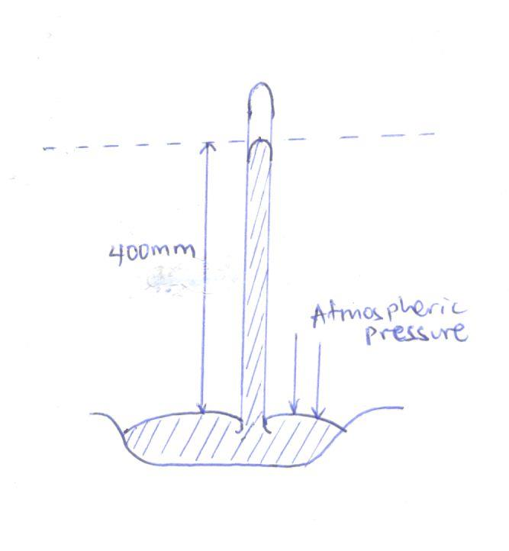

Calculate the atmospheric pressure
(i) in cmHg.
(ii) Pascal or Nm⁻²
(e) Given that the atmospheric pressure of mercury is 76cmHg and the density of mercury 13600kgm⁻³. Calculate the atmospheric pressure in Nm⁻² or Pascal.
(f) (i) The column of mercury supported by the atmospheric pressure is 76cm. Find the
column of water supported by atmospheric pressure in the same place.
(ii) Explain why water is not used in a barometer using the answer in (i).

- (a) Outline the applications of atmospheric pressure.
(b) Explain briefly how a person is able to drink using a straw.
(c) With the aid of a diagram, explain the mode of operation of lift pump or common pump.
(d) With the aid of a diagram, explain the mode of operation of a force pump.
(e) With the aid of a diagram, explain how a bicycle pump works.

- (a) With the aid of a diagram, explain how a monometer can be used to measure the fluid
pressure.
(b)
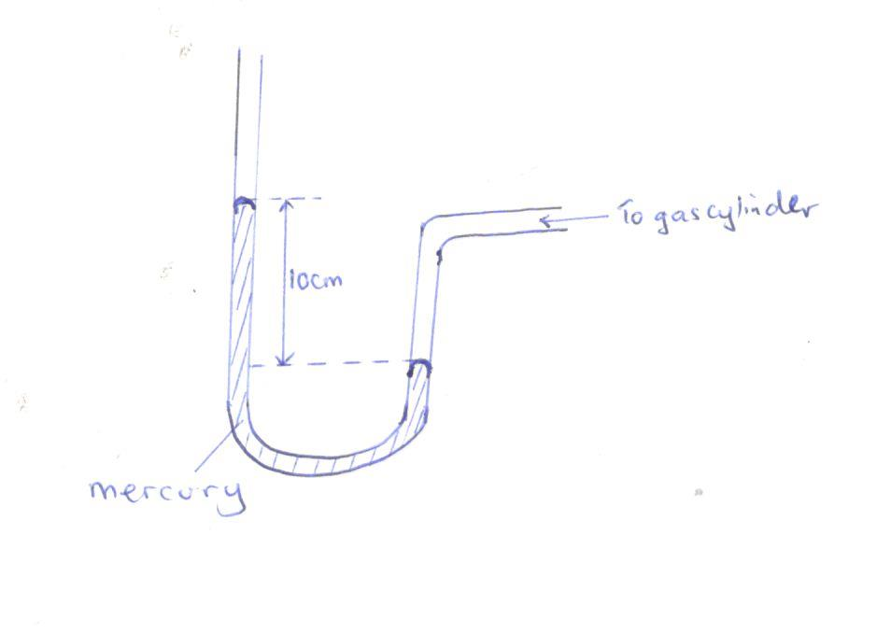
Find the gas pressure if the atmospheric pressure H = 76cmHg and density of mercury 13600kgm⁻³
(i) in cmHg
(ii) in Nm⁻²
(c)
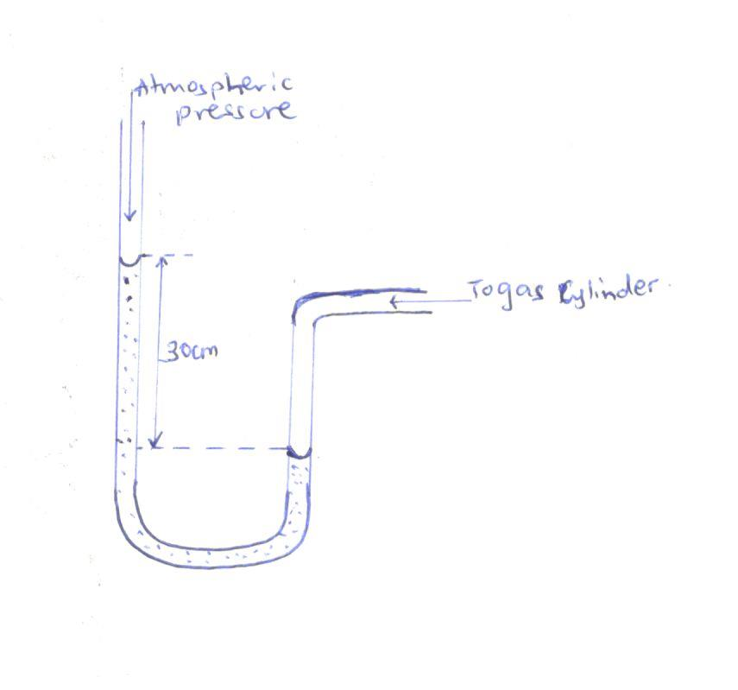
If the density of water is 1000kgm⁻³ and H = 76cmHg. Calculate pressure in Nm⁻².

- (a) Describe an experiment to demonstrate how monometer can be used in comparison or
comparing density of two liquids.

(b)
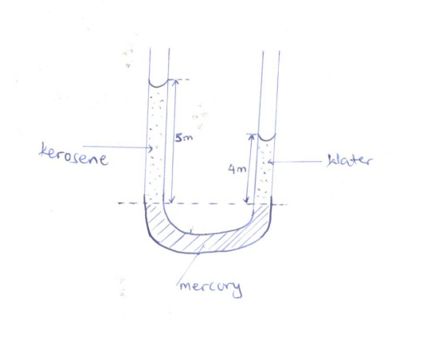
If the density of water is 1000kgm⁻³. Calculate;
(i) The density of kerosene.
(ii) The relative density of kerosene.

(c)
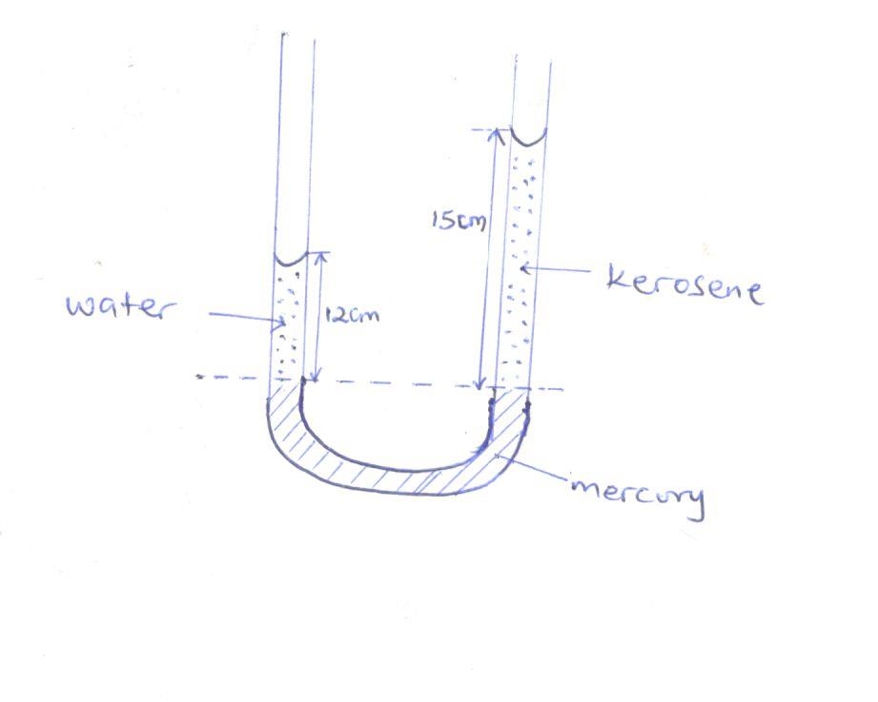
If the density of water is 1000kgm⁻³ calculate
(i) The density of kerosene.
(ii) Relative density of kerosene.

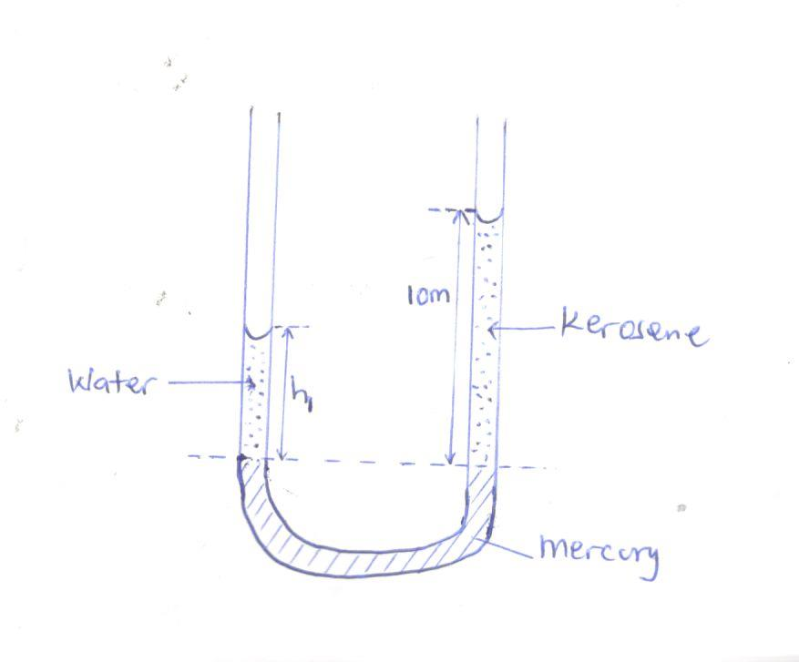
If the density of water is 1000kgm⁻³ and density of kerosene being 800kgm⁻³, calculate the height h₁

ARCHIMEDES AND FLOATATION
- (a) State the Archimedes principle.
(b) With the aid of a diagram describe an experiment to verify Archimedes principle.
(c) (i) A body weighs 40N in air, 15N when wholly immersed in water. Calculate the
upthrust.
(ii) A body weighs 10N in air, when wholly immersed in water it appears to weigh 6N. Calculate the weight of water displaced.
(d) A metal weighs 30N in air and 10N when fully immersed in water. Calculate;
(i) Upthrust.
(ii) Weight of displaced water.
(iii) Volume of displaced water if density of water = 1000kgm⁻³. (Take g = 10ms⁻²)
(iv) Volume of metal.
(v) Density of metal.
(e) A stone weighs 8N in air and 6N when totally immersed in water. Calculate
(i) Upthrust.
(ii) Weight of displaced water.
(iii) Volume of displaced water if density of water = 1000kgm⁻³. (Take g = 10ms⁻²)
(iv) Volume of stone
(v) Density of stone.
(f) Give two applications of Archimedes principle.
(g) (i) An object weighs 20N in air and 5N in water. Find the relative density.
(ii) An object of relative density 2 weighs 10N in air. Find the weight of the object in water.
(h) (i) An object weighs 50N in air, 30N in water and 10N when immersed in a liquid. Find
the relative density of air.

- (a) State the law of floatation.
(b) (i) Describe an experiment to verify the law of floatation.
(ii) What happens to the body when the weight of the body is greater than the upthrust?
(iii) What happens to the body when the weight of the body is less than the upthrust?
(c) (i) Explain why a ship is able to float on water.
(ii) Explain why submarines are able to sink and travel below water.
(d) Give the applications of the law of floatation.
(e) Explain why airships are able to fly in space.
(f) Define the term upthrust.

- (a) Name the three forces that act on a body when it falls through a fluid.
(b) Name the velocity attained by a body as it continues to fall through a fluid.
(c) Define the term terminal velocity.
(d) Draw a graph to show the variation of terminal velocity with time.

- (a) A wooden sphere of mass 6kg and volume 0.02m³ floats on water. Calculate
(i) Volume of the sphere below the surface of water.
(ii) Density of the wood.
(iii) Fraction of the volume of the sphere that would be submerged if it floats in a liquid of density 800kgm⁻³.
(b) The mass of an object 0.5gcm⁻³ is 40g. What fraction of the object is immersed when it floats in water?
(c) The solid of volume 1x10⁻⁴m³ floats on water of density 1x10³kgm⁻³ with ¾ of its volume submerged. Find
(i) The mass of solid.
(ii) The density of solid.
(d) When a metal is completely immersed in a liquid A its apparent weight is 40N. When immersed in another liquid B the apparent weight is 32N. If the density of B is ¾ times that of A, calculate the mass of the metal.
(e) A rubber ballon of mass 5x10⁻³kg is inflated with hydrogen and held stationary by means of a string. If the volume of the inflated ballon is 5x10⁻³m³, the density of hydrogen = 0.8kgm⁻³, the density of air = 1.15kgm⁻³. Calculate the tension in the string.
(f) Explain why a cork stopper held below the surface of water rises when released.

MOMENT OF FORCE
- (a) Define moment of a force.
(b) State the principle of moment of force.
(c) Describe an experiment to determine the mass of a uniform metre rule.
(Principle of moment)

(d)
5cm
2cm
1cm

F
4N 10N

Calculate the value of F.

- A uniform beam 2m long is suspended as shown below.
1.5m
0.5m
10cm
d₁
d₂

M
20kg
Calculate the mass of M.

- In the following figure, the system is in equilibrium. Find the value of force, F.
0.3m

0.1m
0.2m
0.2m

6N
4N
F
5N

- Find the value of the reaction R and force P in the following diagram.
R
5m
4m
3m

10N 5N P

- A uniform metre rule is pivoted at 20cm mark as shown. Find the weight of meter rule.
20cm
20N

0cm
100cm

- A uniform metre rule is balanced horizontally on a pivot at the 15cm mark when a load of 7N is attached at the zero mark as shown below. Find the weight of the metre rule.
Metre rule
15cm

7N

- In the diagram below, the body is in equilibrium. Determine the value of W
4N
8N

50cm
40cm

20cm

W

- A uniform metre rule is suspended from 20cm as shown below. If the metre rule is in equilibrium, find its weight.
40cm
0cm 20cm 100cm

60N

- (a) Describe an experiment to determine the mass of a uniform metre rule.
(b) A uniform metre rule is balanced at 30cm mark when a load of 0.8m is hang at the zero mark. Find the weight of the metre rule.
(c) State the condition for a body to be in equilibrium.
(d) Explain why bus passengers’ luggage is loaded in the boots rather than on top of the bus.
- (a) Define centre of gravity.
(b) Describe the experiment to determine the centre of gravity of irregular lamina.
- (a) State the condition for a body to be in
(i) Stable equilibrium.
(ii) Unstable equilibrium.
(iii) Neutral equilibrium.
(b) State the ways of increasing stability of a body.

NEWTON’S LAW OF MOTION
- (a) State the three Newton’s laws of motion.
(b) Define the following terms
(i) Inertia.
(ii) Newton.
(iii) Momentum and give its S.I unit.
(c) (i) Explain why a passenger when sited in a car moves forward when a car breaks or
stops suddenly.
(ii) Explain why a passenger standing on the floor of a lorry jerks backwards when the lorry starts moving forward.
(iii) Explain that happens to a person seated in a vehicle when it is suddenly brought to rest.
(iv) Explain why passengers in a vehicle need to fasten their seat belts.
(d) A body of mass 4kg travelling at 10ms⁻¹ is accelerating to 16ms⁻¹ in 20s. Calculate;
(i) The change in momentum.
(ii) Rate of change in momentum.
(iii) The applied force.
(e) A body of mass 300g moving at 5ms⁻¹ is accelerated uniformly at 1ms⁻² for 4s. calculate
(i) Change in momentum.
(ii) Rate of change in momentum.
(iii) The force acting on a body.
(f) Briefly explain what happens to an individual in a lift when it instantly;
(i) Moving upwards.
(ii) Moving downwards.
(iii) At rest.
(g) Find the reaction of a girl of mass 50kg standing in a lift. If the lift is;
(i) At rest.
(ii) Ascending upwards with uniform acceleration of 4ms⁻².
(iii) Descending downwards with uniform acceleration of 4ms⁻².
(h) Calculate the reaction of a boy of mass 100kg standing in a lift if the lift is;
(i) At rest.
(ii) Moving upwards with uniform acceleration of 5ms⁻².
(iii) Moving downwards with uniform acceleration of 5ms⁻².
- (a) Define the following terms
(i) Linear momentum and state its S.I unit.
(ii) Inelastic collision.
(iii) Elastic collision.
(iv) Give the difference between inelastic collision and elastic collision.
(b) State the principle of conservation of linear momentum.
(c) (i) A body of mass 2kg travelling at 8ms⁻¹ collides with a body of mass 4kg traveling at
10ms⁻¹ in the same direction. If after collision the two bodies move together, calculate the velocity with which the two bodies move.
(ii) A body of mass 20kg traveling at 5ms⁻¹ collides with another stationary body of mass 10kg and they move separately in the same direction. If the velocity of 20kg mass after collision was 2ms⁻¹, calculate the velocity of a stationary body after collision.
(iii) A body of mass 4kg travelling at 10ms⁻¹ collides with a stationary object and they move together with a velocity of 5ms⁻¹. Calculate the mass of a stationary body.
(d) (i) A bullet of mass 20kg is fired with a velocity of 10ms⁻¹ from a gun of 5kg. Calculate
the recoil velocity of a gun.
(ii) A boy of mass 50kg jumps out of a boat of mass 100kg to the bank with a velocity of 4ms⁻¹. Calculate the velocity with which the boat begins to move backwards.
(e) Give the applications of the Newton’s third law of motion and conservation of momentum.
(f) State the law of conservation of momentum.
(g) Outline the facts on which linear momentum depends.
(h) Explain what happens when a balloon is filled with air and then released in space without tying its open end.
(i) Explain what happens to a passenger in a bus when the driver brakes suddenly.
(j) Explain that happens to a parachutist who jumps from a high flying plane.
(k) State the factors on which linear momentum depends.
3(a) A2kg object moving with a velocity of 8ms⁻¹ collides with a 3kg moving with a velocity of 6ms⁻¹ along with the same direction. if the collision is completely inelastic, calculate the loss in kinetic energy.
(b) Two bodies A and B of mass 2kg and 4kg moving with a velocity of 8ms⁻¹ and 5ms⁻¹ respectively collide and move in the same direction. If object A has a velocity of 6ms after collision, calculate
(i) The velocity of B after collision
(ii) The loss in kinetic energy

(c) A particle of mass 2kg moving with a speed of 10ms⁻¹ collides with a stationary particle of mass 7kg. immediately after impact, the particles move with the same speed but in opposite directions. Find the loss in kinetic energy.
MOTIONS
- (a) Define the following terms as used in motion.
(i) Speed.
(ii) Distance
(iii) Velocity.
(iv) Uniform velocity.
(v) Displacement.
(vi) Acceleration.
(vii) Uniform acceleration.
(b) Differentiate between the terms speed and velocity.
(c) A car travels a distance of 250km in 5 hours. Calculate the average speed in
(i) km/hr.
(ii) ms⁻¹
(d) Sketch a distance – time graph showing
(i) A body at rest.
(ii) A body moving with uniform velocity.
(iii) A body moving with non – uniform velocity.
(iv) A body moving with decreasing acceleration (retardation).
(e) Sketch a velocity – time graph showing;
(i) A body with uniform velocity.
(ii) A body moving with uniform acceleration.
(iii) A body moving with uniform deceleration.
(iv) A body moving with non uniform acceleration.

- (a) A body starts from rest and reaches a speed up 4ms⁻¹ after traveling with uniform
acceleration in a straight line for 2s. Calculate
(i) The acceleration of the body.
(ii) The distance traveled during that time.
(b) A car starting from rest reaches a velocity of 20ms⁻¹ in 5s with a uniform acceleration. Calculate
(i) The acceleration.
(ii) Distance traveled in this time interval.
(c) A body traveling at 10ms⁻¹ is accelerated uniformly for 3 seconds at 5ms⁻². Calculate the final velocity.

(d) A car starts from rest and accelerates for 10ms⁻² a velocity 20ms⁻². It continues with this velocity for a further 20s before it is brought to rest in 20s.
(i) Draw a velocity – time graph to represent the motion and calculate;
(ii) The acceleration of the car.
(iii) The deceleration of the car.
(iv) The distance traveled.
(v) The average speed.
(e)
Velocity (ms⁻¹)

20

A B C

0 10 30 40 Time (s)

The diagram above represents a velocity – time graph for the motion of the body. Calculate;
(i) The total distance travelled.
(ii) The average speed.
(f) A car from rest accelerates to velocity 20ms⁻¹ in 5s, it continues at uniform velocity for 15s and then decelerates so that it stops in 10s.
(i) Draw a velocity – time graph to represent the motion and calculate;
(ii) The acceleration of the car.
(iii) The deceleration of the car.
(iv) The distance travelled.
(v) The average speed.
(g) The diagram below shows a velocity – time graph for a car in motion.

Velocity (ms⁻¹)

60

10 40 50 Time (s)

(i) Find the total distance of the car.
(ii) Calculate the retardation of the car.
(h) A car travelling at 10ms⁻¹ is uniformly accelerated for 4s at 2ms⁻². It then moves with a constant speed for 5s after which it is uniformly brought to rest in another 3s. Draw a velocity – time graph for the motion of a car.
(i) A car travels with a velocity of 10ms⁻¹ for 3s. It then uniformly brought to rest in 2s. Draw a velocity – time graph for the motion of a car

(j) The graph above respresents a velocity- time graph for the motion of the body.

Velocity
(ms⁻¹)

40
C

A B
10

0 2 6 8 E
Time

(i) Calculate the acceleration of the body between OA, AB and BC.
(ii) Calculate the total distance traveled in 8s.
(k) A body starts from rest and accelerates uniformly to a speed of 10ms⁻¹ in 2s. It maintains this speed for 4s before accelerating uniformly again for another 2s.
(i) Draw a velocity – time graph for the motion.
(ii) Find the highest speed attained by the body.
(iii) Calculate the acceleration of the body.
(iv) Calculate the total distance traveled.

(l)
Velocity
40

B
C
10
D
A

0 6 14 20 Time (s)

(i) Calculate at the total distance covered.
(ii) Calculate the distance covered when the body was accelerating.
(iii) Calculate the distance covered when the body has uniform velocity.

(m) The diagram above respresents a velocity- time graph for the motion of the body.
Time
A E
Velocity
B C
D

The diagram above represents a velocity – time graph for the motion of a body. Describe the motion of the body
(i) Along AB
(ii) Along BC
(iii) Along CD
(iv) Along DE
(n) Give three differences between acceleration and velocity.

MOTION UNDER GRAVITY
- (a) An object is raised from rest at point 20m above the ground so as to fall freely vertically
downwards.
(i) Find the time taken to land on the ground.
(ii) Find the velocity.
(b) A ball is thrown vertically upwards with initial velocity of 30ms⁻¹.
(i) Find the maximum height to reach the ground.
(ii) Find the time taken to reach the maximum height.
(iii) Find the time taken to return to the starting point.
(c) A stone is thrown vertically upwards with initial velocity 10ms⁻¹. If the air resistance is neglected;
(i) The maximum height reached.
(ii) The time taken before it reached the ground.
- (a) Sketch a distance – time graph for a body falling freely from rest.
(b) An object falls from rest of the top of a house. Calculate the velocity after 2s.
(c) An object is dropped from a top of a building. If the object hits the ground after 2s, calculate the height from which the object was dropped.
(d) An object is dropped from an helicopter at a height of 20m. If the helicopter is at rest, find
(i) How long an object takes to reach the ground.
(ii) The velocity on its arrival.
(e) An object is released from an aircraft travelling horizontally with constant velocity of 100ms⁻¹ at a height of 250m neglecting the air resistance.
(i) Find how long it takes the object to reach the ground.
(ii) Find the horizontal distance covered by the object between leaving and reaching the ground.
(f) A stone projected from top of a building at a horizontal velocity of 20ms⁻¹ strikes the ground from the building. Find the height of the building.
(g) An object is thrown vertically upwards with a velocity of 30ms⁻¹.
(i) Calculate the time taken to reach the maximum height.
(ii) Find the time taken by the object to come back to the thrown level.
(h) An object is thrown vertically upwards. If it reaches a maximum height of 20m,
(i) Calculate the time it takes to reach the maximum height.
(ii) Find the time taken by the object to return to the starting point.
(i) A stone is thrown horizontally from the top of a cliff at a horizontal velocity of 30ms⁻¹. If it takes 4s to reach the ground,
(i) Find the height of the cliff.
(ii) Find the horizontal distance covered by the stone.
(j) An object of 2kg is dropped from a helicopter at height 20m above the ground. If the air resistance is 0.4N, calculate
(i) The acceleration.
(ii) The velocity.

CIRCULAR MOTION
- (a) Define the term circular motion.
String
(b)
Stone

A

(i) The diagram above shows a stone fixed to one end of the string and then whirled (swung) in horizontal circular path. Copy the diagram and show on it the forces acting on the stone in position A.
(ii) Explain what happens if the string breaks when the stone is in position A.
(c) Give examples of objects moving in circular path.

END

