NAME………………………………………………………………………..CLASS………………………………
NAMAGABI HIGH SCHOOL
END OF TERM II EXAMS 2019
S 1 PHYSICS
DURATION 2HOURS
INSTRUCTIONS.
- Attempt all questions in both sections
- You are required to put the correct alternative A, B, C or D in the box provided.
- Answers to section B should be written the space provided
- Acceleration due to gravity = 10m/s^{2.}
SECTION A (30 MARKS)
- The width of a meter rule is measured accurately by a,
- Vernier caliper
- Micrometer screw gauge
- Tape measure
- Meter Rule.

- The basic quantities of measurement are
- Mass, frequency, and power.
- Time, density and pressure.
- Area, electric current and volume.
- Length, mass and time.

35N 20N
BODY

Find the resultant force on the body above
- 35N C.15N
- 20N D.10N
- Force is given by the product of
- Displacement and velocity
- Displacement and mass.
- Acceleration and mass.
- Velocity and mass.
- What does a beam balance measures.
- Mass C. Volume
- Density D. Pressure

- How can you define matter?
- Physical object on earth.
- Anything that occupies space and has weight.
- Matter refers to liquid such as water which flow.
- Matter refers to solid that are heavy.

- Which one of the following is not a fundamental unit?
- Grams. C. Meters
- Kilograms. D. Seconds

- The ratio of mass of a substance to the mass of an equal vol. of water is referred to as
- Force. C. Up thrust
- Relative density. D. Weight

- Which of the following quantities varies as one moves from the earth’s surface to the moon
- Weight. C. Volume.
- Mass D. Height

- Force of 60N, 10N, 40N and 10N act on a body as shown below.
10N

40N 60N

10N
In which direction does the body moves
- Upwards.
- Downwards.
- To the left.
- To the right.

- P
6N
8N

Two force of 6N and 8N act on object P as shown above. The resultant force on the body object is.
- 1.33N. C. 10N
- 2N. D. 14N

- The product of force and distance is called.
- Work. C. Energy
- Power. D. Force

- Which one of the following quantities is the odd one out?
- Force. C. Momentum
- Velocity. D. Kinetic energy

- Convert 65cm³ to m³.
- 6.5x10⁵ C. 6.5x10⁻¹
- 6.5x10² D. 6.5x10⁻⁵

- Two liquids P and Q are mixed in equal volumes such that the average density of the mixture is 800kg/m³ if the density of p is 500kg/m³. Find the density of liquid Q.
- 1100kg/m³. C. 1500kg/m³.
- 1200kg/m³. D. 2200kg/m³.

- A box of dimension 0.2m by 0.3m by 0.5m is full of a gas of density 200kg/m³. The mass of the gas is.
- 3x10⁻³kg. C. 2x10²kg.
- 6.0x10⁰kg. D. 7x10³kg.

- Which one of the following is not derived Quantity.
- Density. C. Speed
- Volume. D. Length

- A micrometer screw gauge is used to determine the diameter of a circular object. The sleeve reading is noted as 4.5mm while the thimble reading is 35 divisions. The diameter of the object is
- 8.00mm. C. 4.535mm
- 4.85cm. D. 4.85mm

- The dimension of a black board are 2.0x1.5m.the area of this black board in centimeters is
- 3.0cm². C. 3000cm²
- 30000cm². D. 300cm²

- Which of the following is not an s.1 unit symbol for a fundamental quantity?
- Kg C. s
- m D. ms⁻¹

- The density of mercury is 13.6gcm^{-3.} Express this density in kgm^{-3.}
- 13.6kgm⁻³. C. 13600kgm⁻³.
- 0.0136kgm⁻³. D. 1360kgm⁻³.

- The S.I unit of work is
- Joule C. Newton
- Watts. D. Kilograms

- A long of mass 10tones is moving over a leveled road with coefficient of friction 0.25. Find the friction force between the tyres of the long and the road surface.
- 25000N C. 2500N
- 10000N. D. 0.250N

- The formula for coefficient of friction can be given by
- µ=$\frac{R}{F}.$
- µ=$\frac{F}{R}.$
- F= µmg.
- µ= $\frac{F mg}{R}$ .

- The force that keeps a body moving at a constant speed in a circle is.
- Gravitational force.
- Elastic force.
- Centrifugal force.
- Centripetal force.

- A Newton is defined as the:
- Unit of force.
- Force which gives a mass of 1kg an acceleration of 1m⁻².
- Force which produces an acceleration of 1ms⁻².
- Force which gives any mass an acceleration 1m⁻²

- A force which opposes relatives motion between two bodies in contact is

- Friction.
- Static friction.
- Dynamic friction.
- None of them.

- The Quantity which has only magnitude or size is known as.
- Vector quantity.
- Scalar quantity.
- Force.
- Weight.

- An object of mass 3kg has a density 0.5kg/m³.find the volume in m³.
- 1.67m³.
- 6m³.
- 1.5m³.
- 3m³.

- The figure below show a vernier caliper nearly the diameters of the object is

1cm 2cm

0 10

- 1.05cm.
- 1.06cm.
- 1.56cm.
- 1.60cm.

SECTION B (30 MARKS)

- (a) Define the term matter. (1 mk)
………………………………………………………………………………………………………………………………………………………………………………………………………………………………………………………………………………………………………………………………
(b) State any 3 states of matter. (3mks)
………………………………………………………………………………………………………………………………………………………………………………………………………………………………………………………………………………………………………………………………
- Convert 65cm² to m². (2mks)
………………………………………………………………………………………………………………………………………………………………………………………………………………………………………………………………………………………………………………………………………………………………………………………………………………………………………………………………………………………………………………………………………………………………………………………………………………………………………………………………………………………………………………
- (i) Figure below show a micrometer screw gauge. Name the following parts. A ,B,C D,E and F
A B C D E
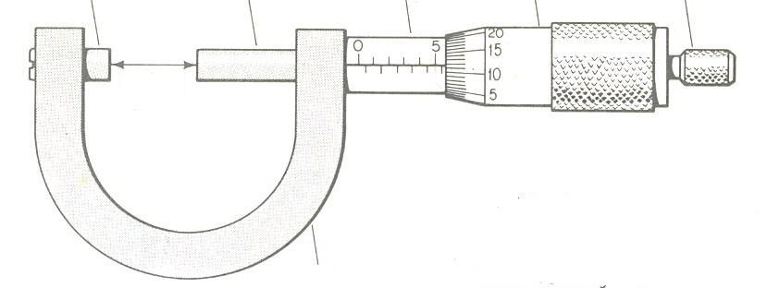
F

A…………………………..B…………………………………….C……………………………………………
D…………………………..E……………………………………..D…………………………………………..
(2 mks)

(ii) Calculate the reading of a micrometer screw gauge. (2 mks)
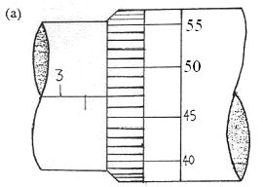

- (a) Define the term friction. (2 mks)
…………………………………………………………………………………………………………………………………………………………………………………………………………………….

(b) A tractor moving on a level load experiences a friction force of 8000N. If the coefficient of friction between the tyres and the tyre ground is 0.1, find the mass of the tractor. (3 mks)
……………………………………………………………………………………………………………………………………………………………………………………………………………………………………………………………………………………………………………………………………………………………………………………………………………………………………………………………………………………………………………………………………………………

- (a) Define the term density and state its S.I unit. (1mk)
………………………………………………………………………………………………………………………………………………………………………………………………………………………………………………………………………………........................................................................
(b) A tank of 2m fall and base area 2.5m² is filled with a liquid of mass 4000kg. Calculate the density of the liquid. (3mks)
……………………………………………………………………………………………………………………………………………………………………………………………………………………………………………………………………………………………………………………………………………………………………………………………………………………………………………………………………………………………………………………………………………………………………………………………………………………………………………………………….
- Complete the table below. (4mks)
Basic Quantity | S.I unit | Symbol.
Mass | … | kg
... | second | …
Length | … | …
- (a) Define the term force and state its S.I unit. (1mk)
………………………………………………………………………………………………………………………………………………………………………………………………………………………………………………………………………………………………………………………………
(b) Differentiate between scalar quantities and vector quantities. (2mks)
………………………………………………………………………………………………………………………………………………………………………………………………………………………………………………………………………………………………………………………………
(c). The figure below shows five forces acting on a 2.5kg mass.
9N

12N
7N
2.5 kg

13N 8N
Calculate the resultant force on the mass. (3mks)
………………………………………………………………………………………………………………………………………………………………………………………………………………………………………………………………………………………………………………………………………………………
Calculate the acceleration of the mass. (2mks)
……………………………………………………………………………………………………………………………………………………………………………………………………………………………………………………………………………………………………………………………………………...................
…. END ….

