BRIGHT SECONDARY SCHOOL SEETA
S.1 MIDTERM 1 2018 COMPUTER STUDIES
TIME: 50minutes

INSTRUCTION
Answer all questions in section A and B

1. Data is a general word for:

A. Processed information. B. Raw materials.
C. Raw facts and figures. D. Dynamic Access Time Application.

- The term used to refer to the ability of computers to perform the same task for long without getting tired is:

A. Endurance B. Versatile.
C. Diligent. D. Accurate.
- A computer performs all the following except:

A. Storage. B. Processing.
C. Output. D. Thinking

- IBM stands for:

A. Input Bytes Mechanism. B. International Business Machine.
C. Inverse Binary Mode. D. Inter Base Multiplications.
- Tangible components of a computer are called?

A. Software B. Hardware
C. Peripherals D. Equipment
- How many bits are found in the word MAD ?
A. 3 B. 8
C. 12 D. 24
7. What is the odd man out?
A. Thermometer B. Pocket Calculator
C. Voltmeter D. CPU

8) Pc in full is
A. Personal calculator B. Pocket Calculator
C. personal computer D. portable computer
9) RAM in full is:
A. Random Access metal B. Read Access memory
C. Random Access memory D. Random Access moment

10). A computer is more intelligent than human being:
A. I do not know B. very true
C. False D. I am not sure

11) One byte is equal to:
A. 4 bits B. 8 bits
C. 6 bits D. 10 bits
12. GIGO in full is
A. Garbage inside Garbage Out. B. Garbage inside Garbage Outside.
C. Garbage In-front Garbage Out-front. D. Garbage in Garbage Out

13) Define the term computer (2 marks)
……………………………………………………………………………………………………………………………………………………………………………………………………………………………………………………………………………………………………………………………………………………………………..
b) Mention the four major functions of a computer (4 marks)
…………………………………………………………………………………………………………………………………………………………………………………………………………………………………….
………………………………………………………………………………………………………………………
C) Give 3 reasons why we study computer today (4 marks)
………………………………………………………………………………………………………………………………………………………………………………………………………………………………………………………………………………………………………………………………………………………………………………………………………………………………………………………………………………………………………………………………………………………………………………………………………………………………………………………………………………………………………………………………………………
14) Define the term information processing cycle (2 marks)
……………………………………………………………………………………………………………………………………………………………………………………………………………………………………………………………………………………………………………………………………………………………………..
b) Outline the stages of information processing cycle (4 marks)
………………………………………………………………………………………………………………………………………………………………………………………………………………………………………………
c) Give the difference between data and information (2 marks)
………………………………………………………………………………………………………………………………………………………………………………………………………………………………………………………………………………………………………………………………………………………………………

15) Write the following in full:
i) PC ………………………………………………………………………………………….
ii) RAM ……………………………………………………………………………………
iii) CPU ……………………………………………………………………………………..
16) Outline any 4 main characteristics of modern computer today (4 marks)
………………………………………………………………………………………………………………………………………………………………………………………………………………………………………………………………………………………………………………………………………………………………………………………………………………………………………………………………………………………………
b) Mention down the four basic parts of computer (4 marks)
,………………………………………………………………………………………………………………………………………………………………………………………………………………………………………………………………………………………………………………………………………………………..
17) Label the following parts of a computer A-D
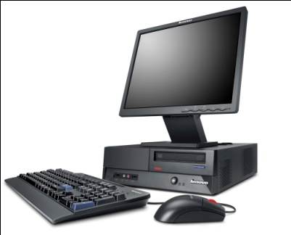
A
B
C
D

A) …………………………………………………………………………………..
B) ……………………………………………………………………………………………
C)……………………………………………………………………………………………
D) ……………………………………………………………………………………………

