273/1

GEOGRAPHY
PAPER 1
2 hour
ENTEBBE BRIGHT SECONDARY SCHOOL
Uganda Certificate of Education
GEOGRAPHY
Paper 1
S.2 END OF TERM 3 EXAMINATIONS 2018
2 hours

INSTRUCTIONS TO CANDIDATES:

- Section A is compulsory.

- Answer only one question from section B.

- Answers to all questions must be written in the answer booklet provided.

SECTION A

- Which country in east Africa has the smallest population?
A. Uganda B. Kenya C. Tanzania D. Burundi
- The coastal plain is bordered by the Indian Ocean in which direction?
A. East B.West C. south D. north.
- The following features or landforms in east Africa are formed as a result of Wave action.
A. Beach B. hills C. Rift valley D.Lakes
- The following are characteristics of the coastal plains of East Africa.
A. they have coral reefs
B. flow into the Pacific Ocean
C. have no deltas
D. have limited basement rocks
- The following lakes are found in the western arm of the East African Rift Valley.
A. lake magadi B. l.Victoria C.L.Tanganyika D.L.Eyasi.
- The coastal plain is a low –lying region of less than
- 350 meters above sea level
- 1000 meters above sea level
- 250 meters above sea level
- 380 meters above sea level

- With in the eastern plateau are steep sided, rounded, isolated hills known as;
- Mountains
- Inselbergs
- Lakes
- coral reefs
- ………………. Is an elongated strip of land formed by sinking of land between two roughly parallel faults?
- inselbergs
- highlands
- rift valley
- lakes
- The highland ranging between …………….. Form a separate and important geographical division.
- 1500-6000 meters above sea level
- 200-600 meters above sea level
- 4000-6900 meters above sea level
- 2000-3000 meters above sea level
- In east Africa there are several processes that have led to landform formation namely;
- Faulting,warping,erosion
- Warping, weathering, wind
- Tectonism,deudation,water
- Tectonism, denudational and depositional.
- Relief refers to;
- flow into the Pacific Ocean
- land formed by sinking of land between two roughly parallel faults
- steep sided, rounded, isolated hills
- the nature of the landscape.

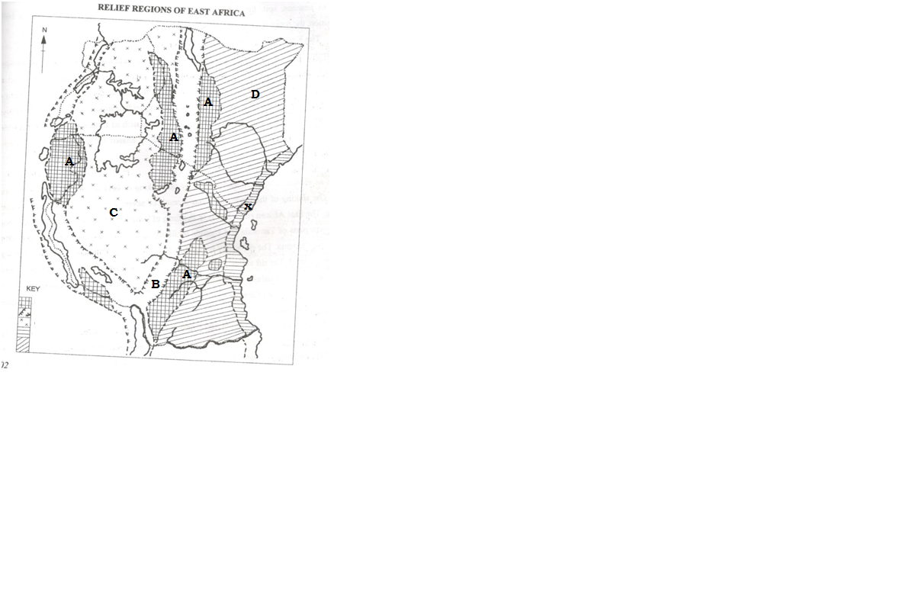
- The relief region X on a map is;

- rift valley
- Inselberg
- Mountains
- Coastal plain.
- The relief regions marked A, B, C, D are;
- coastal plain, highlands, riftvalley
- Highlands, rift valley, central plateau and eastern plateau.
- Coastal plain. highlands, rift valley, central plateau
- Rift valley, central plateau, mountains.
- The east African rift valley is divided into……..sections.
- Four
- Two
- Three
- None of the above
- Which of the following mountains is not a block mountain?
- Usambara
- Lomgnot
- Ulungulu
- Rwenzori
- Which of the following land forms is not produced by faulting or lifting?
- Steep faults
- Escarpments
- Calderas
- Tilt blocks
B

A

Moist laden air air descending
ascending mountain

The winds at B are
A: warm and moist B: cold and moist
C: cold and dry D: warm and dry
- When side A is receiving the type of rainfall shown, side B is
A: Also expecting it B: in a dry shadow
C: warm and wet D: in a rain shadow.
- Which of the following is the most common method of fish preservation used in Uganda?
A. Smoking B. Freezing C. Sun drying D. Seasoning
- The feature formed when a block of the earth's crust is depressed between parallel faults is a
A. Block Mountain B. Hanging valley
C. Tilt block D. Rift valley
- East Africa extends approximately from latitude ---E and ---East
- 28⁰ to 40⁰
- 29⁰ to 41⁰
- 30⁰ to 40⁰
- 31⁰ to 42⁰
- East Africa borders on the east
- Indian ocean
- Zanzibar and Pemba
- Mozambique
- Zambia and Zaire

- -------- is the lake shared by the three east African countries.
- Tanganyika
- Lake kyoga
- Lake Victoria
- Lake George
- The longest lake in east Africa is
- Lake kyoga
- Lake Victoria
- Lake George
- Lake Tanganyika
- Which of the following major relief feature occupies the largest area of east Africa
- The rift valley
- Coastal plain
- Central and lake plateaus
- The highland areas.
- The instrument used to measure the rainfall amounts at a weather station is the:
- Barometer
- Hygrometer
- Anemometer
- Rain gauge
- East Africa is covering a total area of
- 17773200km²
- 1773200 km²
- 177040 km²
- 1780200 km²

- -------is the smallest country in east Africa
- Zambia
- Pemba
- Uganda
- Kenya.
- East Africa extends approximately from latitude N to S.
- 5⁰ to 12⁰
- 12⁰ to 5⁰
- 41_{1/2}⁰ to 11_{1/2}⁰
- 4_{1/2}⁰ to 12⁰
- Isohyets’ are lines drawn on a map to
- Join place of equal temperature
- Join places of equal humidity
- Join places of equal rainfall
- Join places of equal sunlight.
SECTION B

- Study the climate statistics of station Z: (Altitude 2150 metres) found in East Africa and answer the questions that follow:

STATION Z: (Altitude 2150m)

Month | J | F | M | A | M | J | J | A | S | O | N | D
Temperature ºC | 24 | 24 | 25 | 24 | 23 | 22 | 21 | 21 | 22 | 24 | 24 | 24
R.F (mm) | 75 | 115 | 155 | 240 | 205 | 160 | 160 | 185 | 150 | 135 | 110 | 65
Source: Minns, W.J.(1993) A Geography of Africa New Edition P.60

- Draw a suitable graph to show the climate of station Z (08 marks)
- Calculate the:
- mean annual rainfall, (01 mark)
- Annual range of temperature for the station. (01 mark)

- Describe the:
- Characteristics of the climate experienced at the station. (04 marks)
- Economic activities which are carried out in the area where the station is found.

(04 marks)

- Giving reasons for your answer, state the hemisphere in which the station is found
(02 marks)
" PEACE AND THE MERCY OF ALLAH BE UPON YOU".
****END****

