RWENZORI CHRISTIAN VOCATION SS
MID OF TERM II 2019
S.2 BIOLOGY (THEORY)
TIME: 2 HOURS
INSTRUCTIONS:
- Attempt all questions in both sections
SECTION A (30 Mks)
1. A dry dehiscent fruit that splits along many lines of weaknesses is called;

- Follicle
- Legume
- Capsule
- Schizocarp

2. Which of the following components of air is important for energy production?
- ${CO}_{2}$
- oxygen
- nitrogen
- temperature
3. In the leaf, most of the food is made in the

- cuticle
- palisade cells
- spongy cells
- epidermis

4. Clay soil is usually water logged due to

- small pores
- poor drainage
- small particles
- too much water

5. Which one of the following methods of controlling malaria is least harmful to the environment?
- introducing fish in ponds
- draining ponds
- spraying oil on top of water ponds
- use of DDT
6. The following are characteristics of dry indehiscent fruits;
i. Dry single seeded fruit
ii. Dry fruit with seed coat fused with pericarp
iii. Dry fruit with several seeds
Which characteristic is for a Schizocarp?
A. (i)
B. (iii)
C. (ii)
D. (i) and (iii)
7. Which of the following are body protective foods

- lipids
- vitamins
- proteins
- carbohydrates

8. Which of the following pairs of flower parts are essential?

- gynoecium and corolla
- corolla and calyx
- gynoecium and androecium
- androecium and corolla

9. The most destructive stage in the life cycle of a butterfly is

- larva
- pupa
- egg
- adult

10. A caryopsis refers to
- maize seed
- a single seed enclosed in a dry pericarp
- hard fibrous endocarp
- fused testa and pericarp
11. Which one of the following is a feature of an arthropod?
- has 1 or 2 pairs of wings
- has three pairs of legs
- has exoskeleton
- body is divided into head, thorax and abdomen
12. The underground stem of ginger is an example of:

- rhizome
- runner
- stem tuber
- sucker

13. While analyzing a soil sample, the following results were obtained,
Volume of sand = 20cm3
Volume of water = 30cm3
Volume of water and sand after stirring = 45cm3. Find the percentage of air in the soil?
A. 25 B. 2 C. 1 D. 3
14. The following are examples of berries except?

- Avocado
- Tomato
- orange
- Pepper
15. The smallest soil particles are a mixture of

- sand and loam
- clay and sand
- clay and silt
- clay and loam

16. The response of living organisms to the surrounding is termed as:

- Irritability
- Photosynthesis
- Respiration
- Movement

17. In plants, the male gamates are found in the

- anthers
- style
- ovary
- filaments

18. A place where an organism lives is called its

- environment
- habitat
- terrestorial
- surrounding
19. The sucking mouth parts of housefly are called

- proboscis
- mandibles
- maxillae
- cabia

20. Which one of the following brings about an increase in width of a stem of a flowering plant?

- xylem
- cambium
- phloem
- cortex

21. The figure below shows a drawing of a modified root:

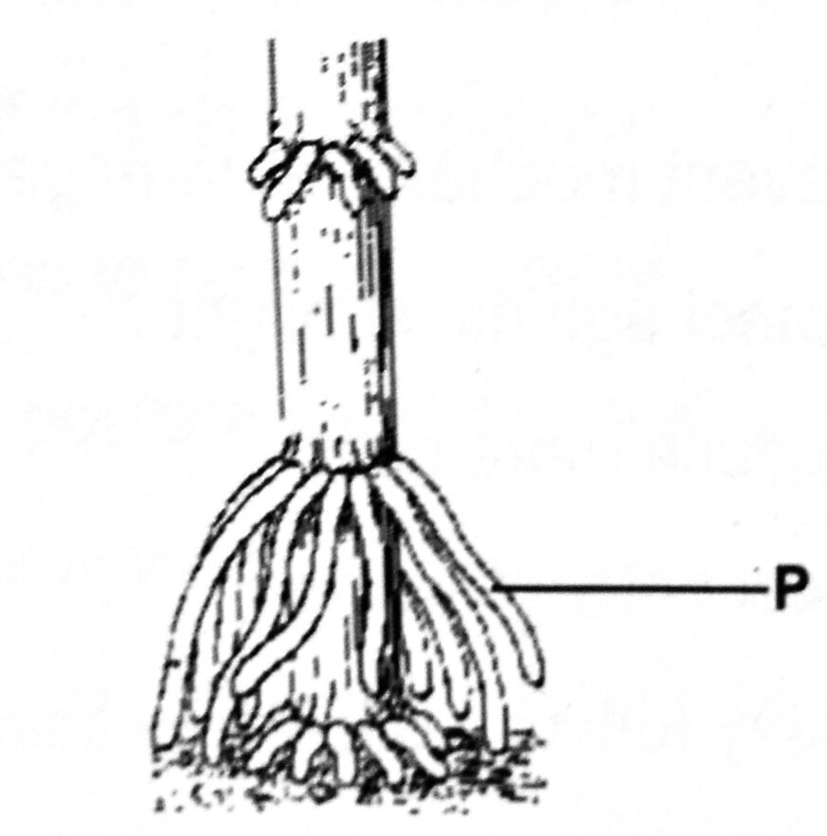

What name is given to the structure labeled P above?

A. Stilt root.
B. Prop root.
C. Clasping root.
D. Breathing root.

22. Which one of the following has two lines of weakness.

- follicle
- legume
- caryopsis
- capsule
23. Addition of humus to sandy soil would
- decrease the capillarity of the soil
- increase the aeration of the soil
- decrease mineral content of the soil
- improve the water retention capacity of the soil
24. The diagram below shows a longitudinal section of a legume:
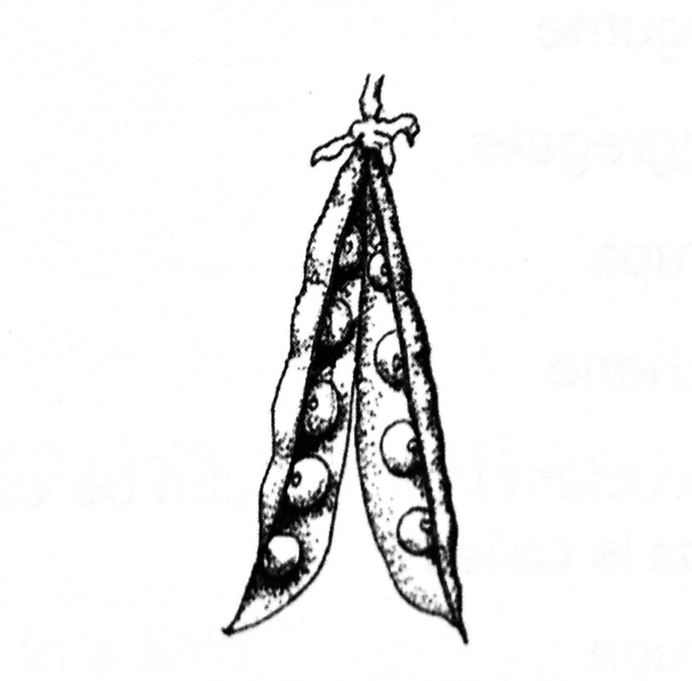

What type of placentation is shown?

A. Marginal
B. Parietal
C. Axile
D. Basal
25. Which one of the following parts of a flower is not essential for reproduction?

- corolla
- stigma
- style
- anther
26. Which one of the following leaves is a compound leaf?
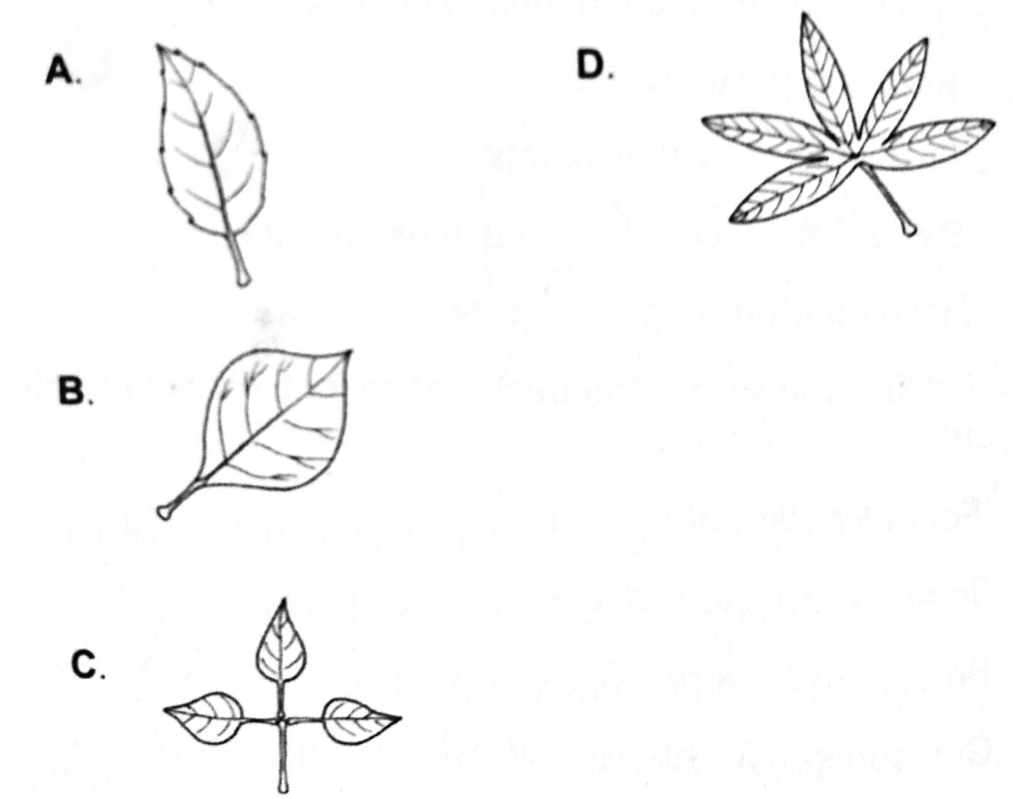

27. A Monoecious plant is the one that has:

A. Pistillate and staminate flowers
B. Pistillate flowers only
C. Staminate flowers only
D. None of the above

28. The following flowers have a Monocarpous pistil except:

A. Crotalaria
B. Beans
C. Peas
D. Hibiscus

29. The following are arrangements in flowers :
i. Flowers remain closed until fertilization.
ii. Stigma and anthers rippen at different times
iii. Anthers and stigma ripen at the same time
iv. Pistil is higher than stamen
Which ones favour self pollination?

A. (i) and (ii)
B. (ii) and (iii)
C. (i) and (iii)
D. (ii) and (iv)

30. The figure below shows the drawing of a transverse section through a dicot stem :

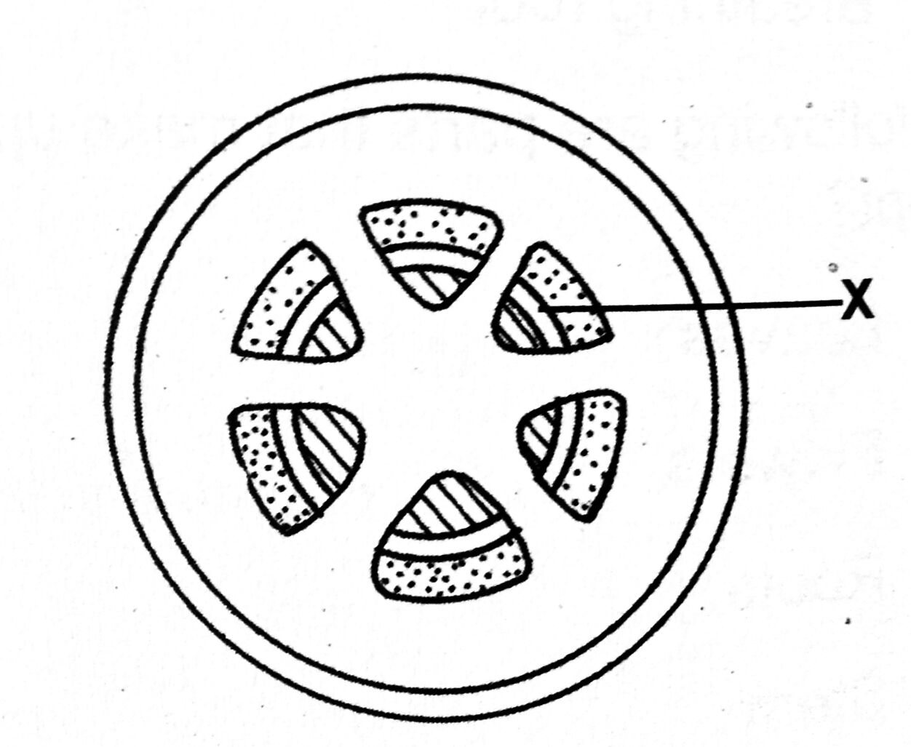

The function of part marked X is to:
A. Support the phloem and its function.
B. Divide continously to make new phloem and xylem
C. Allow food to move from phloem to pith
D. Make food for xylem and phloem
SECTION B (30 MARKS )
31. The key below classifies specimens M,N,O,P and Q
1.(a) Has 2 wings...............................M,P go to 4.
(b) Has 4 wings.............................. N,O,Q go to 2.
2. (a) Has spines on legs................N,Q go to 3.
(b) Has no spines on legs................O.
3. (a) Has hard outer wings...............Q.
(b) Has no hard outer wings...........N.
4. (a) Has a sting........................................P.
(b) Has no sting......................................M.
a) Outline the characteristics of specimen M. (2mks)
.........................................................................................................................................................................................................................................................................................................................................................................................
b). Suggest what specimen M may be. (1 mark).
..............................................................................................................................................................................................
c). Give a full classification of specimen M. (7 marks)
Kingdom...........................................................................Phylum..............................................................................Class....................................................................................Order..................................................................................Family................................................................................Genus.................................................................................Species.................................................
32 (a). Distinguish between the following terms.
i). fruit and seed. (2mks)
............................................................................................................................................................................................................................................................................................................................................................................................
ii). Drupe and Berry. (2mks)
............................................................................................................................................................................................................................................................................................................................................................................................
b). State the food nutrients that can be obtained from oranges. (1mk)
............................................................................................................................................................................................................................................................................................................................................................................................
c). State the characteristics of fruits dispersed by
i). animals. (3mks)
............................................................................................................................................................................................................................................................................................................................................................................................................................................................................................................................................................................
ii). Wind. (2mks)
.....................................................................................................................................................................................................................................................................................................................................................................
33. Kato, a senior two student collected four insects; A, B, C and D; from within the school compound and outlined the characteristics of each.
She then came up with a flow chart that would help her to make a dichotomous key; in order to identify each of the specimens. Below is the flow chart that she drafted.
From the flow chart above;
(i) Outline any two characteristics of specimen D. (02 marks)
………………………………………………………………………………………………………………………………………………………………………………………………………………
(ii) State any one example of an insect that could be represented by specimen A in our environment. (01 mark)
……………………………………………………………………………………………………
iii). Outline any five economic importance of specimen A you have mentioned in (ii) above in our environment ( 05 marks )
........................................................................................................................................................................................................................................................................................................................................................................................................................................................................................................................................................................................................................................................................................................................................................................................c) Outline any two distinguishing characteristics of insects. (02 marks)
………………………………………………………………………………………………………………………………………………………………………………………………………………
SECTION C ( 15 MARKS )
35. a) Define the following terms:
i) pollination (1mark) ii) self-pollination (1 mark )
iii) cross pollination (1 mark)
b) How is self-pollination naturally prevented in flowering plants? (6 marks )
c) Describe the features of a flower that favour pollination by insects (6 marks )
END
By NATUGONZA WISELY KYABOONA
Email: natugonzawisely@gmail.com

