Name …............................................................................................Date........................................
ADM NO. ……………………Class ……...................................... Sign. ………………………..
443
AGRICULTURE
FORM 2
OCTOBER 2017
2 HRS

SECONDARY SCHOOL
END OF TERM 3 EXAMINATIONS 2017
Agriculture Examination

INSTRUCTIONS TO CANDIDATES
- Write your Name, Class and Admission number in the spaces provided above.
- Sign and write the date in the space provided above.
- Answer ALL the questions in SECTIONS A, B and ANY TWO questions from SECTION C.
- Answers MUST be written in the spaces provided in this booklet.

FOR EXAMINER’S USE ONLY
Sections | Questions | Maximum Score | Candidate’s score
A | 1 – 13 | 35
B | 14 – 26 | 25
C | 27 – 29 | 40
C | TOTAL SCORE | 100

This paper consists of 11 printed pages. Candidates should check to ascertain that all papers are printed as indicated and that no questions are missing
SECTION A (35MKS)
ANSWER ALL QUESTIONS IN THIS SECTION

- Differentiate between the following terms as used in Agriculture:-
(a) Olericulture and floriculture (1mk)
………………………………………………………………………………………………………………………………………………………………………………………………………………
(b) Apiculture and aquaculture (1mk)
………………………………………………………………………………………………………………………………………………………………………………………………………………
- State three characteristics of dairy cattle (3mks)
…………………………………………………………………………………..……………………..………………………………………………………………………………………………………..………………………………………………………………………………………
- Give three importance of farm records (3mks)
…………………………………………………………………………………..……………………..………………………………………………………………………………………………………..………………………………………………………………………………………
………………………………………………………………………………………………….
4) a) Give any three farming methods (3mks)
…………………………………………………………………………………..……………………..………………………………………………………………………………………………………..………………………………………………………………………………………………
b) State three roles of Agriculture in the economy of Kenya (3mks)
…………………………………………………………………………………..……………………..………………………………………………………………………………………………………..………………………………………………………………………………………
- Give three factors that influence soil formation (3mks)
…………………………………………………………………………………..……………………..………………………………………………………………………………………………………..………………………………………………………………………………………

- Name three human factors that influence the efficiency of agricultural production. (3mks)
…………………………………………………………………………………..………………
……..……………………………………………………………………………………………
…………..………………………………………………………………………………………
- State three effects of wind on crop production (3mks)
…………………………………………………………………………………..……………………..………………………………………………………………………………………………………..………………………………………………………………………………………
- List three reasons for preparing land before planting (3mks)
…………………………………………………………………………………..……………………..………………………………………………………………………………………………………..………………………………………………………………………………………
- Give two reasons for practicing minimum tillage in land preparation. (3mks)
…………………………………………………………………………………..……………………..………………………………………………………………………………………………………..………………………………………………………………………………………
- Using the Pearson square method, compute a 300kg ration with 24% DCP from wheat containing 14% DCP and cotton seed cake containing 64% DCP (show your working) (3mks)

24%
DCP
Wheat 14% DCP
40parts of wheat
Cotton seed cake 64% DCP
10 parts of cotton seed cake
50 Total parts

- Give two importance of drainage as a land reclamation method. (2mks)
…………………………………………………………………………………..……………………..…………………………………………………………………………….…………………...
- Mention three properties of nitrogenous fertilizers. (3mks)
…………………………………………………………………………………..……………………..………………………………………………………………………………………………………..………………………………………………………………………………………
- A farmer had a plot of land measuring 5 hectares in which he intended to plant maize. He was advised to apply 150 kg of P₂0₅ per hectare at planting and 200kg N per hectare during top dressing. The fertilizer available in the market was Calcium Ammonium Nitrate containing 20% N and Di-ammonium phosphate 50% P₂0₅. Calculate the amount of Diammonium phosphate required. (3mks)

SECTION B (25MKS)
ANSWER ALL QUESTIONS IN THIS SECTION IN THE SPACE PROVIDED
- The diagram below shows a method of bringing tea into bearing. Study if carefully and use it to answer the questions that follow.
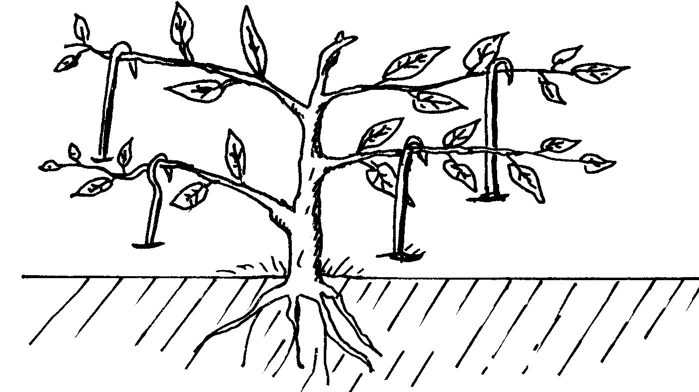

a) Identify the method shown in the diagram. (1mk)
…………………………………………………………………………………...............................
b) Why is it necessary to prune young tea plants as illustrated above? (1mk)
………………………………………………………………………………………………………………………………………………………………………………………………………………
- The diagram below represents a pineapple plant
A
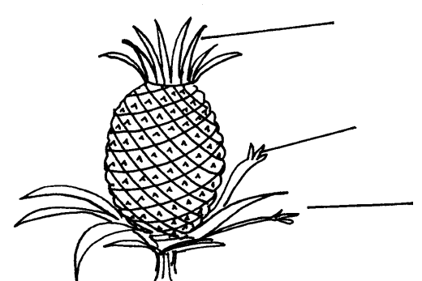

B

C

(a) Identify the parts labeled A, B and C as used in propagating the crop. (3mks)
A……………………………………………………………………………………………………….
B……………………………………………………………………………………………………….
C…………………………………………………………………………………………………………
(b) Give one advantage of using the part labelled C over A and B (1mk)
………………………………………………………………………………………………………………
- Study the illustrations showing field practices below.

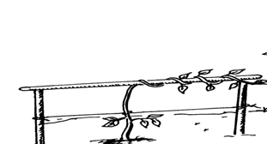  A | 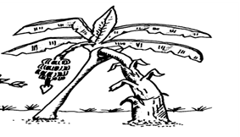  B | 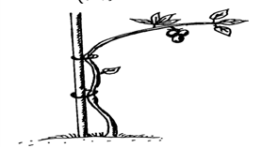  C

a) Identify the field practices shown in the diagrams A,B and C above. (3mks)
A……………………………………………….....................................................................
B………………………………………………………………………….…………………
C…………………………………………………………………………………………….
b) State one advantages of field practice B (1mk)
………………………………………………………………………………………………………
- Below are diagrams K and L showing coffee plants established using two different formative pruning systems. Study them and then answer the questions that follow

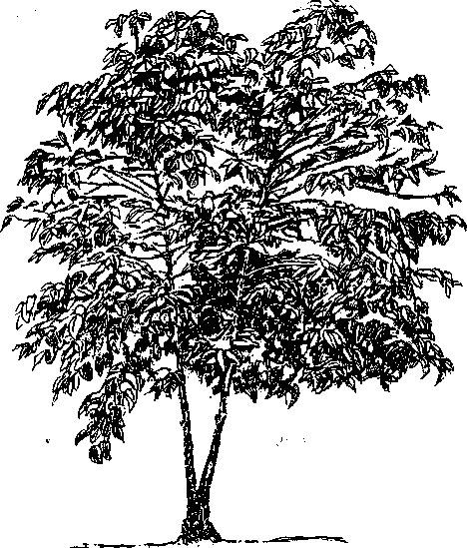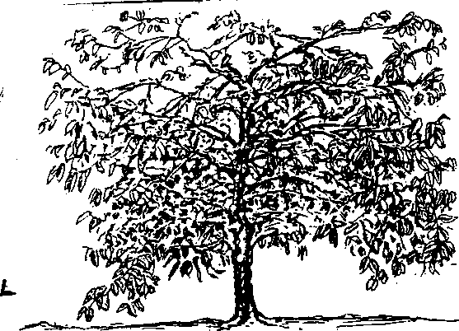
K L
a) Name the system of pruning illustrated in the diagram labeled (2mks)
K…………………………………………………………….
L…………………………………………………………….
b) State one advantages of pruning system L over K in coffee(1mk)
……………………………………………………………………..
- The diagrams below represent livestock parasites.

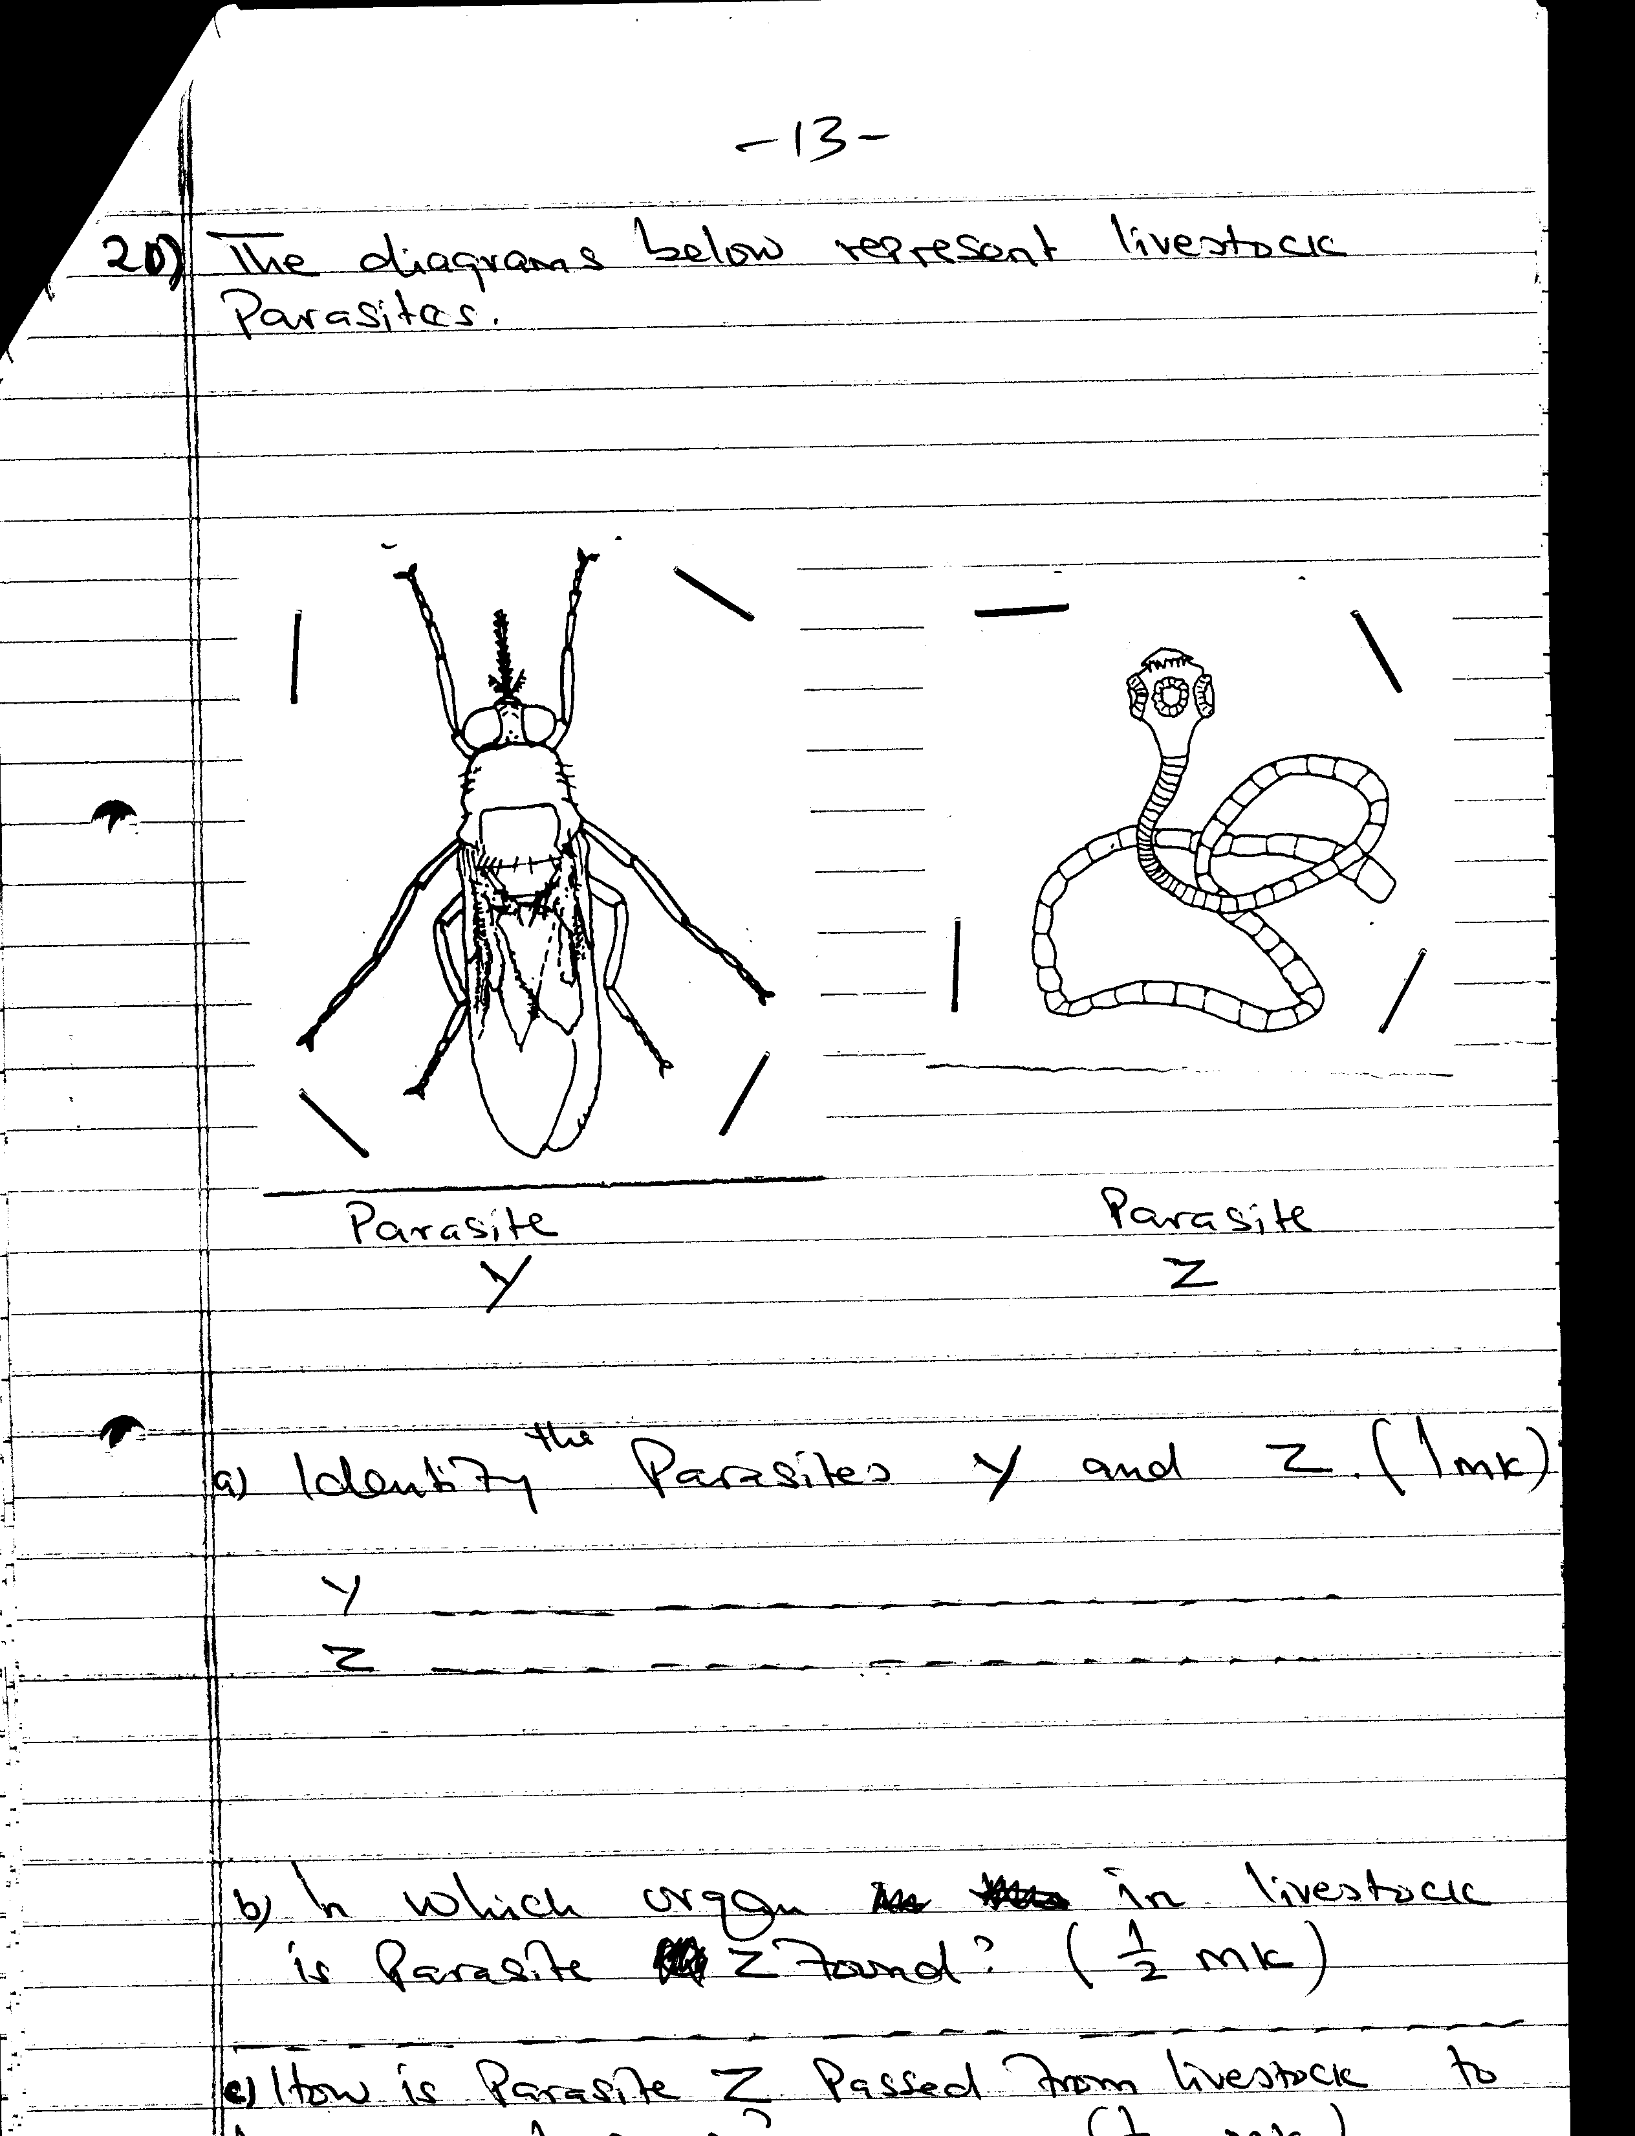Y | 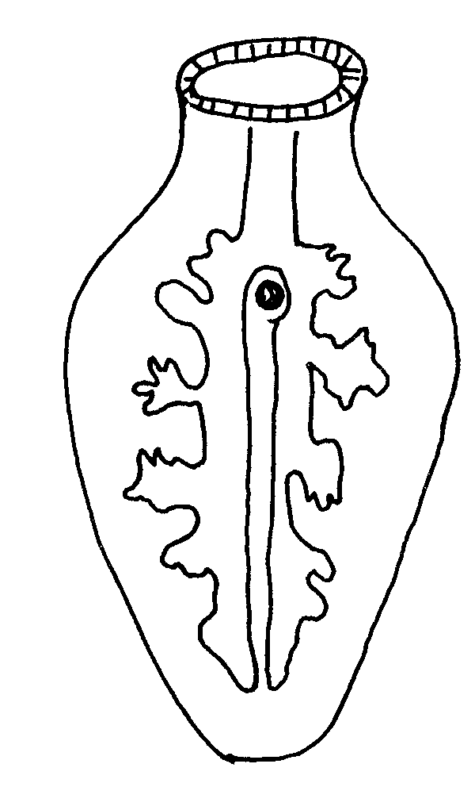K | Z

a) Identify the parasites Y and Z. (3mks)
Y…………………………………………………………………………………….………
Z…………………………………………………………………………………………….
K…………………………………………………………………………………………….
b) Give one control measures of parasite Y (1mk)
………………………………………………………………………………………………
- The diagram below illustrates materials and a method of vegetative propagation. Study it and answer the questions that follow.
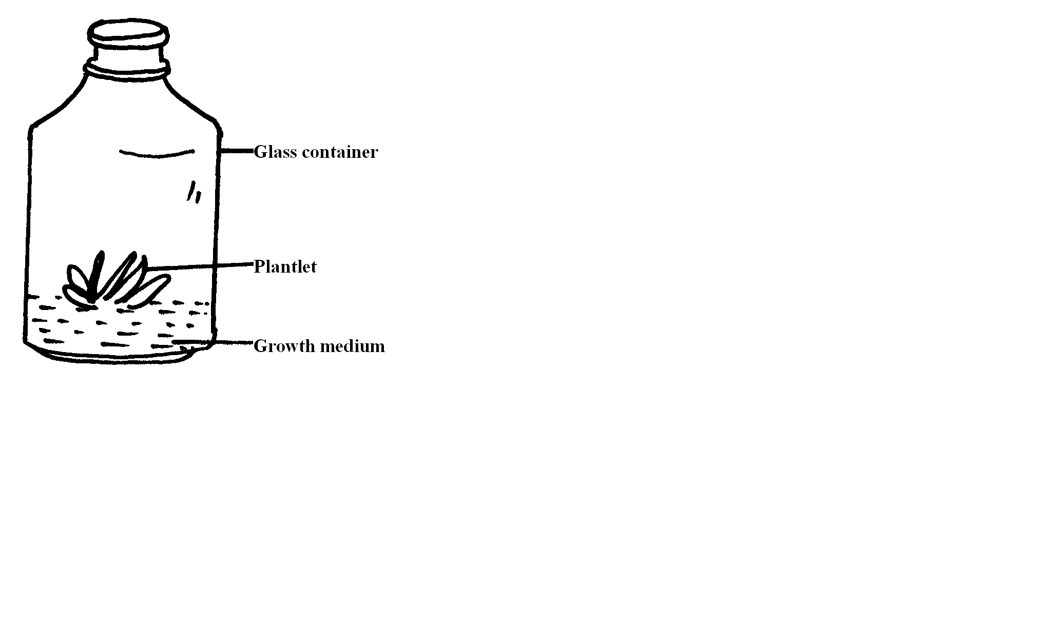
a) Identify the method of propagation illustrated above. (1mk)
………………………………………………………………………………………………………
b) Give one advantage associated with the method. (1mk)
………………………………………………………………………………………………………
- Study the diagram below and answer the questions that follow.
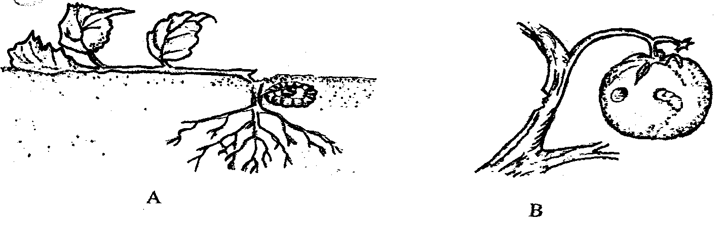

        - Identify the pest A. (1mk)
……………………………………………………………………………………………
b) Give one method that can be used to control the above pest. (1mk)
…………………………………………………………………………………………….
- The illustration below shows a dairy cow suffering from a disease three days after calving down. The cow went down with its head turned back and was unable to stand.

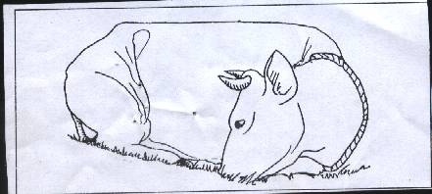

  - Which disease did the cow suffer from? (1mk)
………………………………………………………………………………………………
  - State one way of preventing the disease you have identified in (i) above. (1mk)
……………………………………………………………………………………………….
- The diagram D and E below illustrate some methods of draining waterlogged soils. Study them and answer the questions that follow.

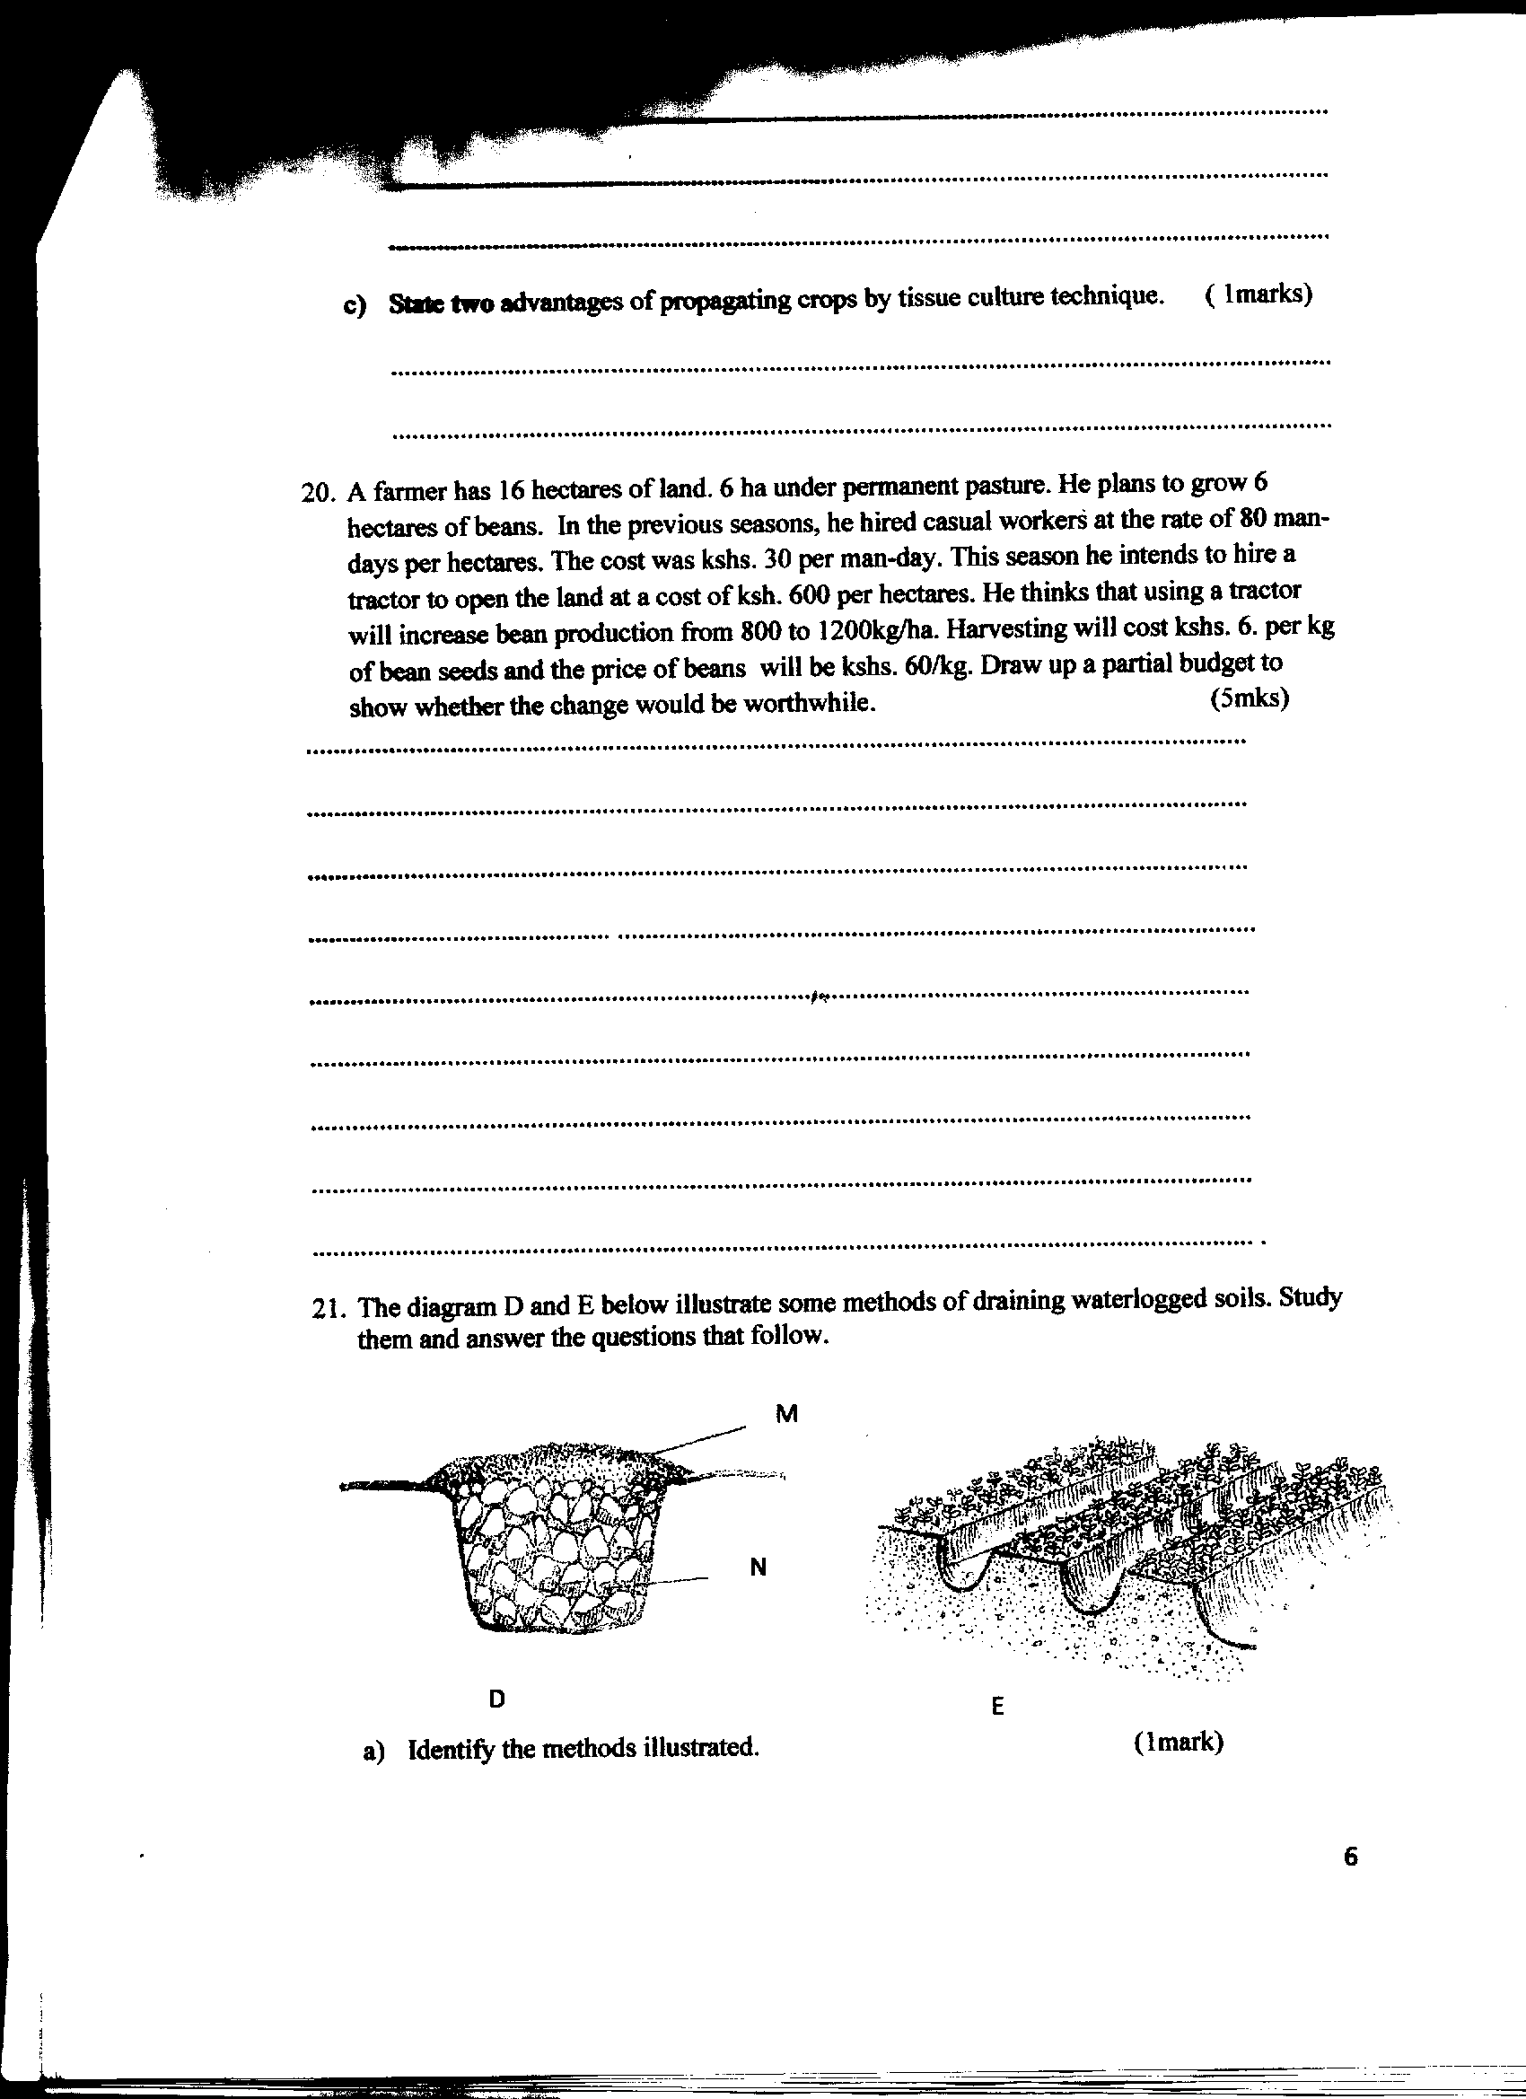

(a) Identify the methods illustrated. (2mks)
D…………………………………………………………………………………………..
E…………………………….……………………………………………………………..
- A part from the methods illustrated above, name any other one way of draining a waterlogged soil. (1mk)
……………………………………………………………………………………………………..
- Study the diagram below and use it to answer the questions that follow.
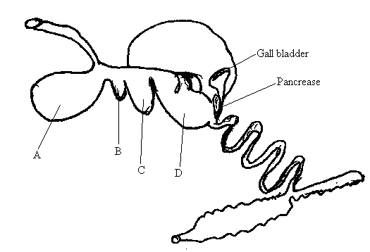
a) Name the stomach parts labeled A, B, C and D (2mks)
A……………………………………………………………………………………………….
B……………………………………………………………………………………………….
C……………………………………………………………………………………………….
D……………………………………………………………………………………………….
SECTION C (40MKS)
ANSWER ANY TWO QUESTIONS IN THIS SECTION IN THE SPACE PROVIDED AFTER QUESTION 20
- a) Explain five factors considered in spacing of crops in the field. (10mks)
          - State five advantages of raising seedlings in a nursery bed. (5mks)
          - State five importance of crop rotation (5mks)
- a) Describe the life cycle of Taenia solium species of tapeworm (10mks)
- List five reasons of pruning in crop production (5mks)
- State five advantages of using seeds as planting materials (5mks)
- Describe the production of tomatoes under the following sub-headings.
a) Varieties (3mks)
b) Land preparation. (4mks)
c) Transplanting (3mks)
    - State ten various methods used to control livestock diseases control disease (10mks)
…………………………………………………………………………………………………………………..…………………………………………………………………………..…………………………………………..………………………………………………………..…………………………………………………………..………………………………………………..…………………………………………………………………..…………………………………..………………………………………………………………………………..……………………..……………………………………………………………………………………………..………..………………………………………………………………………………………………………..…..…………………………………………………………………………………………………………………..……………………………………………………………………………………………..……………………..……………………………………………………………………………..……………………………………..…………………………………………………………………………………………………………………..…………………………………………………………………………………………………………………..…………………………………………………………………………………………………………………..…………………………………………………………………………………………………………………..…………………………………………………………………………………………………………..………………..…………………………………………………………………………………………………………………..…………………………………………………………………………………………………………………..…………………………………………………………………………………………………………………..…………………………………………………………………………………………………………………..…………………………………………………………………………………………………………………..…………………………………………………………………………………………………………………..…………………………………………………………………………………………………………………..……………………………………………………………………………………………………..……………..…………………………………………………………………………………………………………………..…………………………………………………………………………………………………………………..…………………………………………………………………………………………………………………..…………………………………………………………………………………………………………………………….………….……………………..…………………………………………………………………………………………………………………..…………………………………………………………………………………………………………………..…………………………………………………………………………………………………………………..…………………………………………………………………………………………………………………..…………………………………………………………………………………………………………………..…………………………………………………………………………………………………………………..……………………………………………………………………………………………………………………..……………………..…………………………………………………………………………………………..…………………………………………………………………………………………………………………..…………………………………………………………………………………………………………………..…………………………………………………………………………………………………………………..…………………………………………………………………………………………………………………..…………………………………………………………………………………………………………………..…………………………………………………………………………………………………………………..………………………………..……………………………………………………………………………………..…………………………………………………………………………………………………………………..…………………………………………………………………………………………………………………..…………………………………………………………………………………………………………………..…………………………………………………………………………………………………………………..…………………………………………………………………………………………………………………..…………………………………………………………………………………………………………………..……………………………………………………………………………………………………………………..…………..……………………………………………………………………………………………………………………………………………………………………………………………………………………………………………………………………………………………………………………………………………………………………………………………………………………………………………………………………………………………………………………………
MARKING SCHEME
END OF TERM 3 2017
FORM 2 AGRICULTURE
SECTION A (35MKS)
ANSWER ALL QUESTIONS IN THIS SECTION
- Differentiate between the following terms as used in Agriculture:-
(a) Olericulture and floriculture
- Olericulture is the production of vegetables while Floriculture is the production of flowers
(b) Apiculture and aquaculture
- Aquaculture is the rearing of fish in fish ponds while Apiculture is the keeping of bees for honey 2x1=2mks
- State three characteristics of dairy cattle
• Wedge or triangular in shape
• Large stomach capacity that enables the animal to feed heavily for milk production
• Docile with mild temperament
• Large, well-developed udders
• Lean bodies that carry little flesh
• Lean and smooth neck
• Large and prominent milk wells and veins.
• Large; uniform and well-spaced teats
• Wide and well-set hindquarters to accommodate the big udder
- Have a straight top line 3x1=3mks
- Give three importance of farm records
• Show the history of the farm
• Show whether the farm is making a profit or loss.
• Show all the assets and liabilities of the farm which can be used to value the farm.
• Help in supporting insurance claims on death, theft, fire or loss of farm assets.
• Help in tax assessment to avoid over taxation.
• Used as a guide in planning and budgeting.
• Helps to detect losses or theft in the farm.
• Make it easy to share profits or losses in partnerships.
• Help in settling disputes among heirs to estate if the farmer dies without a will.
• Provide labour information on terminal benefits for a worker.
- Help the farmers to gauge the progress of the farm
- Help in comparing the performance of different farms and enterprises
- Help in determining the debtors and creditors of the farm 3x1=3mks
- a) Give any three farming methods
- Organic farming
- Nomadic Pastoralism
- Mixed farming
- Shifting cultivation
- Agroforestry 3x1=3mks
b) State three roles of Agriculture in the economy of Kenya
- Supplies food
- Provides employment
- Source of foreign exchange earnings
- provide market for industrial goods
- Source of capital
- Source of raw materials for industries.
- Leads to improvement of infrastructure in agricultural areas
- Fosters international relationship 3x1=3mks
- Give three factors that influence soil formation
- Parents rock material
- Climate
- Time
- Topography
- Biotic/living organism 3x1=3mks
- Name three human factors that influence the efficiency of agricultural production
- Cultural practices and religious beliefs
- Government policy
- Transport and communication
- Level of education and technology.
- Health especially HIV/AIDS scourge.
- Liberalization of economy.
- Local and/international market forces. 3x1=3mks
- State three effects of wind on crop production
- It causes physical damage to crops / break crops hence crops grown on sheltered sides
- It causes water stress as a result of increased evapotranspiration
- It causes rapid spread of diseases, pests and weed seeds
- It causes stress to crops due to chilling caused by cold winds / frost
- It causes erosion which reduces soil fertility hence poor growth of crops / silting of water ponds;
- It encourages transpiration hence water and mineral uptake
- It increases the rate of evaporation of moisture from the soil 3x1=3mks
- Strong winds destroy farm structures e.g. Crop stores, flower green houses etc.
- List three reasons for preparing land before planting
- To improve soil aeration.
- To Increase water infiltration and assist in the conservation of moisture in the soil
- To incorporate organic matter into the soil and encourage decomposition
- It brings nutrients present in the subsoil to the top soil
- To destroy pests and disease causing organisms
- It loosens the soil for easy germination and root development
- It loosens the soil for easy planting/operation 3x1=3mks
- Give two reasons for practicing minimum tillage in land preparation.
- To reduce the cost of cultivation or ploughing by reducing the number of operations.
- To control soil erosion; mulching and cover cropping greatly reduce chances of soil erosion,
- To maintain soil structure; continuous cultivation destroys soil structure hence is avoided.
- To prevent the disturbance of roots and underground structures e.g. tubers, bulbs etc.
- To prevent exposure of humus to adverse conditions e.g. the sun’s heat that causes volatilisation of nitrogen.
- To conserve moisture, Continuous cultivation exposes the soil to the sun’s heat thus enhancing evaporation of moisture. 2x1=2mks
- Using the Pearson square method, compute a 300kg ration with 24% DCP from wheat containing 14% DCP and cotton seed cake containing 64% DCP (show your working)

24%
DCP
Wheat 14% DCP
40parts of wheat
Cotton seed cake 64% DCP
10 parts of cotton seed cake
50 Total parts

Wheat =

Cotton seedcake=
6x 1/2 =3mks

- Give two importance of drainage as a land reclamation method.
- Facilitates activity of soil living organisms
- It moderates / increases soil temperature/regulates/controls soil temperature
- Improves soil structure
- Improves effectiveness of phosphorous fertilizers and conserve soil nitrogen
- Increase soil volume
- Improve aeration in the soil
- A way of land reclamation for agricultural use
- Regulates different crop cycles i.e. in rice paddies, it is done after two weeks
- To check or reduce leaching
- To reduce salinisation/accumulation of salts
- To reduce erosion rate of top soil (2x1=2mks )
- Mention three properties of nitrogenous fertilizers.
- Are highly soluble in water
- Are easily leached
- Have short residual effect
- Have a scorching/ burning effect
- Are highly volatile
- Are hygroscopic
- Are highly corrosive 2x1=2mks
- A farmer had a plot of land measuring 5 hectares in which he intended to plant maize. He was advised to apply 150 kg of P₂0₅ per hectare at planting and 200kg N per hectare during top dressing. The fertilizer available in the market was Calcium Ammonium Nitrate containing 20% N and Di-ammonium phosphate 50% P₂0₅. Calculate the amount of Diammonium phosphate required.
100 kg contains 50 kg P₂O₅
? Contains 150 kg P₂O₅
150x100
50
=300kg of DAP per Ha
1ha = 300kg of DAP
5Ha =?
5ha x 300
1
= 1500kg of DAP 3mks

SECTION B (25MKS)
ANSWER ALL QUESTIONS IN THIS SECTION IN THE SPACE PROVIDED
- The diagram below shows a method of bringing tea into bearing. Study if carefully and use it to answer the questions that follow.
a) Identify the method shown in the diagram.
- Individual pegging method 1x1=1mk
b) Why is it necessary to prune young tea plants as illustrated above?
- To encourage young tea plants to develop several lateral branches which will establish a frame for the plucking table. 1x1=1mk

- The diagram below represents a pineapple plant
A

B

C

(a) Identify the parts labeled A, B and C as used in propagating the crop.
A - Crown.
B - Slips
C – Sucker 3x1=3mks
(b) Give one advantage of using the part labelled C over A and B
- Gives uniform growth
- Take short time to reach maturity 1x1-1mk
- Study the illustrations showing field practices below.

A | B | C

a) Identify the field practices shown in the diagrams above.
A. Trellising
B. Propping
C. Staking 3x1=3mks
b) State one advantages of field practice B
- It facilitates production of clean fruits
- It facilitates easy spraying of crops
- It prevents the fruits from infestation by soil-borne pests and diseases
- It facilitates easy harvesting of fruits
- It improves the quality of fruits by exposing them to enough sunlight
- It prevents breakage of the plant weak stems 1X1=1mk
- Below are diagrams K and L showing coffee plants established using two different formative pruning systems. Study them and then answer the questions that follow

K L
a) Name the system of pruning illustrated in the diagram labeled
K multiple stem pruning
L Single stem pruning 2x1=2mks
b) State one advantages of pruning system L over K in coffee
- It allows easy picking of berries
- It facilitates easy penetration of chemical spray into the bush
- It minimizes breakage of branches during bearing and harvesting
- It makes it easy to carry out other management practices e.g. spraying 1X1=1mk
- The diagrams below represent livestock parasites.

Y | K | Z

a) Identify the parasites Y and Z.
Y-Tsetse fly/Glossina spp
Z- Tapeworm/ (Taenia spp)
K- Liver fluke 3X1=3mks
b) Give one control measures of parasite Y
Y
Bush clearing to destroy breeding places
Spraying bushes with appropriate insecticides
Trapping and killing tsetse flies
Sterilizing males with sterilizing agents and releasing them.
1x1=1mk
- The diagram below illustrates materials and a method of vegetative propagation. Study it and answer the questions that follow.
a) Identify the method of propagation illustrated above.
- Tissue culture 1x1=1mk
b) Give one advantage associated with the method.
  - It is used to recover and establish pathogen-free plants especially in the control of viral diseases.
  - It is used in mass production of plantlets or propagules.
  - It is fast and requires less space than the cultural methods of using cutting which requires a bigger space.
  - Clones developed are high-yielding and early maturing. 1x1=1mk
  - Since most work is laboratory based, tissue culture can be done all the year round.
- Study the diagram below and answer the questions that follow.

        - Identify the pest A.
- Cut worm 1x1=1mk
b) Give one method that can be used to control the above pest.
- Sprinkling an appropriate insecticide powder at the base of each seedling during planting.
- Spray insecticides on the plant around the roots at ground level.
- Where seedling has been cut dig out the cutworm and kill it physically.
- Early planting of the crop
- Apply chemical poison in the hole together with fertilizer during transplanting. 1x1=1mk
- The illustration below shows a dairy cow suffering from a disease three days after calving down. The cow went down with its head turned back and was unable to stand.

- Which disease did the cow suffer from?
Milk fever/parturient peresis/hypocalcaemia 1x1=1mk
- State one way of preventing the disease you have identified in (i) above.
- Give feeds rich in minerals (Ca²⁺, P₂O⁻₅) starting from the last 2 months of gestation/steam up.
- Give vitamin D injection a week before parturition.
- Dry off the cow sufficiently. 1x1=1mk
- The diagram D and E below illustrate some methods of draining waterlogged soils. Study them and answer the questions that follow.

(a) Identify the methods illustrated.
D-French drain
E-Cambered beds 2x1=2mks
- A part from the methods illustrated above, name any other one way of draining a waterlogged soil.
- Open ditches
- Underground drain pipes
- Planting trees
- Pumping 1x1=1mk

- Study the diagram below and use it to answer the questions that follow.

a) Name the stomach parts labeled A, B, C and D
A- Rumen B-Reticulum C-Abomasum D-Omasum 4x1/2=2mks

SECTION C (40MKS)
ANSWER ANY TWO QUESTIONS IN THIS SECTION IN THE SPACE PROVIDED AFTER QUESTION 20
- a) Explain the factors considered in spacing of crops in the field.
- Height-shorter crops require narrower spacing
- Size of the plant – crops forming canopies require wide spacing
- Plant tiller –produces suckers will end to occupy a big space thus wider spacing
- Soil fertility fertile soil support narrows spacing than infertile soil.
- Purpose of the crop-maize for silage preparation is spaced narrowly than maize for grains.
- Soil moisture- dry areas require wider spacing than wet areas.
- Spreading habits –crops that spread are spaced at wider spacing than crops that do not spread.
- Number of seeds /hole- if more seeds are planted wider spacing is required.
- Mechanization – mechanical operations require wider spacing
- Pure stand- requires narrower spacing that inserts cropped crops. 5x1=5mks
- Disease/ pest control – proper spacing minimizes the spread of pests and diseases.
          - State five advantages of raising seedlings in a nursery bed.
- Facilitate the production of many seedlings in a small area.
- Routine management practices are easily and timely carried out in the nursery bed.
- It makes it possible to provide optimum conditions for growth such as fine tilth, leveled field and shade.
- Facilitate the planting of tiny seeds which develop into strong seedlings that are easily transplanted.
- Ensures transplanting of only seedlings that are healthy and vigorously growing.
- Facilitate the transplanting of seedlings that are already well established thus reducing the period taken in the field.
- Excess seedlings from the nursery may be sold, thus become source of income to the farmers
- Low seed rate per unit area of land
- Reduced labour to care for seedlings.
- Economize on use of chemicals/ water.
- Gives a farmer a head start in planting hence early maturity of the crop 5x1=5mks
          - Explain five importance of crop rotation
- Improves soil fertility: where legumes are included nitrogen is fixed/ added in the soil
- Control pests and diseases: disrupts the life cycle of certain pests and diseases
- Control weeds: control weeds which are specific to certain crops e.g. striga in cereals; cover crops in a rotation will smother certain weeds
- Better use of the soil nutrients: different crops (due to differing root systems) draw nutrients from varying soils horizons/ different crops require different nutrients
- Control of soil erosion: cover crops included reduce soil erosion
- Improve soil structure: When grass leys are included during the crop rotation period, organic matter will accumulate to enrich the soil and improve soil structure
5x1=5mks
- a) Describe the life cycle of Taenia solium species of tapeworm
- Human beings drop tapeworm segments/ proglotides together with their faeces
- Eggs are released from the segment. Once outside the human body
- Eggs are picked by pigs when feeding
- Eggs hatch into embryos in the intestine of pigs
- The embryo penetrate the intestinal wall and enter into the blood stream
- Embryo localize in the liver
- Embryos are disturbed throughout the muscle where they become cyst/ bladder worms
- Bladder worms get into human beings through eating under cooked pork/ bacon
- Once inside the human intestines the cyst wall dissolves and the bladder worm attach themselves to the wall of intestines
- Bladder warm develop into adult tape worm
- Adult tape worm releases segments/ progloltides containing fertilized eggs with human faeces
8x1=8mks
    - List four reasons of pruning in crop production
- Enable controlling over bearing by ensuring required crop leave ratio/ Regulate bearing
- Open up canopy for air and light penetration
- Reduce chemical wastage / Economise on the use of chemical spray
- Facilitate the penetration of sprays
- Control pests and diseases
- Give crop desired shape
- Remove old and unproductive branches
- Make harvesting easy by regulating the height
- Open up the bush by removing micro- climate and allow better air circulation thus discouraging pests and disease organisms
    - State four advantages of using seeds as planting materials
  - Seeds are easily treated against soil borne pests and diseases.
  - They are not bulky therefore storage is easy.
  - They are easy to handle during planting making operation easy.
  - When planting seeds, it is easy to use machines like seed planters and drillers.
  - It is easy to apply manures and fertilizers together with seeds during planting.
  - Fertilizers and manures application can be easily mechanized.
  - It is possible to develop new crop varieties due to cross pollination 4x1=4mks
- Describe the production of tomatoes under the following sub-headings.
a) Varieties 3x1=3mks
Fresh market -round in shape | Processing type-oval shaped
Money maker | Roma VF
Marglobe | Cal J
Ponderosa | Roma nova
Kenton | Primabel
Early beauty | San marzano
Beef eater | Seinz
Hotset | Kenya beauty
Super Marmande | Rutgers
Best of all | 10 x hybrid
Hundred fold | Heinz
Ailsa Craig

b) Land preparation.
- Early preparation of the land
- Deep cultivation to remove perennial weeds
- Secondary cultivation /Harrowing
- Panga, jembe, ox drawn mouldboard plough or tractor drawn ploughs is to be used depending on the scale of production.
- Holes are dug 15 cm deep, at a spacing of 90x60cm or 100x50cm depending on the variety.
- A handful of well rotten manure and a teaspoonful of double super phosphate should be added to each hole and thoroughly mixed with the soil (this totals to 200kg/ha or 10 tonnes of manure per hectare.) 3x1=3mks
c) Transplanting
- Ready after 1 month / when they have 4 -5 true leaves/ when 15cm high /when pencil thick.
- Select health and vigorous seedlings
- Water the nursery thoroughly before to make lifting of seedlings easy.
- Lift the seedlings with a ball of earth on the root.
- A garden trowel should be used to lift
- Transport without damaging the root
- Plant seedlings at the same depth as they were in the nursery
- One seedling planted per hole
- Apply 200 Kg of double supper -phosphate per ha. Or one tea spoonful of same per planting hole
- Mix the fertilizer thoroughly with the soil
- Firm the soil around the base of the planted seedling.
- Transplant on a cloudy day or during late in the evening/ early in the morning
- Water the seedlings immediately after transplanting.
- The seedling should then be mulched and watered regularly 3x1=3mks
    - Describe seven various methods used to control livestock diseases control disease
- Imposition of quarantine: This involves restricting the movement of livestock and livestock products in and out of the affected areas where there is an outbreak of a notifiable disease. The Quarantine method of disease control aims at restriction the disease-causing organism within a given area where there is disease outbreak. Diseases controlled through quarantine are anthrax, foot and mouth disease, Newcastle, rinderpest, rabies and lumpy skin disease.
- Vaccination: A vaccination stimulates production of antibodies corresponding to the disease. Diseases controlled through vaccination in livestock are anthrax, rinderpest, Newcastle, gumboro, fowl typhoid etc
- Control of vectors by use of acaricides and rotational grazing. Disease vectors like ticks and tsetseflies transmit livestock diseases. Therefore they should be controlled using appropriate methods.
- Use of antiseptics and disinfecting equipments and buildings: The farmer must ensure cleanliness in the animal houses and surroundings. Antiseptics are mild antibacterial drugs for use on the skin or in wounds. Disinfectants are used in killing bacteria in buildings, troughs and pigsty floors. They contain germicidal chemicals.
- Use of preventive or prophylactic drugs: such as providing coccidiostats in water or food for poultry to control coccidiosis; drenching animals with appropriate antihelminthes against internal parasites; use of long acting drugs such as sulphanomides to control trypanosomiasis; and addition of antibiotics in livestock feed.
- Proper feeding and nutrition in livestock: well-balanced ration act as a measure of preventing nutritional or metabolic disorders and also ensure vigour and greater resistance to disease. Proper feeding not only avoid deficiency diseases but also make animals strong and hence able to resist disease attack.
- Slaughtering the affected animals: It is advisable to isolate and slaughter the infected animals attacked by certain highly infectious and contagious diseases such as rinderpest, foot and mouth disease, Newcastle, swine fever and brucellosis. The aim is to prevent any further spread of the disease. The carcasses should be burned or buried deeply.
- Use of artificial insemination to control breeding diseases.
- Proper selection and breeding of animals: healthy animals should be selected for breeding. Such animals should be free from disease or be resistant to prevalent diseases. Any animals susceptible to some diseases should be culled. Appropriate breeding policies and programmes should be employed inorder to avoid the transmission of congenital diseases.
- Proper housing and hygiene: livestock structures should have necessary requirements such as; be well ventilated but free from cold winds (draughts), provide adequate space for the number of animals housed, allow for proper drainage, be leak-proof and easy to clean.
- Isolating sick animals: This is separation and confinement of a sick animal from the healthy ones. It is a preventive measure taken when an animal is suspected to have contracted a disease or is actually sick. Animals showing signs of ill-health should be isolated from the rest of the herd to avoid further spread of highly infectious and contagious disease.
- Treatment of sick animals: sick animals should be treated to prevent spread of diseases to other animals.
- Keeping disease resistant and tolerant animals: animal species that are tolerant or resistant to diseases such as zebu which are tolerant to tick-borne diseases can be kept in a tick infested area.
- Fencing: fences restrict the movement of animals within a farm. This helps in preventing animals from coming into contact with other animals outside the farm which may be infected.
- Providing a safe environment: animals may be injured if the farmer does not ensure safety in their environment. Holes in the pasture land should be filled and sharp objects in livestock houses or paddocks should be removed to avoid physical injury. Accidental chemical poisoning caused by empty chemical containers can be minimized if empty containers of chemicals are properly disposed-off by burning or burying to avoid licking by animals. 7x1=7mks

