STRUCTURE OF MATTER
Matter is anything that occupies space and has weight. It exists in different forms/states of small items called atoms.
The three states are
- Solids
- Liquids
- Gas
According to kinetic theory matter is made up of small particles known as molecules which are in a state of continuous random motion. The speed of molecule is increased by increase in temperature.
FORCE BETWEEN MOLECULES
Cohesion /Cohesive force
This is the force of attraction of molecules of the same substance e.g water- water molecules, mercury – mercury molecules
Adhesion/Adhesive force;
This is the force of attraction between the molecules of different substances e.g water – glass molecules.
STATES OF MATTER
Solids;
The molecules are closely packed together, their particles are not free to move from place to another but can vibrate along their mean positions ie move to and fro about their mean positions. This is because their cohesive forces between molecules are strong. Molecules in solids are arranged in a regular pattern called lattice. They have shape and size.
Liquids;
The molecules in liquids are slightly further apart than in solids. Particles are free to move about colliding with each other and with the walls of the container. The cohesive force holding the molecules are weaker than in solids.
They have no definite shape but take up shape of the container.
Gases;
In gases the molecules are much further apart and free compared to those in liquids and so free that they are in constant random motion moving with high speed as they collide with one another and with the walls of a container. The cohesive force is much weaker in gas and can spread easily to occupy the whole volume of a container. Gases lack definite shape and size.
Model; illustrating the states matter.

Diffusion;
It is the movement of molecules of a substance from a region of high concentration to a region of low concentration.
Demonstration of Diffusion in Gases;
- b) Gas mixed

Two Gas jars one full of nitrogen dioxide and the other gas full of air as shown in (a) above.
When the gas cover is removed as shown in (b) the gases mix up and the whole become filled with the
Brown gas(Nitrogen dioxide)
NB: The lighter gas diffuses faster than the heavier gas.
Demonstration of diffusion in liquids:

- Half fill a glass beaker with water
- Using a funnel with a long tube reaching the bottom, slowly pour saturated copper (II) sulphate solution down the tube to form a separate layer.
- Carefully remove the funnel so that the liquids are mixed.
- After some time, the blue colour spreads throughout the beaker. This is due to diffusion of liquid molecules.
Note: The rate of diffusion increases when temperature is increased.
Behavior of liquids on the surface;
When water is dropped on a glass surface it wets it and spreads out in a thin surface because adhesive force between the water molecules and glass is greater than the cohesive force between water molecules.
When mercury is dropped on a glass surface it forms spherical droplets or large flatten drop because cohesive forces between mercury molecules is greater than adhesive forces between mercury and glass.
Spherical droplets of mercury
Large flattened drop

SURFACE TENSION
This is the effect of force on the surface of a liquid which makes it behave like a stretched elastic skin.
Or it is a tangential force on surface of a liquid acting perpendicularly per unit length across any line on the surface.
Effects of surface tension;
Because of surface tension,
- Steel needle when carefully placed on top of water floats, despite its greater density.
- Some birds and insects can walk on the surface of water.
- Some drops of water from the top are in form of a spherical shape.
- Soap film inside the cotton loop when broken makes or forms a circle as shown below
Make a ring of thin wire. Tie a thread loosely across the middle as shown in (i). Dip the ring in soap solution or liquid detergent so that a film forms across it. Break the film on one side of the thread. The thread pulls tight, forming a circle as shown in (ii).This because surface tension stretches molecules on the liquid surface farther
apart than normal.
Explanation on surface tension:
Surface tension is due to molecules on liquid surface being slightly further apart like those in a stretched wire. Therefore experience attractive forces from their neighbours in liquid surface. The forces stretch the molecules on the surface, making it behave like a stretched elastic skin.
Reduction of surface tension;
Surface tension can be reduced by;
- Increasing the temperature of the liquids
- Addition of detergents or soap solution.
Experiment to demonstrate surface tension
- Some water is poured in a clean trough
- It is then left to settle and a filter paper (blotting paper) is placed on the water surface.
- A pin smeared with Vaseline is carefully placed on top of the filter paper as shown below.
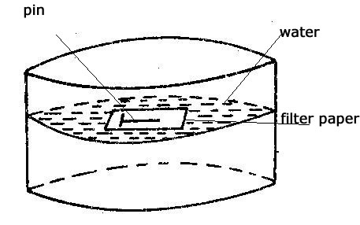
After sometime, the filter paper will absorb water and sink while the pin will remain floating on the water surface.
CAPPILARITY/CAPPILLARY ACTION:
This is the rise or depression of a liquid in a capillary tube.
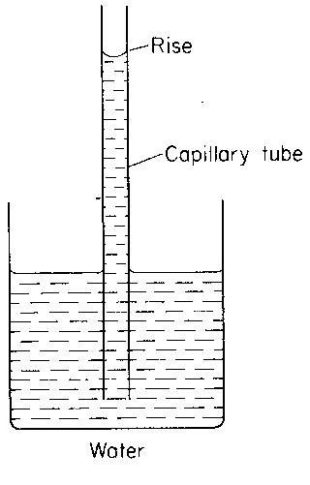
The rise of water in a capillary tube is because the cohesive force between the water molecules is less than the adhesive force between molecules of glass and water. It is also for this reason that water spreads over glass surface
Water spreads
Glass surface
When similar capillary tubes are dipped in mercury, each surface is depressed below the outside level of the beaker and the surface curves down wards as shown below.
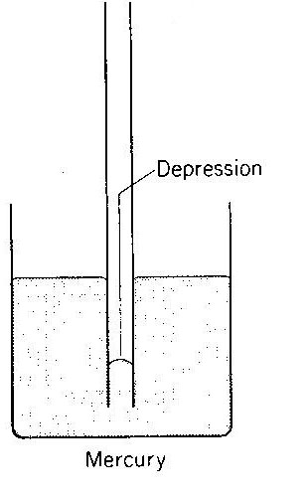
Mercury is depressed more in narrow tube than in a large one. This is because cohesive forces between molecules of mercury are greater than adhesive forces between molecules of mercury and glass. It is also for this reason that mercury does not wet glass but forms droplets on glass as shown.
Mercury droplets

Glass surface
Application of capillarity;
- The rise of oil in a lamp wick upwards.
- Absorption of water in a towel.
- The rise of water in mineral salts in plants
- Action of a blotting paper.
Disadvantages of capillarity;
House bricks and concrete are porous. Capillary action is likely to draw water upwards from
The ground through them, making the building dump (wet).This problem is overcome by putting
Water proof layer made from plastic that is placed in the layers of bricks at the bottom of the house.
BROWNIAN MOTION
It is the random movement of the molecules of a substance in a gaseous stage.
When smoke particles are suspended in air and observed through a microscope. They seem to be in a state of continuous random motion.

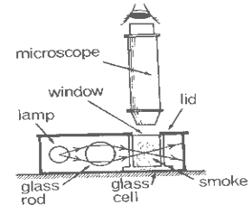
The smoke particles are seen as bright specks moving in continuous random motion. The bright specks are due to collision between smoke particles and gas molecules.
The random motion is due to smoke particles colliding with air molecules which were moving randomly.
When the temperature of the glass cell is increased the random motion increases (smoke particles are seen to move faster), showing that increase in temperature increase the kinetic energy of molecules.
OIL DROP EXPERIMENT
Estimation of the size of an oil molecule.
- A trough is cleaned thoroughly and clean water poured on it.
- Lycopodium powder is sprinkled on the water surface.
- Using a burette a drop of oil of known volume is allowed to gently fall on the surface of water.
- The oil spreads forming a circular film.

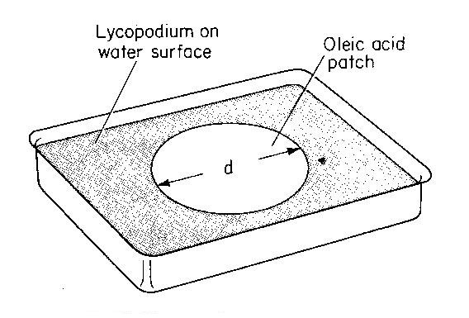

The diameter “d” of the patch is measured using a millimeter scale. Several experiments are performed using fresh water and the average diameter “d” of the patch is determined.
Since the patch is cylindrical, the volume of the patch is;
Where h – is the thickness of the oil patch.
V = πr²h
= π($\frac{d}{2}$)²h
V = π$\frac{d2}{4}$h
4V = πd²h
Therefore the thickness of oil drop
h = $\frac{4V}{πd2}$

Assumptions made in the experiment;
- The oil spreads to form a film of one molecule thick.
- The oil patch is cylindrical in shape.
- There are no air spaces between the molecules.
- The oil drop is spherical in shape.
- The volume of the oil drop is equal to the volume of oil patch.

Example;
1. In an oil drop experiment the radius of the oil was found to be 10cm and the volume of the used was
1.1 x 10⁻⁵cm³.Calculate;
- The diameter of the film
- The thickness of the patch
- The size of the molecule
Answer
Diameter of the patch d = 2r= 2 x 10 = 20cm
Thickness of the patch h = $\frac{4V}{πd2}$
or Thickness h = $\frac{Volume}{Area}$
= $\frac{4x1.1x10-5}{3.14 x20 2}$
= 3.5 x 10⁻⁸cm
The size of the drop = thickness of the patch
= 3.5 x 10⁻⁸cm
Note: Thickness h = $\frac{Volume}{cross sectional area}$
i.e h = $\frac{V}{A}$
2. A student made an oleic acid oil of volume 0.005cm³ to make an oil film on the surface of water.
The average diameter of the oil film was found to be 10cm.Find the thickness of the oil film.
Thickness h = $4v/πd2$
= $\frac{4 x 0.005}{3.14 x 102}$
=6.37x10⁻⁵m
3. Niah, picked on oleic acid oil drop of diameter 0.5mm using a wire and allowed it to drop on a water surface containing lycopodium powder in a circular patch had an average diameter of 200mm.Find the thickness of oil film.
Diameter = 0.5mm
Volume of spherical drop V =$\frac{4}{3}π$r³
= $\frac{4}{3}π$ (0.25)³
= 0.0208$π$mm³
Volume of the patch = volume of spherical drop
$π$r²h = 0.0208$π$
$π$ (100)²h = 0.0208$π$
h =2.08 x 10⁻⁶cm
4. If 1.8 x 10⁻⁴cm³ of oil spreads to form a patch of area150cm².Calculate the thicknesses of the oil patch.
Thickness h = $\frac{V}{A}$ = 1.8 x $\frac{1}{10000}$
= $\frac{0.0008}{150}$
= 1.2 x 10⁻⁶cm
CHANGE OF STATE
- Melting
It is a process by which a solid substance changes into a liquid e.g ice (solid) changes to water (liquid) when heated. Temperature at which solid substance changes to liquid is called melting point.
NB: There is no change in temperature of substance at its melting point. This is because the heat supplied is used to
weaken cohesive forces of attraction between molecules.
2. Boiling
This is the process by which a liquid when heated changes to the gaseous state at a fixed temperature e.g pure
water at 100⁰c changes to vapour by the process of boiling.
There is no change in temperature at boiling point because the heat supplied is used to weaken cohesive attraction
of molecules and the rest is converted to kinetic form of energy.
3. Evaporation;
It is the process by which a liquid changes to gaseous state at any temperature. The rate of evaporation is affected
by the following factors;
Factors;
- Temperature
- Amount of humidity in the atmosphere
- Pressure
- Surface area
- Nature of the liquid
- Wind and dryness of air
Temperature;
The higher the temperature, the higher the average speed at which molecules move and therefore there will be more molecules moving to the liquid surface.
Pressure;
Increase in pressure lowers the rate of evaporation.
Surface area:
When the surface area of a liquid is increased, more molecules are brought to the surface and more rate of evaporation is increased.
Nature of the liquid
Different liquids have different cohesive forces ,those which have greater cohesive forces tend to evaporate less than liquids with less cohesive forces.
Wind and dryness of air
Dryness of air around the liquid surface causes rapid evaporation. Wind blows away water vapor along the body and this causes rapid evaporation to take place.
Differences between boiling and evaporation

Boiling | Evaporation
Takes place at a fixed temperature called boiling . | Occurs at any temperature
Boiling takes place throughout the liquid. | Takes place only on the surface of the liquid
Boiling is a vigorous process | Evaporation is a gentle process
Bubbles are formed with in the liquid | No bubble is formed on the surface of the liquid.
Boiling doesn’t result into cooling | Evaporation result into cooling.

Cooling by evaporation
The molecules which escape from the surface of liquids are those with greater kinetic energy, the molecules which remain in the liquid are those with very low kinetic energy. The energy, the molecules use, as their kinetic energy is the latent heat which they absorb. The absorption of this latent heat from the liquids brings about a fall in temperature, thus a body cools.
Application of cooling by evaporation
-cooling of a body by evaporation of sweat from the body
-cooling water using a porous pot or refrigerator
-cooling of the dog by the saliva on its tongue evaporation
Demonstration of cooling by evaporation
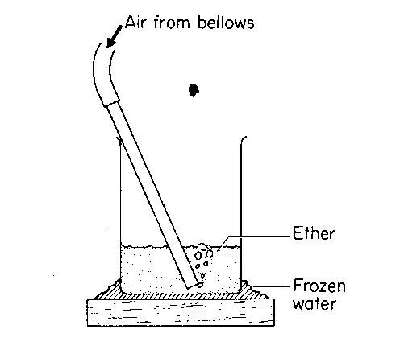
A beaker about one third full of ether is stood in a small pour of water on a flat piece of wood
Air is then bubbled through the ether. The ether evaporates into bubbles and the vapour is carried quickly away as the bubbles rise to the surface and burst thus increasing the rate of evaporation.
After sometime, the water on the wooden block cools to 0⁰c and freezes to form ice. This demonstrates that evaporation causes cooling.
Explanation
As the ether evaporates, it absorbs latent heat from its liquid state with the result that it cools below 0⁰c. At the same time heat becomes conducted through the walls the beaker from the pool of water below it and eventually the water cools to 0⁰c. After this, it begins to loose latent heat and freezes.
The refrigerator
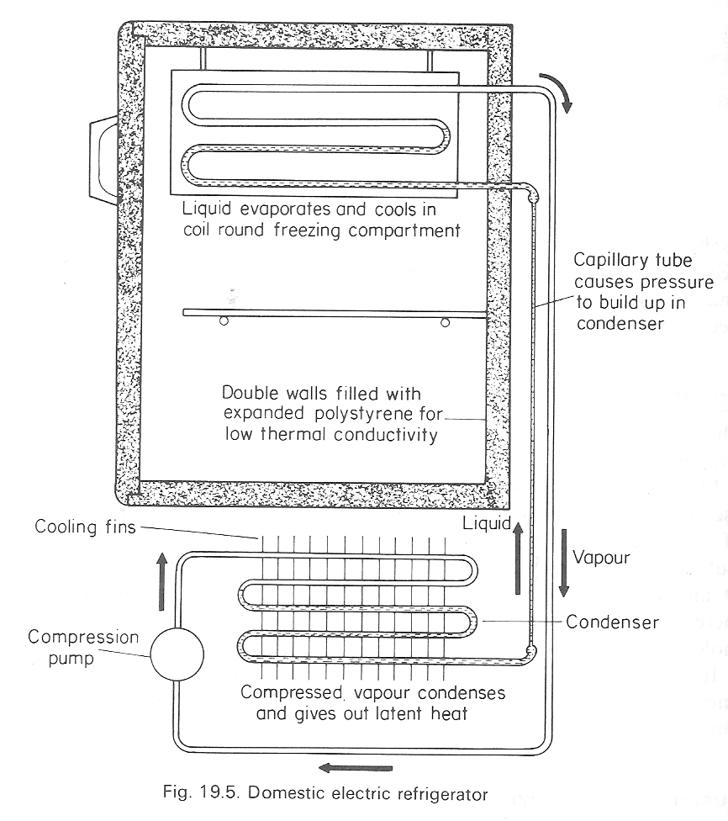
It operates on the evaporation by cooling principle.
The liquid used in a refrigerator is Freon which is volatile (Freon is collective term for suitable refrigerants e.g. dichlorodifluoromethane boiling point about -30⁰c or 243k).
Freon evaporates inside the coiled tubes surrounding the freezing compartment assisted by a pump which reduces the pressure.
When Freon evaporates, it absorbs heat from the surrounding air and this causes the refrigerator and its content to cool. The vapour produced is pumped away and compressed in the condenser where it condenses to liquid again.
The heat released during condensation is quickly removed by cooling fins at the back of the refrigerator.
The process of evaporating and condensing Freon is repeated on and on, thus causing the refrigerator to cool further.
Demonstration of effect of pressure on melting point (regelation)
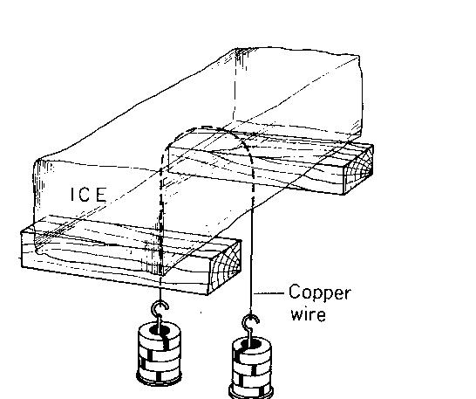
A weighted copper wire is allowed to pass through a block of ice. It sinks through, without cutting the ice block into two pieces
Explanation
When a copper wire is pulled, a very high pressure is exerted on the ice block, lowering its melting point and the ice melts.
The wire sinks through the water which is no longer under pressure and freezes above the wire because melting point returns to 0⁰c
In freezing, the water gives out its latent heat of fusion and thus conducted down through the wire to enable the ice below it to melt. This effect is called regelation (freezing).
Note: If an iron wire is used in demonstration, it passes through the ice more slowly. No effect is obtained if string is used.
VAPOUR PRESSURE.
It refers to the pressure exerted on the wall of the container by the vapour.
Consider a liquid in a closed vessel when molecules escape from the liquid they form vapour the surface of the liquid
the vapour molecules move in directions and exerts a pressure called vapour pressure.
When the bounce off, the vessel strikes the liquids on surface and enter it. The dynamic equilibrium is eventually
reached ,in which the rate at which molecules live the liquid is equal to which others returns to it.
When this happens, the space above the liquid is said to be saturated with vapour.
The vapour pressure used in this state is called saturated vapour pressure but before the equilibrium the vapour
is said to be unsaturated.
Saturated vapour pressure
It is the pressure exerted on the walls of a contain by the vapour when the rate at which molecules are entering
the liquid is equal to the rate at which molecules are entering the liquid.
OR : Saturated vapour pressure
Is pressure exerted the vapour in a dynamic equilibrium in its own liquid.
Boiling point
Is the temperature at which at which the saturated vapour pressure is equal to the external atmospheric pressure.
At this temperature liquid molecules have enough energy to form bubbles of vapour inside the liquid. The bubbles
formed at the bottom contain saturated vapour when the reach the surface they burst.
FACTORS WHICH AFFECT THE BOILLING POINT AND FREZING/MELTING POINT OF WATER
Addition of impurities
Increase or decrease in pressure
Effects of impurities on boiling and melting points
- Melting point
The impurities lower the melting point of a surface e.g when impurity is added to ice it melts at a lower temperature. This is because impurities weaken the cohesive forces in ice molecules making it easy for them to move freely hence the change of state from solid to liquid.
- Boiling point
Impurities raise the boiling point of a substance e.g when salti added to water the mixture must be heated at a higher temperature before it boils. This is because impurities strengthen the cohesive forces between water molecules so more heat must be supplied to weaken them. The increase in the heat supply makes the boiling point to rise.
Effect of pressure on boiling and melting points
Boiling points
Increase in pressure raises the boiling point of liquid. This can be showed below resulting in decrease in gas pressure.

- Water in the flask shown above has to be heated to about 100⁰c before it boils. If the pressure above the flask is high, the liquid starts to boil at a much lower temperature than usual.
- This can be shown by boiling water in the flask for a few minutes so that the steam sweeps out most air .Heating is stopped and the clip is closed
- Cold water is poured on the inverted flask, so condensing the steamed water this reduces pressure above water.
- The water starts to boil and if cooling in this way it continued boiling goes on until above 40⁰c

Melting point
Increase in pressure lowers the melting point of a solid e.g ice. This effect makes skating /skiing possible, the pressure of ice skate melts the ice under it, so that there is a thin layer of water between the skate and ice. The layer of water acts as a lubricant and almost completely removes friction between skate and ice.

The pressure cooker
This is a strong aluminium pan, whose lid is sealed with a rubber sealing ring to prevent steam from escaping from inside the pan.
As the substance e.g water is heated to boil,the steam pressure inside builds up causing the boiling point to rise to about 120⁰c
The high temperature makes the substance get cooked quickly.

