Name………………………………………………………… Stream…............………
HOUSE……………………………………………. SIGNATURE…………………….
STUDENT NO: …………………………………….
840/1
COMPUTER STUDIES
Paper 1
September, 2017

KIIRA COLLEGE BUTIKI
UGANDA CERTIFICATE OF EDUCATION
COMPUTER STUIDES
BEGINNING OF TERM III 2017
SENIOR TWO
Paper 1

TIME: 1 hour 30 minutes

INSTRUCTIONS TO CANDIDATES

Write your name, Stream, House, signature, and Students’ number in the spaces above.

This paper consists of three Sections A and B

Section A contains 20 compulsory objective-type questions.
The correct alternative A, B, C or D against each question must be written in the box provided on the right hand side of each question.

Section B consists of structured questions. Attempt all.

Answers to section B must be written in the spaces provided in the question paper.

For examiner’s only

MCQ | Q21 | Q22 | Q23 | Q24 | Q25 | TOTAL

- The first calculator to contain memory was invented by
- Pascal

- Leibniz
- Babbage
- Bill gates
- Which of the following is very important storage of files currently under use by the computer
- ROM

- CMOS
- BIOS
- RAM
- Using more than one application at a time is called
- Scheduling

- Multimedia
- Multitasking
- Over tasking
- The process of preparing floppy diskette to accept information from a particular computer is called

- Saving
- Disk cleaning
- Opening of file
- Formatting
- Viruses are activated in all the following ways expect
- Deleting e-mail without opening or executing any attachment

- Opening an infected file
- Booting a computer with an infected floppy disk in the disk drive
- Running an infected program
- Keys F1 through F12 are known as _________________ keys
A. editing

B. control
C. function
D. navigation
- Every Friday afternoon, Mr. Yeateesa does a full backup of his computer data. If his hard
Disk fails on the following Tuesday afternoon, what data would be lost?
- No data will be lost

- All the data entered from Friday afternoon to Tuesday afternoon
- All data from the previous week
- Some of the data between Friday afternoon and Tuesday afternoon
- Which of the following device must be used in order to connect two computers for sharing of data

- USB
- NIC
- UPS
- Printer

- The hardware part that protects the internal components of a computer is referred to as
- CPU
- Systems Unit

- System case
- Computer case
- Diligence is
- The ability of computer to think like human beings
- The ability of computer to produce accurate work

- The ability of computer to do repetitive tasks without getting tired
- The ability computer to automate certain activities
- A device that interprets and executes the instructions in the computer and also called the brain of computer is the
- System Unit

- C.P.U
- RAM
- ALU
- Which one of the following types of computer would you use to operate large corporate systems and databases
- Desktop Computers

- Personal Digital Assistants (PDA)
- Mainframes
- Laptops
- A collection of Raw, disorganized and meaningless facts are referred to as……………
- Data
- Information

- A record
- Text
- I can draw an oval object say a sketch map if Uganda by using a;
- Mouse

- Keyboard
- Light pen
- Joy stick
- The……………….stores data temporary in a central processing unit
- ALU

- CU
- Accumulators
- Registers
- The following are storage devices expect
- Printers

- Compact Disc
- Hard disk
- Tapes

- The term used to describe programs and instructions written for computer is
- Hardware

- Analogue
- Software
- Digital
- This component of the central processing unit carries out all the logic and mathematical operations
- ALU

- System Clock
- Registers
- Control Unit
- Data that is copied from an application is stored in the …………………..
- Drivers

- Clipboard
- Terminals
- Prompt
- What is the correct name of the screenshot shown below
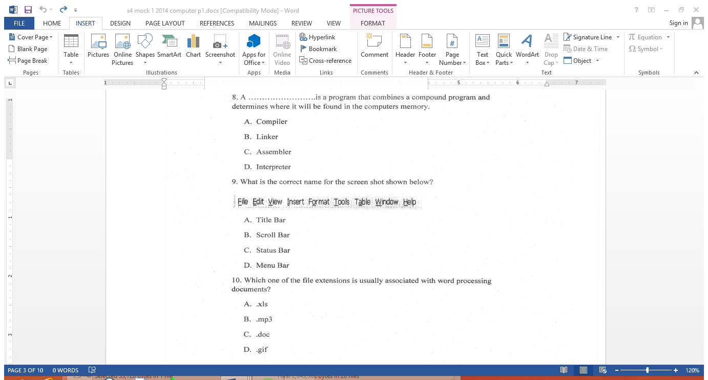
- Title bar

- Scroll bar
- Status bar
- Menu bar
SECTION B
- For each of the following generations stated below, mention one major technological innovation of that generation
- Third generation
………………………………………………………………………………………………………………………………………………………………………………… (01 mark)
- Fourth generation
………………………………………………………………………………………………………………………………………………………………………………… (01 mark)
- Fifth generation
………………………………………………………………………………………………………………………………………………………………………………… (01 mark)
(b) Give any one example of data processing device used during “mechanical era”
………………………………………………………………………………………………………………………………………………………………………………… (01 mark)

(c) Mention one function of each of the following components of the system unit
(i) System Case
…………………………………………………………………………………………………………………………………………………………………………………. (02 marks)

(ii) Power supply unit
………………………………………………………………………………………………………………………………………………………………………………… (02 marks)
(d) Differentiate between a System Unit and a Central Processing Unit
………………………………………………………………………………………………………………………………………………………………………………………………………………………………………………………………………………………………………………………………………………………………………………… (02 marks)
- Define a Micro-processor?
………………………………………………………………………………………………………………………………………………………………………………… (2 marks)
(b) Mention one function performed by the following CPU components

(i) Control Unit
………………………………………………………………………………………………………………………………………………………………………………… (1 mark)
(ii) Arithmetic and Logic Unit.
………………………………………………………………………………………………………………………………………………………………………………… (1 mark)
- Registers.
………………………………………………………………………………………………………………………………………………………………………… (1 mark)
(c) State the difference between the data bus and address bus
………………………………………………………………………………………………
………………………………………………………………………………………………
………………………………………………………………………………………………
………………………………………………………………………………….. (2 marks)

` (d) Other than the CPU mention two other devices that greatly affect the performance
Speed of a computer
…………………………………………………………………………………………
………………………………………………………………………………… (2 marks)
(e) A central processing unit is attached onto a device found inside the system unit called
…………………………………………………………………………………. (1 mark)
- A system Unit is one the major hardware components of a computer. Mention four devices found inside a system unit (4 marks)
- ……………………………………………………………………………………
(ii) ……………………………………………………………………………………
(iii) ……………………………………………………………………………………
(iii) ……………………………………………………………………………………
- ……………………………………………………………………………………..
(b) Briefly explain the functions of any three components given above in (a) (6marks)
(i) ………………………………………………………………………………………
………………………………………………………………………………………
- ………………………………………………………………………………………………………………………………………………………………………………
- ………………………………………………………………………………………………………………………………………………………………………………
- (a) A computer system is a composition of several components. List any four components that make up a computer system. (4 marks)
- ………………………………………………………………………………………
- ………………………………………………………………………………………
- ………………………………………………………………………………………
- ………………………………………………………………………………………
(b) Briefly explain the function of any three components given in (a) above (6 marks)
(i) …………………………………………………………………………………
……………………………………………………………………….…………
…………………………………………………………………………………..
(ii) …………………………………………………………………………………..
………………………………………………………………………………….
…………………………………………………………………………………..
(iii) ……………………………………………………………………………………
……………………………………………………………………………………
- Mention the four categories of computer hardware (4 marks)
- ……………………………………………………………………………………
- …………………………………………………………………………………...
- …………………………………………………………………………………
- …………………………………………………………………………………
(b) Give two examples of Biometric input devices (2 marks)
(i) …………………………………………………………………………….
(ii) …………………………………………………………………………….

(C) Mention one function of the following computer hardware device (4 marks)
- Barcode Reader
………………………………………………………………………………………………………………………………………………………………………………
- Microphone
………………………………………………………………………………………………………………………………………………………………………………
- Speakers
………………………………………………………………………………………………………………………………………………………………………………
- Magnetic strip card reader
………………………………………………………………………………………………………………………………………………………………………………

END

