NAME: ……………………………………………………………. STREAM: ……………………
NANKONDO BRIGHT S.S
B.OT II COMPUTER EXAM FOR S.2
INSTRUCTIONS
Attempt all questions in both sections.
Time: 1$\frac{1}{2}$ hours
SECTION A: (20 MARKS)
- It is a flat surfaced magnetic surface, which is sensitive to finger movements; it is used as a mouse on some micro computers.
A. Tracked Ball B. Serial Mouse C. Lamped mouse D. Touch Pad
2. [Keyboard, Mouse, Scanner, Printer, floppy diskettes e.t.c] which is the most appropriate term which can be used to refer to the set of computer-related devices in the square bracket?
A. Input Devices B. Computer Accessories C. Storage devices D. Computer peripherals
3. The information displayed on the computer screen is termed as:
- Softcopy B. Photocopy C. Hardcopy D. Carbon copy
4. A LaserJet printer.
- Is an impact printer C. Can print on continuous paper
- Is faster than a dot-matrix D. Can print color
5. Printers produce ………copy while monitors produce………..copy.
- Soft, printed B. Printed, hard C. Hard, soft D. Soft, hard
6. Mr. Kaggwa’s son who lives in the US sent him a Laptop recently, the Laptop can do the ordinary computer work, play Music and data CD’s , it also has a facility which enables it to save on DVD’s and play DVD’s. With reference to characteristics of computers, which of the following statements best describes Mr. Kaggwa’s Laptop?

- It is a Hi-tech Computer C. It is Versatile Computer
- It is a Multi-User Computer D. It is a Y2K compliant Computer
7. A touchpad is an example of ………………………..
- Output Device B. Micro Computer C. Mouse Device D. Input Device

8. Which of the following is not a component of the computer system? (i) Software (ii) Live ware (iii) Hardware (iv) Human Ware (v) Data
- (i) and (iii) only B. (i), (iii) and (v) only C. (iv) and (v) only D. None of the above
9. Mr. Binsobedde is a Deputy headmaster of a newly established school. The Secretary of this school has just acquired a computer and one of the tasks which requires her to use a computer is running multiple copies of School documents like Registration forms, Requisition notes, School exams e.t.c . Which of the Printers below will be the most cost saving if connected to her Computer?
- Laser Jet Printer B. Dot matrix Printer C. Daisy Wheel Printer D. Photocopier

10. Which of these is the easiest to carry from one place to another?
- Personal Digital Assistant C. Super Computer
- Main frame Computer D. Desktop computer

11. Which of the following group of devices does not belong to the same group?
- Mouse, Keyboard, Joystick B. Plotter, Printer, Scanner
- Diskettes, Hard disks, Zip Drive D. ALU, Control Unit, Primary storage
12. Introduction of peripheral devices such as the Optical Scanners was one of the technological innovations experienced in the ……………. generation of computers.
A. First B. Third C. Second D. Fourth
13. An input device which can recognize Barcodes; commonly used in supermarkets and departmental stores is called………………………..………………………
A. Optical Character Recognition Reader C. Magnetic Ink Character Reader
B. Bar Code Reader D. Optical Mark Recognition Reader
14. The ability of computers to handle more than one task in one go is called
- Mobility B. versatility C. Analog D. Multiple
15. Which of these is the easiest to carry from one place to another?
- Personal Digital Assistant C. Super Computer
- Main frame Computer D. Desktop computer
16. Which of the characteristics below refers to the provision on a computer, which allows the user to communicate to the hardware using software, and the hardware responds by executing the given commands?
A. Diligence B. Artificial Intelligence C. Reliable D. Interactive
17. If you tapped this set of Keys on the Keyboard [Ctrl + S], then it means I want to …………
- Open a new File C. Underline the highlighted text
- Save the changes made to my File D. Change the FONT of the text
18. If you want to close your file after the you have finished the practical, you would then have to use this set of keys on the Keyboard
A. Ctrl + C B. Alt + F₄ C. Ctrl + Esc D. Ctrl + S
19. Which of the pairs of keys below appears twice on the keyboard?
- Enter, Shift B. Shift, Caps Lock C. Caps Lock, Enter D. CTRL, Tab
20. What is Computer Literacy?
- The ability to use the computer as a tool to do appropriate tasks
- The ability to evaluate the positive and negative effects of computers
- The ability to understand the basic concepts of computers
- All the above

SECTION B: (40 MARKS)

21. (a). (i).Below is a sketch of a Mouse Device, Study it and name the labeled parts. (03 marks)

A:………………………………………….. B:…………………………………………..

C:……………………………………………………....……………………………………..…..
B
C
A 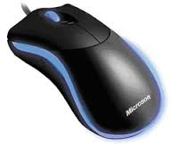

(ii).Under which category of hardware does the above device fall. (01 mark)
…………………………………………………………………………………………………………..
(iii). Identify any two functions performed the device above. (02 mark)
…………………………………………………………………………………………………………………………………………………………………………………………………………………….

(b).Use the diagram below to and name the Four (4) parts of the enhanced keyboard.
(04 marks)

A
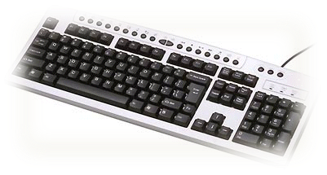 B

C D

A……………………………………………………………………………..B…………………………………………………………………….
C…………………………………………………………………………………..D……………………………………………………………….

22. (a) If your mother opened up a Secretarial Bureau in Nankulabye town, which also engages in printing of document for customers, which two types of printers would you recommend for her to purchase for this purpose? (02 Marks)
……………………………………………………………………………………………………………………………………………………………………………………………………………………………………………………………………………………………………………………
(b) Give one reason for your choice of printer/s in 22(a) above. (01 mark)
………………………………………………………………………………………………………………………………………………………..
(c).Mention any two examples of each of the following: (04 marks)
Impact printers Non-impact printers
i………………………………………………………………. i…………………………………………………………………………
ii……………………………………………………………….. ii………………………………………………………………………..
(d). List down any three printing media. (03marks)
i………………………………………ii……………….…………………iii……………..…………...
- (a).For each of the following situations, state the most appropriate hardware device to use. (05 marks)

- Making a hard copy of a document ………………………………………………………………………………………………
- Converting a document on paper into a digital format ………………………………………………………………………………………………
- The salesman who needs to determine the price of a commodity at the supermarket ………………………………………………………………………………………………
- An input device to play a computer game
………………………………………………………………………………………………
- To accurately print out vector graphics
………………………………………………………………………………………………
(b). Study the following hardware components and answer the questions below.
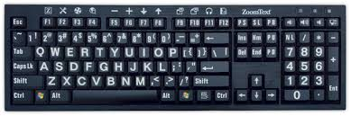 | 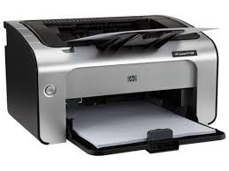 | 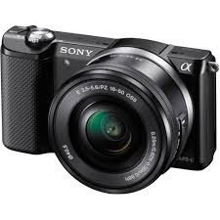
Figure A | Figure B | Figure C

(i). Identify component labeled Figure C. (01 mark)
……………………………………………………………………………………………………………………………………………………
(ii).Identify any four factors one should consider when acquiring Figure B. (04 marks)
………………………………………………………………………………………………………………………………………………………………………………………………………………………………………………………………………………………………………………………………………………………………………………………………………………………………
- (a). Distinguish between hardcopy and softcopy as used in data processing. (02 marks)
………………………………………………………………………………………………………………………………………………………………………………………………………………………………………………………………………………………………………………………..………
(b). Identify three disadvantages of using dot-matrix printer. (03marks)
……………………………………………………..……………………………………………...………………………………………………………………………………………………..…………………………………………………………………………..………………………………………………
(c). Give three ways through which computers can prove costly/expensive. (03marks)
…………………………………………………………………………………………………...……...…………………………………………………………………………………………..…………………………………………………………………………………………………………………..………
(d). Define a command. (02 marks)
…………………………………………………………………………………………………...………………………………………………………………………………………………………….……

END
BY: MR. MUGWISA DARIUS

