FORM THREE MID TERM TWO 2017 MARKING SCHEME  1. R.E = 0.05 + 0.05 + 0.05  8.2 6.2 5.7  = 0.02293  P.E = 0.02293 × 100 ✓  = 2.293 ✓a | M1  M1  A1 | represent  or equivalent  CAO
2. JKF1 or JK1F or J1KF  0.8 × 0.7 × 0.4 + 0.8 × 0.3 × 0.6 × 0.2 × 0.7 × 0.6  0.224 + 0.144 + 0.084  = 0.452 | M1  M1  A1

03

3. 1 - 13500 = 13,500 × 10/100 = 1350 }
13501 - 27000 = 13,500 × 15/100 = 2025
27001 - 45000 = 18000 × 20/100 = 3600 }
45001 - 62400 = 17400 × 25/100 = 4350

4a.AX x XC =XD x XB
6 x 6.5=5x X
X= 7.8

b) BT²= AT x CT
BT² = 19.5 x 7
BT = 11.68
11,325 }
1, 056
B1 ✓ value to be replaced

 |  | 5. ∫2 = 1  4π2LC  L = 1  4π2 ∫ 2 C  3. Absolute error = 82 x 3.15 - 82 x 3.05  2 |  |  | M1  A1  2
 |  | 6. (Log2x)2 + Log28 = Log2 x 4 (Log2x2 + 3 = 4Log 2x  Let Log2x = t t2 - 4t + 3 = 0  (t -1) (t -3) = 0 t = 1 or 3  Log2x = 1, x = 2  Log2x = 3, x = 8 |  |  |  |  |  | M1  A1  B1  03 |  |  |  | quadratic equation  Both values
7. |  |  |  | 4x² – 9x – 1 = 0  x² – ^{9 x} /₄ – ¼ = 0  x² – ^{9 x} /₄ = ¼  x² – ^{9 x} /₄ + (⁻⁹/₈)² = ¼ + (⁻⁹/₈)²  (x – ^{9 x} /₈)² = ¼ + ⁸¹/64 = ⁹⁷/₆₄  x – ⁹/₈ = ¼ + ⁸¹/₆₄ = ⁹⁷/₆₄  x ^{– 9}/₈ = ±  either x ^{– 9}/₈ = + 1.2311  x = 1.2311 + 1.125 = 2.35611  or  x ^{– 9}/₈ =-1.2311  x = -1.2311 + 1.125 = -0.10611 |  |  |  |  |  |  | M1  M1  A1 |  |  | Completing the squares  For both ans  Accept 4dp
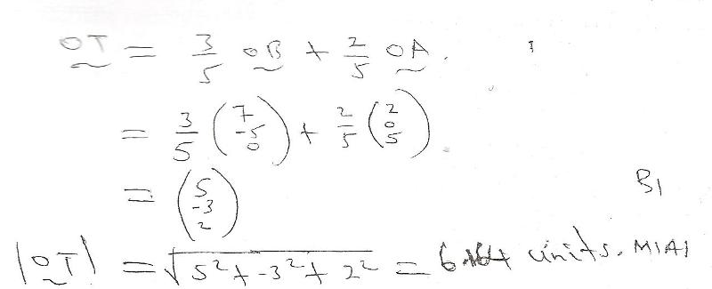
8.
 | 9. ⎛14 0 ⎞  PQ = ⎜ ⎟  ⎝ 0 14 ⎠  ⎛ 4 1 ⎞⎛ x ⎞ ⎛ 9 ⎞  ⎜ ⎟⎜ ⎟ = ⎜ ⎟  ⎝ − 2 3⎠⎝ y) ⎠ ⎝ − 1⎠  1 ⎛ 3 − 1⎞⎛ 4 1 ⎞⎛ x ⎞ 1 ⎛ 3 − 1⎞⎛ 9 ⎞  14 ⎜ ⎟⎜ ⎟⎜ ⎟ = 14 ⎜ ⎟⎜ ⎟  ⎝ 2 4 ⎠⎝ − 2 3⎠⎝ y ⎠ ⎝ 2 4 ⎠⎝ − 1⎠  ⎛ x ⎞ ⎛ 2 ⎞  = ⎜ ⎟ = ⎜ ⎟  ⎝ y ⎠ ⎝1 ⎠  Points = (2, 1) |  |  |  |  |  | B1  M1  A1  03 |  |  | ✓ multiplication  Multiplying by the invese
 |  |  | 10. a, a + 6d, a + 24d . . . . . . a + 6d = a + 24d  a a + 6d  a² + 12ad + 36d² = a² + 24ad  12ad = 36d²  a + 19d = 22 . . . . . (ii) }  a = 3d . . . . .(i)  3d + 19d = 22  22d = 22  a = 3 }  d = 1 |  |  |  |  |  | B1  M1  M1  A1
 |  |  | b) S = 40 [2a + (n − 1)d ]  40 2  = 20[2 × 3 + 39 × 1]  = 900  c) i) ar9 = 3(3)9  = 59,049  ii) ⎛ r n − 1 ⎞ 3(310 − 1)  a⎜ ⎟ =  ⎝ r − 1 ⎠ 3 − 1  = 3 (59048)  2  = 88,572 |  |  |  |  |  | MARKS  M1  A1  M1  A1  M1  A1 |  |  |  | REMARKS

11. a) V = k + mr²  95 = k + 25m  167 = k + 49m  72 = 24m m = 3  k = 95 - 75 = 20  v = 20 + 3(10)² = 320 b) i) KR 2  P1 =  T  1× 1.2²  P2 = 0.9 = 1.6  ⎛ − ⎞  %age = ⎜ 1.6 1 ⎟ × 100  ⎝ 1 ⎠  = 60%  ii) 12 = 36 k ,  9  k = 2  3R 2  P =  T | M1  A1  B1  B1  M1  M1  A1  M1  A1  B1 | ✓ formation of simultaneous equations  ✓ values of m and k  ✓ substitution of r = 10  ✓ volume
 | 10

