SOIL
1. The table below shows the amount of water collected when 50 cm³ of water was added to 100 cm³ of dry soil samples A and B and a mixture containing equal volumes of soil samples A and B. Study it carefully and answer the questions that follow.
Soil sample | Amount of water added | Amount of water collected
100 cm³ of A | 50 cm³ | 5 cm³
100 cm³ of B | 50 cm³ | 40 cm³
Mixture of 50 cm³ of A and 50 cm³ of B | 50 cm³ | 25cm³

(a) Calculate the volume of water retained in each of the soil samples.
(i) Soil sample A: (02 marks)
(ii) Soil sample B: (02 marks)
(iii) Mixture of soil samples A and B: (02 marks)
(b) Calculate the percentage of water retained in each of the soil samples
(i) Soil sample A: (03 marks)
(ii) Soil sample B: (03 marks)
(iii) Mixture of soil samples A and B: (03 marks)
(c) Which of the soil samples would be best to a farmer? Give two reasons for your answer. (04 marks)
2. An experiment was carried out to compare the rates of capillarity of clay soil and sandy soil. The results are recorded in the table below:

Time/days | Rise of water(cm)
Time/days | CLAY SOIL | SANDY SOIL
0 | 0 | 0
0.5 | 10 | 25
1 | 22 | 26
2 | 34 | 27
3 | 40 | 28
4 | 43 | 29
5 | 45 | 30

(a) Using the same axes, represent the data in an appropriate graphical form. (06 marks)

(b) Account for the difference in: (08 marks)
(i) the rate of capillarity of the two soil samples in the first 12 hours of the experiment.

(ii) the extent of capillarity at the end of the 5 days of the experiment.

(c) Describe an experiment you would carry out to demonstrate the presence of living organic matter in a soil sample. (06 marks)
17. In an experiment 2 soil samples L and J were used to determine the volume of water each soil sample can allow to pass through in a given time interval. The results obtained are shown in the table below:
Time in seconds | Volume of water collected(cm³)
Time in seconds | Soil sample L | Soil sample J
5 | 5 | 10
15 | 10 | 15
30 | 15 | 20
45 | 19 | 25
60 | 23 | 30
75 | 25 | 30

- Plot a graph showing the amount of water collected in a given time interval for both L and J. (08 marks)
- Describe the shape of the graph

- What soil factor was being investigated? (01 mark)
- According to the results obtained, which of the 2 soil samples would you recommend for plant growth? Give a reason for your answer. (02 marks)
- Suggest the identity of each soil sample, giving a reason for your answer.(06 marks)
Soil sample | Identity | Reason
Soil sample L
Soil sample J

(e) Apart from the factor being investigated above, name 3 other factors that affect soil fertility. (03 marks)
ENZYMES
2. The table below shows the effect of increasing temperature on the rate of an enzyme-controlled reaction:
Temperature / ⁰C | 0 | 10 | 20 | 30 | 40 | 50 | 60 | 70
Rate of reaction (arbitrary units) | 0.0 | 1.1 | 1.8 | 4.3 | 8.5 | 2.8 | 0.0 | 0.0

(a) Represent the information in a suitable graphical form. (05 marks)
(b) Describe the shape of the graph. (05 marks)
(c) Explain the behaviour of the graph:
(i) At 0⁰C: (02 marks)
(ii) From 20⁰C to 30⁰C: (03 marks)
(iii) At 40⁰C: (02 marks)
(iii) From 45⁰C to 55⁰C: (03 marks)
3. 1cm³ of catalase solution was added to equal volumes of hydrogen peroxide solution at different pH values. The volume of oxygen collected in 1 minute was measured and the results were as follows:

pH of solution | 5.5 | 6.0 | 6.5 | 7.0 | 7.5 | 8.0 | 8.5 | 9.0
Volume of oxygen in cm³ collected | 33 | 50 | 83 | 125 | 200 | 111 | 66 | 40

(a) Reflect the above results on a suitable graph by plotting volume of oxygen in cm³ collected against pH of solution. (07 marks)
(b) Describe the shape of the graph. (04 marks)
(c) Account for the rate of the reaction at
(i) pH 5.5 (02 marks)
(ii) pH 7.5 (02 marks)
(iii) pH 9.0 (02 marks)

(c) Write down a word equation for the reaction catalyzed by catalase. (01 mark)
(d) What is the significance of the reaction you have given in(c) above in a living tissue? (02 marks)
4. A piece of liver measuring 1 cm x 1cm x 1cm was crushed in a mortar using a pestle to obtain a fine paste. 5cm³ of water was added, mixed well and the liquid decanted off into a test tube.
The procedure was repeated using a piece of Irish potato tuber.
1cm³ of hydrogen peroxide was put in a measuring cylinder, and a drop of the liver extract added to it. The level of froth in centimeters was read after every 10 seconds for 40 seconds
The procedure was repeated using the Irish potato tuber extract.
The results are shown in the table below:
Time (seconds) | 10 | 20 | 30 | 40
Level of froth for liver extract (cm³) | 3.2 | 3.6 | 3.9 | 4.8
Level of froth for Irish potato extract (cm³) | 1.2 | 1.3 | 1.4 | 1.5

(a) Draw a graph to show the variation of level of froth with time for the two extracts.
(08 marks)
(b) (i) Compare the two curves in (a) above (04 marks)
(ii) Explain the difference in level of froth with time for the two extracts. (04 marks)
(c) How do the results of each solution relate to the activity of the organisms from which they were obtained?
(i) Liver extract (02 marks)
(ii) Irish potato extract (02 marks)
5. A group of students used the set of apparatus shown in the figure below to determine the optimum pH for enzyme M which catalyses the breakdown of hydrogen peroxide into water and oxygen. Cubes of liver were placed in buffer solutions ranging from pH 5 to 9.

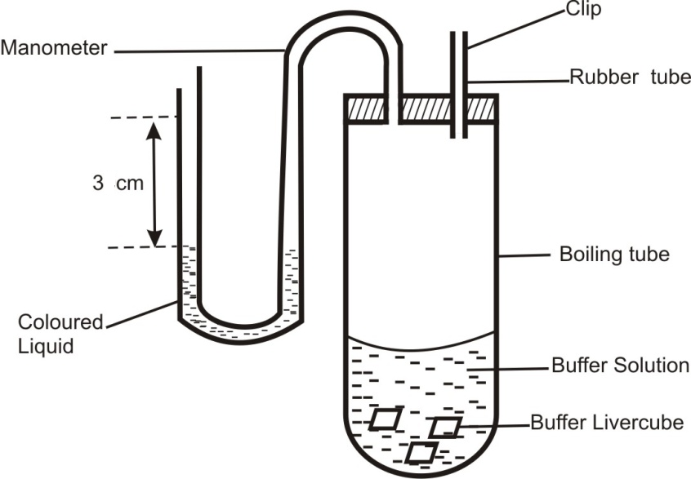
Hydrogen peroxide solution was added to each boiling tube in turn, and the time taken for the fluid in the manometer tube to rise by 3cm measured. Each test was repeated twice.
The students’ raw results are given in the table below:
pH | Experiment 1 | Experiment 2 | Experiment 3 | Average time (s) | Rate of reaction ( cm/s )
5 | 7min 40s | 8min 17s | 8min 3s
6 | 2min 14s | 2min 7s | 1min 39s
7 | 0min 20.8s | 0min 17.9s | 0min 17.1s
7.5 | 0min 14.2s | 0min 13.7s | 0min 13.0s
8 | 0min 17.4s | 0min 17.0s | 0min 16.6s
9 | 9min 40s | 9min 57s | 9min 23s

(a) Complete the table above by calculating the average time and rate of reaction for each pH. (06 marks)

(b) Plot a graph of rate of reaction against pH on a graph paper. (05 marks)

(c) Using your graph, determine the optimum pH for enzyme M. (01 mark)
(d) Explain why the activity of enzyme M was very slow at pH 9? (02 marks)
(e) How would you modify this experiment to determine the optimum temperature for the activity of enzyme M? (02 marks)
(f) The enzyme M used in the experiment above is found in many plant and animal cells.
(i) Suggest the name of the enzyme M (01 mark)
(ii) Give the reason why enzyme M catalyses the breakdown of hydrogen peroxide in the plant and animal cells (01 mark)
(g) In the experiment above:
(i) State one variable that must be kept constant? (01 mark)
(ii) What is the purpose of the buffer solution in which the liver material is suspended? (01 mark)
6. The following data was obtained while carrying out at experiment to show the effect of substrate concentration on enzyme activity.
Rate of product formation (arbitrary units) | 0 | 35 | 50 | 60 | 75 | 90 | 100 | 100
Substrate concentration (mmol l⁻¹ | 0 | 10 | 20 | 25 | 35 | 50 | 60 | 80
- Draw a suitable graph to represent the above information
- Describe he shape of the graph
- Explain how substrate concentration affect enzyme activity.
- What factors must be kept constant in the experiment
- How can the effect of substrate concentration be demonstrated using a tissue such as liver
Nutrition in plants
7. An investigation was made to determine the effect of carbon dioxide concentration in parts per million (ppm) and light intensity on the rate of photosynthesis of a plant in a green house.
The investigation was conducted at two different light intensities: 0.05 and 0.25 arbitrary units of light intensity. A constant temperature of 22ºC was maintained throughout.
The results are indicated in the table below:
Carbon dioxide  concentration (ppm) | Rate of photosynthesis (mg dm⁻² h⁻¹)
Carbon dioxide  concentration (ppm) | AT 0.05 UNITS LIGHT INTENSITY | AT 0.25 UNITS LIGHT INTENSITY
300 | 12 | 25
500 | 14 | 30
700 | 15 | 35
900 | 15 | 37
1100 | 15 | 37
1300 | 12 | 31

(a) Using the same axes, represent the information in the table graphically. (06 marks)

(b) For the experiment at 0.25 units light intensity, explain the effect of increasing carbon dioxide concentration on the rate of photosynthesis of the plant. (10 marks)
(c) Give 2 similarities and 2 differences in the effect of changing carbon dioxide concentration on the rate of photosynthesis at the two light intensities.
8. The table below shows results of an investigation carried out on the fresh waterweed Elodea. The plant was placed under water with a constant carbon dioxide concentration, and the number of oxygen bubbles evolved per minute by the plant was recorded with increasing distance of a light bulb from the experimental setup. The investigation was carried out at 22⁰C.

Distance of bulb from setup(cm) | 5 | 10 | 15 | 20 | 25 | 30
Number of oxygen bubbles evolved per minute | 30 | 28 | 15 | 10 | 5 | 2

(a) What was the aim of the experiment? (01 mark)
(b) What is the relationship between:
(i) distance of bulb from the experimental setup and light intensity received by the plant? (01 mark)
(ii) number of oxygen bubbles evolved by the plant and its rate of photosynthesis?
(01 mark)
(c) Represent the information in the table graphically. (06 marks)

(d) (i) Describe the trend of the graph. (03 marks)

(ii) Account for the observed trend. (04 marks)
(d) Suggest two reasons why the method of counting the number of oxygen bubbles evolved per minute may not be the best way of determining the rate of photosynthesis? (02 marks)
(e) What is the importance of photosynthesis by aquatic plants? (02 marks)

HETEROTROPHIC NUTRITION
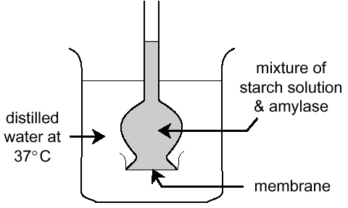
7. (a) A student set up the experiment illustrated above and kept it at 37 º C.
After five minutes, the distilled water in the beaker was tested and found to contain a sugar but no starch.
(i) What had occurred inside the tube? (02 marks)
(ii) What statement can you make about the permeability of the membrane? (01 mark)
(iii) Explain the presence of sugar and absence of starch in the beaker after 5 minutes.(02 marks)
(iv) Why was the experiment carried out at 37⁰C? (02 marks)
(v) An identical experiment was set up and kept at 0⁰C. After five minutes, how would the results of the experiment differ from those in the first experiment at 37⁰C? Explain your answer. (03 marks)

(b) Four test tubes were placed in a water bath for 15 minutes. The table below presents the contents, pH, kind of pepsin enzyme, temperature and appearance after 15 minutes.

 | Tube 1 | Tube 2 | Tube 3 | Tube 4
Contents | Eggwhite | Eggwhite | Eggwhite | Eggwhite
pH | 2 | 2 | 8 | 2
Enzyme | present (unboiled) | Present  (boiled) | present  (unboiled) | present (unboiled)
Temperature | 0ºC | 37ºC | 37ºC | 37ºC
Appearance | Cloudy | Cloudy | cloudy | Clear
Account fully for the results obtained in each test tube. (10 marks)
9. A hungry person had a meal, after which the concentrations of glucose and amino acids in the blood were determined. This was measured hourly as the blood passed through the hepatic portal vein and the iliac vein in the leg. The results were as shown in the table below.
Time (hours) | Concentration of contents in  hepatic portal vein (mg/100ml) |  | Concentration of contents in the iliac vein of the leg (mg/100ml)
Time (hours) | Glucose | Amino acids | Glucose | Amino acids
0 | 85 | 1.0 | 85 | 1.0
1 | 85 | 1.0 | 85 | 1.0
2 | 140 | 1.0 | 125 | 1.0
3 | 130 | 1.5 | 110 | 1.5
4 | 110 | 3.0 | 90 | 3.0
5 | 90 | 2.0 | 90 | 2.0
6 | 90 | 1.0 | 90 | 1.0
7 | 90 | 1.0 | 90 | 1.0
(a) Using the same axes draw graphs of concentration of glucose in the hepatic portal vein and the iliac vein in the leg against time. (07 marks)
(b) Account for the concentration of glucose in the hepatic portal vein from
(i) 0 - 1 hour (02 marks)
(ii) 1 - 2 hours (03 marks)
(iii) 2 - 4 hours (03 marks)
(iv) 5 - 7 hours (02 marks)
(c) Account for the difference in the concentration of glucose in hepatic portal vein and the iliac vein between 2 and 4 hours. (02 marks)
(d) Explain why the concentration of amino acids in the hepatic portal vein took longer to increase. (01 mark)

MOVEMENT IN AND OUT OF CELLS

10. Mammalian red blood cells transferred from blood plasma to a less concentrated solution swell, and if they swell sufficiently, they burst; in which case they are said to have haemolysed. And when comparable discs of potato tuber are placed in sucrose solutions of varying concentrations their mass changes.
The table below shows the percentage of red blood cells haemolysed and the percentage change in mass of discs of potato tuber separately placed in a series of sucrose solutions ranging from 0.0 to 0.6M in covered dishes at a constant temperature of 20⁰C.

Concentration of sucrose solution (mol/dm³) | Red cells haemolysed | Mass of potato tuber discs
0.0  0.1  0.3  0.3  0.4  0.5  0.6 | 100  90  80  68  30  16  0 | ⁺ 22  ⁺ 17  ⁺ 9  ⁺ 3  ⁻3  ⁻10  ⁻15

- Represent the information graphically using the same set of axes. (07 marks)
- From your graph, determine the sucrose concentration at which the proportions of haemolysed to non-haemolysed cells are equal. (01 mark)
- Fully explain how you arrived at your answer in (b). (02 marks)
- Give an explanation of each of the following :
- Red blood cells placed in a 0.0M sucrose solution swell and burst while plant cells do not. (02 marks)
- Red blood cells haemolyse over a range of sucrose solution concentrations rather than at one particular sucrose concentration. (01 mark)
- Positive percentage changes in mass of potato tuber discs. (02 marks)
- Negative percentage changes in mass of potato tuber discs. (02 marks)
- Suggest reasons why:
- The dishes containing the red blood cells or potato tuber discs are covered during the experiments. (02 marks)
- The solutions are kept at a constant temperature of 20⁰C during the experiments. (01 mark)
TRANSPORT IN PLANTS
11. A careful study was done on the effect of temperature and relative humidity on the rate of transpiration on a bright sunny day, and the following information obtained:
Temperature | 10⁰C | 20⁰C | 30⁰C | 40⁰C | 50⁰C | 60⁰C | 70⁰C
Relative humidity/% | 69 | 62 | 48 | 41 | 30 | 19 | 8
Rate of transpiration (cm³/s) | 22 | 30 | 41 | 49 | 61 | 73 | 84

(a) (i) Construct a graph to show the relationship between relative humidity, temperature and transpiration using the same axes.
(ii) Describe how the changes in temperature and relative humidity influence the rate of transpiration.
(b) Explain the effects of
(i) rise in temperature on the rate of transpiration.
(ii) rise in humidity on the rate of transpiration.
(c) Describe any five structural adaptations of plants that reduce transpiration.
12. An investigation was carried out into the relationship between the rate of water absorption and the rate of transpiration in sunflower plants at various times of the day.
The results are shown in the diagram below:
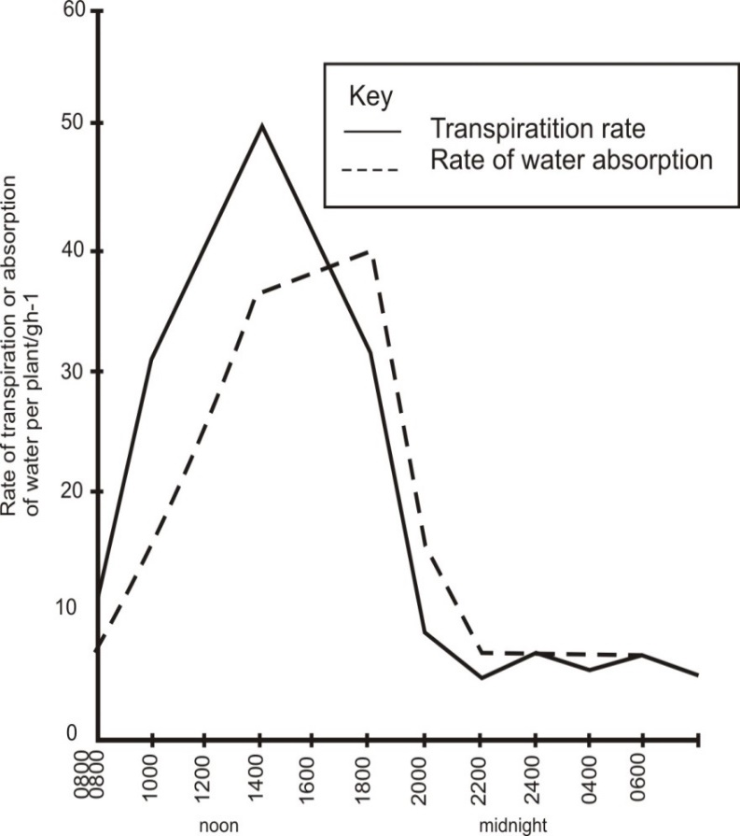
Time of the day / 24 hour clock
(a) Describe the change in the rate of water absorption from 08.00 hours to 20.00 hours.
(03 marks)
(b) What are the differences in the changes in the rate of water absorption and the rate of transpiration from 08.00 hours to 20.00 hours? (03 marks)
(c) Account for the changes in the rate of transpiration that took place:
(i) From 08.00 hours to 14.00 hours.
(i) From 14.00 hours to 20.00 hours
(i) From 20.00 hours to 06.00 hours
(d) Explain the relationship between the changes in the rate of water absorption and the rate of transpiration.
13. In an experiment to determine the effect of ringing on the translocation of sugar in phloem, a ring of bark from the stem of a tree was removed. The amount of sugar in grams per 10cm³ piece of the bark above the ring was measured at 3-hour intervals. Sugar was also measured in the bark of the stem at the same height of a similar tree which was not ringed. The results are shown in the table below:

Time of day | Amount of sugar in grams per 10cm³ piece of bark
 | Normal stem | Ringed stem
07.00 | 0.48 | 0.48
10.00 | 0.57 | 0.66
13.00 | 0.70 | 0.90
16.00 | 0.65 | 1.01
19.00 | 0.56 | 0.90
22.00 | 0.47 | 0.75
01.00 | 0.40 | 0.56

(a) Using the same axes, plot a graph of the amount of sugar against time.
(b) What was the amount of sugar at 14.30 in:
(i) ringed stem,
(ii) normal stem?
(c) How much sugar would be in the normal stem if the experiment was continued for another 3 hours? (d) Give reasons why there was sugar in the stems of both trees at 0700 hours?
(e) Account for the shape of the graph for:
(i) ringed stem between 0700 hours and 1600 hours.
(ii) normal stem between 1300 hours and 0100 hour.
- Other than carbohydrates name two compounds that are synthesized by plants.
- Name the structure in phloem that control translocation of manufactured food.
TRANSPORT IN ANIMALS
13. The pressure of the flow of blood in a mammal was determined in two different vessels. The data was taken within a period of 1 minute and was presented as follows:
Time in seconds | Blood vessel A/mmHg | Blood vessel B/mmHg
0 | 160 | 320
10 | 164 | 360
20 | 165 | 320
30 | 178 | 400
40 | 172 | 360
50 | 160 | 320
60 | 160 | 360

(a) Plot a graph of blood pressure in both vessels against time on the same axes.
(b) Describe the variation in blood pressure in Blood vessel A.
(c) From the graph, suggest the possible identity for:
(i) Blood vessel A.
(ii) Blood vessel B. (iii) Give a reason for each of your answers in (i) and (ii) above.
(d) Explain any factor that would result in an increase in blood pressure in both blood vessels above.
(e) State two structural differences between the two vessels mentioned in (c) above
RESPIRATION
14. A biologist collected data from an athlete during and after a period of running of 6 minutes. The data is shown in the table below:
Time/minutes | 0 | 4 | 8 | 12 | 16 | 20 | 30 | 50 | 60 | 70
Concentration of lactic acid in blood (mg/100 cm³) | 3 | 28 | 50 | 40 | 33 | 26 | 12 | 5 | 3 | 3

- Represent the information graphically. (06 marks)

- Describe the change in concentration of lactic acid over the 70 minutes. (06 marks)
- Explain the change in lactic acid concentration in blood between:
- 2-6 minutes (04 marks)

- 10-20 minutes (02 marks)
What are the effects of excessive accumulation of lactic acid in the body? (02 marks)

